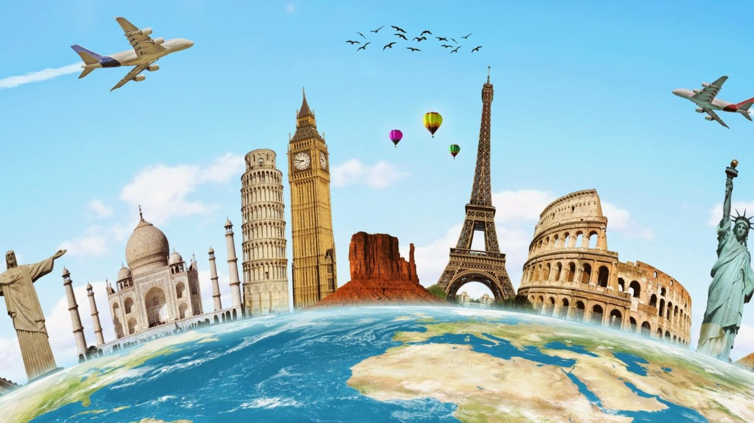
1.What is tourism?

2.Why do people travel?

3.Why do people use travel guides?

4.When was the first guide written?
5.How many people are involved in tourism industry all over the world?

1.What is tourism?

2.Why do people travel?

3.Why do people use travel guides?

4.When was the first guide written?
5.How many people are involved in tourism industry all over the world?

1.What is tourism?

2.Why do people travel?

3.Why do people use travel guides?

4.When was the first guide written?
5.How many people are involved in tourism industry all over the world?

1.What is tourism?

2.Why do people travel?

3.Why do people use travel guides?

4.When was the first guide written?
5.How many people are involved in tourism industry all over the world?

Why do people travel?
According to the text | According to the video
Why do people travel?
According to the text | According to the video
Why do people travel?
According to the text | According to the video

Domestic
Adventure
Cultural
Ecotourism
Health
Rural
Sport
Educational

Domestic
Adventure
Cultural
Ecotourism
Health
Rural
Sport
Educational

Adventure
Cultural
Ecotourism
Health
Sport
Educational
Rural
Domestic

- requires that a tourist is ready to take risks and possesses special training and skills. It includes difficult activities and extreme sports, such as mountaineering, desert hiking, scuba diving, rock climbing, and so on.(adventure)
- this kind of tourism involves things, such as history of a given region, the lifestyle of people in a particular geographical locale, architecture, religions, festivals, cuisine, and so on. (cultural)
- involves a travel to virtually undisturbed areas of natural beauty. It involves traveling to places, the primary attractions of which are flora and fauna, natural and/or artificial landforms. It also includes the concepts of geotourism and wildlife tourism. (ecotourism)
- The term constitutes the travel of patients from one place to the other in order to get proper medical care and treatment. (health)
- involves sport(s) and the excitement and enjoyment it offers, as its basis. It can be either active or passive in nature, which means that one can either travel to another place in order to participate in a sport, or just to watch it being played. (sport)
- Domestic tourism is tourism involving residents of one country traveling only within that country.
- the main purpose of travel is to get knowledge and experience on certain topics , rather than travel itself (for example -discovery in the form of excursions)
- Rural tourism may be defined as the movement of people from their normal place of residence to rural areas for a minimum period of twenty-four hours to the maximum of six months for the sole purpose of leisure and pleasure. Rural tourism refers to all tourism activities in a rural area.

Why do people travel?

Класс: 11
Цель урока: совершенствование навыков восприятия и понимания речи на слух
Задачи урока:
- Коммуникативная задача: обсудить популярные виды туризма.
- Образовательные: совершенствовать умения и навыки практического владения английским языком по теме «Tourism» в устной речи.
- Развивающие: способствовать развитию умений работать в парах, группах, создать условия для развития лингво-культурологической компетенции учащихся.
- Воспитательные: способствовать формированию культуры общения, создать условия для формирования положительного отношения к путешествию и интереса к другим странам и культурам.
Оборудование урока: доска, мультимедийное оборудование, раздаточный материал.

Ход урока
1) Введение в атмосферу иноязычного общения
T: Good morning, dear children and our guests! I am very glad to see you! You may sit down.
T: Now look at the board, please. You can see some statements (‘The world is a book: if you don’t travel, you read only one page’, ‘Sometimes one day spent in other places may give you more than ten years of living at home’). How do you understand them? Do you agree with them?
T: Look at our today’s topic and guess what we are going to discuss.
To discuss tourism and travelling in general we should find the answer to the question “Why do people travel? What are their reasons and purposes?”. Give me please your ideas?
2) Чтение
- Предтекстовый этап There are some new words. Let’s discuss them (Emerge, travel guide, destination, hospitality). Answer the questions(in pairs) (Приложение 1)
- Текстовый этап read the text ant check your guesses (Приложение2)
- Послетекстовый этап -make a list of reasons for travelling according to the text
-now we’ll watch a video in which people are talking about
reasons for travelling. Watch and complete your table (Приложение 3)
3) Восприятие и понимание речи на слух
- Преддемонстрационный этап (in groups)
-phonetic exercise (read after me)
-discuss how you would define the following types of tourism (Domestic-Adventure-Cultural-Ecotourism-Health-Rural-Sport-Educational) (Приложение 4)
ФИЗКУЛЬТМИТУТКА (в группах: группа1-названия видов туризма, группа2-определение) Your task is to find your pair (Приложение 5)
- Демонстрационный этап
Listen to people speaking about their preferences and say which type of tourism they prefer.
- Последемонстрационный этап
-why do people prefer these types of tourism?
-discuss with your partner what type of tourism you like most and why.
4) Рефлексия
- What have we discussed today? What is the main reason for travelling?
- T: Our lesson is finishing. Let's talk about your homework. I'd like you to write a short essay about your most favourite and least favourite types of tourism.
You've worked very hard today. Your marks are … . The lesson is over. Bye!

ПРИЛОЖЕНИЕ 1
1.What is tourism?
2.Why do people travel?
3.Why do people use travel guides?
4.When was the first guide written?
5.How many people are involved in tourism industry all over the world?

ПРИЛОЖЕНИЕ 2
Since the beginning of time humans have travelled to find food, water, safety or resources. The idea of travel for pleasure emerged much later. The earliest travellers walked. The invention of the wheel and the sail provided new modes of transportation. Each improvement in technology increased individuals’ opportunities to travel. As roads were improved interest in travel for education, sightseeing, and religious purposes increased. One of the earliest travel guides, a 10 volume Guide to Greece was written in 170 A.D. by Pausanias, a Greek, for Roman tourists.
Tourism is a temporary, voluntary movement of people to destinations outside their normal places of work and residence, the activities undertaken during their stay in those destinations, and the facilities created to cater for their needs. It is a collection of activities, services, and industries that delivers a travel experience, including transportation, accommodations, eating and drinking establishments, shops, entertainment businesses, activities, and other hospitality services provided for individuals or groups travelling away from home. The World Tourism Organization (WTO) claims that tourism is currently the world’s largest industry with annual revenues of over $3 trillion. Tourism provides over 250 million jobs all over the world. Six million jobs in tourism in the United States make the tourism industry the country’s largest employer.
ПРИЛОЖЕНИЕ 3
Why do people travel?
According to the text | According to the video

ПРИЛОЖЕНИЕ 4
Domestic
Adventure
Cultural
Ecotourism
Health
Rural
Sport
Educational

ПРИЛОЖЕНИЕ 5
requires that a tourist is ready to take risks and possesses special training and skills. It includes difficult activities and extreme sports, such as mountaineering, desert hiking, scuba diving, rock climbing, and so on.
this kind of tourism involves things, such as history of a given region, the lifestyle of people in a particular geographical locale, architecture, religions, festivals, cuisine, and so on.
involves a travel to virtually undisturbed areas of natural beauty. It involves traveling to places, the primary attractions of which are flora and fauna, natural and/or artificial landforms. It also includes the concepts of geotourism and wildlife tourism.
The term constitutes the travel of patients from one place to the other in order to get proper medical care and treatment.
involves sport(s) and the excitement and enjoyment it offers, as its basis. It can be either active or passive in nature, which means that one can either travel to another place in order to participate in a sport, or just to watch it being played.
It is tourism involving residents of one country traveling only within that country.
the main purpose of travel is to get knowledge and experience on certain topics , rather than travel itself (for example -discovery in the form of excursions)
This type of tourism may be defined as the movement of people from their normal place of residence to rural areas for a minimum period of twenty-four hours to the maximum of six months for the sole purpose of leisure and pleasure. Rural tourism refers to all tourism activities in a rural area.

Adventure
Cultural
Ecotourism
Health
Sport
Educational
Rural
Domestic

Учреждение образования «Могилевский государственный областной лицей № 2»

Урок английского языка
в 11 классе
«Why do people travel?»

Подготовила
учитель английского языка
Анищенко Анна Андреевна

Могилев, 2020

