11 класс
Тема: Great People. Who do you think you are?
Цель: развитие коммуникативных способностей учащихся: монологически и диалогически высказываться по теме урока, давать свою оценку, выражать собственное мнение, используя активную лексику.
Оборудование: мультимедийное средство, аудиозапись, презентация.
ЗАДАЧИ:
- образовательные: к концу урока учащиеся должны уметь употреблять изученную лексику по теме в дилогической и монологической речи, развивать умения восприятия речи на слух с целью понимания содержания с последующим выполнением задания, способствовать расширению словарного запаса;
- развивающие: развивать навыки говорения по теме, развивать эмоционально – образную сферу и творческие способности учащихся, интерес к истории своей семьи, прошлому своей страны, ;
- воспитательные: создать условия для: патриотического воспитания учащихся, национальной гордости; обучения высказыванию своего мнения; расширения кругозора учащихся по теме «Великие люди Беларуси».
ПЛАН УРОКА:
- Мотивационно-целевой этап
- Речевая разминка
- Активизация изученной лексики
- Проверка домашнего задания: презентация проектов (контроль монологической речи)
- Восприятие и понимание речи на слух. Выполнение заданий
- Рефлексия
- Заключительный этап: Подведение итогов. Выставление отметок.
- Объяснение домашнего задания.

I.Мотивационно-целевой этап. Введение темы
T: I want to start our lesson with such a philosophical question:
Who Do You Think You Are? (How can you answer the question?)
P1, P2, P3…(I’m a girl………)
T: Now, have a look at these words of wisdom: “No man ever looks at the world with clear eyes. He sees it edited by the heritage of the ancestors”
How do you understand these words? Can you add anything else to your previous answers?
P1:
T: You are right. At last, what are we going to speak about at our today’s lesson?
P2:
T: That’s it. But not only about ancestors, but our contemporaries, too. And at the end of the lesson we’ll answer the question: Why is it important to know your roots?

II.Основная часть.
- Повторение лексики
T: Let’s start with the revision of our active vocabulary.
Look at these words & find the pairs of synonyms & antonyms & write them down into two columns.
contemporary, descendant, custom, roots, offspring, tradition, origin, ancestor, background
synonyms | antonyms
1.  2.  3.  4. | 1.  2.  My mark is …..

Сверить со слайдом – оценить себя

- Выполнение теста (контроль знания активной лексики)
T: Fill in the missing words in necessary form:
Use the correct form of each word to fill in the blanks: contemporary, custom, fellow countryman, tradition, origin, ancestor, inheritor, offspring
- We should be thankful to our (ancestors) for the knowledge, (customs and traditions) and they had left for us.
- What is the (origin) of the name “White Rus”?
- V.Korotkevich is my (fellow countryman) .
- There are a lot of well-known ( contemporaries) with Belarusian roots who live abroad but create in honour of their historical motherland.
- We are the (inheritors) of the richest Belarusian culture.
My mark is ….. Name _________________

Сверить с ответами - оценить себя
T: You know the active vocabulary rather well, so I hope you’ll use as many new words as possible in your speech.

- Проверка Д/з (презентация проектов)
T: Your HT was to tell us about one of your ancestors or a well-known Belarusian. You’re welcome! ………………Well done. We are all proud of your great relatives & our famed fellow countrymеn.

- Восприятие и понимание речи на слух
А) Предтекстовые задания:
- T: If we speak about our ancestors we can’t but remember some our great fellow countrymen, whose names are well-known all over the world. They did a lot not only for their motherland but the whole mankind. We can call them “citizens of the world”. Do you remember some of such people?
P1: Fr.Scoryna
P2: Mark Chagall
P3: Borys Kit
P4: Zhores Alferov
T: Here is a mini quiz. Read & answer the questions. You have 2 minutes
(Приложение 1)
Compare your answers with your partner.

Б) Прослушивание 1
T: Now, listen to the conversation & check your answers. (Приложение 2)
В) Прослушивание 2
T: Another task. Listen to the conversation again & match the facts from the list with the people who the girls speak about. (прослушивание) (Приложение 3)
T: Look at the screen & check yourselves.
Give marks to yourselves.
Г) Выполнение послетекстовых заданий
T: Which famous people from the list did you know before?
P1,P2,P3………
Did you know that all these men have Belarusian roots?
P1
P2
P3
- Cовершенствование навыков говорения (неподготовленная речь)
T: You will get a card with a name of a famous person. Imagine that you are this person. Be ready to speak about some facts from your biography & about your ancestors. You have 2 minutes to get ready…………..
(стать в 2 круга и обменяться информацией)
T: Now, let’s find out “Who Is Who”………
Well done.

- Рефлексия
T: We have come back to our question: Why is it important to know your roots?
P1
P2
P3
- «Круги по воде»
Remarkable, respectful
Outstanding
Optimistic
Traditional, talented
Self-confident, skillful, super

- Подведение итогов. Выставление отметок
T: Please, give marks to yourselves for your work at the lesson, including your HW, & hand in your pieces of paper.
All of you used active vocabulary, understood the text for listening & did all the tasks without mistakes. You expressed your opinions on the topic of the lesson & gave full answers to the questions. Of course, there were some grammar & phonetic mistakes, but it’s natural & these mistakes didn’t prevent understanding & communicatuion.
You are getting excellent marks.
- Д/з
T: You’ll read a fantastic story “I, Robot” by I.Asimov & express your opinions on what you will have read.

Приложение 1
- Which film studio produced “Tom & Jerry”, “Casino Royal” & “Legally Blonde”?
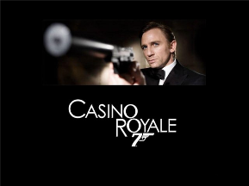
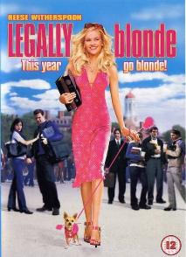
- Metro-Goldwin-Mayer (MGM)
- Warner Bros
- Walt Disney Studios

- Which actor & film producer has been working as a UNO Messenger of Peace?
- Michael Douglas
- Michael Jackson
- Michael Jordan

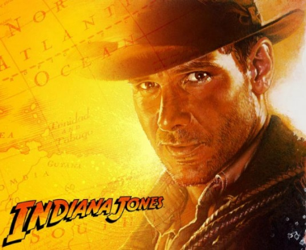
- Which well-known actor played the part of Indiana Jones?
- Brad Pitt
- Robert Pattison
- Harrison Ford

- Which famous artist was the oldest of nine children & died when he was 97 years old?
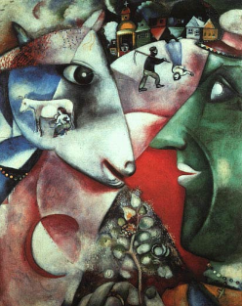
- Leonardo Da Vinci
- Marc Chagall
- Pablo Picasso

- Who was the author of sci-fi stories “The Edge of Tomorrow” & “I, Robot”?
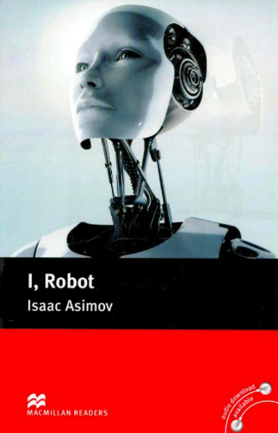
- Ray Bradbury
- Stephen King
- Isaac Asimov

Приложение 2

- Oh, it’s amazing!
- What is it?
- I’ve just bought a magazine with an article about James Bond. They’re going to start a new Bond film soon at MGM studio. “Casino Royal” was a big success.
-Yes. Almost all films by Metro-Goldwyn-Mayer are good. Remember “Legally Blond” or “Tom and Jerry”.
- Right. I’ve read that Louis B. Mayer, the creator of MGM, was in fact from Belarus.
- Really?
- Yeah! He was born in Minsk, and later his parents moved to New York. He always understood what people wanted to see at the cinema and that’s why his studio always had "more stars than there are in the heavens".
- That’s true. Then, logically, MGM should invite Harrison Ford or Michael Douglas to play the part of James Bond.
- Why?
- Haven’t you seen the new programme “Who Do You Think You Are”? They invite famous people and travel with them around the world to learn the story of their ancestors. The first programme was with Michael Douglas. They showed the place in Belarus where Michael’s ancestors had a farm.
-So, Douglas has Belarusian roots, too?
-Yeah. His grandparents were quite rich, but in 1908 they decided to leave their motherland. They said that Michael Douglas has a cousin who lives in Mogilev.
- Cool! Michael is not only a successful actor and producer. He’s also a UN Messenger of Peace.
- I see. And did you mention Harrison Ford? Is he somehow Belarusian too?
- Surprise, surprise! Well, actually, he’s half German and half Belarusian. His mother’s parents lived in Minsk.
- Fantastic! So worldwide known Indiana Jones is half Belarusian…
- Well, he became Indiana Jones not at once. Harrison Ford had difficult times. He even worked as a carpenter to earn money because his acting career wasn’t very successful in the beginning.
- I really can’t believe it! Let’s go online and search the net. I’d like to know who else has Belarusian roots.
- OK. I’ve just found a website with the list of people with roots in Belarus. Louis B. Mayer, Harrison Ford, Michael Douglas, …. oh, guess who else is in the list!
- And who?
- Marc Chagall and Aizek Asimov.
- Marc Chagall? An artist from Vitebsk?
- Yes, he is an artist. And he was born and lived in Belarus until he emigrated to France. Oh, can you imagine he had nine brothers and sisters and he was the oldest. …Oh, and he died when he was 97. That’s a long life!
- I see. And you also said something about Aizek Asimov. I’m keen on his sci-fi novels and stories. Is he from Belarus, too?
- They say he is. He was born in a place on the border between Belarus and Russia. His ancestors were millers and in 1923 they left the Soviet Union and moved to New York. It’s a pity, but I’ve never read any of his books.
- Are you joking?! His books are fantastic! Do you remember the film “I, Robot” with Will Smith?
- Of course, I do.
- It’s based on Asimov’s story!
- Really? It seems to me, my next book will be Azimov’s sci-fi novels.

Приложение 3

Louis Mayer, Harrison Ford, Isaac Asimov, Michael Douglas, Marc Chagall
- He founded a film studio in Hollywood.
- He worked as a carpenter when his acting career wasn’t very successful.
- His work influenced a lot of science-fiction films.
- He has a cousin who lives in Mogilev.
- He’s half German & half Belarusian.
- He said he had “more stars than there are in the heavens”.
- His ancestors had a farm in Belarus.
- He was born & lived in Belarus until he emigrated to France.
- His ancestors were millers.
- There were ten children in his family & he was the oldest.

Ключ для учителя
Louis Mayer, Harrison Ford, Isaac Asimov, Michael Douglas, Marc Chagall
- He founded a film studio in Hollywood. (Louis Mayer)
- He worked as a carpenter when his acting career wasn’t very successful. (Harrison Ford)
- His work influenced a lot of science-fiction films. (Isaac Asimov)
- He has a cousin who lives in Mogilev. (Michael Douglas)
- He’s half German & half Belarusian. (Harrison Ford)
- He said he had “more stars than there are in the heavens”. (Louis Mayer)
- His ancestors had a farm in Belarus. (Michael Douglas)
- He was born & lived in Belarus until he emigrated to France. (Marc Chagall)
- His ancestors were millers. (Isaac Asimov)
- There were ten children in his family & he was the oldest. (Marc Chagall)

