Внеклассное мероприятие на тему «ШЕКСПИРОВСКИЕ ЧТЕНИЯ»
ПЛАН УРОКА
Тема урока: «Шекспировские чтения»
Тип: литературная прогулка
Цель урока: развитие навыков устной речи
Задачи урока:
1) образовательная: создать условия для реализации всех видов речевой деятельности: аудирования, чтения, говорения и письма;
2) развивающая: развивать творческий потенциал учащихся, их языковые и познавательные способности; а также способствовать развитию памяти, внимания, мышления.
3) воспитательная: повышение интереса к иностранному языку, культуре, расширение кругозора.
4) повысить уровень мотивации к овладению устной иноязычной речью.
Формы работы: фронтальная, парная, индивидуальная.
Оборудование: компьютер, раздаточный материал, магниты, рабочая тетрадь.

Содержание урока
1. Организационный этап.
Good afternoon, I’m glad to see you. (We are glad to see you too.)
-How are you, students? (We are OK, thank you).
Today we are going to speak about one of the greatest playwrights. Can you guess who it will be? Absolutely right! William Shakespeare. And in this lesson, you are introduced to Shakespeare as the topic for the lesson and pool the knowledge that we already have about him with a mind map and quiz activities.
2. Основной этап.
By the way, what do you know about William Shakespeare? Cool. According to our lesson we will add information and your task - to write it and create a mind map, you will do it all together. You may start. Write what comes to mind when you think about William Shakespeare.
Now, we will watch a video your task is to answer the questions: Where and when he was born? What did he build? Were there women? Who played in the theatre? What are the most famous plays? Did he write sonnets, comedies? https://www.youtube.com/watch?v=ocrgDc6W7Es
Физкультминутка
3. Основной этап.
We know more about William Shakespeare. Let’s do the crossword, you’ll do it in pairs.
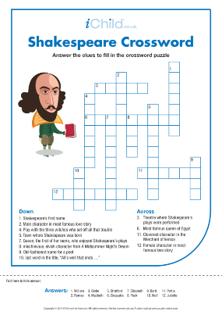
We know that William Shakespeare wrote sonnets. Piece the lines of the sonnet back together. Do you recognize it? Who wants to read?
My mistress' eyes are nothing like the sun;
Coral is far more red than her lips' red;
If snow be white, why then her breasts are dun;
If hairs be wires, black wires grow on her head.
I have seen roses damasked, red and white,
But no such roses see I in her cheeks;
And in some perfumes is there more delight
Than in the breath that from my mistress reeks.
I love to hear her speak, yet well I know
That music hath a far more pleasing sound;
I grant I never saw a goddess go;
My mistress when she walks treads on the ground.
And yet, by heaven, I think my love as rare
As any she belied with false compare.
Good job, but some words are missed; let’s try to put them into the gaps.
I prepared the audio of this sonnet, do you know the actor Alan Rickman? Would you like to listen this sonnet in his performance?
Let’s read this sonnet.
Add more information (a mind map) Write 6 questions about William Shakespeare.
4. Заключительный этап.
Let's conclude today’s lesson, what new information did you get? Was it interesting?
5. Домашнее задания. Выставление отметок.
I’m very pleased with your activity at the lesson. What about you? Did you like the lesson? Your marks are…. Your home task is…
Thank you for your work! Our class is over, good-bye!
Государственное учреждение образования «Средняя школа №2 г. Могилева»

План-конспект открытого урока
по английскому языку
в 8 «Б» классе
по теме «Шекспировские чтения»

Подготовила и провела:
учитель английского языка
Давыденко Мария Игоревна

Могилев, 2021

