**План-конспект учебного занятия по английскому языку**

**Тема:** Ведущий прогноза погоды

**Класс:** 9 «Б»

**Место учебного занятия**: 10/19

**Вид учебного занятия:** традиционный

**Формы работы:** индивидуальная, коллективная, фронтальная

**Цель:** развитие навыков говорения в рамках заданной темы

**Прогнозируемый результат:** предполагается, что к концу учебного занятия учащиеся смогут выразить свое отношение к прогнозу погоды и выступить в роли ведущего прогноза погоды

**Задачи:**

**Образовательная:** содействовать развитию коммуникативной компетенции учащихся посредством развития навыков монологической речи;

**Развивающая:** создать благоприятные условия для развития памяти, внимания, мышления и воображения у учащихся;

**Воспитательная:** содействовать развитию познавательного интереса к окружающему миру, любви к природе

**Дидактическое оснащение**: учебник, наглядный и раздаточный материал, видеозапись, аудиозапись

**Ход учебного занятия:**

1. **Организационно-мотивационный этап**:

Good afternoon, boys and girls! Sit down, please. How are you today? I am glad to see you all here.

Tell me, please: What’s the weather like today? Do you like it? Why? Why not? What is your favourite kind of weather?

Good. And now, please, look at the screen. There you may see some words. Your task is to solve the rebus (the puzzle) and to answer: What is the topic of our today’s lesson?

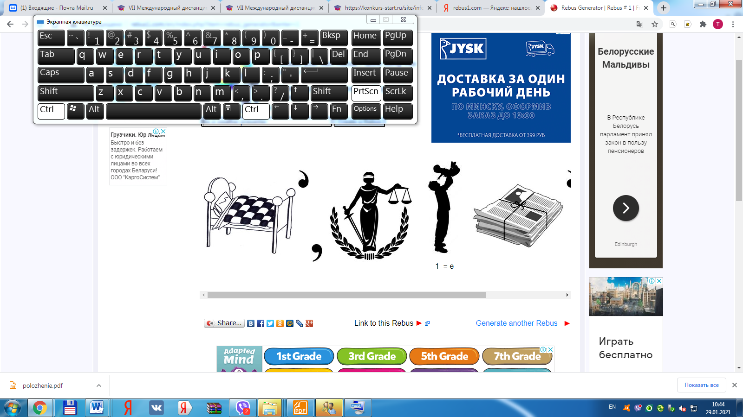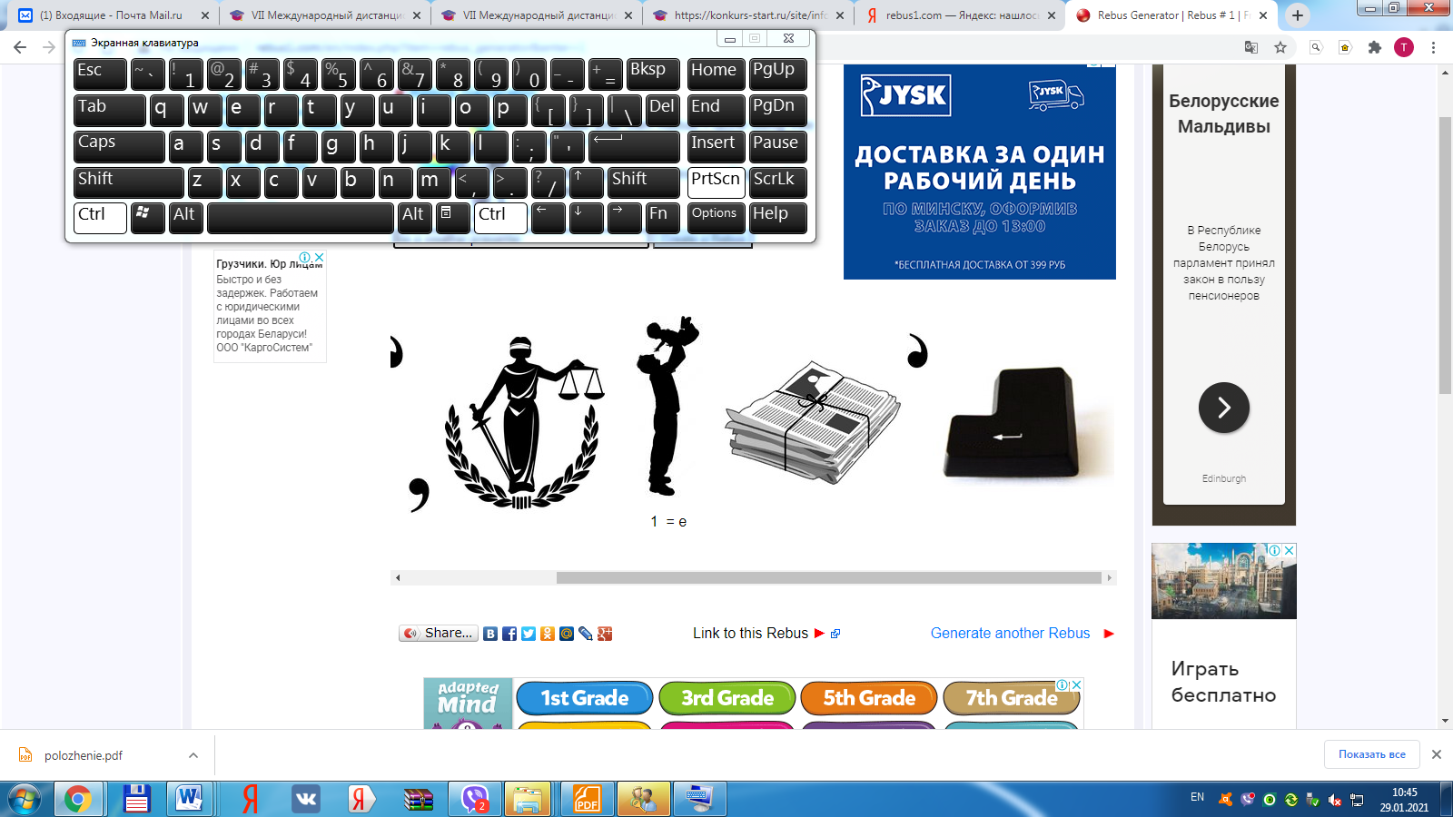

Right you are. The topic of our lesson is “Be a weather presenter.”

1. **Этап целеполагания:**

Now, please, look at the topic of the lesson once again and answer: What are we going to do today? What do you think?

We will

* read the text;
* do some exercises;
* watch one video;
* describe the weather;
* be a weather presenter.

Right you are. Very good.

1. **Операционно-познавательный этап**

**3.1.Предтекстовый**

And now, we’re going to work on the text. But, before it, let’s do the following: Please, look at the screen. We’re going to watch one video. Your task is to watch it and to answer: What is it about?

Video: <https://yandex.by/video/preview/?filmId=15191546851226804928&from=tabbar&parent-reqid=1612023583991412-1489802884260210632453675-production-app-host-man-web-yp-304&text=weather+forecast+definition>



Is everything clear? Ok.

Tell, me, please: What is weather forecasting? How do you understand it? Who is weather presenter? Should we trust weather forecast? Why? Why not?

Good job.

**3.2.Текстовый:**

Now, it’s time to work on the text. Your task is to listen, read the story and formulate its main idea in one sentence. Define the genre of the story.

**Three men in a boat**



I remember a holiday of mine, which was completely ruined one late autumn because we were foolish enough to read the weather forecast in the local newspaper. “Heavy showers, with thunderstorms, may be expected today,” it said on Monday, and so we gave up our picnic, and stayed indoors all day, waiting for the rain. And people passed the house, as happy and merry as could be, with the sun shining out, and not a cloud to be seen.

“Ah” we said, as we stood looking out at them through the window, “won’t they come home wet?!” And we chuckled (усмехнулись) to think how wet they were going to get.

By twelve o’clock, with the sun pouring into the room, the heat became unbearable, and we wondered when those heavy showers and thunderstorms were going to begin.

“Ah! They’ll come in the afternoon, you’ll see,” we said to each other.

“Oh, won’t those people get wet!”

At one o’clock the landlady (хозяйка дома) came in to ask if we weren’t going out, as it seemed such a lovely day.

“No, no,” we answered, with a knowing chuckle, “not we. We don’t mean

to get wet – no, no.”

And when the afternoon was nearly gone, and still there was no sign of rain, we tried to cheer ourselves up (подбодрить себя) with the idea that it would come down all at once, just as the people had started for home, and they would finally get wet more than ever. But not a drop ever fell, and it finished a great day, and a lovely night after it.

The next morning we read that it was going to be a “warm, fine, fair day; much heat;” and we dressed ourselves in light things, and went out, and, half-an-hour after we had started, it began to rain hard, and a bitterly cold wind began to blow, and both kept on for the whole day. So we came home with colds and rheumatism all over us, and went to bed.

The weather is a thing I never can understand.

*After Jerome K. Jerome*

Is it clear? Have you got any questions?

**Релаксационная пауза:** It’s high time to have a rest. That’s why we’re going to do the following. Please, close your eyes, listen to the song and imagine that you are in a hot country:

* Where are you?
* What can you see?
* What’s the weather there? Do you enjoy it?

Good job.

It’s time to do some exercises. The **1st** task for you is to match parts of the sentences. (ex 2, p 143)

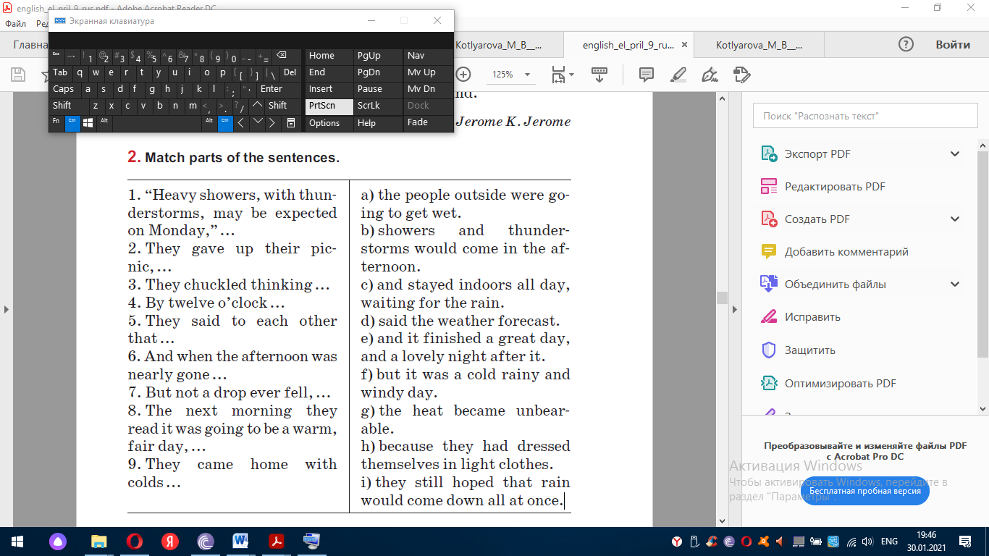

Ok.

The **2nd** exercise is to answer some questions: Why was the author’s holiday completely ruined? Have you ever been in a similar situation? Please, discuss this exercise, at first in pairs.

And now, prove that the story is humorous. Give examples from the text. What helps you to feel the humour?

Tell, me, please: Do you believe in weather forecast? Is it a good idea to

trust weather forecast?

Well done.

**3.3.Послетекстовый**

And now, I hope it’s high time to **take part in a Weather Presenters Competition.**  I would like you to create your weather forecast and to present it as a weather presenter.

Your task is to l**isten to the participants and vote for (проголосуй за)**

a) the best weather forecast presenter,

b) the best story,

c) the best weather,

d) the longest weather forecast,

e) the shortest weather forecast.

Who is ready to start?

Good job.

As you can see. “There is no bad weather, there are bad clothes”

Please, open your books at p 144, ex. 6. Listen and read the poem below. What does it teach us?

Do you try to follow the final advice of the poem?

When the weather is wet,

We must not fret (не ворчи).

When the weather is cold,

We must not scold (не ругайся).

When the weather is warm,

We must not storm (не кричи, не горячись).

But be thankful together,

Whatever the weather.

Well done.

1. **Контрольно-оценочный**
   1. **Контроль:** Now, you will get a card and you will have to do some

exercises. (some cards, according to the level of knowledge). You will have some minutes to do this exercise.

**Card 1. Составьте предложения.**

1.A lot of / the central / rain / the days / see / areas / will / during.

2.Will / by / evening / the temperature / by / fall / two degrees.

3. Will / a day / be / a bit / higher / temperature.

4. Next / the snow / cover / the ground / week / will.

5.Tomorrow / and / the sky / be / morning / blue / be / cloudless / will.

**Card 2. Переведи**.

1.Какая погода будет на следующей неделе?

2.К концу недели погода ожидается солнечной и теплой.

3. Говорят, будет дождливо, но тепло.

4. Температура упадет к вечеру.

5. В выходные дни погода будет пасмурной, с легким и умеренным ветром.

**Card 3. Исправь ошибку.**

1.On the whole, it will a fantastic sunny day.

2.Southern regions will have a cloudy and breez day.

3.The night temperature will be round average.

4. It will cold outside tomorrow.

5.What’s weather like today?

The time is over. Please hand out your papers.

**4.2.Оценивание:**

I’m satisfied with your work, that’s why your marks are the following:

8/9/10 – I’m satisfied with your answers. They were full and nice. You were active during the lesson. You’ve ever tried to improvise. That’s was nice.

7/6/5 – Your work was good, but not enough. You have some mistakes. Try to be more attentive.

**4.3.Этап домашнего задания:**

Open your record books and write down your hometask: ex.1, p145. Your task is to complete the sentences. Or as you wish you may try to create your own poem about weather**.**

Thank you for your work. Good bye.