Государственное учреждение образования
«Средняя школа № 31 г. Бреста»

ПЛАН-КОНСПЕКТ УРОКА ПО АНГЛИЙСКОМУ ЯЗЫКУ В V КЛАССЕ

«Wild nature»

Урок разработала:
учитель высшей категории
английского языка
Млынец Н.И.

Брест 2022
Тема урока: Дикая природа Беларуси
Цель:
Образовательная: ввести новый лексический материал по теме, совершенствовать навыки использования ранее изученного лексического и грамматического материала по теме.
Развивающая: развивать познавательный интерес учащихся, активизировать мыслительную активность учащихся, расширять кругозор.
Воспитательная: воспитывать положительное отношение учащихся к обсуждаемой теме, учить работать в группах, воспитывать гордость за свою Родину.
Оборудование: аудиозапись, компьютерная презентация, доска, раздаточный материал.
Литература: образовательная программа по предмету «Английский язык» КТП для 5 класса, учебник Демченко Н.В., шкала оценки результатов ученой деятельности учащихся по иностранному языку.

Ход урока:
Good morning, boys and girls, sit down, please. Today our lesson will be devoted to … I’ve prepared a crossword. Do it and the main word of this crossword is the title of our lesson.

 |  | c | o | w
 |  |  | p | i | g
 |  | b | u | l | l
 |  |  |  | d | o | g
 |  |  |  | l | a | m | b
r | a | b | b | i | t
 | c | a | l | f
 |  |  | h | e | n

You should unscramble the word, translate this word .
1. ocw | 5. mlab
2. gip | 6. bbitra
3. ulbl | 7. acfl
4. odg | 8. ehn
So, where do these animals live?
All of these animals live on the farm and they are called domestic animals.
But the main word of the crossword is ”Wildlife”. How can we translate it?
Look at the blackboard. Here you can see the definition of this word.
Wildlife – animals, birds and plants that grow independently of people, usually in natural conditions.
Введение новых лексических единиц
And today at the lesson we are going to discuss animals and birds which live in our forests. So we start learning the names of these animals.
Look at the computer slide and repeat after me:
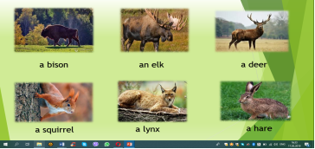
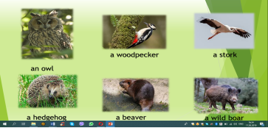
Отработка лексических единиц
1. Now let’s read the words
2. Let’s read and translate them.
3. Read the transcription.
4. Well done!
And now let’s see how attentive you were. On the blackboard you can see the pictures of animals and birds we discussed at the beginning of our lesson. You should go to the blackboard and match the name of a bird or an animal to the right picture. and be ready to answer the question “Have you ever seen this animal in real life?”
5. Your task is to guess these animals and birds according to their description
I suppose that you’re tired a little bit. It’s time for playing a game. When you hear the name of domestic animals you clap your hands. When you hear the name of wildlife animals you stamp your feet.
( a cow, a pig, a beaver, a cat, a bison, a stork, a dog, a sheep, a deer, an elk, a fox, a lynx,a bull, a horse, a hen)
As you can see our forests or pushchas are rich in wildlife. But there are some animals and birds that can be called the symbols of our country. What are they? (a bison and a stork)
A bison and a stork are called the national symbols of Belarus.
Развитие навыков восприятия и понимания иноязычной речи на слух
Let’s see what facts you know about bison. Take green cards. There are some sentences. Listen to the text and decide which of them are true and which are false:
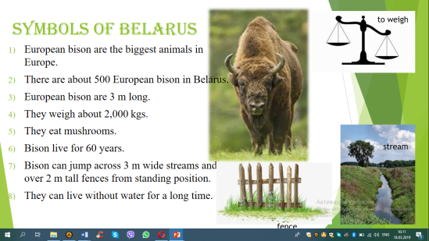

Then we discuss if the ideas were correct.
You know that the bison live in Belovezhskaya Pushcha.
Have you ever visited it?
Was it fun?
Did you see a bison here?
What other animals did you see?
Belovezhskaya Pushcha is the oldest National Park of Belarus. It’s a unique ecological place. We must proud of it. And now let’s watch a video about Belovezhskaya Pushcha.
Nice! But if you remember we have 2 symbols. We have discussed the bison and now it’s time to learn some interesting facts about storks.
Развитие навыков восприятия и понимания иноязычной речи на слух
Before listening to the text I want you to pay your attention to some words “the county under white wings”. How can you translate it? It’s a name of the book by Belarussian writer V.Korotkevich.
People call Belarus “the county under white wings” and believe that storks bring them luck and happiness.
So take blue cards, listen to the text and fill in the gaps
White storks are big birds. They can be 120 cm long. A stork has long legs, large wings and a long red beak. These beautiful birds live in Europe and they spend winter in South Africa. They can fly more than 10 thousand km. Storks live in the fields near rivers, lakes and swamps and build their nests on top of trees and houses. One stork eats about 100 insects daily. A stork family needs about 200 kilograms of food in one season. Storks also eat mice, frogs, fish and earth-worms. In Belarus there are about 40 thousand storks. People
call Belarus “the country under white wings” and believe that storks bring them luck and happiness.
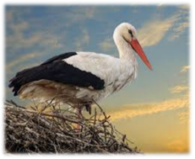
Are you ready? Now let’s check how attentive you were. Read the text.
And answer my questions
What does a stork look like?
In what continent do they like?
Where do they spend winter?
Where do they live?
What do they eat?
Thank you, it was great! As you can see the wildlife of Belarus is really rich and unique. At the beginning of the lesson we got acquainted with the names of some birds and animals that live on the territory of our country.
And now toy are divided into2 groups. Your task is to prepare a presentation about Belarussian national symbols. I’ll give you an envelope. Your task is to make a story about a bison and a stork. But you should be attentive. Not all the sentences are true to the animals. Choose the right sentences, make a story and be ready to read this story to your classmates. You have 3 min.
Объяснение домашнего задания.
Рассказать про зубра или аиста (на выбор).

Подведение итогов
As you can see there are many names of animals and birds which we will work with today. Tell me, please:
- Where do these animals live?
- Which animals or birds are the most beautiful?
- Which animals or birds are the most dangerous?
- Which animals are the strongest?
- Which animals or birds are the funniest?

Use the phrases which help us to express our opinion:
I think …
As for me …
In my opinion…

I liked your work very much today, you worked hard and to my mind you deserve good marks.
Now guess my riddles.
Riddles:
- This animal lives in the forest. It is neither big nor small. It likes to eat carrots and it is afraid of a fox and a wolf. This animal runs very fast. (A hare.)
- This animal is very big. It is grey and sometimes white. It has a very long nose. It lives in India and Africa. It likes to eat leaves and grass. (An elephant.)
- This animal lives at home or in the street. It is a man is friend. It can run, but can is fly and climb. It is very clever and friendly. (A dog.)
- This animal lives in the river or near the water. It is green. It can jump and swim, but it can neither run nor climb. (A frog.)
- Gena is not a boy. He is big, long and green. He is very clever. It can swim. He has a friend Cheburashka. (A crocodile.)
- This animal is red and sly. It likes hens, cocks, hares and ducks. It lives in the forest. (A fox.)
- It is grey. It can run, jump and walk. It is very small. It likes bread and cheese. It lives in the house. (A mouse.)
This animal can be black, grey, white or red. It lives in the house. It can catch a grey mouse. It likes meat, fish and milk. It can run, jump, climb and walk. (A cat.)

