Технологическая карта открытого урока английского языка в 5 классе

Предмет | Английский язык
Учитель | Учитель английского языка ГУО «Средняя школа №41 г. Могилева
 | Васьковская Юлия Викторовна
Тема урока | В цирке (At the circus)
Класс | 5
Тип урока | Урок совершенствования лексических единиц
Вид урока | Открытый урок
Форма урока | Фронтальная, индивидуальная, парная, групповая
Цель урока | Формирование коммуникативной компетенции
Задачи урока | Образовательная: создать условия для отработки лексических навыков.  Развивающая: способствовать развитию памяти, внимания, воображения у учащихся.  Воспитательная: содействовать развитию навыков сотрудничества и познавательного интереса к предмету. Способствовать воспитанию культуры общения в разных видах коллективного взаимодействия.
Оборудование | Компьютер,проектор, компьютерная презентация, доска
Дидактическое оснащение | Учебник English Student’s Book 1(Л.М.Лапицкая)  Английские стихи для детей (О.Г.Розова, Л.С.Пузанова), Учебное пособие Magic Box Pupil’s book Н.М.Седунова, наглядный и раздаточный материал.

Технологическая карта урока в 5 классе

Этап | Задачи урока | Содержание урока |  | Время
1 | 2 | 3 | 4 | 5
I. Организационный этап | Создание атмосферы иноязычного общения | ●Good morning,  children!  I’m glad to see you. I think we’ll enjoy our lesson today.  ●How are you? Are you fine today? It’s very well we are all fine today.  ●What date is it today?  ●What day is it today?  ●What is the weather like today?  Ok, let’s begin our lesson. | The pupils greet the teacher and answer the questions. | 2 min.
II Целеполагание | Определить тему и цели урока. Подготовить учащихся к иноязычному общению. | Look at the screen.  -Boys and girls, now you should guess what we are going to talk about today. What is the topic of our lesson? The clowns, trained animals, acrobats, jugglers…. Where can we see all of them?  -Yes, you are right! We can see them at the circus. And today the topic of our lesson is at the circus. | ●The topic of our lesson is at the circus… | 2 min.
III Фонетическая зарядка | Настроить артикуляцию учащихся на английскую речь. | Teacher: Let’s begin with phonetic drill.  Look at the  board.  Let’s read the poem and when we hear the sound [aʊ] clap your hands.  At the circus in the town  There are acrobats and clowns  Big wheels that go round and round  And the swing goes up and down.  Well done! And now I will put some words away and you should remember them.  At the circus in the …  There are acrobats and ….  Big wheels that go round and round  And the swing goes up and …... | Pupils read the poem and repeat after teacher. | 3 min.
IV.Актуализация знаний | Повторить ранее изученную тему. (Present Simple Tense, General questions and Special questions. | And now answer some questions, please: 1)Do you like to relax?  2) Do you like going to the circus?  3) Why do you like circus?  So I agree with you. Circus is a very interesting place. As for me when I was a little girl I liked to go to the circus with my mother. | Pupils answer the questions. | _{2 min.}
V Операционно-познавательный  Работа с текстом: Предтекстовый этап  Текстовый этап  Восприятие и понимания речи на слух  Послетекстовый этап  V Физкультминутка  VI Работа с карточками | Создать условия для формирования учебно-познавательной компетенции.  Создать условия для успешного понимания текста, для расширения кругозора учащихся.  Создание условий для активного слушания и иноязычного общения.  Создание условий для анализа информации и выражения своей точки зрения.  Снятие напряжения, активизация внимания учащихся  Контроль усвоение лексических навыков  Расширение кругозора учащихся. | Let’s continue our lesson.  At home you read and translated the text «Dumbo» Did you like the text?  Was it difficult for you?  Now look at the blackboard and repeat the unknown words from the text.  Feather- перо  Suddenly- вдруг, внезапно  You’ll listen the text and then be ready to fulfill the tasks.  Well done! Children let’s try to find the sentences in the text.  And now let’s answer the questions.  Who is Dumbo? Where does he live? Why is he special? Is Dumbo funny? Is he sad?  Why is he sad? Has he got a friend?  And now let’s do the exercises.  Teacher:. Children I see you are tired. Let’s sing a song and dance together  We're at the circus,  We’re at the circus,  We’re at the circus,  Oh,it’s fun!  We can see a bear,  One,two,three.  The bear can dance  For you and me.  We can see a tiger,  One,two,three.  The tiger can jump  For you and me.  We can see a lion,  One,two, three.  The lion can run  For you and me.  We can see a monkey,  One,two,three.  The monkey can draw  For you and me.  Now you should fulfill the tasks.  And now children I have got a surprise for you. I prepared an interesting task. Look at the screen, please. There are hidden words here. You must find them and circle them. But there are some unknown words here. Let’s read them together and try to remember all of them  Let’s repeat our words.  Cotton candy  Peanuts  Spectators  Balloon  Popcorn  Acrobat  Tent  Big top  Juggler  Look at the screen and do the exercises.  The second task is to match the words with their definitions.  The third task is to unscramble the words. Расшифровать слова.  Your next task is to guess the riddles.  A chimp likes bananas, apples and honey, and it’s very, very …  At the circus, in the town, there’s a very happy …  Lulu can sing, and Chuckles can …  There’s a lot of fun for us. Let’s go to the …  Perfect! Well done!  You did a good job! But can you write the words correctly? I hope so.  Now take the sheets of paper and your task is to underline the words which are not correct. | Pupils answer the questions and repeat the unknown words after the teacher.  Pupils listen the text and find the sentences.  Pupils answer the questions.  Pupils do the exercises.  Pupils sing a song and do the physical exercises.  Pupils do the exercises. | 5 min.  5 min.  5 min.  2 min.  8 min
VIII Диалогическая речь | Развитие навыков диалогической речи | Let’s continue our work. I see you like circus. Let’s make your own dialogues where you should explain why you like circus and what you can do there. | Pupil 1…  Pupil 2… | 5 min.
X Рефлексия | Формировать у учащихся способности к анализу учебной деятельности. | I would like to know your opinions about our lesson.  Did you like the  lesson? What did  you like best of all?  If you liked the lesson, put the red apple on the tree.  If you liked the lesson but it was difficult for you then put the yellow apple on the tree.  If you didn't like the lesson and didn't learn anything, then put the green apple. | Pupil 1:Yes, I did  Pupil 2: I liked the lesson because…. | 2 min.
IX Предъявление домашнего задания  Подведение итогов | Разъяснить принцип выполнения домашнего задания. | OK. Our lesson is coming to the end.  You worked hard today. I’m sure that you have found out something interesting for you during the lesson.  Open your record books and put down your hometask.  Your homework will be to write and tell about your last visit to the circus. Is it clear? Ok!Perfect!  I liked your work today and think you deserve good and excellent marks. Thank you for being active.  Your marks are …  Thank you for your work. Our lesson is over. Goodbye, children. I wish you good luck!  . | Pupils write down their homework  Everything is clear.  Thank you! Goodbye,teacher. | 4 min.

Vocabulary cards

I Listen and answer: Who likes Dumbo?
This story started one spring morning when a circus came to a town. All the people and animals in the circus were happy. The happiest of all was Mrs Jumbo, the elephant. She had a new baby elephant. His name was Dumbo. The circus animals laughed 1 at him because his ears were very, very big. But
Mrs Jumbo loved her son very much. In the morning there was a great parade. Horses and giraffes, funny monkeys and dogs, lions and tigers, bears and elephants walked down the street. When people saw Dumbo, they shouted “Look! Look at that funny animal with big ears! He can’t be an elephant! He’s a clown!” Dumbo was very sad. The next day they made Dumbo into a clown. They dressed him in a baby dress and put a hat on his head. Dumbo didn’t like it. He didn’t want to be a clown. He was very sad. The smallest animal in the circus was Timothy the Mouse. He wanted to help Dumbo. “Hi, Dumbo! I’m your friend. Your ears are beautiful! I can teach you to fly,” said Timothy. And Timothy started teaching Dumbo to fly. The elephant wanted to learn but he fell down 1 . Suddenly a bird flew to the friends and said, “Here, take this magic feather. It can help you to fly.” Dumbo took the feather and up went his ears. And ... and … he flew! In the evening show Timothy gave Dumbo the magic feather. The elephant jumped up to fly but dropped 2 the magic feather. Dumbo fell down. Timothy saw that and shouted, “The feather isn’t magic! You can fly!” Up went Dumbo’s ears and … he flew up! “Hooray!”shouted the people in the circus. Dumbo became a hero!
II Are the sentences true or false?
- Dumbo was a baby elephant. 2. The animals at the circus thought that Dumbo was funny. 3. Mrs Jumbo was Dumbo’s aunt. 4. Mrs Jumbo loved Dumbo very much. 5. Dumbo was happy to be a clown. 6. The feather was magic. 7. Dumbo could fly. 8. Timothy was a good teacher.

III Choose the correct answer
1. Dumbo was born …
a) in spring. b) in autumn. c) in winter.
2. The animals laughed at Dumbo because …
a) he was big. b) his ears were big. c) he was a baby.
3. At the parade people …
a) liked Dumbo. b) laughed at Dumbo.
c) played with Dumbo.
4. Dumbo was sad because …
a) he was funny. b) he didn’t want to fly.
c) he didn’t want to be a clown.
5. Dumbo flew up because …
a) the feather was magic. b) people laughed at him.
c) Timothy helped him.

IV.Find the words.
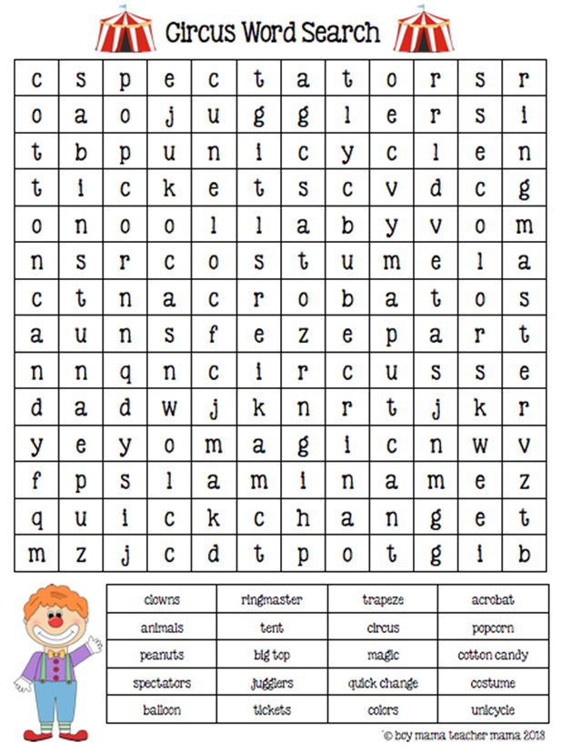

V Match the words with their definitions
circus | a)качаться
magician | b)смешной
clown | с)фокусник
swing | d)клоун
funny | e)цирк
аudience | f) жонглер
arenа | g)кольцо
juggler | h)зрители
acrobat | i)арена
trick | j)акробат
ring | k)трюк

VI. Unscramble the words
IGWSN, AGCIAMNI,YNUFN, UCRUSCI, NOCWL, OPRNPOC, ALONOB, LONI, NETT, TANHPELE

VII Underline the wrong words.
Cloun, magician, fanny, circcus, swing.

VIII. Guess and say.
A chimp likes bananas, apples and honey, and it’s very, very …
At the circus, in the town, there’s a very happy …
Lulu can sing, and Chuckles can …
There’s a lot of fun for us. Let’s go to the …
IX. Read the dialogue and insert the correct word.
- Hello!
- – (Hello! / Bye!)
- – Let`s go to the (circus/bathroom).
- – Look! The cats can (jump/swim)!
- – Oh, yes! The dogs can (climb/dance)!
- – Look at the chimps! They can climb and (swing/sing)!
- – Do you like the show?
- – Yes, I am (happy/sad)!

