FORM 6
UNIT 1
Lesson 7
Exercise 3a
I. Look at the picture and try to guess what you will hear about. Write down the words that describe the pictures.
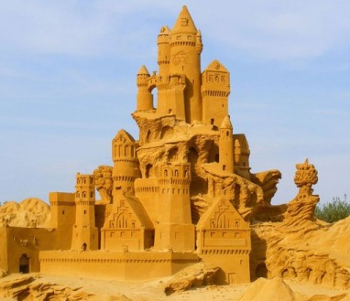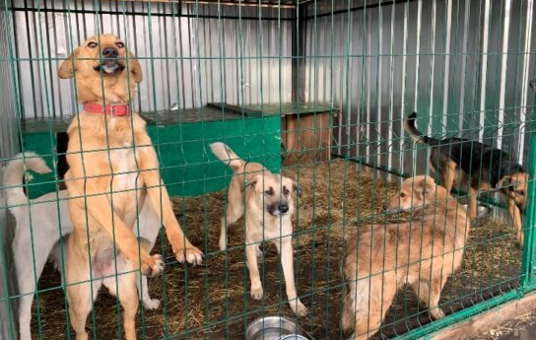
II. Choose the correct variant.
1. Sandra’s cousin will take her
1) to the seaside;
2) to the cinema;
3) to the café;
2. They’ll visit
1) a Zoo;
2) a sand art festival;
3) an amusement park;
3. For the sand competition Sandra’s cousin will make
1) sandcastles;
2) a sand dragon;
3) a sand turtle;
4. For this festival Sandra will need
1) some tools;
2) some water;
3) some sand;
5. Sandra is going to make
1) a sand castle;
2) a sand turtle;
3) a sand dragon;
6. Tim is going to invite Bruce
1) to the seaside;
2) to his place;
3) to a sand art festival;
7. Tim is going to help
1) homeless people;
2) the poor;
3) homeless pets;
8. Tim is going to play with the homeless dogs
1) on Sundays;
2) on Saturdays;
3) on Tuesdays;
III. Fill in the gaps.
1. Next summer I want to do something …….
2. We will watch people making different …….
3. My cousin will make a ……. for the sand competition.
4. I’m going to learn to make …….and animals too.
5. My cousin will make a ……. for the sand competition.
6. I’m going to buy some ……. for this festival.
7. I’ll use a plastic ……., a ……. and a …….to make small details of my sand sculpture.
8. There’s a ……. not far from my house.
9. I’m going to visit dogs in the ……. at weekends.
10. I think I’m going to draw …….
IV. Answer the questions in pairs. Check with the class.
1. What does Sandra want to do next summer?
2. Where will Sandra’s cousin take her?
3. What will they make at the sand competition?
4. What is Sandra going to learn?
5. What will Sandra take part in?
6. What is Sandra going to buy for this festival?
7. Where is Tim going to invite Bruce?
8. What is there not far from Tim’s house?
9. Who is Tim going to visit?
10. What will Tim learn?
11. Why will Tim draw posters?
12. Will Tim take one dog home?
V. Tell your classmates about your holiday plans.

UNIT 2
Lesson 4
Exercise 3a
I. Look at the pictures and try to guess what you will hear about. Write down the words that describe the pictures.
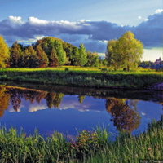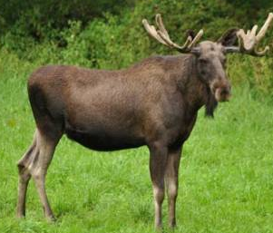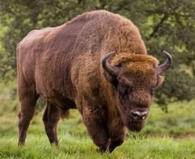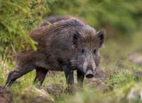
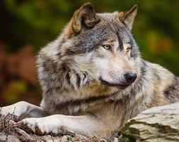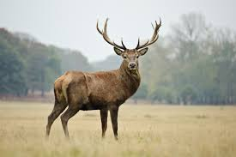
II. Find the word s in the word square. Highlight them.
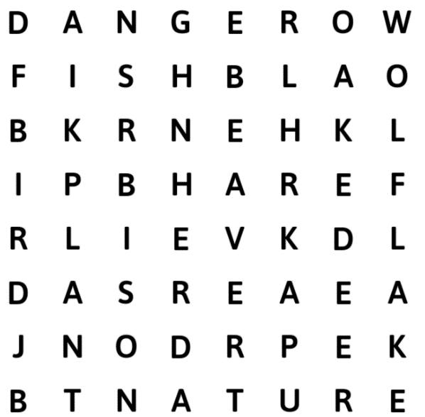
III. Choose the correct variant.
1. There are ……. species of trees in Belarus.
1) 111;
2) 11111;
3) 11;
2. There are about ……. species of plants and mushrooms in Belarus.
1) 12000;
2) 1200;
3) 120;
3. Some oaks in Bielaviezhskaya Puscha are
1) 7000 years old;
2) 700 years old;
3) 70 years old;
4. More than ……. species of animals live in the wilds of our country.
1) 300;
2) 3000;
3) 30000;
5. There are about ……. species of fish in Belarus.
1) 600;
2) 6000;
3) 60;
6. There are about ……. species of birds in our republic.
1) 30500;
2) 305;
3) 3050;
7) In Prypyatsky National you can see ……. moss species.
1) 200;
2) 2000;
3) 20;
IV. Fill in the gaps.
1. Mother ……. gave our country beautiful blue ……., thick ……. and many ……. of animals and plants.
2. There are ……. and ……. wood trees, oaks, and ash-trees in Belarussian forests.
3. Never in your life will you forget meeting a ……. of European …….
4. This animal is one of the ……. of Belarus.
5. Unfortunately, people have always killed ……. uncontrollably.
6. Belarussian lakes are rich in fish where you can find ……., ……., ……..
7. There are practically no ……. snakes in Belarus.
V. Answer the questions in pairs. Check with the class.
1. What did Mother Nature give us?
2. How many species of plants and mushrooms are there in Belarus?
3. What trees grow in Belarus?
4. How many species of animals live in Belarus?
5. What animal is one of the symbols of Belarus?
6. Why are the lives of many wild animals in danger now?
7. Is European bison endangered animal now?
8. What lake is especially rich in fish?
9. How many species of moss are there in Prypyatsky National Park?

UNIT 3
Lesson 3
Exercise 3a
I. Look at the pictures and try to guess what you will hear about. Write down the words that describe the picture.
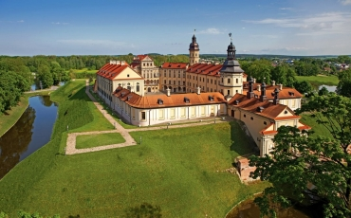
II. Find the word s in the word square. Highlight them.

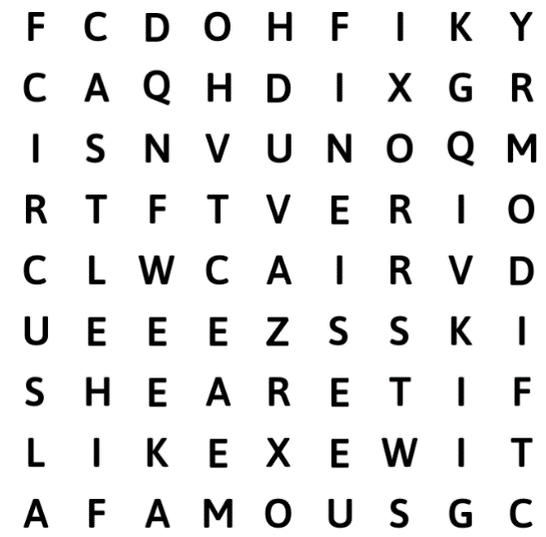

III. Put the sentences in the correct order.
A. Mr Rambler: Oh, Nick, are you there?
B: Nick: Hello, Uncle Andrew.
C: Mr Rambler: Yes, I have. I’ve visited Nesvizh. I went there last Friday. I saw
the famous castle of Nesvizh.
D: Nick: Yes, Uncle Andrew. Have you been to any castles?
E: Mr Rambler: I went there last week.
F: Nick: Yes, Uncle Andrew. How are you?
G: Mr Rambler: Yes, I have. I’ve been to the castle of Mir.
H: Nick: And what about other cities? Have you visited any?
I: Mr Rambler: Hello!
J: Nick: When did you go there?
K: Mr Rambler: I’m fine. I’m in Belarus. I’ve been to the circus. Can you hear
me, Nick?
L: Nick: Have you seen Yan?
M: Mr Rambler: It was fantastic!
N: Nick: What was it like?
IV. Discuss with your classmate your last visit to an interesting place.

UNIT 4
Lesson 8
Exercise 4a
I. Look at the picture and try to guess what you will hear about. Write down the words that describe the picture.

II. Find the word s in the word square. Highlight them.
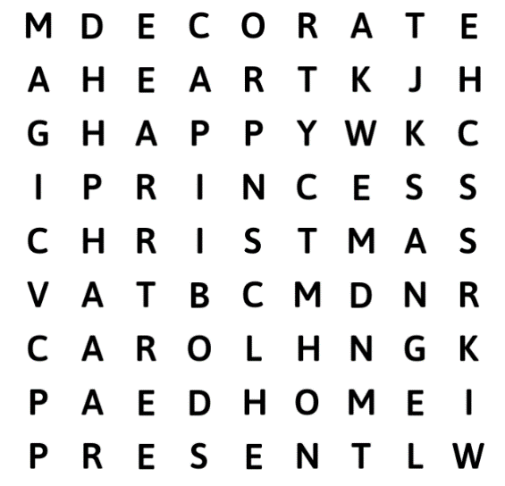
III. Choose the correct variant.
1. In the village Galgate it was
1) frosty;
2) cold;
3) snowy;
2. Elaine was walking home with her
1) father;
2) friends;
3) granny;
3. Elaine wanted to have
1) a dog and a cat;
2) a tasty cake and some sweets;
3) a new dress and pretty dolls;
4. Henry was
1) a shoemaker;
2) a cook;
3) a dressmaker;
5. Maureen was
1) a doctor;
2) a farmer;
3) a blacksmith;
6. In his dream Henry saw
1) an angel;
2) Father Frost;
3) deer;
7. Henry gave the boots to
1) Maureen;
2) Pat;
3) Elaine;
IV. Fill in the gaps.
1. It was ……. in the village of Galgate.
2. The people were getting …….
3. ……. Elaine was walking home with her father.
4. She imagined pretty dolls under pretty dolls under the …….
5. Henry, ……., was sitting by the window.
6. Then Maureen, ……., came to his shop.
7. My little …….. Pat has no shoes.
8. Don’t give rich …….
9. But good people can make ……. too.
10. The ……. were ready in four hours.
V. Answer the questions in pairs. Check with the class.
1. What was the weather like in Galgate on that day?
2. What was coming?
3. What were the people of Galgate getting?
4. Where was Elaine walking with her father?
5. What did she want to have for Christmas?
6. What was Henry?
7. Why was he sad?
8. What did Maureen ask Henry to do?
9. What dream did Henry have that night?
10. Whom did he give the boots?
VI. Tell your classmates how you celebrated your last Christmas.

UNIT 5
Lesson 3
Exercise 4a
I. Look at the pictures and try to guess what you will hear about. Write down the words that describe the pictures.
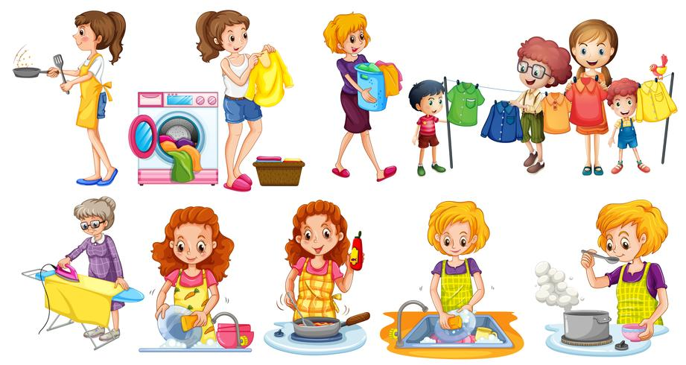
II. Find the word s in the word square. Highlight them.
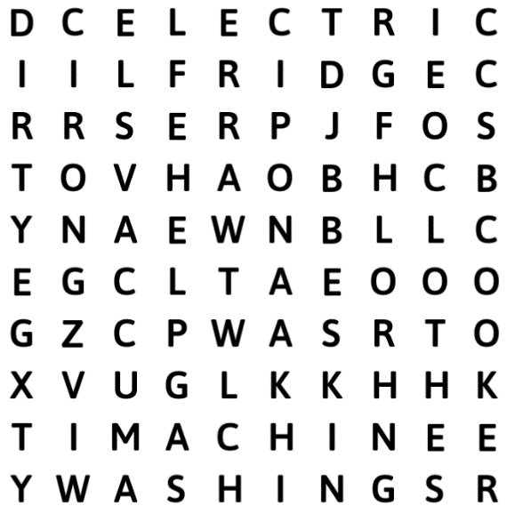
III. Agree or disagree. If you disagree, give the correct information.
1) Yan has just had a fight with Rosie.
2) Rosie says that Yan is too naughty.
3) Rosie is so bossy.
4) Yan washes the floor every day.
5) Susie can only feed the cat and water the flowers.
6) Mum is always telling Yan to tidy up.
7) Rosie has to put all the dirty dishes into the dishwasher.
8) Yan wishes they had a maid at home.
IV. Fill in the gaps.
1. I’ve just had a ……. with Rosie.
2. She says I’m too …….
3. I ……. the floor every day.
4. She can only ……. the cat and ……. the flowers.
5. But I ……. it!
6. What I really ……. is washing up!
7. Oh, I never ……. the dishes.
8. I only help with the ……. sometimes.
9. Oh, I think …….. is horrible.
V. Put the phrases in the correct order.
A. — Well, I think, tidying up is OK. What I really dislike is washing up! Rosie
can’t load the dishwasher, so I have to put all these dirty dishes into it. Yuk!
B. — Oh, sisters!
C. — Oh, I never wash the dishes. My mum always does it and dad does the
washing and the ironing. I only help with the dusting sometimes and go shopping
every Saturday. I like shopping. It’s fun.
D. — Well, I’m OK. I’ve just had a fight with Rosie.
E. — Fine, thanks! How are you?
F. — She isn’t good at sweeping. She can’t do anything! She can only feed the cat
and water the flowers. And I do all the chores!
G. — Why? What’s happened?
H. — She says I’m too bossy. But she doesn’t want to do anything about the
house. She’s so messy!
I. — Can you believe it? I sweep the floor every day.
J. — Oh, I think housework is horrible. I wish we had a robot at home.
K. — Hi, Yan! How are you doing?
L. — Yeah.
M. — Oh, I do a lot of housework too. Mum is always telling me to tidy up. But I
hate it! It’s so boring.
N. — Why doesn’t she do it?
VI. Discuss with your classmate your household chores.
UNIT 6
Lesson 2
Exercise 2b
I. Look at the picture and try to guess what you will hear about. Write down the words that describe the picture.
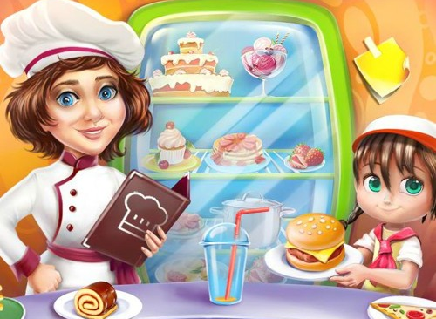
II. Find the word s in the word square. Highlight them.
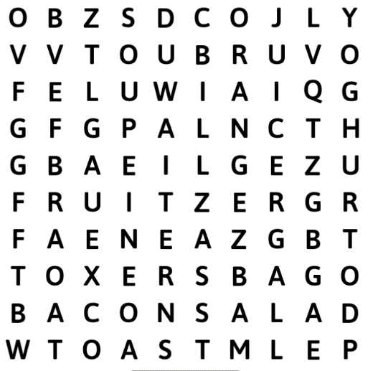
III. Put the phrases in the correct order.
Conversation I.
A. Mother: A vegetable soup, a green salad and a tomato juice for me, please.
B. Waiter: And for you?
C. Son: One pizza, fruit salad, yoghurt and orange juice, please.
D. Mother: Excuse me, waiter!
E. Waiter: Anything else?
F. Mother: Can I have the bill, please?
G. Waiter: Can I help you?
H. Mother: No, thank you.

Conversation I.
A. Waiter: And for you?
B. Father: Very much! Thank you. Can I have the bill, please.
C. Waiter: Here you are, madam.
D. Father: Mm... And I’d have eggs on toast with bacon, too.
E. Waiter: Yes, sir. Here you are. Cash or credit card?
F. Daughter: Fish and Chips and a chocolate ice-cream, please.
G. Waiter: Just a moment. Here you are, sir. Thank you.
H. Father: Credit card, please.
I. Waiter: Are you ready to order?
J. Father: Yes. One small pizza, two kiwi ice-creams and a hot-chocolate, please.
K. Waiter: Did you enjoy your meal?
L. Waiter: Anything else?

IV. Role-play a conversation in a café with your classmate.

UNIT 7
Lesson 1
Exercise 2a
I. Look at the picture and try to guess what you will hear about. Write down the words that describe the picture.
II. Find the word s in the word square. Highlight them.
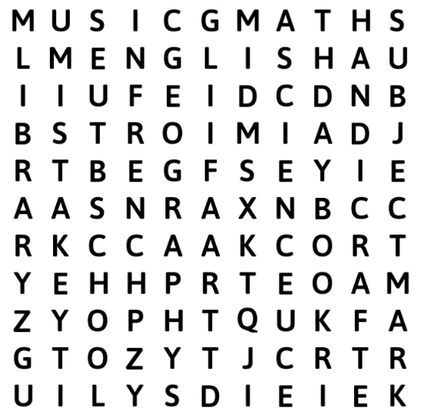
III. Choose the correct variant.
1. Nick has
1) nine subjects at school;
2) ten subjects at school;
3) eight subjects at school;
2. The green book is
1) Geography;
2) Maths;
3) English;
3. The thick blue book is
1) Biology;
2) French;
3) Science;
4. The pink book is
1) Geometry;
2) Geography;
3) Russian Reading;
5. The book for Handicrafts lessons
1) yellow;
2) blue;
3) green;
6. The History book is
1) violet;
2) orange;
3) dark blue;
7. Learning French is
1) easy;
2) interesting;
3) difficult;
IV. Fill in the gaps.
1. How many ……. do you have this year?
2. The green one is Maths — the book for ……..
3. It’s about the ……. — the planets, the stars, about water and air, about animals and trees.
4. This yellow book is for your ……. lessons.
5. You’ll learn how to make things by …….
6. They read and speak about books in ……. lessons.
7. I’ve been to ……. many times, but ……. is very difficult!
8. I have to write your name and the ……. of books in my notebook.

V. Put the phrases in the correct order.
A. Librarian: Now, come here, Nick. These are your books for this school year. How many subjects do you have this year?
B. Nick: And which is that one?
C. Librarian: This is a book for your Art lessons. You see, the book is very bright,
like a beautiful picture.
D. Nick: The orange one.
E. Librarian: It’s your History book. Do you like history?
F. Nick: My Music book is very thin. It’s the thinnest of all the school books.
G. Librarian: I agree with you. Reading is wonderful. Well, let’s finish with books. This is the last one — French. Can you speak French?
H. Nick: Which one is Geography?
I. Librarian: Well, Nick, now you’ve got all the books. You can take them home, but first I have to write your name and the number of books in my notebook.
J. Nick: I don’t know yet. It’s a new subject.
K. Librarian: The pink one. Do you like geography?
L. Nick: Thank you, Mrs Page.
M. Librarian: OK, let’s start. The green one is Maths — the book for mathematics. The thick blue one is Science. It’s about the world — the planets, the stars, about water and air, about animals and trees. This one is Geography.
N. Nick: You know, Mrs Page, my Belarusian friend Yan has a very interesting subject — Literature. They read and speak about books in Literature lessons. Why don’t we have Literature? I love reading.
O. Librarian: This yellow book is for your Handicraft lessons. You’ll learn how to make things by hand. It’s a very helpful book.
P. Nick: Only a little. I’ve been to France many times, but French is very difficult!
Q. Librarian: Which one?
R. Nick: Ten, Mrs Page.
S. Librarian: I don’t know Nick. Here’s one more book — English.
T. Nick: I love history. I like to learn about the past.
VI. Answer the questions in pairs. Check with the class.
1. How many subjects does Nick have this year?
2. What color is the Math book?
3. What is Science about?
4. What will Nick learn in Handicraft lesson?
5. What color is the History book?
6. Why does Nick love History?
7. What book is very bright, like a beautiful picture?
8. What book is the thinnest of all?
9. What do pupils do in Literature lesson?
10. Can Nick speak French?
VII. Role-play a conversation in a café with your classmate.

UNIT 8
Lesson 4
Exercise 2a
I. Look at the picture and try to guess what you will hear about. Write down the words that describe the picture.
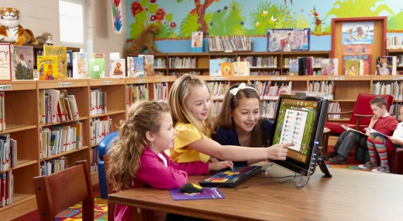
II. Choose the correct variant.
1. Ben is going
1) to the library;
2) home;
3) to school;
2. Today is
1) Monday;
2) Thursday;
3) Tuesday;
2. Ben went to the library
1) two days ago;
2) last week;
3) a week ago;
3. Ben borrowed
1) Harry Potter series;
2) The Hunger Games Series;
3) To kill a Mockingbird;
4. Harry Potter series are
1) amusing;
2) exciting;
3) interesting;
5. Nick likes
1) detective stories;
2) romantic stories;
3) adventure stories;
6. Nick’s favorite adventure story is
1) Wonder Woman;
2) Spark;
3) Robinson Crusoe;
7. This evening Nick is going
1) to watch a film;
2) to ride a bike;
3) to swim in the lake;
III. Fill in the gaps.
1. It’s Thursday, so it’s a …….. Club Day today!
2. Have you read all the books you borrowed last time?
3. The books were really …….
4. I ……. them, they’re really exciting.
5. You’ve ……. Harry Potter, haven’t you?
6. I ……. the films, all of them.
7. And I like ……. films very much.
8. They’re more interesting than ……. stories or ……. films.
9. What’s your …….. adventure story?
IV. Put the phrases in the correct order.
A. Nick: Robinson Crusoe. Have you watched it?
B. Ben: I don’t know yet. Why?
C. Nick: No. And I like adventure films very much. They’re more interesting than detective stories or horror films.
D. Ben: I’d love to. Thanks. So, see you this evening.
E. Nick: Again? Have you read them three or four times already?
F. Ben: No... But I’ve read it!
G. Nick: I’m going to watch a film, Charlie and the Chocolate Factory. Would you like to come?
H. Ben: Oh, you’re not a bookworm at all, are you?
I. Nick: Ha-ha, what a surprise! By the way. What are you going to do this evening?
J. Ben: Hmm, 5 times... I enjoy them, they’re really exciting. You can understand me, can’t you? You’ve read Harry Potter, haven’t you?
K. Nick: See you.
L. Ben: I see. What’s your favourite adventure story?
M. Nick: Me? No, but I watched the films, all of them, 4 or 5 times I think.
N. Ben: Harry Potter series.
O. Nick: Ha-ha, what a surprise! By the way. What are you going to do this evening?
V. Discuss your favorite book with your classmate.

UNIT 9
Lesson 5
Exercise 2a
I. Find the word s in the word square. Highlight them. Try to guess what you will hear about.
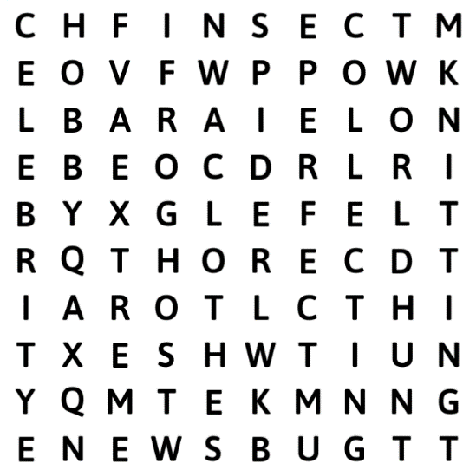
II. Choose the correct variant.
1. Knitting seems to be a hobby good for
1) a boy;
2) a girl;
3) elderly people;
2. Ryan Gosling’s favorite is
1) collecting stamps;
2) reading;
3) knitting;
3. Ryan Gosling learned to knit while he
1) was working on a film;
2) was on holiday;
3) was on a plane;
4. Claudia Schiffer loves collecting
1) stamps;
2) dresses;
3) bugs;
5. Taylor Swift’s hobby is
1) collecting bugs;
2) knitting;
3) making snow globes;
6. Paris Hilton’s hobby is
1) fishing;
2) hunting for frogs;
3) hunting for bugs;
III. Fill in the gaps.
1. Ryan Gosling — a Hollywood ……. — is proud to say that his hobby is knitting.
2. Knitting helps you ……. and you get something out of it at the end.
3. You get a nice ……. for someone who wants to have an ……. scarf.
4. Claudia Schiffer makes clothes with a ……. as a logo.
5. Taylor Swift has the ……. in her hands from her talent to her unusual hobby!
6. Paris Hilton loves …… and hunting for frogs!
7. After catching them with her hands, she puts them in a ……. and then sets them free.
IV. Put the sentences in the correct order.
A. This sweet singer knows how to make a snow globe.
B. He learned to knit while he was working on a film.
C. It’s hard to believe that this blonde beauty likes insects.
D. We all have our likes and dislikes.
E. In the 1990s she was a popular name in modelling.
F. Another beautiful lady — Paris Hilton — loves fishing and hunting for frogs!
G. Can you imagine, that Claudia Schiffer loves collecting bugs?
H. But don’t you worry!
I. She even makes clothes with a spider as a logo.
V. Describe your unusual hobby.

