План-конспект урока по английскому языку в 6 классе по теме «Food. Meals of the day»

Тип урока : урок введения и первичного закрепления лексических единиц.
Цель : формирование лексических навыков по теме «Еда»
Задачи: образовательная : создать атмосферу для формирования лексических навыков;
Воспитательная: содействовать развитию интереса к изучению иностранного языка;
Развивающая: способствовать развитию памяти, внимания и воображения у учащихся.
Оборудование: учебник «English 6. Student book» Н.В.Юхнель, раздаточный материал, карточки.

Ход урока:
- Организационный момент
Good afternoon boys and girls. I am happy to see you smiling and in good health. Now look at the board and guess what are we going to speak about today?
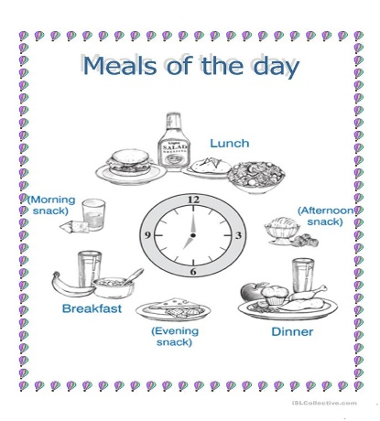
Yes, you are right we are going to speak about food and meals of the day…
- Речевая зарядка
There is a module sentence written on the board and each pupil answers the questions using the module
like
eat breakfast
I have……. (what…) for snack
prefer lunch
enjoy dinner
select

- What do you like for breakfast?
- What to do prefer for dinner?
- What to you eat for lunch?
- What to you have for snack?

- Основной этап урока:
Let’s talk about our meals and see what we eat
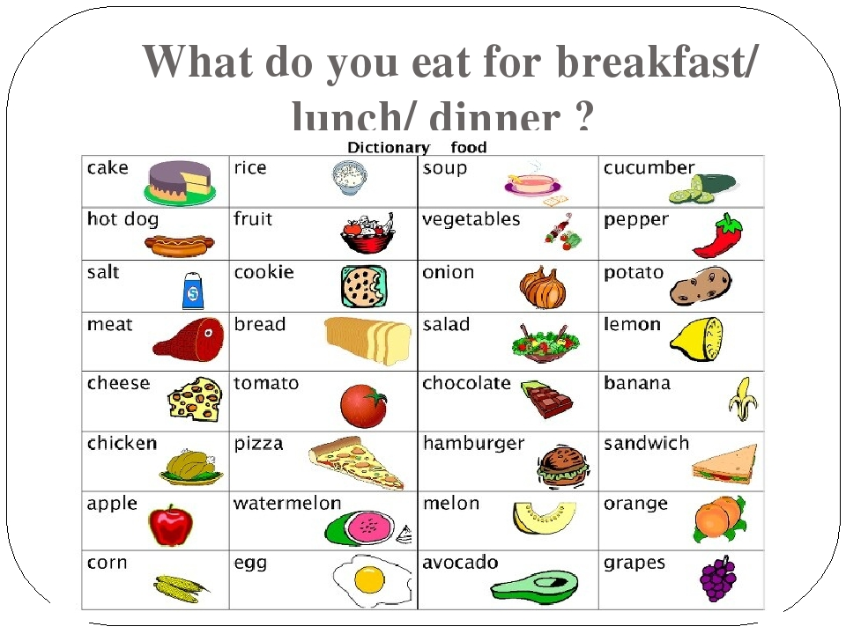
Let’s divide into 4 groups, discuss the food and make up the menu for breakfast/dinner/lunch and snack.
Let’s compare it with the meals in Nick’s family ( Ex.2a p.135 SB)
Now let’s get to your book. We need to read the words Ex.3 p.136 and decide when we are going to eat this food: breakfast/ snack/lunch or dinner/.
And finally we are going to listen to Nick’s friend Tim speaking about his meals and compare it with our picture dictionary:
I love my food. In my fridge there is always some fruit and vegetables. I usually have a few eggs on toast for breakfast. I like fish, so I eat little meat. I can have some bacon, but not every day. Sometimes I have cereal with some yoghurt or a few sandwiches for lunch. For dinner I usually have soup and little spaghetti. I eat few crisps or sweets, because they are not good for me. I just drink some milk before I go to bed at night. Oh! And fish and chips! They are my favourite. I can eat them morning till night.
Answer my questions:
- What is there in Tim’s fridge?
- What does Tim have for breakfast/lunch/dinner?
- What’s Tim’s favourite food?

- Заключительный этап урока
What do you have for breakfast/snack/lunch/dinner?
Open your record-books and write down your home task : Ex.1 p.20(WB) Ex.4 p.136 SB
Your marks are…..

