Тема: Дикая природа Беларуси

Цель урока: .
совершенствование коммуникативных навыков и навыков восприятия речи на слух учащихся по теме «Дикая природа Беларуси».
Задачи: создать условия для:
Образовательный аспект: - формирования лексико-грамматических навыков по теме «Дикая природа Беларуси»;
Развивающий аспект: развития речи учащихся по теме «Дикая природа Беларуси», навыков восприятия речи на слух основе текста о Зубре; формирования грамматических и речевых навыков продуктивной речи по теме;
Воспитательный аспект: воспитания патриотизма, развития любви к Родному краю.
воспитывать критическое отношение учащихся к обсуждаемой теме,
Оборудование: Оборудование: аудиозапись, видеозапись, доска, раздаточный материал.
Литература: образовательная программа по предмету Английский язык, КТП для 5 класса, шкала оценки результатов ученой деятельности учащихся по иностранному языку.

Ход урока

I. Этап организации начала урока
T: - Good morning/afternoon.At first, we remember some words. Let’s play the game.
Game “answer and sit”

a rock
a hill
a valley
a waterfall
a swamp
a field
a forest
a sea coast
a river bank
a path
A pony
A cow
A goat
A sheep
A hen
A rooster
A goose
A turkey
A barn
Hay сено
Grain зерно
A fence
A kitchen garden

II. Этап проверки выполнения домашнего задания
Ex.2-3 p.53-54 wb
III. Этап подготовка к основному этапу урока
3.3 Выход на тему урока.
Слушают звуки леса (video)
https://www.youtube.com/watch?v=68zWLYPzW7o&ab_channel=%D0%97%D0%B2%D1%83%D0%BA%D0%B8%D0%BF%D1%80%D0%B8%D1%80%D0%BE%D0%B4%D1%8B
T:-What we are going to talk about?
Wildlife of Belarus
3.3 Целеполагание
T:-What are we going to do today?
- to learn the words
- to listen to the text
- speak English
IV. Этап усвоения новых знаний и способов действий
- Before we start our work let’s learn how we call in English some animals and birds which live in our forests.
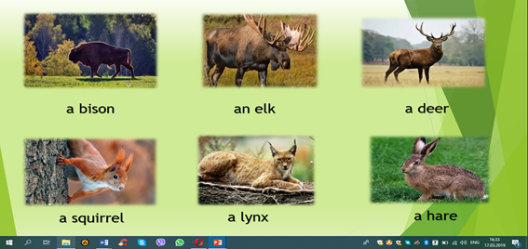

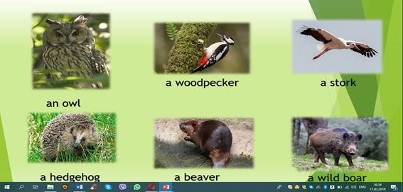

- repeat after me
- read the words

T:- As you can see there are many names of animals and birds which we will work with today. Use the phrases which help us to express our opinion:
I think …
As for me …
In my opinion…
T:- Tell me, please:
1 Where do these animals live?
2 Which animals or birds are the most beautiful?
3 Which animals or birds are the most dangerous?
4 Which animals are the strongest?
5 Which animals or birds are the funniest?
V.Этап первичной проверки знаний
Ex.2c p.59 sb (работа в парах)
5.1 релаксация
https://www.youtube.com/watch?v=NewQm6GYjQg&ab_channel=%D0%97%D0%B2%D1%83%D0%BA%D0%B8%D0%BF%D1%80%D0%B8%D1%80%D0%BE%D0%B4%D1%8B
VI. Закрепление знаний и способов действий
T:- As you can see our forests or pushchas are rich in wildlife. But there are some animals and birds that can be called the symbols of our country. -What are they?
Symbols
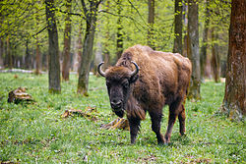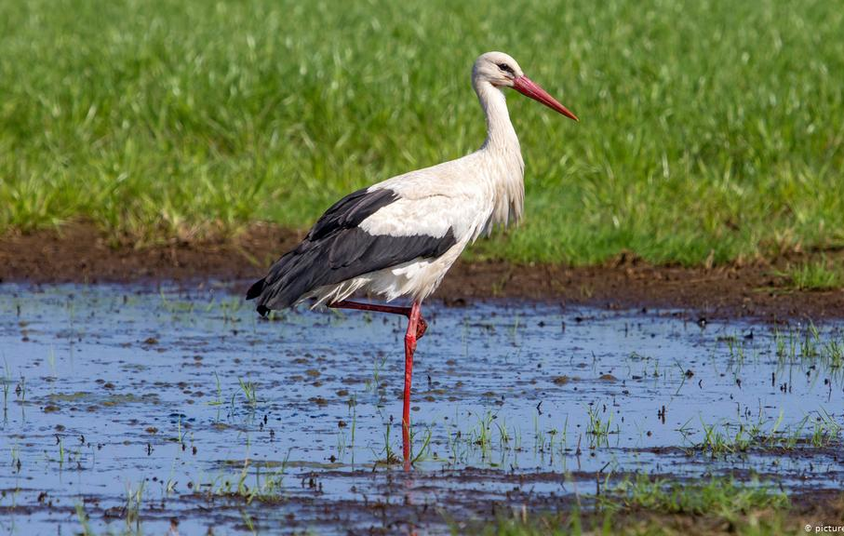

Ex.4 p.60 sb
T:- Let’s see what facts you know about bison. Listen to the text and decide which of them are true and which are false:
Card
1. European Bison are the biggest animal in Europe.
2. There are about 500 European bison in Belarus.
3. They eat mushrooms.
4. Bison live for 60 years.
5. They can live without water for a long time.
T:- Nice! But if you remember we have 2 symbols. We have discussed the bison and now it’s time to learn some interesting facts about storks.
T:-Read the text and answer the questions
card
White storks are big. they can be 120 cm long. A stork has long legs, large wings and a long read beak. These beautiful birds live in Europe and they spend winter in South Africa. They can fly more than 10 km. Storks live in the filds near rivers, lakes and swamps and build their nests on top of trees or houses. One stork eats about 100 insects daily. A stork family needs about 200 kg of food in one season. Storks also eat mice, frogs, fish. In Belarus there are about 40 000 storks. People call Belarus “the country under white wings” and belive that storks bring them luck and happiness.
T:- Let’s check how attentive you were. Answer my questions:
1. How long are the storks?
2. Where do storks spend winter?
3. Where do these birds build nests?
4. What do they eat?
5. How many storks are there
in Belarus?
6. Why do people call Belarus “the country under white wings”?
VII. Обобщение и систематизация знаний
T:- Finally answer my questions:
- What Belarusian wild animals do you know?
-What animals are the symbols of Belarus?
- Why do people call Belarus “the country under white wings”?
X. Этап подведения итогов занятия
Our aims were to learn the words, listen to the text and speak English. We worked hurd, our lesson is success.
XI. Рефлексия.
- Use the phases to express your feelings.
I am happy | because | I…
I am sad |  | worked hurt
I am normal |  | didn’t work hurd
XI. Этап информации о домашнем задании, инструктаж по его выполнению
T:- Open your record books, please. Write down your hometask. Your hometask is Ex.6 p.61, sb

