**Enjoy your English with the poems and rhymes.** РАЗВИТИЕ ЛЕКСИЧЕСКИХ НАВЫКОВ УЧАЩИХСЯ V КЛАССОВ НА УРОКАХ АНГЛИСКОГО ЯЗЫКА ПОСРЕДСТВОМ ПОЭТИЧЕСКОГО МАТЕРИАЛА

Невозможно научить общаться на изучаемом языке без хорошего лексического запаса. При этом введение и активизация лексических единиц должна происходить в контексте, а не изолированно. В этом случае стихи– это тот текстовый материал, который дети любят, который им интересен, работа с ним положительно эмоционально окрашена, что в значительной степени содействует качественному усвоению материала. Современные учебные пособия для пятиклассников гимназии насыщены рифмовками и стихами, которые мы можем эффективно применять для увеличения их лексического запаса. На мой взгляд, яркость, образность, фантазия в стихах и рифмовках мотивируют у детей интерес к иностранному языку, а их разучивание– это активный прием пополнения словарного запаса учащихся.

В связи с этим для меня становится актуальным процесс изучения и анализа наиболее эффективных форм и приемов работы со стихами и рифмовками на учебных занятиях по иностранному языку.

Одновременно осуществлялось приобретение навыков работы по введению, активизации и закреплению лексических единиц посредством применения поэтического материала; использование его в качестве здоровьесберегающих технологий; подборка и систематизация упражнений к стихам и рифмовкам по всем темам школьного курса. Применение поэтического материала на уроках английского языка способствует активной мыслительной деятельности учащихся, непроизвольное усвоение рифмованных речевых оборотов и декламация небольших стихотворных произведений в V классах помогает вовлекать учащихся во внеклассную работу по предмету для участия в драматизации театральных постановок.

Подводя итог сказанному, хочу заметить, что применение стихов не является на учебных занятиях самоцелью и не служит развлечением. Его грамотное использование и сочетание с другими приемами и методами работы может стать эффективным средством обучения лексическому аспекту языка на разных ступенях обучения.

**Предлагаю подборку стихов и рифмовок с заданиями к различным разделам учебника 5 класса для гимназий по английскому языку, которые можно применять на разных этапах урока:**

*Summer Holidays ( Unit 1)*

**\*Put the lines in the correct order.**

**\* Listen and check.**

**\* Guess “The world= our Planet”**

**\* Are you happy to be together at school again? Do you agree that together we`ll make the world better?**

4. Much better and happy forever

2. It is great to have parties together.

3. Together we’ll make the world

1. Together it’s nice to be here

***

Dear friends!

May all your dreams come true!

I wish you happiness and love!

Don’t forget your teachers and your school! Be happy!

At the seaside.

Come to the beach.  
Come to play in the sun.  
Come to splash in the water.  
Come to have fun!

**\*Read the poem and tell us what you can do at the seaside.**

**\*Look at the pictures in your books ( Ex. 2 p. 10, Form 5) and choose the best variant for the poem. Try to explain why.**

**\*Do you like going to the beach? What do you enjoy doing there?**

***

I didn`t miss my chance

Last year I visited France,

Last month I went to Rome,

Last week I stayed at home.

**\*Complete the poem with the rhyming words.**

**\*What did you do last year? Last month? Last week?**

In summertime.

In summer I like to play ... seaside  
In summer I like to go to the ... sometimes  
I like to pick up … shells   
To put them on the shelf. outside  
That’s what I like to do … shelf  
When it comes the summertime. summertime

* **Guess the meaning of the word with the help of the picture.**
* **What does the boy like doing in summer?**
* **Find the verbs in the poem and put them in the past.**
* **What do you like to do in summer? Start with the phrase: In summer I like to…**

***Cinquain “Summer Holidays”***

1. Funny, hot, happy
2. To play, to go outside, to swim
3. I like summer very much.
4. Rest/relaxation.

***Be active. ( Unit 2)***

**\* Listen to the poem and revise the days of the week.**

**\* Answer the question of the poem.**

**\* What`s your favourite day? Why?**

**Every week has 7 days,**  
**See how many you can say:**  
**Sunday, Monday, Tuesday,**  
**Wednesday, Thursday, Friday,**  
**Saturday. What’s today?**

**Moving Activity**

Look left, right *(глазами влево, вправо)*  
Look up, look down  *(глазами вверх, вниз)*  
Look around.  *(глазами по-кругу)*  
Look at your nose  *(смотрим на нос)*  
Look at that rose  *( смотрим на картинку с розой)*  
Close your eyes  *(закрываем глаза)*  
Open, wink and smile.*(открываем, моргаем и улыбаемся)*

**2.**

**Riddle**

Of all the days that`s in a week

I dearly love but one day

And that`s the day that`s between

Saturday and Monday. ( Sunday)

* **Insert the words and guess the riddle.**
* **What`s the day you dearly love? Dearly love=love very much.**

**Cinquain “ Feelings”**

**1. Feelings**

**2. happy, sad, merry**

**3. like, dislike, hate**

**4. I dislike go shopping**

**5. emotions**

**Autumn**

Red leaves and yellow leaves  
Orange leaves and brown,  
Leaves are dancing everywhere  
Happily dancing down.

**\*\*\***

October leaves are lovely   
They rustle when I run    
Sometimes I make a heap   
And jump in them for fun.

* Read the poem. What is it about?
* Try to guess the meaning of underlined words. ( rustle- to make a sound under your feet; heap – a group of leaves lying all together)
* Do you like jumping in the leaves?

**Moving Activity**

Leaves are falling, (руки вверх, шевелим пальчиками, опускаем их вниз)

Leaves are falling.

One fell on my **nose**. (указательным пальцем дотрагиваемся до носа)

Leaves are falling,  (руки вверх, шевелим пальчиками, опускаем их вниз)

Leaves are falling.

One fell on my **toes**. (дотрагиваемся до пальцев на ногах)

Leaves are falling, (руки вверх, шевелим пальчиками)

Leaves are falling.

One fell on my **head**.  (указательным пальцем дотрагиваемся до головы)

Leaves are falling, (руки вверх, шевелим пальчиками, опускаем их вниз)

Leaves are falling.

Yellow, orange, and red.

***

* Autumn is bright? Why? Do you agree?
* Match the colors to the seasons.

# Spring is ….  yellow

# Summer is … white

# Autumn is ... green

# Winter is ...  bright

* What is the color of autumn for you?

*Cinquain “ Workshop”*

1. *Workshop*
2. Outdoor, active, interesting
3. To dance, to draw, to have fun
4. I`d like to go to a drama workshop
5. Club

**\*Write a poem about your friend to the lesson “ Be happy”**

Pupils ` poems about friends.

I want to be merry

And never be sad,

I want you to be happy,

My real and nice friend.

**\*\*\***

I `ve got a friend

I want to smile.

My best friend is my dad

And that`s fine.

***

I like to ride a bike

I dearly love to play,

I was happy to meet Mike,

It was my best day.

**\*\*\***

I`m happy to be your friend,

You are happy to be mine,

Our friendship will never end,

Don`t forget to meet today online.

**Moving Activity**

One, two, three, four.  
Look at the window, look at the door,  
Look at the ceiling, look at the floor.  
One, two, three, four.

**Indefinite / definite articles**

* **Read the poem and think when we use ” a” and when we use “the”.**

I know a girl. The girl is nice.

You know a teacher. The teacher is wise.

She has a friend. The friend is sad.

He has a brother. The brother is glad.

* **Do you know somebody who is nice, wise, sad, glad?**
* **Guess the topic of our lesson today. ( Lesson 12/ Reading for pleasure)**

**Riddle**

I can catch a ... 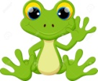 (frog)

I can sleep like a … 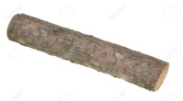 (log)

I can find your…  (sock)

My name is ... . 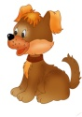 ( dog)

**What`s on TV? ( Unit 3)**

* **Read the poem and complete it with the best word.**
* **Give Russian equivalent to the phrase underlined.**
* **Choose the best title:**

1. **My very dear friend.**
2. **TV is super.**
3. **My favourite films on TV.**

Oh, I love watching my TV!

It always keeps me company.

It shows the cool things I can do.

I learn a lot from it, it`s true!

Detectives, comedies, cartoons,

I watch them every afternoon.

I hate to see the words “ the End”

TV`s my very dear … ( Tent, friend, dad, end)

* **Is TV your friend? Can you learn a lot from TV?**
* **Change the names of the films to make it true about you and read aloud.**

**Cinquain “ Films”**

1. Film
2. Romantic, detective, horror.
3. To watch, to like/ dislike the film
4. I hate romantic films.
5. Comedy.

**\* Tell the classmates about films using the poem**

**Diamante “ Films”**

1. Films
2. Exciting, touching, silly
3. Teach, entertain, make us cry
4. Fun, free time, family, TV
5. Teach, give information, help
6. Interesting, horror
7. Books

* **Compare films and books**

***Acrostic poem.***

**Make up your words to the first letters, connecting to the topic and make up the sentences with these words.**

**T**alk show

**V**ery interesting

**P**ast

**R**omantic

**O**K

**G**reat

**R**arely

**A**ction

**A**dventure  
**M**usic  
**M**ickey Mouse  
**E**xciting

**\*\*\***

***Acrostic poem***

**Cool –** synonym to “super”

**Adventure –** a film about pirates, travelling.

**Touching**- it makes you cry  
**OK**- it`s good **Often-** practically every day  
**Never-** opposite to always

**S**illy- without sense

**Diamante “What`s your favourite cartoon character?”**

1. **Simba**
2. **Big, kind, clever**
3. **Grows, becomes a king, loves his family**
4. **Lion, king, cartoon character, father**
5. **Hates Simba, fights**
6. **Angry, bad**
7. **Scar.**

* **Use the poem to tell us about Simba. Draw a picture of him orally. Do you like Simba? Why?**

**Festivals and Celebrations ( Unit 4)**

***

December is the best of all,  
Snow-flakes dance, snow-flakes fall.  
People see **the New Year** in,  
When December ends, it will begin.

* Guess the name of the unit
* Add other holidays you know.
* What other holidays do we celebrate in winter?

**\*\*\***

* **Read the title of the poem and guess what it is about.**
* **Listen to the poem and guess the topic of our lesson.**

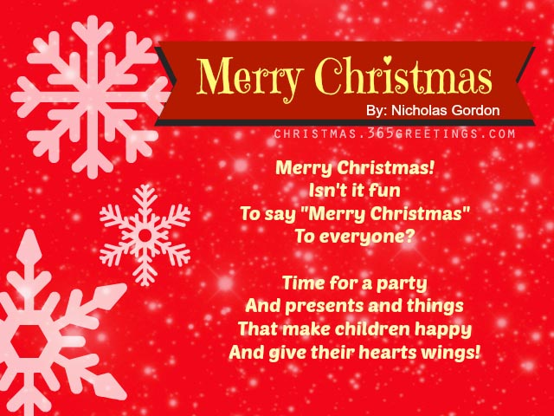

* **What` Christmas for you? Your assossiations with the word “ Christmas”.**
* **Read the poem and say how the British greet each other at Christmas? And what about Belarusian people?**
* **Do you get presents at Christmas? Does it make you happy?**
* **Do you know any other poems about Christmas?**

**Acrostic poem to the lesson “ Before Christmas”**

**C**arol

**Ha**ng stockings

**R**ed

**I**ce

**S**anta

**T**insel

**M**erry

**A**ngel

**S**nowflakes

**Moving Activity**

**“Penguin Dance”**

Put your hands up in the air and shake your booties round  
Hand up on your toes and turn around around  
Hands way up high, hands way down low  
Stamp with your feet and jump, jump, jump

* Listen to the song and work in groups and put all the lines in the correct order.
* Watch the video and sing the song in teams.
* What`s the song about?
* What`s the mood of the song? What picture can you draw while listening to it?  
  **\*\*\***

Dashing through the snow  
In a one-horse open sleigh  
O’er the hills we go  
Laughing all the way.  
The bells on bobtail ring  
The making our spirits bright  
Oh what sport to ride and sing  
A sleighing song tonight.  
  
Jingle bells, jingle bells  
Jingle all the way!  
O what joy it is to ride  
In a one-horse open sleigh.

**Be healthy. ( Unit 4)**

* **Complete the poem with the correct word.**
* **Read different recommendations how to be healthy and tell us which of them you follow.**
* **What should people do to be healthy?**
* **Add your ideas.**

If you want to be .., day

Eat bananas every … sweets

Porridge, chicken, fish and … chips

Make your spirit very … high

Eat less sugar, salt and … rye 

No cookies, rolls and ... OK

If you want to be OK,

Keep the diet every day.

Eat much salad,

Eat more fruit

Never, never touch junk food!

**Healthy Lifestyle**

If you don’t feel your best

Better set your mind at rest.

Do love sport, forget the pills,

Be nice and healthy.

If the weather is OK,

You can go jog all day.

You are welcome to the gym,

And you’ll be healthy.

***

If you want to be OK,

Eat an apple every day.

If you want to do a lot,

You should go in for sport.

* **Learn some recommendations by heart.**
* **Moving Activity**
* **Listen to the song “Hockey-Pockey” and put the drafts in the correct order.**
* **Move to the song.**

|  |
| --- |
| 3.You put your left foot in, You put your left foot out, You put your left foot in, And you shake it all about. You do the Hokey Pokey And you turn yourself around, That's what it's all about.  2. You put your right foot in, You put your right foot out, You put your right foot in And you shake it all about. You do the Hokey Pokey And you turn yourself around, That's what it's all about at's what it's all about.   1.You put your right hand in, You put your right hand out, You put your right hand in And you shake it all about. You do the Hokey Pokey And you turn yourself around, That's what it's all about. |

**Travelling**

We all love to travel

And see the surrounding world.

Let’s make the Earth

Close place for all!

* Revise our special words and learn the poem by heart.

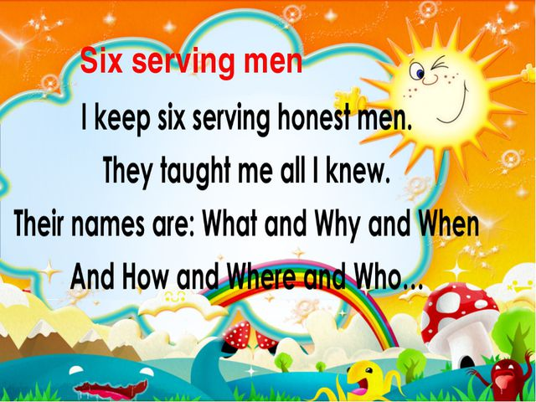

* I`ll divide you into three teams and you`ve got some minutes to learn it by heart line by line. I wish you to be always healthy and never be ill.



Proverbs about health

*Choose the proverb you like best. Read it, agree or disagree and say why.

* Start your answer “ I agree/disagree with these words because …



In the city ( unit 6)

* Listen to the poem and guess the topic of the lesson.
* Where is the stranger going?
* Read the poem in pairs.
* Change the place where you are going and role-play the dialogue.

Excuse me, sir,

Can you tell me the way

To the nearest bank?

It`s not far away.

Cinquain “ Minsk”

1. Minsk
2. Beautiful, big, old
3. Visit, see, live
4. I am proud of Minsk.
5. capital

Diamante “ Minsk”

1. Minsk
2. Big, old
3. Was founded, became, visit
4. Capital, city, city-hero, the national Library
5. Grows, is my native town, was built
6. nice, small
7. Drogichin

* **Using the poem tell about Minsk**
* **In your teams make your acrostic poems about Drogichin.**

**Acrostic poem**

**D**ear for me

**R**est

**O**ld

**G**reen

**I**deal

**C**entre

**H**ouse

**I** was born here

**N**ice

**Moving Activity**

* Listen to the poem. What is it about?
* Guess the meaning of the words in bold, using the pictures.
* Read the poem in pairs. Remember your lines. Move to the poem.

**The wheels** on the bus go round and round,   
Round and round, round and round,  
The wheels on the bus go round and round,  
All through the town.  
**The horn** on the bus goes beep, beep, beep!  
Beep, beep, beep! Beep, beep, beep! Etc.   
**The wipers** on the bus go swish, swish, swish!  
Swish, swish, swish! Swish, swish, swish! Etc.   
The baby on the bus goes “ Wah, wah, wah!  
The parents on the bus go “Shh,shh,shh”!

**Countries and continents ( Unit 8)**

* At the end of the lesson let`s sing the beautiful song.( video)
* I`ve got you cards with the names of the continents. Listen to the song and put them in the correct order.
* What are the symbols of different continents? ( work in groups)
* Choose a card for you, listen, try to repeat the rhyme and stand up when you hear your continent.

The world is split into continents.

There are seven in all.

And if you get the gist ( суть)

We are going to make a list from biggest to small.

They are Asia, Africa,

North America and South America, Antarctica and Europe,

Finally Australia.

1. Read the poem and complete it with the rhymes to the names of the countries.
2. Say what the poem is about and choose the best title of it.

* Different cats
* Different countries
* Cats from all over the world

A cat from France can sing and … OK

A cat from Japan has a big blue … rain

A cat from Spain walks in the … fan

A cat from Brazil goes up the… hill

A cat from the UK is always… dance

But my cat likes to hide in boxes.



Small, dangerous, animals, tall



Too, you.



Free, see.

* Read the poem and complete it with the correct word
* Listen to me and check.
* What animals live around us?
* Why should we protect them? Do you protect the animals?
* Let`s lean one of the drafts you like best. Do you like the poem?

Proverb

**East or west- home is best**. Guess the Russian equivalent of it. Do you know any other proverbs about home? What are we going to discuss today? Look at the picture and guess the meaning of “ east/west”. What other parts of the world are there?

Cinquain “Continent” ( 7 groups)

* 1. Asia
  2. The biggest, cold and warm.
  3. Visit, see, find
  4. I live in Asia.
  5. Continent.

Travelling ( Unit 9)

CInquain

1. Travelling
2. Relaxing,adventurous,enjoyable
3. Go by car, visit new places, see landmarks.
4. I like travelling
5. Rest

* Listen to the poem and guess the topic of our lesson.
* How can people travel?
* How do you like to travel?
* Let`s lean the poem line by line.
* What` s common in all word expressions?( by)

We go by car,

We go by boat,

We go by land,

We go,go,go.

And we go by train,

And we go by plain,

And sea and air

From here to there.