План-конспект урока по английскому языку в 6 классе по теме «School subjects»

Цель : содействовать совершенствованию навыков говорения по теме «Школа»
Задачи: Образовательная : создать атмосферу для формирования лексических навыков;
Воспитательная: содействовать развитию интереса к изучению иностранного языка;
Развивающая: способствовать развитию памяти, внимания и воображения у учащихся.
Оборудование: учебник «English 6. Student book» Н.В.Юхнель, раздаточный материал, карточки.

Ход урока:
- Организационный момент
Good morning, children! I’m glad to see you . Now look at the board and guess what are we going to speak about today?
Yes, you are right, Today we will talk about school subjects.
- Речевая зарядка
Answer my questions.
- Do you go to school?
- Are you a good student?
- What subjects do you learn?
- Do you like our school?
- How many girls and boys are in your class?
- Are your teachers always happy with you? Why? Why not?

- Основной этап урока:
  - Look at the blackboard. There is a poem. At first listen to me and then read it together. Find the words that rhyme.
School books everywhere,
Books on the table, books on the chair,
I hope, I don’t get books in my hair,
Books, books everywhere.
Large books and small books
And short books and tall books
And red books and green books and blue.
Maths and Geography, Science and History,
Music and Handicraft too!

  - Now look at the pictures and try to guess what subjects are here. Tell me about them
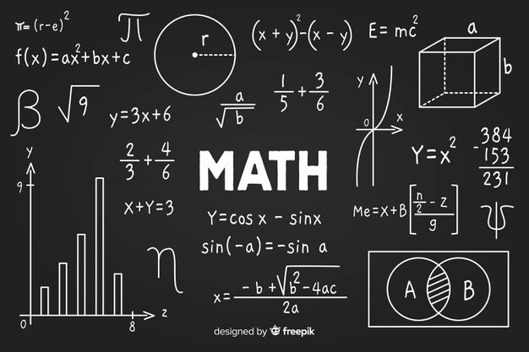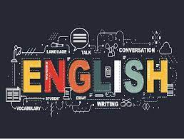
Do you like Maths?/Art?/English?/ History? Is it difficult/easy subject for you?
  - And now I will give you the cards. Your task is to write three true sentences about your favourite and least favourite subjects.
My favourite subject is … because …
I often get … marks in … because…
My least favourite subject is… because…
Report to the class. White the results on the board. What subjects are the most favourite or least favourite ones in your class?

3.4. Let’s talk about our school
a. Describe your typical day at school to your new American friend.
b. Tell him or her about your school.
c. Tell him or her about your school subjects.
d. Tell your friend about your English lessons.
e. Describe your classroom to your friend.
f. Tell your friend where your get knowledge.
g. Describe your typical lessons.
- Заключительный этап урока
What is your favourite and least favourite subject? Why?
Open your record-books and write down your home task : Ex.6 а, b, c, p.136
Your marks are…..

