Управление по образованию, спорту и туризму Несвижского райисполкома
Государственное учреждение образования «Грицкевичская средняя школа»

ПЛАН-КОНСПЕКТ УРОКА АНГЛИЙСКОГО ЯЗЫКА В 10 КЛАССЕ ПО ТЕМЕ “HOUSES AND HOMES. MODERN OR PERIOD?”
Номинация «Иностранные языки»

Качанович Валентина Леонтьевна,
учитель английского языка высшей
квалификационной категории
80297627597

Тема: Houses and homes. Modern or period?
Цель: развитие коммуникативных умений учащихся в рамках предложенной темы.
Задачи учебного занятия:
- совершенствование монологической и диалогической речи по теме;
- развитие навыков чтения с извлечением основной информации;
- обогащение словарного запаса учащихся;
- развитие памяти, внимания, критического мышления учащихся, умений обобщать, делать выводы;
- совершенствование знаний о национально-культурном наследии своей страны и стран изучаемого языка;
- организация рефлексии и самооценки своей учебно-познавательной деятельности.
Прогнозируемый результат: предполагается, что к окончанию урока учащиеся будут вести монологическое высказывание о преимуществах и недостатках проживания в современных и старинных домах.
Тип урока: комбинированный.
Методы: коммуникативный, интерактивный, объяснительно-иллюстративный.
Принципы: коммуникативной направленности, активности, наглядности, доступности и посильности, последовательности формирования знаний, умений и навыков.
Применяемые формы деятельности: фронтальная, индивидуальная.
Оснащение урока: интерактивная панель (мультиборд), классная доска, раздаточный материал, мультимедийная презентация, дидактический материал.
Ход урока
І. Организационно-мотивационный этап. (Стадия вызова)
1. Введение в атмосферу иноязычного общения.
Good morning, dear pupils. I’m glad to see you. I’m fine today. What about you? I hope that you are well too. Today we’ll work with you in the presence of some guests. Welcome to our lesson, dear friends.
2. Целеполагание. Введение в коммуникативную ситуацию урока
So, let’s start our lesson. Look at the blackboard, read the theme of our lesson, look at these pictures round the classroom and on the presentation, try to guess what the aim of the lesson is. What are we going to do at our lesson? (Slide1).
(учащиеся самостоятельно формулируют цель и задачи урока)
Well done. At the end of the lesson we’ll see if we have achieved our aims.
What is the synonym to the word “modern”? What is the synonym to the word “period”? What words do you associate with the word “modern”? What words do you associate with the word “period”? Here you can see the pictures of modern and period houses. What house would you like to live in? Go to the blackboard and take the picture of the house you would like to live in. At the end of the lesson we’ll see if you’ve changed your opinions.
II. Операционно-познавательный этап. (Стадия осмысления)
- Актуализация изученного материала
- Before speaking about differences and similarities between modern and period houses, about advantages and disadvantages of living in these houses I want you to answer a very interesting question: What are the most important things in people’s lives? (The pupils name such words as health, love, family, house, home). What’s the difference between the words “house” and “home”? Read the information on these slides and comment on it. (Slides 2 - 5)
- What do you look for in your family life at home? Take these lists of paper. Put the features into the order of priority. (Appendix 1) What is the most important for you in your family life? What is on the first, the second and the third places?
- Take these lists of paper and write on the fish bones what turns your house into a home. Your time is 3 minutes. Are you ready? Come here and fix the fish bones to the blackboard. Read aloud. What are the most popular things? (Appendix 2)
d) Look at these word clouds and find the words which describe a good home. (Appendix 3) Write them down into your exercise-books. Read these words aloud. Make sentences with them. (Slide 6)
- Развитие навыков монологической речи
Last week I gave you the task to conduct a survey among the pupils and teachers of our school. The questions were: Do you like your home? Why? What does the home mean for you?
Come here and tell us the results of your surveys.
(Учащиеся выходят к доске и рассказывают о результатах опроса учащихся и учителей школы).
All pupils of primary school like their homes because their mums, dads, sisters and brothers live there. The home means for them a lot of toys, bedtime stories, getting presents on New Year and birthdays.
The pupils of middle ages (from the 6th up to the 8th forms) love their homes very much because they feel comfortable and safe there. They have loving and caring parents who are always there for them. Home is a place where they can spend evenings with their loving parents.
The senior pupils love their homes very much. Home is a place where they can rest, relax, listen to music, meet their friends, discuss problems with parents. They associate their homes with birthday parties of all the members of the family, with presents, Sunday pies and tea.
Teachers women understand a home as comfortable atmosphere for work and rest, a caring husband, hard-working children understanding that “mum is working”. Home is a place where they can rest after a busy school day.
Teachers men think that a home is a place where they return after work to enjoy tasty meal and relaxation. A home for them is a place where they are always welcome and safe, where their souls rest peacefully.
What do all these answers have in common?
As you can see, a home for everybody is the place where you always want to return and where you feel comfortable.
- Физкультминутка
Are you tired? Let’s rest a little. Sit comfortably, close the eyes and imagine your dream house. (Учащиеся закрывают глаза, слушают мелодию со звуками природы, отдыхают). (Slide 7)
Open your eyes. How does your dream house look like?
- Гимнастика для глаз
Stand up. Look at the pictures in the corners of our classroom (picture 1, 3, 2, 4). What do you see there? Would you like to see such beautiful flowers and butterflies near your dream houses? Why? Look through the windows as far as you can. Well done! Take your seats, please. We continue our work.
- Развитие навыков устной речи на основе прочитанного текста
- Last lesson we spoke with you about different types of houses. What types of houses do you remember? All these types of houses can be divided into two big groups: modern and period houses. At home you read the forum on modern and period houses. What do most participants prefer: modern or period houses? Why do people like or dislike living in modern and period houses? Prove with the facts. How many advantages of living in a modern house did you find? How many disadvantages of living in a modern house did you find? How many advantages (disadvantages) of living in a period house did you find? Whom of these people do you agree with? (“thin” and “thick” questions).
- Open your workbooks on page 21. Let’s do exercise 3. Read the opinion from the forum on modern and period houses. What house does the author live in? Does he like his house? Why? What are the advantages of his house? Are there any disadvantages?
- Использование регионального компонента
Are there any period or only modern houses in our town Nesvizh? What is your opinion? Look at the slides of the presentation, name these places and describe them in short. (Slides 8 – 11)
- Совершенствование навыков диалогической речи
- Let’s hold debates. Pull out the lists of paper. (Учащиеся вытягивают из пакета листки бумаги, чтобы определить, о каких домах им нужно говорить).
So, Vladislav and Zhenya must prove that it is better to live in a period house. Yura must prove that it is better to live in a modern house. Think a little. Come here, please. Let’s start.
- Now it’s time for an interview. Take these lists of paper and your pens, stand up, go along the classroom and ask your friends in what houses they would like to live. (Чтобы сэкономить время, на листках бумаги написаны имена одноклассников, учащиеся будут фиксировать только ответы на вопросы).
What are the results of your interview?
III. Оценочно-рефлексивный этап. (Стадия рефлексии)
Great! That’s enough for today. Did you like our lesson? What tasks were the most interesting for you?
Have we achieved our aims? What new knowledge have you got today? Could you finish my sentences?
- Thanks to the lesson I’ve learnt …
- At the lesson I got acquainted with …
- Some people prefer living in modern houses because …
- Some people prefer living in period houses because …
(“Thin” and “thick” questions).
Have you changed your opinions about period houses? Who would like to live in a period house?
If you were asked to shoot a film about our lesson, what would you choose?
Let’s make a cinquain about the topic of our lesson.
A house
Modern, period
Warms, unites, protects
I like my house
A home
Compose a short story using this cinquain.
Write down your homework. Write an essay “I would like to live in a modern (period) house”.
Thank you for your work. You were great! Your marks for the lesson are …
Have a nice day. May your homes know peace, love and happiness. (Slides 12 – 13).

Appendix 1

What do you look for in your family life at home? Put the features into order of priority.
- Good things to eat
- Friendly atmosphere
- Isolation and independence
- Care and attention
- Support in troubles
- Good reasonable advice
- Interesting people to meet
- Living space
- Luxury
- Amenities of home life
- All modern conveniences

Appendix 2

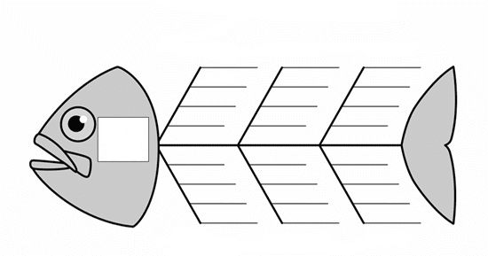

Appendix 3

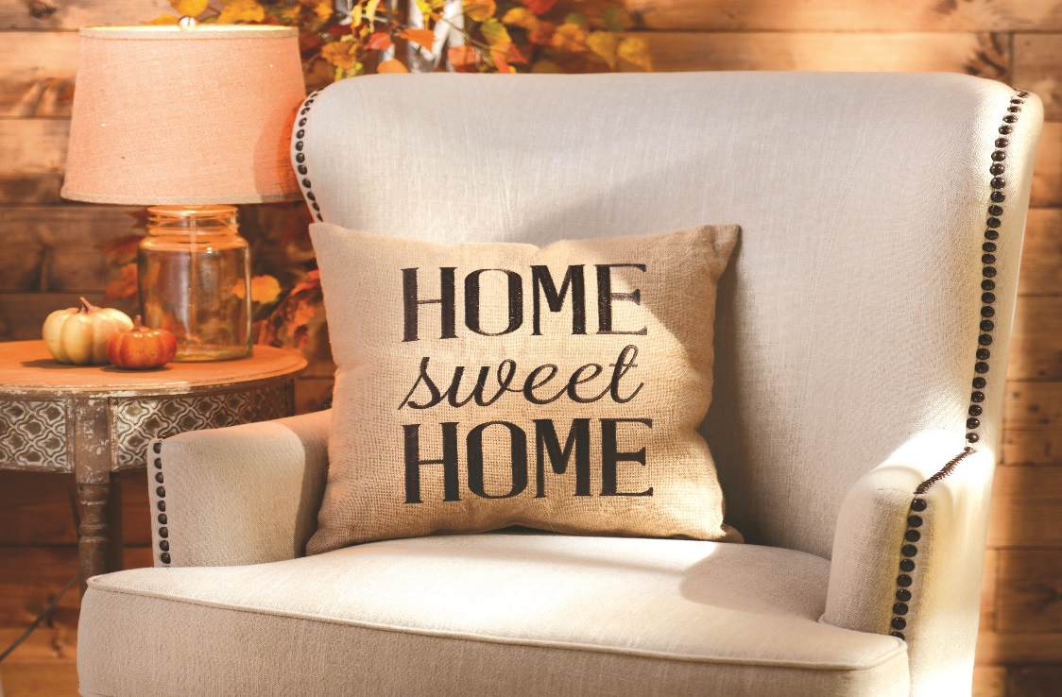

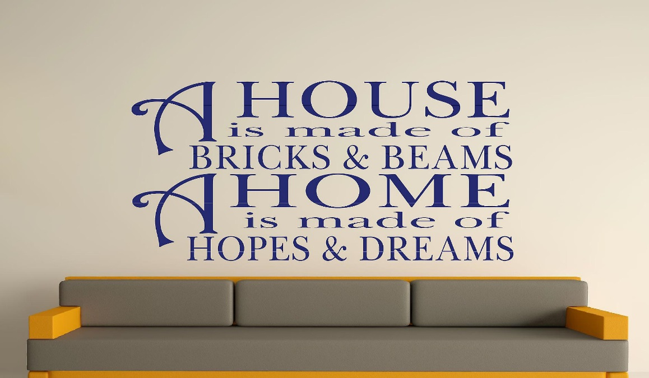

Appendix 4
