План урока

Тема: «Интернет зависимость»

Класс: 9

Цели:

Образовательная: развитие навыков говорения, восприятия и понимания речи на слух, чтения, лексических навыков по теме «Internet Addiction».

Развивающая: развитие памяти, внимания, мышления, творческих способностей учащихся; развитие умения планировать свое высказывание; развитие познавательного интереса к предмету.

Воспитательная: воспитание познавательного интереса к изучаемому языку, развитие навыков работы в коллективе, индивидуальной работы.

Оснащение: учебник, видеозапись, презентация, раздаточный материал, доска.

Ход урока | Задачи | Содержание | Пед. модель | Время
1.Начало урока. Организационный этап | Введение в атмосферу иноязычного общения | Good afternoon, people! I’m very glad to see you! How are you today? | T - Ps | 1
2. Целеполагание | Постановка целей и задач урока | Look at some pictures. What do you see there? What is the topic of our lesson?  Right you are. The topic of our lesson is Internet addiction. At the beginning of the lesson we will check your hometask (which was finding information about different Internet sites), then talk about some jokes about the Internet and say how much truth there is. Then we will listen to a song with some words missing, fill in the gaps and answer some questions. We’ll do a little test and try to find out whether you are addicted to the Internet. | T - Ps | 1
3.Развитие навыков говорения | Развитие навыков подготовлен-ной речи | At the previous lesson we read a text about the history of the Internet. And today we will talk about different Internet sites and, of course, about Internet addiction. Let’s start.  Which most popular Internet sites do you know? Name some of them please. Which of them do you personally use? Fine. Your hometask was to speak about your favourite Internet sites. Let’s check it. Who wants to start? | T – Ps | 7
4.Развитие навыков говорения | Развитие навыков неподготов-ленной речи | I promised you an interesting task. As you know, in every joke there is a little bit of joke. Let’s see whether it’s true. Look at these pictures and say what you think about them. | T – Ps, Ps - T | 7
5. Развитие навыков восприятия и понимания речи на слух | 1.предтекстовый этап (объяснение задания)  2.текстовый этап (развитие навыков восприятия речи на слух)  3.послетекстовый этап (развитие навыков чтения) | The Internet is so popular nowadays that there are a lot of songs about it. And now I offer you one of these songs. That is “MySpace Girl”. But some words there are missing so your task is to fill in the gaps and then I’ll ask you to answer some questions. Before we start look at the blackboard. There are some new words. Try to explain what they mean:  Be over driving through;  Clue;  Cute.  For the very first time just listen to the song. And your task is to fill in the gaps while listening for the second time.  OK. Let’s read and check what you’ve got.  And now tell me, please, do you personally use Internet services like MySpace to find people? Does it help? What can you find out about a person on the Internet? | T – Ps,  Ps - T | 10
6.Развитие лексико-грамматических навыков | Развитие лексико-грамматических навыков по теме “Internet Addiction” | I’d like to offer you a little test. Read the text and choose one word for each gap. | T - Ps | 7
7. Развитие навыков чтения | 1.предтекстовый этап (снятие трудностей при выполнении задания)  2.текстовый этап (развитие навыков чтения)  3.послетекстовый этап (развитие навыков говорения) | Are you addicted to the internet? Let’s check. I offer you 20 questions. You have to answer and get points:  0 = Never  1 = Rarely  2 = Occasionally  3 = Frequently  4 = Often  5 = Always  And then we’ll see your results.  So, read and answer. You have 5 minutes.  Now count you points and tell me how many you’ve got. What are your results? Do you agree? |  | 7
7.Домашнее задание | Объяснение домашнего задания | For the next lesson you task is to write an essay (10 sentences) about Internet addiction and ways to avoid it. | T - Ps | 1
8.Заключитель-ный этап | Подведение итогов урока, выставление отметок | I offer you this briefcase. You may put there all the ideas and all your thoughts about Internet addiction. What will you put there?  Your marks for today are… | T - Ps | 2

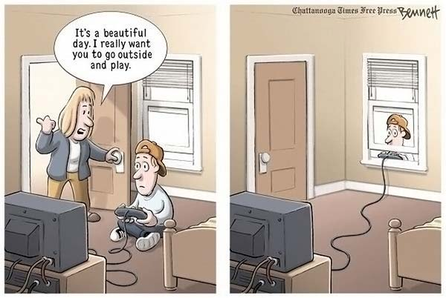

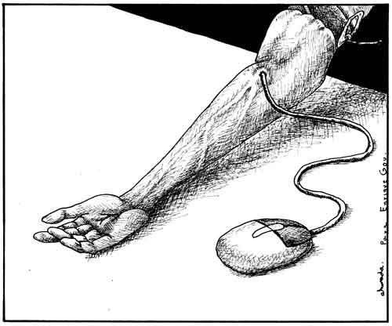

MySpace Girl
I saw you once, it was enough
You asked me what I wanted, I want you
But I replied, I'll have some fries
So mesmerized,
My heart was over driving through
I saw your name and unashamed
I searched within 500 miles to find
Any clue just as to who I've fallen for
Cause you've got me and I've got time
I saw your picture on Myspace
Maybe someday we can turn it into ourspace baby
I don't care how long it takes
I'm saving space in my top 8 for you
The second time you were so nice
I loved the way told me to enjoy my day
But I know what you meant to say instead
Was really that you wanted us to run away
I said let's go, I'll pack my clothes
Just promise me you'll wear
That purple dress you have
You look so cute when you're confused
You backed away and asked me
How I knew about that
I know you're scared
I know our love is crazy
And I'm so crazy
You make me crazy
For you

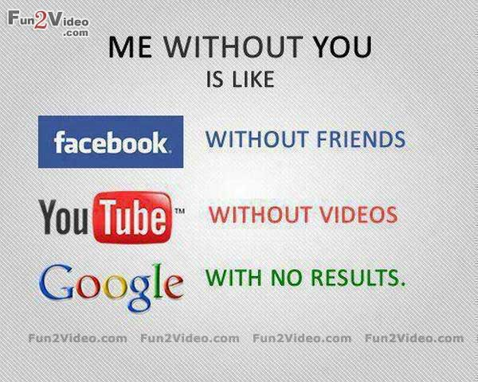

Fill in the gaps

Internet has many advantages and disadvantages. Firstly, it’s good for the kids to know (1) how to use a computer and Internet. They (2) can use internet tools to communicate, entertain (3) themselves and buy different things. In addition, they can find information, search good articles (4) for their schools. Furthermore, they can learn things from the Internet. They can also do their homework on computer (5) without wasting time writing down. (6) However, there are also negative effects. They (7) may open some bad sites or even (8) worse. They might be (9) addicted to games on the computer or even online-games (10) which are most the time violent. This could have a negative (11) impact on kids because they learn what they see and do.

1. a) how b) when c) what d) who

2. a) may b) must c) should d) can

3. a) ourselves b) themselves c) himself d) myself

4. a) for b) in c) with d) to

5. a) with b) without c) on d) for

6. a) in case b) instead of c) however d) despite

7. a) may b) must c) should d) can

8. a) good b) better c) bad d) worse

9. a) connected b) addicted c) made d) shown

10. a) who b) when c) which d) whom

11. a) impact b) influence c) addiction d) way

Internet Addiction Test (IAT)
The Internet Addiction Test (IAT) is the first Validated measure of Internet Addiction described in the IAT Manual to measure Internet use in terms of mild, moderate, to several levels of addiction.
For more information on using the IAT and building an Internet Addiction treatment program in your practice, visit RestoreRecovery.net for our comprehensive workbook and training programs.
Based upon the following five-point scale, select the response that best represents the frequency of the behavior described in the following 20-item questionnaire.
0 = Never
1 = Rarely
2 = Occasionally
3 = Frequently
4 = Often
5 = Always
- ___How often do you find that you stay online longer than you intended?
- ___How often do you neglect household chores to spend more time online?
- ___How often do you prefer the excitement of the Internet to going out with your friend?
- ___How often do you form new relationships with fellow online users?
- ___How often do others in your life complain to you about the amount of time you spend online?
- ___How often do your grades or school work suffer because of the amount of time you spend online?
- ___How often do you check your e-mail before something else that you need to do?
- ___How often does your job performance or productivity suffer because of the Internet?
- ___How often do you become defensive or secretive when anyone asks you what you do online?
- ___How often do you block out disturbing thoughts about your life with soothing thoughts of the Internet?
- ___How often do you find yourself anticipating when you will go online again?
- ___How often do you fear that life without the Internet would be boring, empty, and joyless?
- ___How often do you snap, yell, or act annoyed if someone bothers you while you are online?
- ___How often do you lose sleep due to late-night log-ins?
- ___How often do you feel preoccupied with the Internet when off-line, or fantasize about being online?
- ___How often do you find yourself saying “just a few more minutes” when online?
- ___How often do you try to cut down the amount of time you spend online and fail?
- ___How often do you try to hide how long you’ve been online?
- ___How often do you choose to spend more time online over going out with others?
- ___How often do you feel depressed, moody, or nervous when you are off-line, which goes away once you are back online?

After all the questions have been answered, add the numbers for each response to obtain a final score. The higher the score, the greater the level of addiction and creation of problems resultant from such Internet usage. The severity impairment index is as follows:
NONE 0 – 30 points
MILD 31- 49 points: You are an average online user. You may surf the Web a bit too long at times, but you have control over your usage.
MODERATE 50 -79 points: You are experiencing occasional or frequent problems because of the Internet. You should consider their full impact on your life.
SEVERE 80 – 100 points: Your Internet usage is causing significant problems in your life. You should evaluate the impact of the Internet on your life and address the problems directly caused by your Internet usage.

A briefcase

