XIX practical conference of students' research works
«Intelligence»

THE RESERVES OF THE EFFECTIVE USE OF HISTORICAL, CULTURAL, NATURAL AND SPIRITUAL HERITAGE IN DOMESTIC TOURISM

Author:
Daria Gorbunova
student of the 10th form
Osipovichi Secondary School
named after B.M. Dmitriev

Tutor:
Yuliya Cherepko
Teacher of English
Osipovichi Secondary School
named after B.M. Dmitriev

Mogilev, 2021

CONTENTS
Introduction 3

1. Theoretical aspects of the design tours with the use of historical and cultural, natural and spiritual heritage

1.1 Tour is as the main product of the tourist enterprises 5

1.2 Excursion is the main component of cultural and educational
tour 7

2 The efficiency and the development of the cultural and educational tour and ways of the promotion of the new tour 10

Conclusion 14

Bibliography 15

Appendix A 16

Appendix B 18

Appendix C 19

INTRODUCTION
A man travels the world over in search of what he needs, and returns home to find it.
The modern tourism industry is one of the highest-income industries in the global economy that’s why today it is important to talk about the potential of the tourism development in the Republic of Belarus. Belarus has significant potential for the development of the tourism - a rich historical and cultural heritage.
Material and spiritual values belong to the historical and cultural heritage of the Republic of Belarus. They have a constant historical value for the people of Belarus, regardless of property rights on them, the time of their creation and location.
The cultural and historical potential of any region is expressed in its historical heritage. The presence of unique historical objects may predetermine the successful development of tourism in the region. Interest in historical events, historical personalities and historical objects is the strongest tourist motive that needs to be studied and promoted to the tourist services market.
Tourist potential of the Republic of Belarus is based on the beauty of the
natural landscapes, the uniqueness of the historical and cultural sights, as well as memorable places associated with Belarusian and world history and culture.
The study and comprehensive use of the heritage sites, their preservation and restoration are essential for the prevention of the destruction of the national wealth. Mastering of the historical heritage contributes to the preservation of the spirituality of the people, otherwise the culture gives way to false values. That’s why I have chosen this theme for my research.
Thus the initial hypothesis of the work appeared: you can have a wonderful trip and you needn’t go to another country or even to another region. But you should know about the historical and cultural heritage of you region.
The aim of the work is to study the historical and cultural heritage of Mogilev region, to examine the preferences of the people for travelling and to create a new cultural informative tour.
The objectives of the study are:
to study the theoretical foundations of the development of cultural and educational tour;
to create a new cultural and educational tour
to calculate the efficiency and determine conditions and factors of the promotion of a new cultural and educational tour.
The object of the work is a cultural heritage of the Mogilev region
The subject of the work is the historical and cultural, natural and spiritual sights used for creating a tour around the Mogilev region.
The topicality of the research is defined by the importance of popularizing and development of home tourism in Belarus as it is an essential part in the economy of the country. By the present work we try to show that it is necessary to involve Belarusian people in domestic tourism and raise the economy of the country rather than spend money abroad.
The methods used are: the methods of theoretical research ̶ studying and analyzing the literature; methods of survey and interview were used to fulfill the practical part of the research; analytical and descriptive methods were used to interpret the data obtained from the survey; the inductive method helped to make conclusions.
The novelty of this work is that we have a new tour, taking into account the views and the preferences of the people. We also tried to create a new tour available from the point of finances and time. The advantage of this tour is that it can be adapted and applied to any age group and satisfy different interests and needs.
Our tour can be used in addition to the school lessons as out of class activities or as a pleasant and useful pastime for everybody who wants to enrich their knowledge of Mogilev and the Mogilev region.

1 Theoretical aspects of the design tours with the use of historical and cultural, natural and spiritual heritage
1.1 Tour is as the main product of the tourist enterprises
Tourism and tourism activities are complex social processes. We can say that these concepts are multifaceted types of human life. Tourism activity is often seen as the activity of the tourism organizers (tour operators, travel agents, as well as other participants) in the formation of a consumer product - a tourism product, on the one hand, and the activity of the tourist consuming this product, on the other hand.
It is believed that the tourist product is the result of the activities of the tourist enterprises in the form of the services or their complex, designed for sale in the market. It can be presented in various forms in depending on the satisfaction of the certain needs of the consumer and his preferences. It may be separate tourist services (for example, hotel accommodation, airline tickets) and a complex of similar services provided to the consumer in the form of tourist travel with the specific targets and on a pre-planned route. Tourist product, consisting of a range of services, united and interconnected by a single purpose of travel, usually called a tour. Consequently, the tourist product is the basis of the tour, its individual elements may be included in the program of the tour. [1, с. 42].
The tour is the main type of the tourist product which acts on the tourism market. Consumer searches not separate services or goods on the market but their combination, offered by tourist representatives in the form of specific tours. When the consumer chooses a tour he isn’t interested in the service provider who forms the tour. It is much more important for him how the quality of tour components matches his own ideas about the trip. [2, c. 35].
In general, a tour is a comprehensive service program for the tourists, consisting of accommodation, food, transportation, guide services and those services that will be included in a particular tour, depending on the purpose of the tourists [3, с. 215].
Considering the diversity of consumer needs in the tourist rest and a target orientation of various tours, we can take various criteria for their classification.
Table 1 - Classification of types of tours
purpose of the travelling | Cognitive, recreational, sports, healthy, medical, guided, hunting, business, congress, adventurous, entertaining, event
type of the transport | Planes, cars, trains, sea and river cruises, walking, horse riding, etc
the quantity of the tour users | Group, individual.
degree of the standard range of the services | Package tour, individual tour.
the duration of the tour | one day tour (more than 24 hours), multi-day tour
Note - Source: [1, p. 43, table 1].
Depending on the number of users, tours are divided into individual and group.
Individual tours are designed for individual consumers or small groups (up to 5 people). Individual tours provide the tourist with more independence, but they are more expensive, because the tourist pays for some types of services completely unlike group tours, where this price is divided among all members of the group. That is why individual tours are inaccessible to the mass consumer.
Group tours are cheaper, accessible to the general tourist, but in them each participant is obliged to obey the travel order established for the group [4, p. 27].
As the tour is a complex product that includes travel services of other manufacturers, it is also important to know what services and to what extent are provided in the tour. Considering the structure of the tour, we highlight the main range of services that make up the basis of the tour, and additional services that can be included in the tour at the request of the consumer.
The tour contains basic and additional services. The main complex of services is a set of services that forms the basis service within the tour. According to the purposes and destination tour the main range of services includes:
- accommodation services;
- catering services;
- transportation services;
- software services.
The main complex of services in the tour is its basis and forms its consumer value and dignity.
Additional services are an important component of the tour, including any services that can be provided to the consumer at his request and in according to his interests for an additional fee. Additional services can be offered to the consumer at the time of the purchase of the tour and during the tour . [5, с. 389].
Creating a tourist product is accompanied by studying its consumer qualities and properties, identifying the most attractive sides for the tourists. They are the guidelines for the development and implementation of the tourist product.
There are several basic consumer properties of the tourism. product:
- reasonableness
- efficiency ;
- integrity ;
- clarity
- flexibility;
-usefulness;
The organization of cultural and educational tours must take into account factors: resting place, prestige or, on the contrary, cost savings, as well as the age of the tourists. The process of creating any tourist program starts with the development of common goals, development of the forecasts, based primarily on the study of the consumer demand and supply of the competitors. [6, с. 110].
Informational and methodological support for each tour includes:
1 Technological map of the tourist travel route
2 Schedule of the loading of a tourist enterprise by groups of tourists on certain time
3 Information leaflet to the tourist trip package
4 Booking Sheet
5 Agreements with partners
6 Calculation of the cost of the tour
7 Writing texts for tourists
Competent theoretical design and the formation of tours is the basis for their successful promotion and implementation in practice.
1.2 Excursion is the main component of cultural and educational
tour
Tours originated on the basis of informative, educational, scientific and business trips. Sightseeing activities and sightseeing organizations contributed to the wider development of the tourism. An excursion is a methodically thinking display of the places, historical and cultural monuments. This display is based on the analysis which is in front of the eyes, as well as a good story of the specialist about the events associated with it. [5, c. 27].
This leads to signs that distinguish an excursion from tourism and travelling:
-the length of time from one hour (45 minutes) to one day;
-the presence of tourists (groups or individual tourists);
-the presence of a specialist (guide, guide-interpreter) conducting
excursion;
-visibility, visual perception, display of excursion objects on
their location;
- movement of participants of the excursion according to a pre-arranged
route;
-the focus of the display of objects, the presence of the theme of the tour;
- activities of the participants (observation, study, research objects).
If there isn’t one of these signs it is not a guided tour. [7, с. 275–276].
The most important stage in the preparation of excursions is the selection of excursion objects, creating a bright visual range that can remain forever in memory of the tourists and makes them to desire to return to this tourist center again. The axiom of the excursion process is the rule: “from the show to the story ", suggesting the primacy of visual impressions before verbal information.
Then the technological map of the excursions is developed, as a plan of showing objects and presentation of the material, ensuring the effectiveness of excursion techniques.
The text is created according to the plan: a control text — for a travel company and individual text, which takes into account the features of the perpetrator — a guide. Excursion preparation takes place in three main stages.
Preliminary work, where there is the development of the theme, the definition of the goals and tasks. At the same time, there is a selection of objects on which a tour is built.
The formation of the theme is a short and concentrated presentation of the main content of the tour. The choice of the theme of the tour depends on the potential demand, specific order or targeted creation "Bank" of the tours. After selecting a topic, the purpose of the tour is determined. The purpose determines the relevance of the topic. Sightseeing object is the subject (phenomenon) giving an idea of the characteristics (features) of the certain era of the development of the society, science, technology, culture, nature, art and increase interest to the knowledge of the surrounding reality [7, c. 281].
The objects can be: places associated with historical events; natural sites and reserves; buildings and constructions; memorial monuments and complexes; works of architecture and town planning; original engineering structures; objects that related to the life and work of great people; technical exhibits; monuments of art; expositions of the museums, art galleries, exhibitions; archaeological sites, etc. [8, с. 26].
The cognitive value of the object can be determined due to historical, territorial and methodological features. It can also be expressed in time - in minutes (hours) of examination, which is determined by the amount of information contained in the object.
The specifics of the tour is the combination of the show and the story in it. The classification of excursions is the distribution of excursions into groups according to the characteristics in these groups. Nowadays, classification can be used in the work of excursion institutions , which is based on the following features:
- of participants;
- content;
- subjects;
- location;
- form of transportation;
- cyclicality [8, p. 26].
Thematic tours are divided into historical, industrial, environmental ,art, literary, architectural .[5, p. 40].
The classification of excursions has great importance for the organization of excursion activities by tourism enterprises, promotes the specialization of tour guides, guide-interpreters, promotes the quality of preparation, the development of the excursions and their conduct. The theme of the excursions is a set of topics that allow a tourism company to organize excursions from episodic events to organizing cycles.
Creating new topics is due to various reasons:
-differentiated approach to serving different groups;
-demand for a certain type of excursion;
- further development of excursion activities.
Preparation of a new excursion topic is a complex and a long process. The work is considered completed when the necessary materials have been prepared on the topic, including a list of literature on the topic, cards (passports) of excursion objects, control and individual texts, a technological map — the main document of the excursion and others.
The content of these materials does not remain unchanged. Creating excursions for various groups of excursionists requires adjusting the excursion texts (both control and individual), technological map, and other materials [9, p. 48].
The effective use of historical and cultural heritage in tourism is paid attention not only to tourism organizations, but also directly by the government. This is reflected in acts, decrees, national programs and other documents. The State Register of Historical and Cultural Values of the Republic of Belarus is maintained; work on the inclusion of monuments in the UNESCO World Heritage List; restoration and protection of monuments.
From the point of view of the excursion methodology, the historical and cultural heritage is considered as excursion objects - natural or historical-cultural realities that give an idea of the characteristic features of the particular era in the development of society, indicate the level of science, culture, art or demonstrate the natural environment of a certain region. Excursion objects are the material (even when it is a phenomenon of spiritual culture) basis of the show, so when you include them in the visual series of excursions it is very important to take into account their classification features.
And we have such an opportunity. For this we use for the first time in Belarusian historiography options of a comparative chronological study and analysis of the masterpieces of domestic architecture and art, developed by A.F. Samusik taking into account the evolution of all the main European stylistic directions [10, p.125].
As A.F. Samusik noted, the entire domestic historical and cultural heritage is divided into six main groups to improve the accounting of historical and cultural monuments, as well as to create conditions for their study and protection. It is reflected in table 2:
Table 2 — Classification of types of monuments
Name of monuments | Examples
documentary monuments | chronicles
ethnographic monuments | customs, traditions, etc.
archeological monuments | objects which were found during archaeological excavations, etc.
architectural monuments | Buildings, districts, cities, etc.
art monuments | art paintings, graphic arts, sculptures, etc.
historical monuments | native places of famous people, places of battles, etc.
Note - Source: [19, p. 130, table 2].
It should be noted that this classification of historical and cultural monuments of Belarus has a similar character with the accepted classification of thematic excursions. At the same time, there are significant further details, which, however, as the studies show, are far from being fully used in the activities of tourism organizations [19, p. 130].
Cultural and educational tourism is becoming a popular destination in Belarus. Creating a cultural and educational tour is a complex process that requires the active participation of managers and specialists such as guides and / or interpreters. The content of the tour, its program and the main components, their cultural and cognitive value, are directly dependent on the knowledge, competence, degree of practical experience of these specialists, their skills and ability to choose the most effective methods of influencing the participants of the tour.

2 The efficiency and the development of the cultural and educational tour and ways of the promotion of the new tour
Taking into account the theory I studied, I decided in practice to create a cultural-educational tour for my relatives from Moscow. The tour was interesting for my Russian relatives, because the history of Mogilev is closely connected with the history of the Russian people, the Russian Empire — the city has been within its territorial limits, or on the border with Russia for a long time.
Also, when I translated my excursion into a foreign language, it became possible to use this work in foreign lessons when pupils study topics related to sights and tourism in Belarus.
My teacher and I studied the main attractions of the city of Mogilev on the Internet and analyzed what might be interesting for my guests. The next thing I did was asking for help at the travel agency “Visit-tour” in order to know what it is worth paying attention to organize a simple one-day tour. Then I made a trip to Mogilev to see how the sights I selected were located and analyzed in what order to combine them to have a logical tour. I also calculated the time of the route. We decided to make this route which was based on the personal emotions and impressions.
The tour program includes a sightseeing tour of Mogilev, a walk in Podnikolye Park, a visit to Mogilev zoo and Buinichi Field, memorial complex, and lunch in “Korchma” — café of Belarusian cuisine . I decided that it would be very interesting when the historical, religious, and entertaining direction would be combined.
When I was developing the route of a sightseeing tour of Mogilev, I decided to stop at the following objects:
1) the historical center of the city, located on Sovetskaya Square.
2) Podnicolye Park , where a lot of work has recently been done to improve and restore the territory. In the park a staircase with a cascading fountain was opened;
3) an architectural monument, which located on the territory of Podnekolye Park, has an important historical and cultural significance for citizens and visitors:
St. Nicholas Monastery
4)Buinichi field;
5)Mogilev zoo
In modeling the route, the geographical location of the objects, the possibility of the driving to them, and the construction of the text of a sightseeing tour were taken into account.
The proposed route belongs to the category of thematic-chronological routes. The feature of this route is its informational richness in the first part of the tour, after which tourists are offered to visit the main memorial places of Mogilev in a more dynamic mode, which allows guests to redistribute their attention between the main objects of the show.
The program of the first half of the day includes a sightseeing tour of Mogilev, its center, visiting the main attractions of the city: monuments, buildings, structures. Then guests will have a wonderful walk in Podnekolye Park. This park has been converted recently. Paths were laid in the park, trees were planted, benches, drinking fountains were installed. The park in Podnikolye is a green recreation area without large constructions. This is a great place to relax, where people can take a walk, ride horses, relax with children, ride bicycles, eat ice cream and just have a good time.
There is St. Nicholas Monastery near the park. It is one of the few surviving buildings in the Belarusian Baroque style. The monastery, which is part of the UNESCO World Heritage tentative list, includes St. Nicholas Cathedral (among the most valuable Baroque buildings in Europe), the Temple of St. Onuphrius the Great, a belfry, and living quarters. The pride of St. Nicholas Church is a beautiful four-tier iconostasis made by skilled Mogilev carvers in the 17th century, among whom was Klim Mikhailov, a native of Shklov. He is famous for his work on the Tsar Palace in Kolomenskoye and on the chambers of the Kremlin. Similar iconostasis can be seen only in the Smolensk Cathedral of the Novodevichy Convent in Moscow.
The program of the afternoon of the tour includes a visit to the Buinichi Field located outside the city. On the way to the memorial, tourists are given information about the heroic past of the city and the region so that by the time tourists approach the complex, they have a strong desire to get acquainted with the memorial in detail.
Buinichi Field was opened on May 9, 1995. In the center of the memorial, which covers an area of more than 20 hectares, sightseers can see a 27-meter chapel - a symbol of the greatness of the military spirit of the Slavs, and military equipment of the Great Patriotic War (tanks, divisional guns, artillery pieces and anti-aircraft guns). The walls of the chapel are painted with frescoes, marble plaques with the names of the defenders of Mogilev are placed in the niches, and in the center is the Foucault pendulum, a symbol of eternal life, movement and the memory of everyone who died in this field in 1941. The chapel is crowned with a cross of an ancient Greek pattern.
Nearby is a small artificial reservoir "Lake of Tears", a symbol of the tears of mothers who lost their sons during the war. Four alleys diverge from the chapel. One of them bears the name of the famous writer Konstantin Simonov, who praised the heroism of the defenders of Mogilev in his books, The Living and the Dead and The Different Days of the War.
Buinichi Field memorial complex has become a center for patriotic education of youth. Here, Memory Shows, courage lessons, meetings with veterans of the Great Patriotic War, ceremonial receptions of students in the ranks of the pioneer organization and the Belarusian Republican Youth Union are held here.
A separate part of the developed sightseeing tour around Mogilev for tourists is visiting Mogilev Zoo with a demonstration to tourists not only the inhabitants, but also of the Belarusian territorial landscapes, and the holding of some recreational activities.
This part of the tour takes 1.5–2 hours and serve to distract the excursionists from the information richness of the first part of the tour. Here, tourists have a rest. Moreover, the composition of the zoo allows you to relax not only physically, but also spiritually.
When you visit the zoo, you will know about the history and goals of its creation, its condition at the present and the development in the future. You will be proposed to take part (for those who wish) in recreational activities – horse-riding, a trip around the zoo in a steam train and visiting animals.
The developed tour “Memorial places of Mogilev in the Republic of Belarus” refers to weekend tours.
The excursion and educational tour “Memorial places of Mogilev in the Republic of Belarus” is distinguished by its versatility and can be designed for a group of 10 to 40 people. At the same time, the age category of the group can be different - it can be both schoolchildren and tourists aged 18 to 50, veterans of the Great Patriotic War.
The most favorable time for this trip is from May to September.
Tour program:
The tour starts at 8.00 from the railway station in Mogilev, where we will arrive by train.
9.00 ̶ 11.00 – a sightseeing tour of Mogilev with a visiting the most interesting objects - building-monuments of architecture and history of the city; a) Monuments to heroes who died during the Great Patriotic War; b)Podnikolie Park; d) architectural monument located on the territory of the city, having important historical and cultural significance for the people and guests — St. Nicholas Monastery:
11.00 ̶ 12.00 – transportation to the Buinichi Field memorial complex.
12.00 – 14.00 – visit to the Buinichi Field memorial complex. Tourists are invited to walk around the complex, get acquainted with the history of the wars that took place here, examine the 27-meter chapel and military equipment of the Great Patriotic War (tanks, divisional guns, artillery pieces and anti-aircraft guns).
After that, tourists visit the "Lake of Tears", located within the complex
14.00 ̶ 14.30 ̶ lunch in the cafe “Buinichi Field”.
14.30 ̶ 15.00 ̶ transportation from the Buinichi Field memorial complex to the Mogilev zoo.
15.00 ̶ 16.30 – visiting Mogilev zoo. Examination of Belarusian landscapes, expositions of the zoo, participation in excursions “Safari”, “Life of wild animals”, “Bison - Belarusian pride”, competitions, entertainment events organized here.
16.30 ̶ 17.00 ̶ transportation from the Mogilev Zoo to café “Korchma”.
17.00 - 17.30 – dinner in the cafe "Korchma".
17.30 - 18.00 – transportation to the railway station
The tour price includes:
- pre-ordered lunch at the cafe;
- transportation by bus;
- services of a guide in the Mogilev Zoo and the Buinichi Field memorial complex;
- a sightseeing tour in Mogilev zoo.
I tried to create a new tourist product of excursion and educational orientation “Memorial places of Mogilev in the Republic of Belarus ”. For the development of a new tourist product of excursion and cognitive orientation, a theme was chosen dedicated to the historical past of the city of Mogilev. The tour route includes acquaintance with the history of the city, the main architectural monuments, monuments and social objects, industrial enterprises and modern objects of the city, as well as visits to the most significant places.
This tour was very successful among my guests. Then my teacher offered me to take part in a research competition and I thought why not to translate this excursion into foreign language. Many foreign tourists visit our every year to have a rest or visit their friends and relatives. Also many foreign tourists come to our country to get education. Belarus differs from any other country by its people, nature and sights. And I think it will be interesting for them to visit Mogilev. Moreover it is “the year of Homeland” in Belarus.
A successful travel company, of course, tried to provide with a variety of services as many customers as possible. Here, success depends on the service and the product. And nowadays many travel companies try to diversify their range of services as much as possible in order to satisfy as many customer needs as possible. That’s why I decided to propose my tour to travel agent.
A tour brochure was developed to attract tourists. The tour brochure is intended for tourists; it is a small colorful publication with a small amount of photo materials and advertising information.
My educational tour will be very useful in the foreign lessons in school when pupils learn about Belarus or Belarusian sights. Also it can be used in universities to tell foreign students about our country.

Conclusion
The study showed that the creation of a cultural tour is a complex process that requires competent theoretical design and formation. The contents of the tour, its program and the main components, their cultural and cognitive value, are directly dependent on knowledge, competence, and degree of practical experience, skills and abilities to choose the most effective methods of influence on the tour participants.
During the work, I studied the theoretical aspects of tour design, the historical, cultural, natural and spiritual heritage of Mogilev.
In the process of research, a new sightseeing tour “Memorial places of Mogilev in the Republic of Belarus” was developed. To develop a new tourist product of an excursion and educational orientation, a topic was chosen dedicated to the historical past of the city of Mogilev, which includes acquainting visitors with the history of the city, the main architectural monuments, monuments and social objects, industrial enterprises and modern objects of the city.
The creation of new tourism products, among which the tour “Memorial places of Mogilev in the Republic of Belarus”, can positively affect the dynamics of the development of the tourism industry in the Mogilev region, and increase the level of entrepreneurial initiative in the use of tourist facilities. Created a comprehensive tour and educational tourism product will satisfy the needs, interests, needs and expected satisfaction of tourists.
We came to the following conclusions:
1 Learning sights of our homeland encourages domestic tourism.
2 To create a new tour is a complicated task that requires the knowledge of history and culture of the country on the one hand and certain experience in the sphere of tourism on the other hand.
3 The process of creating a new tour can be a fun, interesting, useful and natural pastime, which does not require much financial and physical effort and is available to everyone.
4 Creating a new tour is easy and interesting way of learning foreign language and promotion of Belarusian tourism on the international arena.
The aim of our work is achieved, the objectives are completed and the hypothesis of the study is confirmed.
I consider our new tour to be of great interest to students learning foreign language, to everybody who wants to improve knowledge about Belarus. This work shows that you can have a wonderful trip and you needn’t go to another country or even to another region. But you should know about the historical and cultural heritage of your region.

BIBLIOGRAPHY
1 О формировании и продвижении конкурентоспособного туристического продукта: материалы X Международной научной конференции "Беларусь в современном мире", Минск 28 октября 2012 г./ Белорус. гос. экон. ун-т: редкол.: Я. И. Аношко, Д.Г. Решетников. ̶ Минск: БГЭУ, 2012. ̶ 186с.
2 Биржаков, М.Б. Введение в туризм: учебно практич. пособие / М. Б. Биржаков. – Санкт-Петербург: Герда, 2000. – 315 с.
3Бирицкая, Н.М. Туроперейтинг: учеб.-метод. пособие / Н.М. Бирицкая. ̶ Минск: БГЭУ, 2005. ̶ 209с.
4 Ганский, В.А. Экскурсоведение: учебно-мет. комплекс для студентов спец. 1-89 01 01«Туризм и гостеприимство» / В.А. Ганский, Е.В. Вовнейко – Новополоцк: ПГУ, 2012. – 254 с.
5 Организация туризма: учеб. пособие / А. П. Дурович, Т. М. Сергеева и др.; под общ. ред. Н.И. Кабушкина. ̶ Минск: Новое знание, 2003. ̶ 632с.
6Дурович, А.П. Организация туризма: учебное пособие / А. П. Дурович. – Минск: Современная школа, 2010. – 383 с.
7 Савина, Н.В. Экскурсоведение: учеб. пособие / Н.В. Савина, З.М. Горбылева. – Минск: БГЭУ, 2004. – 335 с
8 Емельянов, Б.М. Экскурсоведение: учеб. пособие / Б. В. Емельянов. – Минск: Советский спорт, 2004. – 216 с.
9 Зорин, И.В. Менеджмент туризма. Туризм как вид деʀҭҽљности: учеб. пособие / И. В. Зорин, Т. П. Каверина; под общ. ҏед. В.А. Квартальнова. - Минск: Финансы и статистика, 2001. ̶ 287с.
10 Самусік, А.Ф. Помнікі гісторыі і культуры Беларусі: вучэбны дапаможнік / А.Ф. Самусік. ̶ Минск: БГЭУ, 2013. ̶ 367 с.

APPENDIX А
AN EXCURSION OBJECT CARD
Name: St. Nicholas Monastery
Date: XVI I century
Events connected with this object: At the beginning of the XVIII century, the monastery was attacked by the Swedes, and later by Russian troops, Tatar and Kalmyk regiments. St. Nicholas Monastery was significantly damaged during the fire.
In 1937, there was a prison in St. Nicholas Cathedral. In 1941, the prison was closed. In 1946, a book base was presented in the cathedral. In 1991, numerous human remains were discovered. These remains were probably victims of Stalinist repressions.
Location: Mogilev
Description: On August 6, a procession annually takes place from the monastery to the house where St. George (Konissky) lived and worked. The Primate of the Belarusian Orthodox Church, Metropolitan Filaret, repeatedly visited the monastery with his pastoral visit. Nowadays, the monastery has a Sunday school and a youth Orthodox choir. Archbishop Maxim, thanks to the hard work of which St. Nicholas Convent was brought back to life, is now resting in the monastery near the St. Nicholas Cathedral, and the abbess of the monastery, Abbess Eugene (Voloshchuk), is also buried there.
Creator: Kiev Metropolitan Peter
Opening time: daily

Name: Buinichi Field
Date: XXcentury
Events connected with this object: battles took place near Buinichi in 1941 during the defense of Mogilev. In 1941, the line of Soviet defense was in this place and it was a difficult struggle. The battles began on July 10. German troops hoped to occupy the regional center, and, sent 70 tanks to Buinichi Field. The main battle lasted 14 hours. The defense of Mogilev lasted until July 22.
Location: Mogilev
Description: Buinichi Field appeared at the place of the battle in 1995. It includes a 27-meter chapel, an arch, an alley with a central composition. There are examples of military weapons of theSecond World War period, high relief boards, as well as a monument to Konstantin Simonov.
Creator: Vladimir Chalenko
Opening time: daily

Name: Mogilev Zoo
Date: XXI century
Events connected with this object: the railway began to function in the zoo in the spring of 2009. The train can reach speed of 10 km / h. The road is 2 km long and allows you to get to know the inhabitants of a large aviary.
Location: Mogilev
Description: A walking route is along the zoo, there are observation platforms. Visitors have the opportunity to observe animals in their usual conditions. The main part of the zoo is occupied by spacious enclosures in which the inhabitants of the Belarusian forests live. There is “Belarusian Village” , an open-air museum, in the zoo.
Creator: the government
Opening time: daily

APPENDIX B
TOUR PROGRAM

The tour starts at 8.00 from the railway station in Mogilev, where we will arrive by train.
9.00 ̶ 11.00 – a sightseeing tour of Mogilev with a visiting the most interesting objects - building-monuments of architecture and history of the city; a) Monuments to heroes who died during the Great Patriotic War; b)Podnikolie Park; d) architectural monument located on the territory of the city, having important historical and cultural significance for the people and guests — St. Nicholas Monastery:
11.00 ̶ 12.00 – transportation to the Buinichi Field memorial complex.
12.00 – 14.00 – visit to the Buinichi Field memorial complex. Tourists are invited to walk around the complex, get acquainted with the history of the wars that took place here, examine the 27-meter chapel and military equipment of the Great Patriotic War (tanks, divisional guns, artillery pieces and anti-aircraft guns).
After that, tourists visit the "Lake of Tears", located within the complex
14.00 ̶ 14.30 ̶ lunch in the cafe “Buinichi Field”.
14.30 ̶ 15.00 ̶ transportation from the Buinichi Field memorial complex to the Mogilev zoo.
15.00 ̶ 16.30 – visiting Mogilev zoo. Examination of Belarusian landscapes, expositions of the zoo, participation in excursions “Safari”, “Life of wild animals”, “Bison - Belarusian pride”, competitions, entertainment events organized here.
16.30 ̶ 17.00 ̶ transportation from the Mogilev Zoo to café “Korchma”.
17.00 - 17.30 – dinner in the cafe "Korchma".
17.30 - 18.00 – transportation to the railway stati

APPENDIX C
BROCHURE OF MOGILEV
The city was established on the bank of the Dnieper River more than seven centuries ago. If you look at the map of Belarus, you will not be surprised why Mogilev has been used as a strategic location many times over its history. During the First World War the Russian Army Headquarters and the residence of Emperor Nicholas II were located there. Before the Second World War, there were plans to relocate Belarus’ capital to Mogilev, because Minsk was too close to the country’s western border. A testimony to that was the hasty construction of the House of Soviets in Mogilev. The building was nearly the exact replica of the Minsk-based House of Government. During the Great Patriotic War Mogilev held out against the enemy for 23 days, including 16 days in complete encirclement.
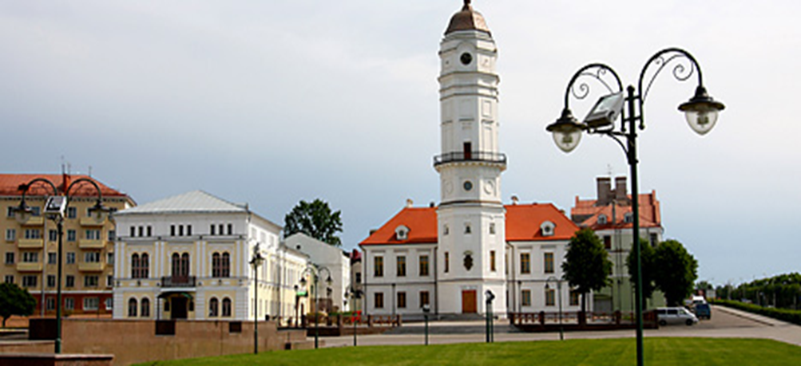

Today visitors to the city are welcomed by the sculpture of a railway station inspector erected near the old railway station (1902). The air of history can be felt in the pedestrian Lenin Street that has been known since the 16th century under various names, like Vetryanaya Street, Bolshaya Sadovaya Street and Inzhenernaya Street. Here one can see beautiful buildings dating back to the 18th-19th centuries: the former municipal administration building, the palace of the archbishop, the gymnasium which famous students included the First Hawaii Senate President Nikolai Sudzilovsky and a celebrated explorer of the Arctic Otto Schmidt… The street is divided by the Square of Stars featuring the world’s only monument to the stargazer and the sundial consisting of 12 chairs symbolizing the Zodiac signs.

The main object of the memorial is a chapel, a symbol of dignity and patriotism of Slavic warriors. The brick temple was built there. At the top of the copper dome, 27 meters in height, there is a cross in the old Greek style.
The interior of the temple is very interesting, there are murals and niches with memory boards, which depict all the names of Mogilev fighters who participated in the defense. The chapel has a pendulum named after Foucault. It is a symbol of remembrance of all the soldiers who died in battles for the city. The crypt with the remains of six soldiers was built under the chapel. One of the soldiers was identified. An old Greek cross can be seen at the top of the chapel.
There are four alleys which lead to the chapel, going from all over the complex. One of the alleys goes from the old obelisk, it is considered as the main alley. The second alley, the left one goes from the intersection of the Bobruisk highway and the road which leads to the railway station "Buinichi". The third alley called Simonov goes from the stone of the same name - Simonov stone. The last alley, the fourth one goes named after defenders of the city of Mogilev goes from the shore of the Lake of Tears.
Simonov alley is divided by the moat line designed for the protection against tanks. The alley ends with a symbolic stone monument "Konstantin Simonov". On the side of the stone there is an inscription "All his life he remembered the battlefield of 1941 and bequeathed to scatter his cremated remains here." Memorial monument to the famous writer was established in 1980.

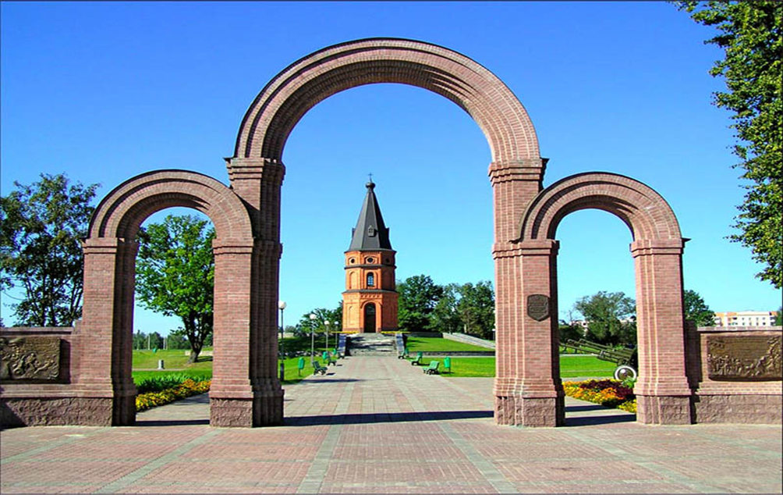

Podnekolye park has been converted recently. Paths were laid in the park, trees were planted, benches and urns, drinking fountains were installed. The park in Podnikolye is a green recreation area without large construction projects. This is a great place to relax, where people can take a walk, ride horses, relax with children, ride bicycles, eat ice cream and just have a good time.
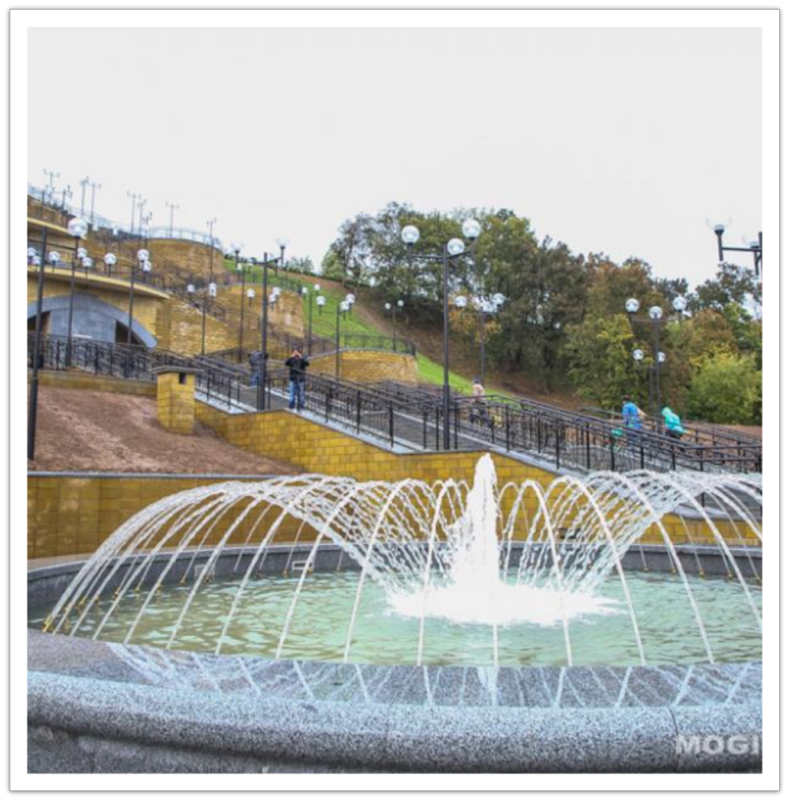

St. Nicholas Monastery is one of the few surviving buildings in the Belarusian Baroque style. The monastery, which is part of the UNESCO World Heritage tentative list, includes St. Nicholas Cathedral (among the most valuable Baroque buildings in Europe), the Temple of St. Onuphrius the Great, a belfry, and living quarters. The pride of St. Nicholas Church is a beautiful four-tier iconostasis made by skilled Mogilev carvers in the 17th century.
St. Nicholas Monastery.

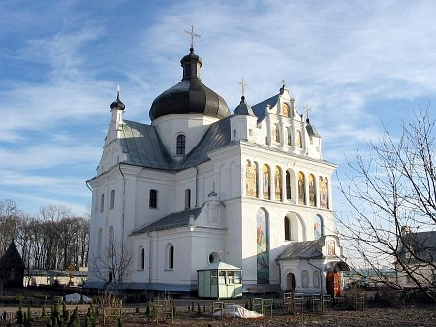
During a visit to the zoo, it tells about the history and goals of its creation, its condition at the present stage of development and in the future. It is also proposed to take part (for those who wish) in a tour of the zoo with visits to recreational activities - horseback riding and ponies, a trip around the zoo in a steam train, and a visit to the equipped zoo.

