Класс: IX
Тема: «Leisure time»
Цели:
образовательные –формирование рецептивных лексических навыков; совершенствование монологической речи.
развивающие – развивать рецептивный лексический навык, языковую догадку, развивать внимание, память, мышление.
воспитательные – воспитывать доброжелательное отношение к ошибкам одноклассников.
Задачи: развивать фонематический слух, учить узнавать слово и понимать его значение в тексте, уметь давать дефиниции.
Языковой материал: leisure, debate, useful tips
Речевой материал: «Leisure», «dialogue»
Оснащение урока: ноутбук, интерактивная доска, проектор, аудиотекст, бонусы, диалог, English Student`s book, Авторы: Лапицкая Л. М., Демченко Н. В., Волков А. В., Калишевич А. И., Севрюкова Т. Ю., Юхнель Н. В.

№ п/п | Содержание этапа | Время | Примечание
1. | Good afternoon, boys and girls! You may sit down! Today we continue to speak about «Leisure time», housework. We are going to revise recreational activities, work in pairs, discuss the questions, study the new words.  T: Look at the blackboard.  Let’s revise some phonetic rules.  As you remember, some English letters may have different sounds for example letter I has 2 sounds [ai] and [i].  Letter I has sound [ai] in open syllables. For example in the word time.  And short sound [i] in closed syllables. As in a word music.  T: Let’s read the poem and find letter I and its sound.  [ai] – time, kites, riding, bikes, like.  [i] – swimming, camping, comic, flying, doing, playing, things.  T: Let’s read the poem together, pronouncing the words correctly.  Free time, free time, we love our free time.  Swimming, camping, comic books, there is so much to do.  Free time, free time, we love our free time.  Volleyball and flying kites, playing soccer, riding bikes.  Doing all the things we like, there is so much to do.  T: What are we going to speak about? (Free time)  T: Yes, you are right!  T: Today we continue to speak about free time or leisure time.  - What do you like doing in your free time?  - Do you stay at home or do you go out?  - Do you have a lot of leisure time?  - What is your favourite hobby? Why?  - Where do you prefer to hang out with your friends?  - Do you prefer to spend your free time with your family or with your friends?  - What do you like doing at free time with your friends?  - What activities do you do with pleasure?  - Is leisure time important in your life? | 8
2 | Look at the blackboard and complete the definition of leisure  Leisure - …  Listen to the definition and explain from all that has been said the definition of leisure.  Video: What are the most popular activities in the UK? Watching TV, spending time with friends and families, listening to music, shopping  What are the most popular activities in the USA?  Watching tv, reading, computer and Internet, spending time with friends and families  More phrases with do: do sports, do gardening, do arts and crafts, do karate, do judo, do aerobics, do athletics, do gymnastics  More phrases with go: go shopping, go swimming, go jogging, go running, go skiing, go fishing, go sailing  Jogging and running are synonyms, aren`t they?  Is it correct to use the phrase "play the tennis"?  PB p 186 ex.4,4b  What do you think about recreational activity? To express your opinion use the phrases: I believe…, I think…, I consider…, To my mind…, In my opinion…etc  So, let`s check your homework. Your homework was individual to compose a poem « Our best friend is our hobby».  Speak about 1.5 min about free time, choosing a picture from the list:  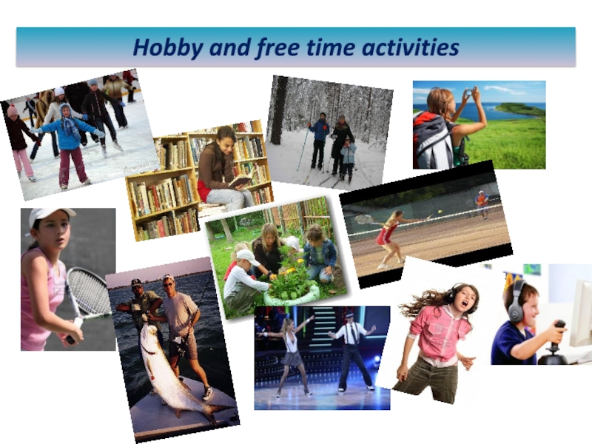  Well done, let's go to the Physical Exercise.  Hands up! Hands down!  Hands on hips, sit down!  Stand up, hands to the sides -  Bend left, bend right.  Hands on hips,  one, two, three, hop,  one, two, three, stop. Stand still!  Revision grammar material in app «plickers».  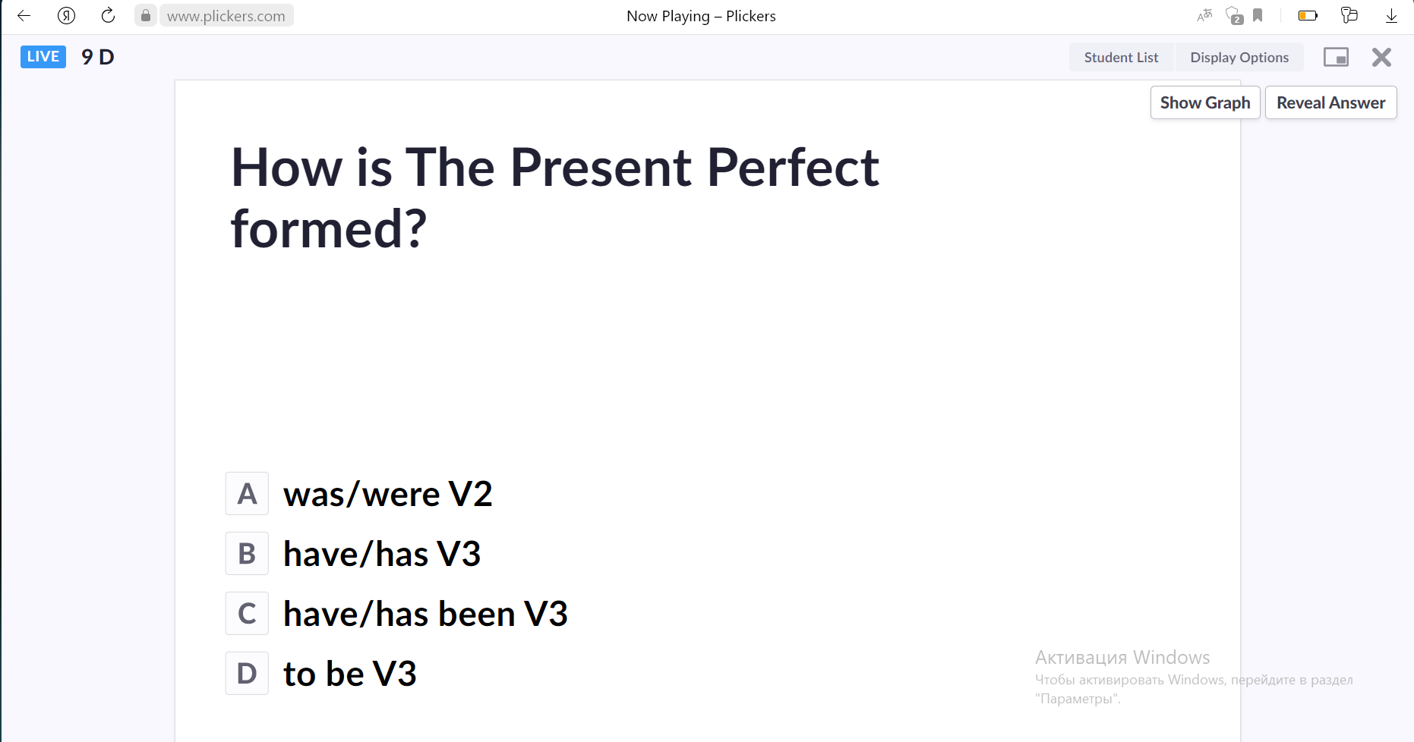  - How is The Present Perfect formed?  A was/were V2  B have/has V3  C have/has been V3  D to be V3  - Find the example of the Present Perfect tense.  A My mother was happy to get the letter.  B I`ve written five pages of the new book this morning.  C My neighbour has been playing the piano since morning.  D I didn`t answer the phone.  - How is the Present Perfect Continuous formed?  A have/has been V3  B have been V3  C been V3  D have/has been Ving  - Find the example of the Present Perfect Continuous tense.  A Have you finished the classes?  B Nick was hungry so he bought a sandwich.  C I have been driving for many hours.  D As a result we had a wonderful time.  - Complete the sentence: You ________ the dishes for an hour and you ________yet!  A have been washing ; haven`t finished  B has finished ; have been washing  C have been finishing; have been washing  D have washed; have finished | 3  10  9 | Literature: English Student`s book, Авторы: Лапицкая Л. М., Демченко Н. В., Волков А. В., Калишевич А. И., Севрюкова Т. Ю., Юхнель Н. В.  Video: https://www.youtube.com/watch?v=Rl50I0GV3gE&t=1s  Students should have their own QR codes to answer the questions.
3 | Listen to Yan and Nick talking about the things do about the house. What problem has Nick got? Before listening, look at the screen and guess the meaning of the words.  messy [ˈmesɪ]  bossy [ˈbɔsɪ]  horrible [ˈhɔrəbl]  Let `s remember the phrase to be good at , look at the screen. Give me any examples.  Good job! Хорошая работа!  Praise:  Magnificent! Великолепно!  Fantastic! Фантастически!  Keep it up! Так держать!  Superb! Превосходно!  Well done! Молодец!  Excellent! Отлично!  Perfect! Идеально!  Brilliant! Блестяще!  That's perfectly correct. Абсолютно верно.  Yes, you've got it. Да, у тебя это получилось.  That's just what I was looking for. Это как раз то, что я искал.  You really figured it out! Ты действительно с этим разобрался!  I like that! Мне это нравится!  Very good! Очень хорошо!  Good for you! Молодец!  Great you are! Молодец!  That's right. Правильно.  That's nice. Это мило.  That's it. Это оно.  Exactly. Точно.  We will have a debate. For this task you have to divide into two groups according to the color of the bonstick you choose. Do not forget about debate rules:  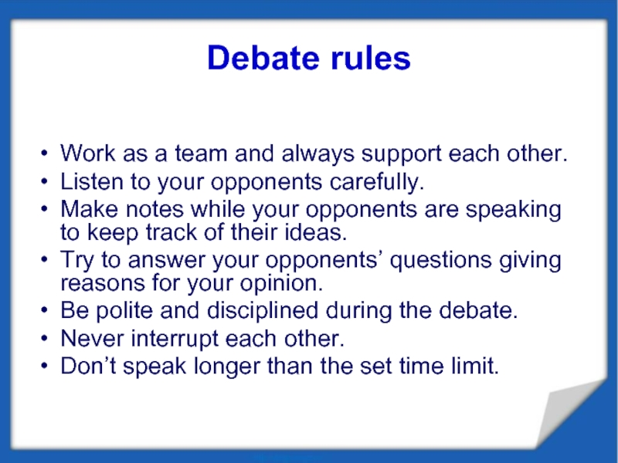  Debate  1)Many parents think that children should spend less time playing computer games, that they should play outside or do some sport instead.  2)Many parents often complain that teenagers don`t want to spend their free time with them. | 12 | You need white and red color bonsticks.
4 | So, students, your work is good. I think we have achieved the aims: to develop listening skills, to improve oral speech, to revise vocabulary material, to have fun.  As for your marks today –  Pupils`names – I`m satisfied you’re your work today. Your answers were full and nice. You were active during the lesson. You have 8,9,10. Ok.  Pupils`names - Your work was good , but not enough . You should read more, learn the words, translate the text. You have 6,7  Pupils`names - Your work was weak. You should be more attentive, active. Unfortunately, you have 3,4,5  Write down your homework, WB  Do you have any questions?  Cood luck. | 3

