Тема урока: Организация праздника
Вид речевой деятельности: Чтение
Цель урока: развитие навыков изучающего чтения.
Задачи:
образовательная: создать условия для отработки лексических навыков, навыков изучающего чтения;
развивающая: создать условия для развития коммуникативных навыков через разнообразные виды речевой деятельности;
воспитательная: содействовать развитию познавательного интереса через содержание учебного материала.
Оборудование: доска, мел, компьютер.
Дидактическое оснащение: учебник «English 5.Pupil’s book» (Л. М. Лапицкая и др.), рабочая тетрадь
«Workbook-1, 5» (Л. М. Лапицкая и др.), раздаточный материал.

ХОД УРОКА
I. Организационный момент. Введение в тему урока и определение целей
— Good afternoon, boys and girls! How are you today? I’m glad to see you all here.
— The topic of our lesson is «Last Christmas». What are we going to speak about? Guess, please. Do you have any ideas?
— Today we are going to speak about Mike’s and your last Christmas and we will help the snowman to get the presents. To get the presents we should complete some tasks. Let’s help him!
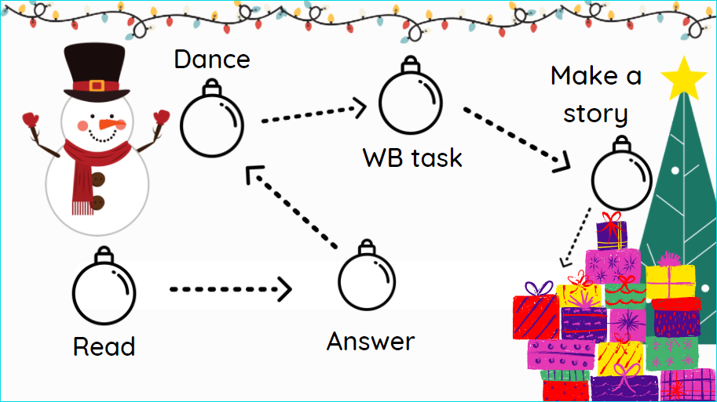

II. Речевая зарядка. Развитие навыков говорения
First, let’s answer some questions about special days. (Wordwall) https://wordwall.net/ru/resource/26424218
IV. Основной этап урока. Развитие навыков чтения
a) Предтекстовый этап. Снятие языковых трудностей
— We are going to read a text, but at first answer my question, please. Where can we celebrate our holidays? (at home, in the country, in the mountains, abroad, at the seaside.) Can you guess where our boy from the text celebrated his last Christmas? Do you have any ideas?
b) Текстовый этап. Чтение текста
— Read about Mike’s favourite holiday. Was he happy at Christmas last year? Ex. la, p. 114. PB.
The answer to the question: Yes, he was. Mike was so happy!
c) Послетекстовый этап. Контроль понимания прочитанного текста. Развитие навыков говорения
— Say if the sentences are True or False (Wordwall) https://wordwall.net/ru/resource/26426058
— Answer the questions. Ex. lb, p. 115. PB.
Key to ex. lb.
1. Mike usually celebrates Christmas in the mountains.
2. He celebrated last Christmas in the mountains.
3. The weather was fine.
4. He played snowballs and made a snowman.
5. They decorated the house with candles and lights.
6. They had a fantastic Christmas dinner in the evening.
7. He ate roast turkey and Christmas pudding.
8. He was happy because he got a present (a ticket for a football match).
Физкультминутка
— Stand up, please. Let’s have a rest and dance.
Развитие навыков восприятия и понимания иноязычной речи на слух
What happened to Rotty and Moldy? We will make up story, but first let’s revise the past form of the verbs.
- ex. 1, p. 89 WB
- Let’s make up a story ex. 2a, p. 115. PB.
— Listen to the story and compare it with yours.
The Tree Monsters wanted to celebrate Christmas too. Rotty decorated a cactus, and Moldy hung
old boots on the fireplace. Moldy sang Christmas carols, and it was funny. Then the Tree Monsters
wrote letters to Santa Claus. Soon they got a present. They opened the box and saw a big spider. It
was scary, and the Tree Monsters ran away.
V. Заключительный этап урока. Подведение итогов урока, объяснение домашнего задания, выставление отметок
— Where do you usually celebrate Christmas (New Year’s Day)?
Where did you celebrate last Christmas (New Year’s Day)?
What was the weather like?
What did you do?
What did you eat?
Were you happy?
— You’ve done a great job today. What have we done today? What task did you like best?
— Open your record books and write down your hometask. Your hometask is ex. 2c, p. 116. PB. You
are to write about Rotty and Moldy’s Christmas.
— Your marks are ... .

