План-конспект урока английского языка в 5 классе “Healthy breakfast”
(Здоровый завтрак)

Гапеева Надежда Александровна?
учитель английского языка
ГУО «Средняя школа №12 г. Новополоцка»

Место урока: 2/15
Тема: Что у меня на завтрак
Коммуникативная ситуация: Мой завтрак
Тип урока: урок введения и первичного закрепления грамматических единиц
Вид урока: традиционный
Цель урока: к концу урока учащиеся смогут рассказать, что они кушают на завтрак
Задачи:
Образовательные: учить пользоваться английским языком в речевой деятельности в рамках предложенной коммуникативной ситуации урока; создать условия для практического применения изученных лексических единиц и лексико-грамматических конструкций в речевых ситуациях; повторить “I like…”, “I don`t like…”, “I would like…”; способствовать формированию грамматических навыков (исчисляемые, неисчисляемые существительные, употребление артиклей a/an и местоимения some).
Развивающие: способствовать развитию зрительной и ассоциативной памяти, языковой догадки, способности к сравнению языковых единиц, построению высказывания по образцу и самостоятельно, способности логично и связно излагать информацию.
Воспитательные: создать благоприятные условия для воспитания умений работать в парах, в группах и самостоятельно; привить любовь и интерес к здоровому питанию.
Оборудование урока: учебное пособие «Английский язык» 2 часть для 5 класса Л. М. Лапицкая и др., тематические картинки по теме, раздаточный материал (Приложения 1, 2, 3 , 4).
Применяемые формы деятельности: фронтальная, парная, групповая, индивидуальная.

Ход урока:

- Организационный этап
Задача этапа: ввести в атмосферу иноязычного общения
Good morning! I am glad to see you! How are you? Are you hungry? Did you have breakfast before school? Great!

- Целемотивационный этап
Задача этапа: представить коммуникативную ситуацию урока, сформулировать цели урока
The topic of our lesson is Healthy breakfast. Today we are going: -to revise active vocabulary; -to learn new grammar rules (countable and uncountable nouns, articles a/an and the pronoun some; -to speak about our breakfast. The questions are: “What do you have for breakfast? Is your breakfast healthy?”.

- Обобщение и систематизация изученного ранее материала
Задача этапа: тренировать навыки использования в устной речи языкового материала по теме, навыки вопросно-ответной работы
Now let’s revise our words. I am going to show you cards (https://drive.google.com/file/d/1hh5ELKTt3oB_oZlcZYsac2tO5olqPnEK/view?usp=sharing (с. 1-14) with our active words, you are to make sentences.
Проверка домашнего задания. Ex. 3a, p 5. (SB).
Nikita is in Britain. Now, It’s breakfast time. What do people usually have for breakfast? How do you think? What is Nikita going to have for breakfast? Listen to the dialogue to revise it.
Tapescript:
Mike: What would you like for breakfast? We’ve got cereal, toast, jam, honey…
Nikita: I’d like some cereal, please.
Mike: Here you are. Would you like some toast and jam?
Nikita: No, thank you.
Mike: Would you like tea or coffee?
Nikita: Tea, please. I don’t like coffee.
Mike: Sugar?
Nikita: Yes, please.
Mike: Milk?
Nikita: Tea with milk?
Mike: Yes, we always have tea with milk.
Nikita: OK. Tea with milk.
Mike: Anything else?
Nikita: No, thank you. I’m full (я сыт).

- Развитие грамматических навыков по коммуникативной ситуации урока
Задача этапа: ввести новый грамматический материал
Now we are going to explain the usage of the word some in the sentences form the dialogue: I’d like some cereal, please. Would you like some toast and jam? The rule will help us. Open your Interactive notebooks and glue the rule which I gave you (Приложение 1).
What are countable nouns? What are uncountable nouns?
When do we use a/an? When do we use some?

- Физкультминутка. Moving activity
Задача этапа: здоровьесбережение
I see that you are tired. Let’s have a rest. Please, stand up, go to the board and make a circle. I have an envelope with different questions. Your task is to pass on this envelope. When the music stops, a person who has the envelope, should open it, take a card with question and ask it a classmate. Then pass this envelope again until the music stops. Let’s start. (Would you like some cereal with milk? Would you like some fish with milk? What would you like to have for breakfast? What would you like to have for lunch? What would you like to have for dinner?).

- Закрепление изученного грамматического материала
Задача этапа: тренировать навыки использования грамматического материала по теме
To remember and understand the rule let’s pick mushrooms and put them into the baskets (Приложение 2). But be attentive. We’ve got three different baskets. Why? What do you think? Let’s put our mushrooms into right basket. (a – basket, an – basket and some – basket).
Your task is to fill in a \ an \ some. Well-done! How many mushrooms are there in the first (second, third) basket? What are they?

- Контроль знаний и учений
Задача этапа: формировать лексико-грамматические навыки при построении высказывания по теме урока
The questions of our lesson were: “What do you have for breakfast? Is your breakfast healthy?”. Can you answer them? Tell us about your breakfast using a help box (Приложение 3).
Help box: We usually have breakfast at _____ o`clock. We often have _______ for breakfast. Our favourite drink is _______. Our favourite food is ________. Sometimes I`d like to have __________ for breakfast. It is yummy.

- Подведение итогов
Задача этапа: дать оценку работы класса, отдельных учащихся, объяснить домашнее задание
Open your record books and write down your hometask for the next lesson. You are to write and tell us what you have for breakfast.
Your marks are…
8,9,10 - I`m satisfied with your work today. Your answers were full and nice. You were active during the lesson.
6,7 – your work was good, but not enough. You should read more (learn the words).
3,4,5 – you were not active. You should be more attentive. Unfortunately, you have…

- Рефлексия
Задача этапа: осознать результативность своей деятельности
Use the table and share your opinion about the lesson (Приложение 4).

- The lesson was… | interesting | boring | usual
- There were … new thing to me | many | few | no
- I was … at the lesson | active | passive | neutral

Give me your record-books. See you tomorrow.

ПРИЛОЖЕНИЕ 1

Элементы для интерактивной тетради

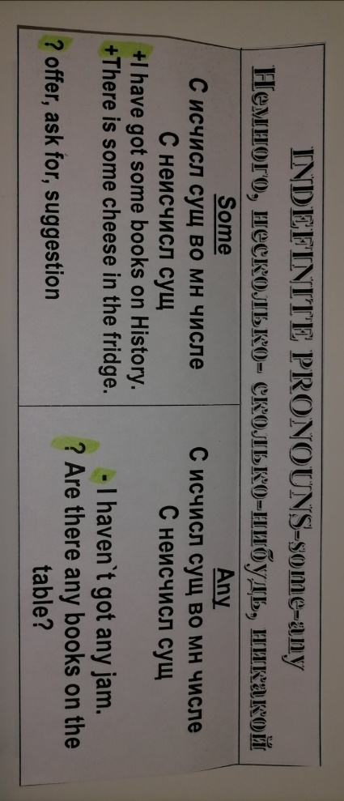

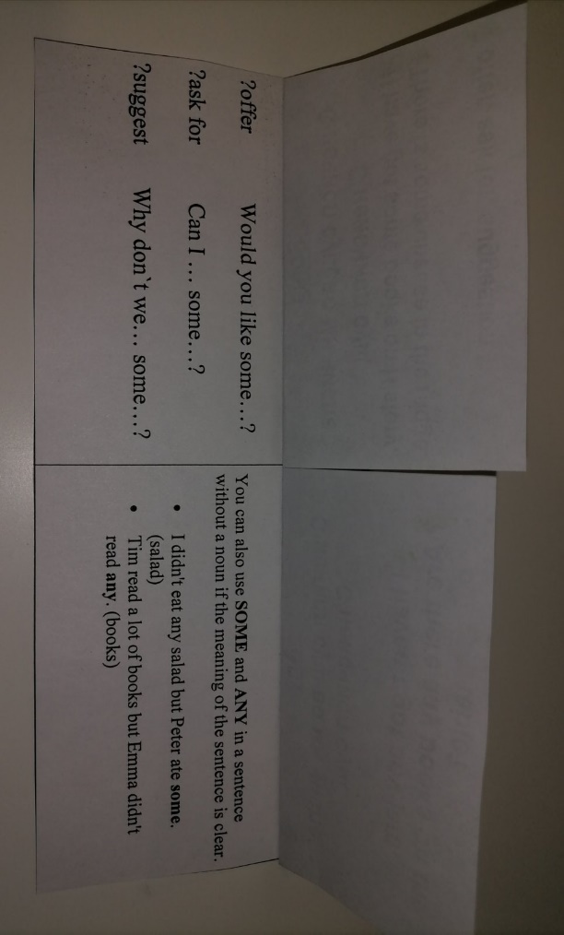

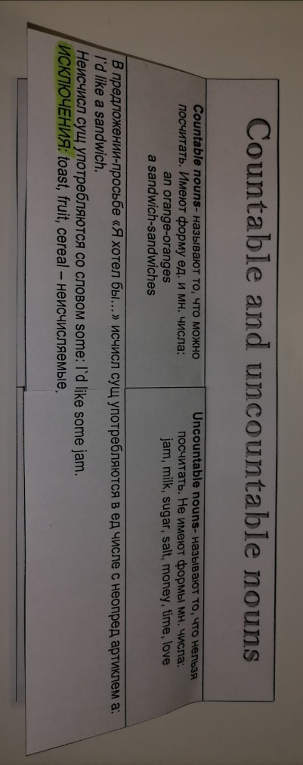

ПРИЛОЖЕНИЕ 2

Лексико-грамматическая игра «Грибник» (a/an, some)

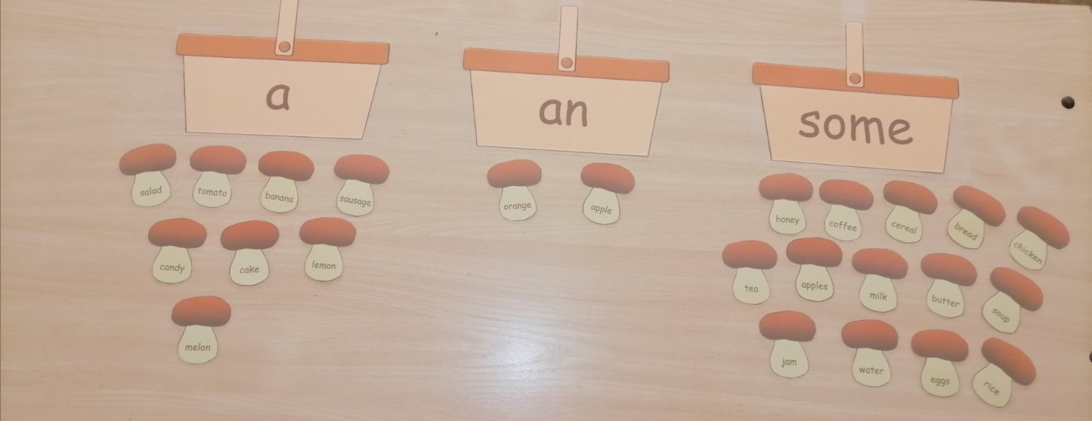

ПРИЛОЖЕНИЕ 3

Опора для устного высказывания по теме «Мой завтрак»

Help box: We usually have breakfast at _____ o`clock. We often have _____________________________________________________ for breakfast. Our favourite drink is _____________________. Our favourite food is ________________. Sometimes I`d like to have __________ for breakfast. It is yummy and healthy.

Help box: We usually have breakfast at _____ o`clock. We often have _____________________________________________________ for breakfast. Our favourite drink is _____________________. Our favourite food is ________________. Sometimes I`d like to have __________ for breakfast. It is yummy and healthy.
Help box: We usually have breakfast at _____ o`clock. We often have _____________________________________________________ for breakfast. Our favourite drink is _____________________. Our favourite food is ________________. Sometimes I`d like to have __________ for breakfast. It is yummy and healthy.
Help box: We usually have breakfast at _____ o`clock. We often have _____________________________________________________ for breakfast. Our favourite drink is _____________________. Our favourite food is ________________. Sometimes I`d like to have __________ for breakfast. It is yummy and healthy.
Help box: We usually have breakfast at _____ o`clock. We often have _____________________________________________________ for breakfast. Our favourite drink is _____________________. Our favourite food is ________________. Sometimes I`d like to have __________ for breakfast. It is yummy and healthy.

ПРИЛОЖЕНИЕ 4
- The lesson was… | interesting | boring | usual
- There were … new thing to me | many | few | no
- I was … at the lesson | active | passive | neutral

- The lesson was… | interesting | boring | usual
- There were … new thing to me | many | few | no
- I was … at the lesson | active | passive | neutral

- The lesson was… | interesting | boring | usual
- There were … new thing to me | many | few | no
- I was … at the lesson | active | passive | neutral

- The lesson was… | interesting | boring | usual
- There were … new thing to me | many | few | no
- I was … at the lesson | active | passive | neutral

- The lesson was… | interesting | boring | usual
- There were … new thing to me | many | few | no
- I was … at the lesson | active | passive | neutral

