10 класс
Тема: Belarus is proud of their names.
Цель: развитие речевых умений учащихся в рамках указанной темы.
Обр: создать условия для развития навыков говорения учащихся.
Разв: способствовать овладению учащимися основными способами речемыслительной деятельности (выделение главного, анализ, обобщение).
Восп: содействовать воспитанию чувства гордости за свою страну и народ.
Оборудование: учебник «English 10. Student’s Book.» (Ю.В. Юхнель, Е.Г. Наумова, Н.В.Демченко), ТВ, ноутбук, применение образовательных ресурсов Wizer.me, learingapps
Ход урока

- Организационный момент. Введение в тему урока, целеполагание
Т: Good – morning, students! I am glad to see you all and I am hope you are ready for the lesson. Look at the screen!
https://app.wizer.me/preview/GQHXBY
Слайд 2 (ФОТО –коллаж)
Т: - I have some pictures to show you.
Who are these people?
Where are they from?
What do they have in common?
(ответы учащихся)
Т: - What synonyms do you know for the word famous?
Слайд 3
(Outstanding, famous, well-known, prominent, notable, celebrity)
Слайд 4
Т: -Translate the epigraph and say what we are going to speak about.
Everything I did in my life I did for my homeland and its fame.
The topic of our lesson is Belarus is proud of their names.
Слайд 1
Т: - Our aim is to develop your listening and speaking skills and prove that we are really proud of our country for the notable names.

1.Речевая зарядка
T: - Let’s think! What kind of people are called famous?
P: - They are those who improved our life.
- They who found cures for serious diseases.
- Made progress in different fields of science.
- They made our life more entertaining: singers and musicians.
Т: - You are absolutely right! These persons achieve success in different spheres of life (science, sport, medicine, politics, education and so on). They make our life comfortable, easier, longer and etc.
II Основной этап урока
- Проверка Д/З (сообщения учащихся о выдающихся личностях Беларуси).
Развитие навыков говорения, развитие восприятия и понимания речи на слух.
T: - At home you have to prepare a short report about one of the prominent person. Listen to very attentively you may write down some facts on the sheets of paper
(ФОТО на доске знаменитостей, сообщения о которых дома готовили учащиеся )

ПРИЛОЖЕНИЕ 1
2. Работа в парах «Guess the celebrity». Развитие диалогической речи, аутентичных навыков
Т: - Now I like you to stand up! I have several ropes, pull one. You have a pair.
( КАРТОЧКИ с именами ).
There is a card with a name of celebrity for you. Your task – ask questions to each other and guess whose name is written on the card.

3. Совершенствование навыков говорения
(WIZER. ME Карточки-тесты)
Т: - Let’s check up your outlook. Match the photos with the names.
4. Развитие навыков изучающего чтения
Т: -Read the biography of an outstanding Belarusian scientist Zhores Alfferov.
Be ready to make questions after reading.
ПРИЛОЖЕНИЕ 2
III.Заключительный этап. Рефлексия
Т-: Your friend wants to become famous. What advice would you give him?

Д/з. упр.3, с.228
Т: - You are going to improve the biography above using the facts from the autobiography you read at home and your own ideas

https://app.wizer.me/preview/GQHXBY

ПРИЛОЖЕНИЕ 1

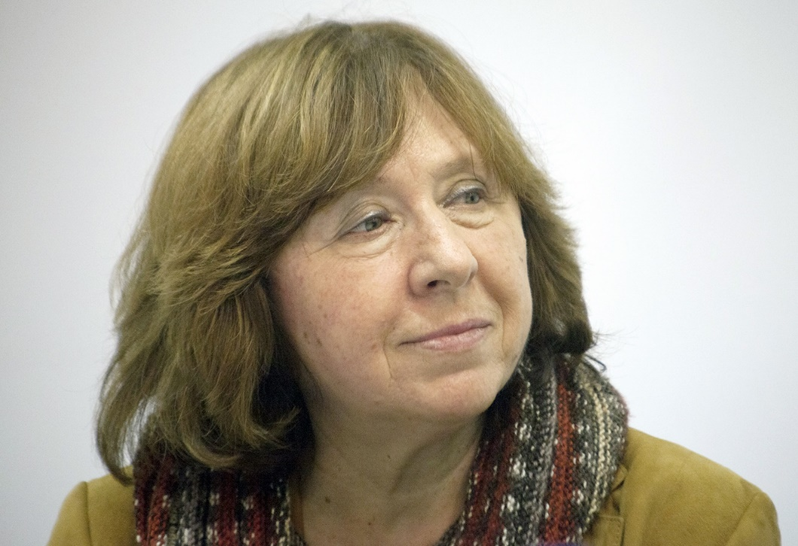

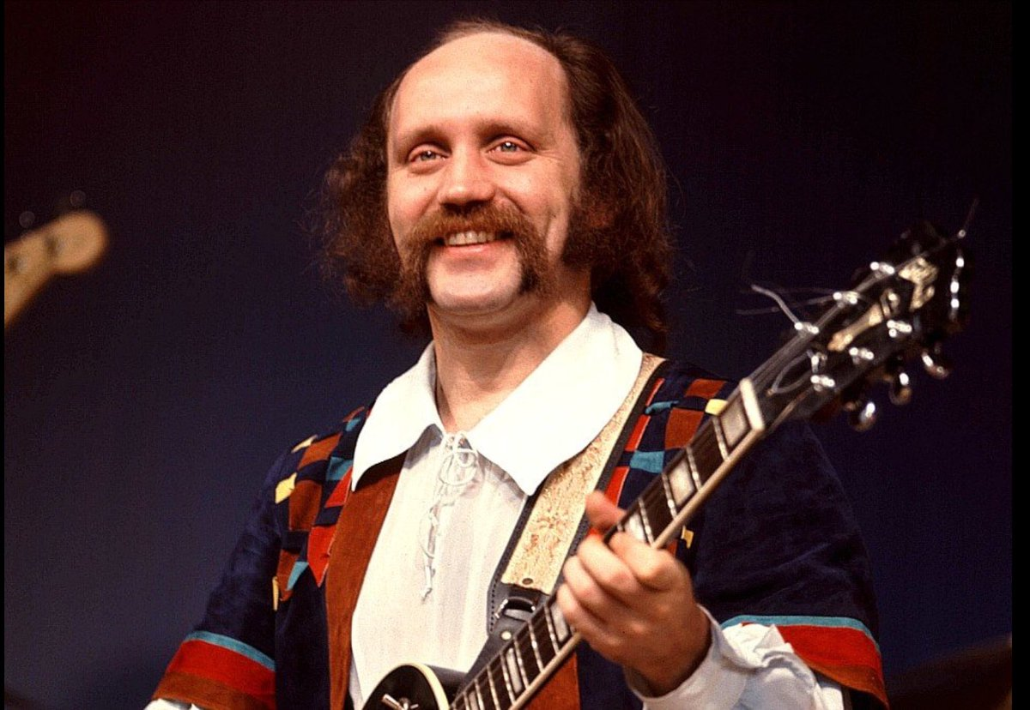

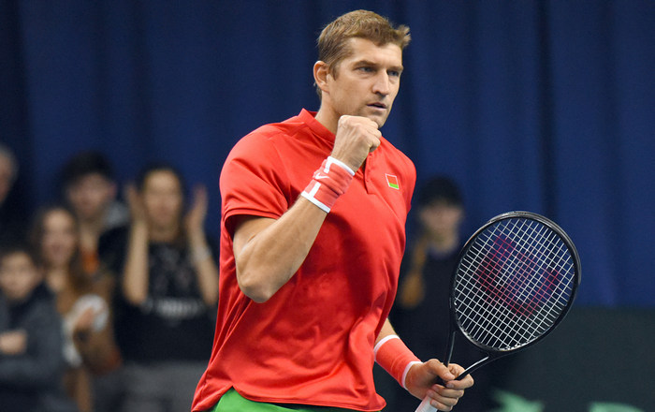

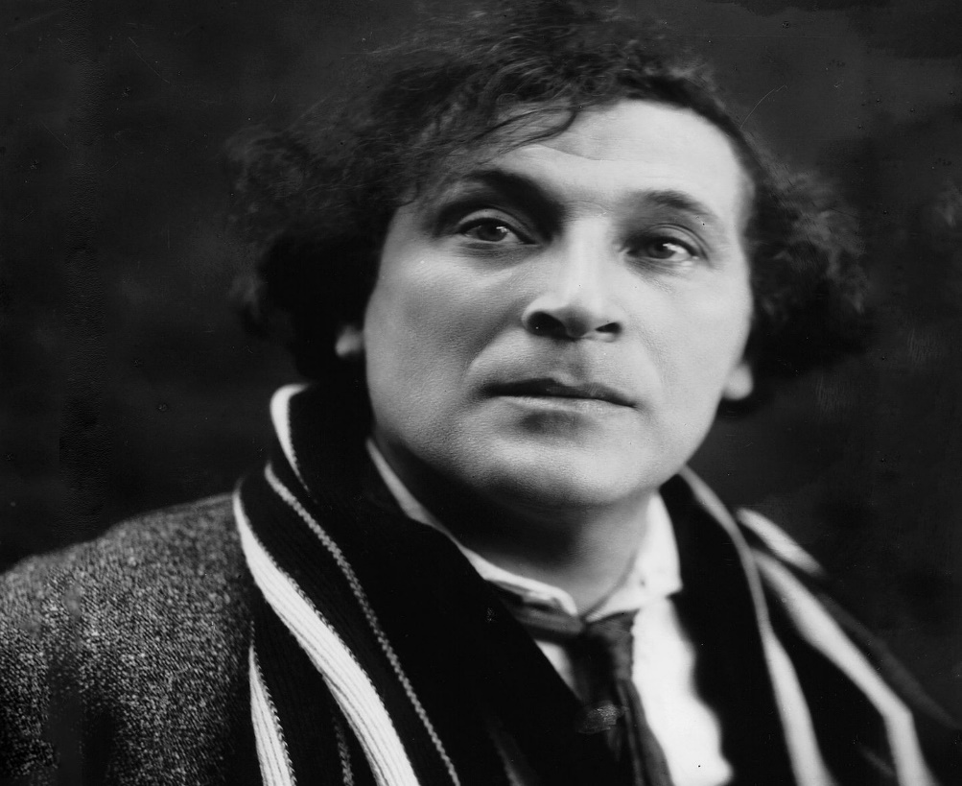
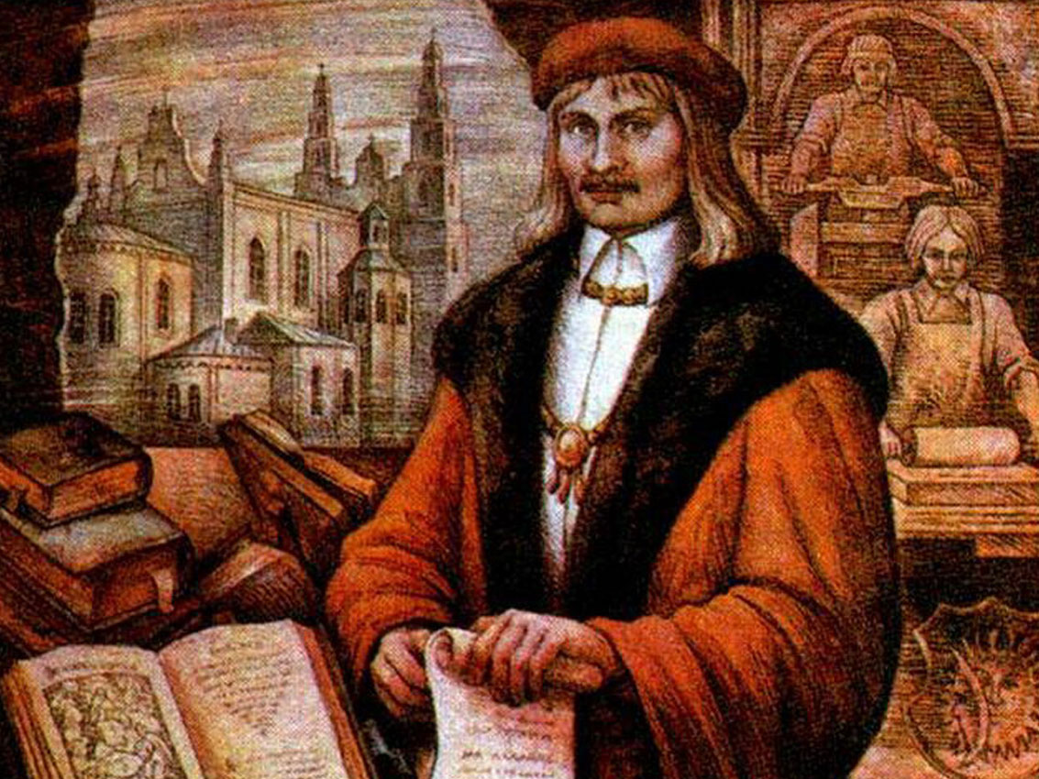

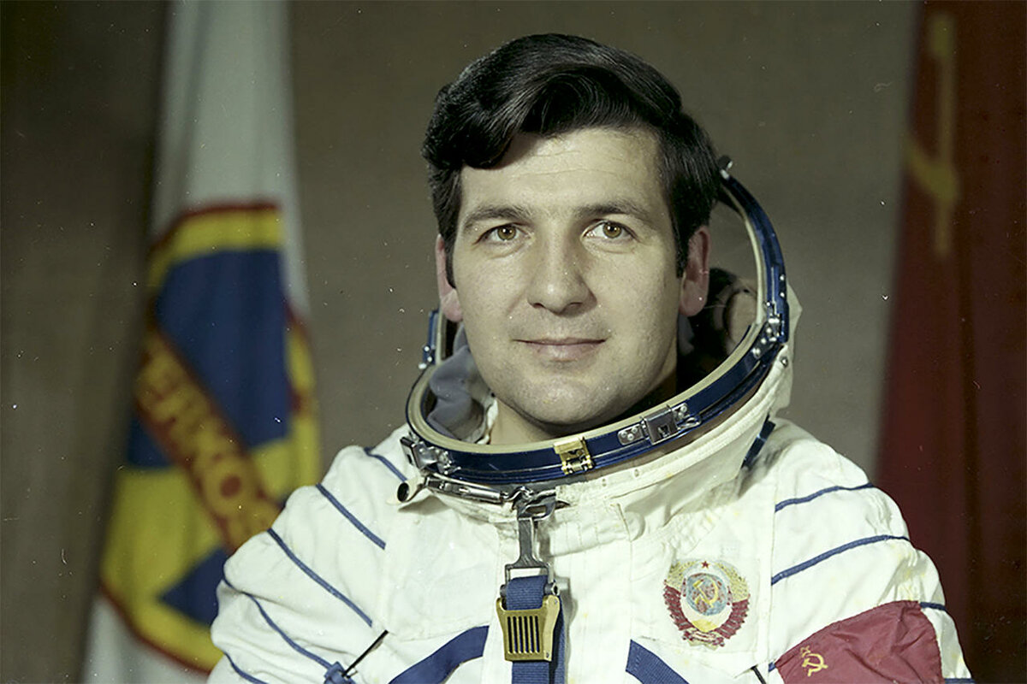

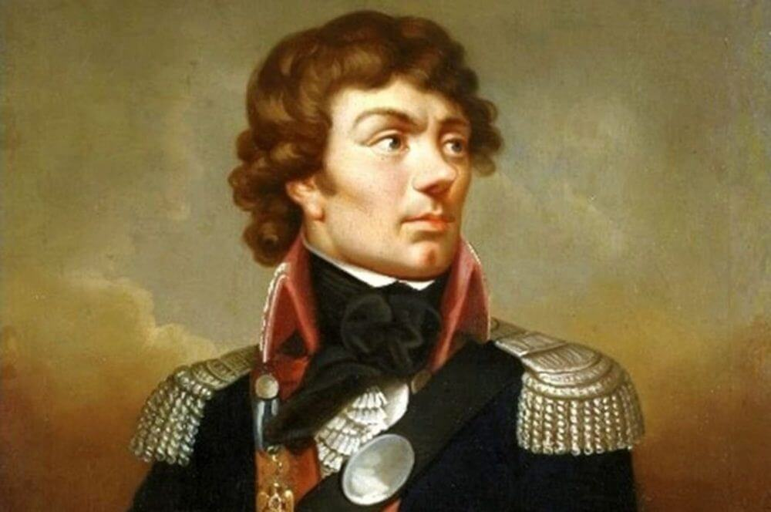

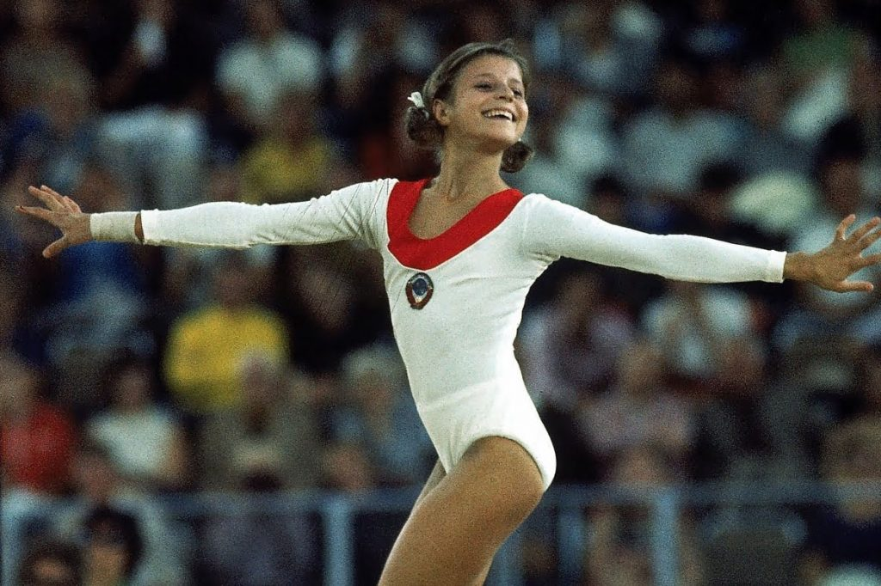

ПРИЛОЖЕНИЕ 2

