План-конспект открытого урока 4 классе "Breakfast, Lunch and Dinner"

Aims: 1) To form lexical and pronunciation habits of speaking;
2) To improve grammatical habits.
New language/Pronunciation and phonics:
Morning, afternoon, evening, breakfast, lunch, dinner.
In the morning. For breakfast.
Sounds [ŋ], [ɑː], [uː].
Revision: Food. Letter secrets: ng= [ŋ], ch=[tʃ].

1. Warm up
Ball game "Food".
2. Checking homework
Ex. 2, p. 75
3. Vocabulary presentation
A. Introduce the words morning, afternoon, evening, using pictures.
-Look at the blackboard. The first picture-the sun gets up. Its morning. The second picture-the sun is in the sky. Its afternoon. And the third picture-the sun goes to bed. Its evening.
Checking understanding.
-Whats morning? Whats afternoon? Whats evening?
Pronunciation.
[ŋ]-morning, evening.
[uː]-afternoon.
-Lets repeat all together.
B. -I get up in the morning.
Write this sentence on the board.
-When do you go for a walk? When do you brush your teeth? When do you go to school? When do you do your homework?
-I have porridge, sausages,egg and tea in the morning. Its my breakfast (hang on a picture). I have soup, sandwiches and juice in the afternoon. Its my lunch (hang on a picture). I have pasta, fish and salad in the evening. Its my dinner (hang on a picture).
Checking understanding.
-Whats breakfast? Whats lunch? Whats dinner?
-When do you have breakfast? lunch? dinner?
Ex. 1c p. 61-Guess the words.
Pay attention! in the morning / for breakfast
Ex. 2 p. 62-Letter secrets.
-Make up funny phrases with the words from the exercise.
4. Moving activity
Game "The crocodile"
5. Listening
Ex. 3a p. 62
-Who can you see? (Mike and his mum). Listen and number the pictures.
---
-Listen again and be ready answer the question: -What does Mike have for breakfast, for lunch? and for dinner? (see Model ex. 3b p. 62).
6. Speaking
Ex. 4a p.62 -Make up a short dialogue in pairs. Ask each other What do you have for breakfast, lunch and dinner?
7. Homework
Ex. 4b p. 63 -Write 6 sentences about your breakfast, lunch and dinner.
(Marks)
8. Round up
-What do you want to have for dinner today?
-Thank you for the lesson! The lesson is over!

Приложение 1

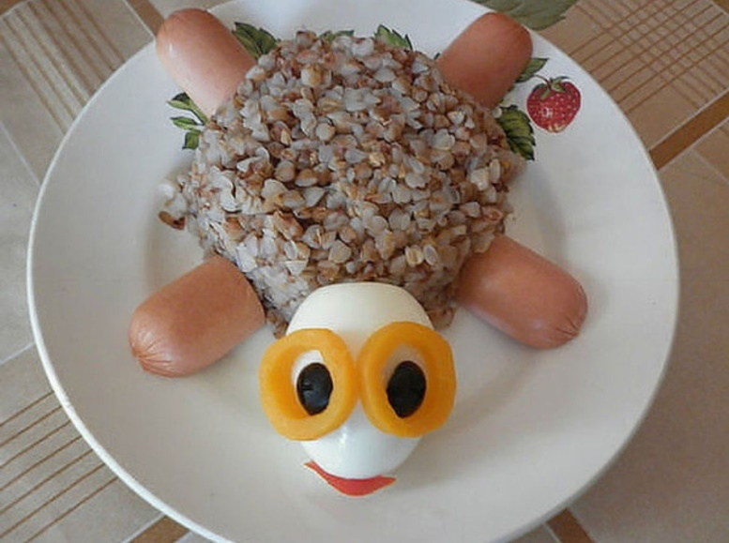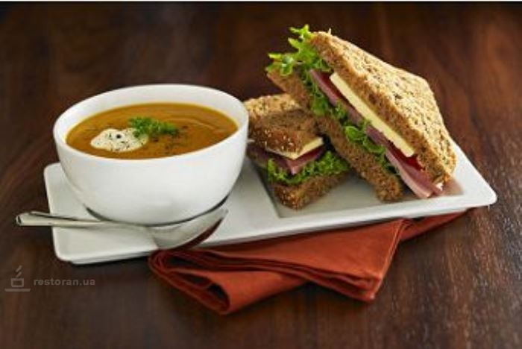
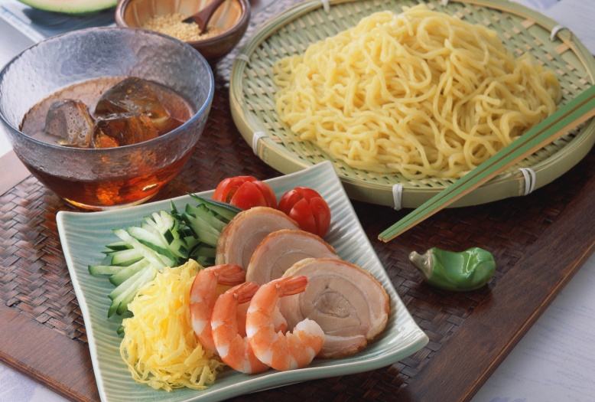

morning
[ˈmɔːnɪŋ]

evening
[ˈiːvnɪŋ]

afternoon
[ɑːftəˈnuːn]

breakfast
[ˈbrɛkfəst]

lunch
[lʌntʃ]

dinner
[ˈdɪnə]

Приложение 2

get up make my bed
do my exercises get dressed
wash my hands and faces
brush my hair have breakfast
brush my teeth go to school

