План конспект внеклассного мероприятия по английскому языку в 6 в классе.
Игра-конкурс «Belarus and the UK»
Цель: формирование коммуникативной компетенции учащихся в рамках данной коммуникативной ситуации мероприятия.
Задачи:образовательные: активизировать лексические единицы по теме, формировать навыки монологической и диалогической речи, восприятия и понимания речи на слух, совершенствовать навыки чтения;
развивающие: развить память, внимание, активность, образное и логическое, мышление, языковую догадку, умение работать в группе;
воспитательные: расширить кругозор учащихся, научить учащихся слушать и слышать друг друга.
Ход мероприятия
Hello, everybody. Glad to see you, boys and girls and our dear guests! Today we have a funny game. So many guests have come to see your and our work. We're sure you know much about our country and the UK. Are you ready? Let’s start. Your task is to divide in to two groups. Name your teams and choose the captains.

- Let’s try to know the topic of our game. (Каждая цифра – буква английского алфавита, расшифруйте послание.)
2 | 5 | 12 | 1 | 18 | 21 | 19 | 1 | 14 | 4 | 20 | 8 | 5 | 21 | 11
Belarus and the UK key is Belarus and the UK

- Word searching. Find the following words.
Belarus stork capital
Scotland bison temperature
Symbol cornflower golden eagles
London tartan flag
Costume golf nation
Anthem population emblem
area
P | P | L | O | B | M | Y | S | F | F | R | S
O | S | T | O | R | K | T | L | L | L | E | C
P | P | E | M | B | L | E | M | O | L | W | O
U | C | O | S | T | U | M | E | G | D | O | T
L | O | N | D | O | N | P | A | C | R | L | L
A | N | T | H | E | M | E | G | A | L | F | A
T | A | R | T | A | N | R | N | P | S | N | N
I | N | T | F | E | D | A | O | I | K | R | D
O | N | T | D | F | S | T | I | T | W | O | A
N | N | L | D | G | K | U | T | A | F | C | R
K | O | N | T | S | U | R | A | L | E | B | E
G | B | I | S | O | N | E | N | D | V | W | A

- Places of interests
1 | Pobeda Square | i | 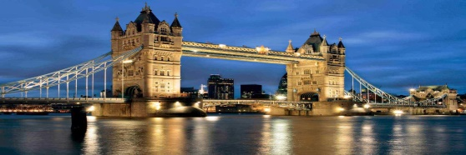
2 | Trafalgar Square | h | 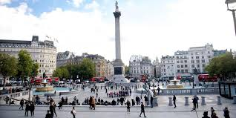
3 | The National Opera and Ballet theatre | j | 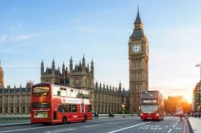
4 | London Eye | u | 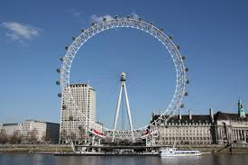
5 | Gorky Park | a | 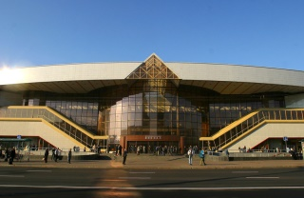
6 | Tower Bridge | t | 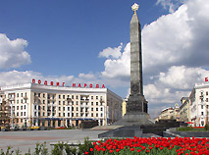
7 | The National Library | n | 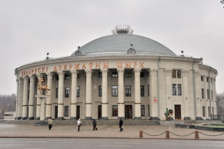
8 | The Circus | k | 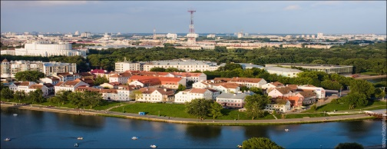
9 | Big Ben | o | 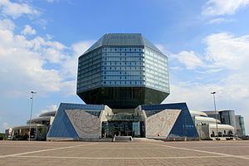
10 | The Central Railway Station | e | 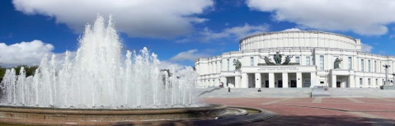
11 | Madame Tussauds Museum | c
12 | The Troitskoye Suburb | n | 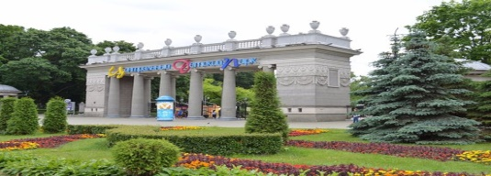
Key isThe Union Jack

- Quiz (учащиеся из разных команд выходят, выбирают вопрос и задают своим соперникам).
What are the national symbols of Belarus?
Where does Belarus lie?
What’s the area of Belarus?
What’s the population of Belarus?
What’s the population of Minsk?
What’s the capital of Belarus?
When was Minsk founded?
How many regions are there in our country?
Which lake is the largest in Belarus?
In which region is Belovezhskaya Pushcha?
Which flower is the symbol of our Belarusian fields?
Which bird is the symbol of our fields?
Can you describe the Belarusian national costume?
Can you describe the Belarussian national flag?

- Captain (конкурс капитанов. Капитаны подходят к доске, выбирают конверт с текстом и пазлами о символах РБ. Пока капитан готовит свой перассказ, остальные участники команды пытаются собрать пазлы, чтобы узнать, о каком символе будет рассказывать их капитан).
1)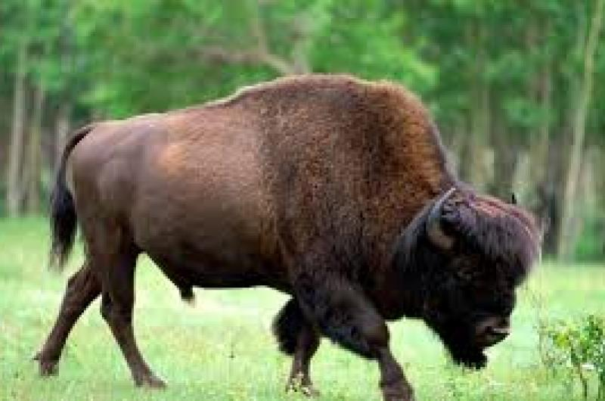 2)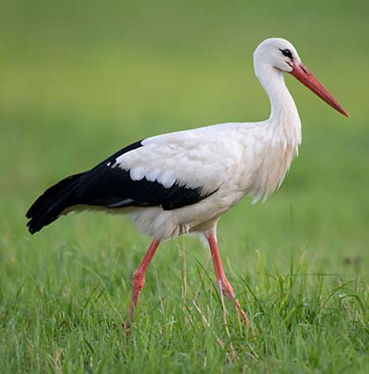
1) Bison.
The European bison is the largest animal on the continent. There are about 5000 bison in Europe. Most of them live in Belovezhskaya Pushcha in Belarus and Poland. Bison can be 180 cm tall and about 3 m long, and weigh 800–1000 kg. Bison eat grass, leaves, mushrooms and berries. Bison can’t live without water. In winter they break ice on rivers and lakes to get water. They can live up to 27 years old. Bison can jump across 3 m wide streams and 2 m tall fences from a standing position.

2) White stork
White storks are big birds. They can be 120 cm long. A stork has long legs, large wings and a long red beak. These beautiful birds live in Europe and they spend winter in South Africa. They can fly more than 10 thousand km. Storks live in the fields near rivers, lakes and swamps and build their nests on top of trees and houses. One stork eats about 100 insects daily. A stork family needs about 200 kilograms of food in one season. Storks also eat mice, frogs, fish and earth-worms. In Belarus there are about 40 thousand storks. People call Belarus “the country under white wings” and believe that storks bring them luck and happiness.
- Sing the song “I love Belarus”
I'm feeling great. And it’s easy to be strong
When all the hearts keep on beating as one
The sky is blue and I'm writing a new song
Saying that I'm free, friendly and young
I have so much and I'm ready to show you
Let's come together so here is my hand
We're gonna fly watching lakes in their full view
Fields are full of gold, and it's all my land

I love Belarus
Got it deep inside
I love Belarus
Feel it in my mind
And I wanna see the sun
Shining from above
You will always be the one
I can’t get enough
I love Belarus
Got it deep inside
I love Belarus
Feel it in my mind
And I wanna see the sun
Shining from above
And I'm gonna every day
Give you all my love.

