Do you care what you wear?
(Порядок имени прилагательного перед именем существительным)

Цель урока: активизация лексико-грамматических навыков по теме «Fashion».
Задачи урока:
- Коммуникативная задача: рассказать о предпочтениях в одежде с использованием имен прилагательных
- Образовательные: совершенствовать умения и навыки практического владения английским языком по теме «Fashion» в устной речи; создать условия для овладения учащимися основными грамматическими навыками по теме «Имя прилагательное».
- Развивающие: способствовать развитию умений работать в парах, группах, создать условия для развития лингво-культурологической компетенции учащихся.
- Воспитательные: способствовать формированию культуры общения, создать условия для формирования положительного отношения к моде.
Оборудование урока: доска, мультимедийное оборудование, карточки.

Ход урока
1) Введение в атмосферу иноязычного общения
T: Good morning, dear children and our guests! I am very glad to see you! You may sit down.
T: Now look at the board, please. You can see 2 English proverbs (‘’Clothes make a man”. “Good clothes open all doors”). How do you understand them? Do you agree with them?
T: Look at our today’s topic and guess what we are going to discuss.
To discuss fashion and speak about your preferences in clothes we should revise our vocabulary. And I’d like to propose you to work in pairs (work in pairs). You’ve got cards and your task is to draw your favorite items of clothes and name them (Приложение 1).
2) Восприятие и понимание речи на слух
- Преддемонстрационный
You’ve named you favorite clothes. And now we’ll watch a video. A girl is speaking about her preferences in clothes. There are 5 items which she is describing.
- Демонстрационный
Listen and answer the questions on your cards (Приложение 2).
- Последемонстрационный
(answer the questions and check the answers)
3) Презентация грамматического материала
- Ознакомление
(work in groups) This girl has got only five favourite items of clothes. But there are some people who are addicted to shopping, fashion and clothes. They like everything and enjoy different styles. Now you’ll work in groups and read a poem of one girl of fashion. She is speaking about her preferences in clothes. Your task is to read this poem and underline all adjectives (Приложение 3).
We see that there are a lot of adjectives. Some of them can be unfamiliar for you. I’ll show you a picture and you should guess the meaning of the adjective (Colourful Tigh Waterproof Baggy Fluffy Comfy).
When do we use adjectives? While describing clothes we can use numerous adjectives. And we can’t name them chaotically, because in English their order is fixed according to the meaning. Look at the blackboard. Here is a word combination describing a dress. Let’s find out the order of adjectives in English. (a beautiful small new tight black plain lace dress)
4) Физкультминутка
It’s time to have a rest. Stand up please and go to the blackboard in two teams. I give you cards and your task is to present correct descriptions of items of clothes. (An elegant long new colourful skirt. A comfy baggy plain woolen coat.)
b) Тренировка грамматического материала
- (individual work) On one website people describe clothes and comment on them. But they don’t know English well that’s why they make mistakes. Help them to describe clothes correctly (Приложение 4).
c) Применение грамматического материала
-(individual work) We’ve spoken about fashion, some people’s preferences in clothes and even helped to correct people’s mistakes. Now it’s time to speak about your preferences in clothes. Imagine that you are famous designers and you should create your ideal outfit for one occasion. Use as many adjectives while describing clothes as you can.
5) Рефлексия
- What have we done today? Look at the blackboard (s-k-i-r-t), name adjectives with these letters.
T: Our lesson is finishing. Let's talk about your homework. I'd like you to write a composition about your favourite clothes and your attitude to fashion using the words and expressions that you've learnt at this lesson.
You've worked very well today. Your marks are … . The lesson is over. Bye!

Приложение 1
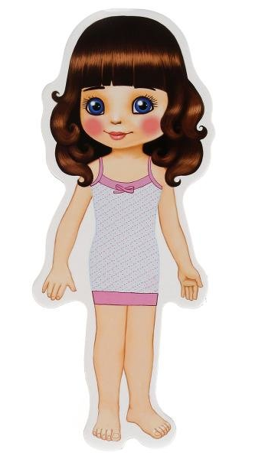
Приложение 2

- What does she say about her sweater?
- It’s the softest thing she’s ever had
- It’s green
- It’s oldfashioned
- She says that her second favourite thing is …
- Short-sleeved
- Shoulderless
- Checked
- How does she describe her jeans?
- They are fashionable
- They are comfy
- They are multicolor
- What colour is her favourite top?
- Green
- Black
- red
- What does she like in her dress?
- Little studs (шипы)
- Its color
- Its material and pattern
Приложение 3

Fashionable dresses and colourful blouses,
Jackets that go with a skirt or with trousers,
Sandals and high heels and comfy tight jeans
These are my favourite, favourite things.
Big, baggy T-shirts and warm, fluffy sweaters,
Trainers and raincoats and waterproof jackets,
Caps and a rucksack, and some old jeans,
Just let me stay in my favourite things.
A Burberry coat and a shirt from Cerutti,
Calvin Klein bag and sunglasses from Gucci,
Elegant trousers and smart blue jeans
Don't laugh at me, I'm in love with these things.
(Cerutti, Gucci, Burberry — are famous designer labels.)

Приложение 4

1) I’m taking this white beautiful silk blouse.
2) I think this leather tight black trousers will be popular for discos.
3) I’m sure this short linen plain skirt will be a hit this season.
4) I’m sure this cotton tight plain T-shirt will be popular this season and next season too.
5) This pink short lace top looks romantic.
6) This new light colour woolen warm sweater is a must for cold days.
7) These baggy denim blue jeans have been popular with teenage girls for a couple of seasons.

Учреждение образования «Могилевский государственный областной лицей № 2»

Урок английского языка в 9 классе
«Do you care what you wear?»

Подготовила
учитель английского языка
Анищенко Анна Андреевна

Могилев, 2018

