Тема: Планы на будущее
11кл
Дата: 26.10.2021
Место урока: 10\13
Вид урока: комбинированный
Формы работы: фронтальная, индивидуальная, парная
Цель урока: развитие навыков говорения
Задачи:
Образовательная: содействовать развитию навыков говорения посредством совершенствования лексических и грамматических навыков, навыков восприятия и понимания речи на слух
Развивающая: создать условия для развития коммуникативных навыков через разнообразные виды РД
Воспитательная: повышение компетентности учащихся в области планирования карьеры
Прогнозируемый результат: предполагается, что к концу урока учащиеся смогут рассказать о своей будущей профессии и обосновать свой выбор
Оборудование: презентация Power Point, доска, раздаточный материал (подготовка к ЦТ), материалы для подготовки к экзамену,

Ход урока
Организационный момент
Good afternoon, pupils! How are you? We have an interesting lesson today.
Целеполагание
Look please at the board. What do you see? Slide 1
What are we going to discuss today?
We are going to discuss our future career!
Right! We are going to discuss your future career! And at the end of the lesson you will be able to describe your future plans.
Речевая разминка
Учащиеся, сдающие ЦТ, выполняют карточки
Look please at the board. What do you see? What do you think about these words? Slide 2
Confucius said….
I agree with him. We must choose right career to have happy future.
It is very important to choose career. If we make a mistake in choosing profession we won’t be happy. We shall not find ourselves in this word.
Проверка домашнего задания
Card 10 reading questions
Основной этап урока
There are some things in my bag. Choose please 1 thing and make dialogues Slide 3
- – Hi, heard you got a new job?
– Yes, I am now a correspondent in our city newspaper.
– This is an interesting job?
– Very, for example, yesterday we did a report from the maternity hospital about the record birth rate for the last 5 years. And last week I talked with the teachers of the bio-medical faculty about the medicine of the future.
– And about this you wrote articles?
– Yes, both will be published in the next issue of the newspaper and appear on the website.
– I’ll read them with pleasure.
- – Who do you work for?
– I’m a copywriter in an advertising agency.
– Do you advertise?
– I write texts for websites, come up with slogans, write scripts for commercials, texts for outdoor advertising, come up with ideas for advertising campaigns.
– And I could see the result of your work?
– Did you see the billboard on Oktyabrskaya street with the advertisement of the fitness center?
– Of course. Good publicity. If you are good at writing, you might not want to spend talent on a momentary advertisement, but write, for example, a book with which you will become known to a wide audience.
– Advertising – this is serious creativity. This is a stage of development. My school, where I learn to communicate with the audience. Perhaps in the future, there will be something more serious.
- –What do you do?
–I am a programmer
–do you like your job?
-Yes, I do
-What do you at the office?
-I make different programmes!
I offer to you to watch a short video and fill in the mind map on the board.
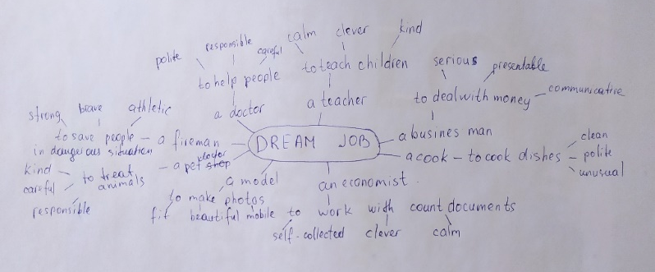
Slide 4
1.Which jobs have you heard? Slide 5
2.What do business men do?
3.Which personal characteristics do business men have?
4.Who wants to be a business man?
Релаксация
You prepared a song. Who is ready to discuss it? Slide 6
Основной этап урока
Continue filling in the mind map on the board
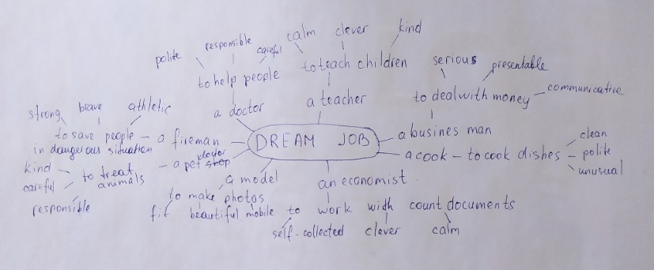 Slide 7
1.Which jobs have you heard?
2.What do business men do?
3.Which personal characteristics do business men have?
4.Who wants to be a business man?
Заключительный этап урока
What have we done today? What was new for you? What was interesting for you? Do you like the lesson? What can you say about your future plans? Slide 8
Your home task is to write down a topic and publish it on the Padlet, screen this QR code Slide 9
Your marks are
8,9,10 I am satisfied with your work today. Your answers are fool and nice. You were active during the lesson
6,7 Your work was good, but not enough. You should read more (learn the words)
3,4,5 You were not active. You should be more attentive. Unfortunately, you have

