Тема: Покупки
Коммуникативная ситуация: Магазины в Великобритании и Беларуси
Класс: 7 (повышенный уровень)
Цель урока: формирование коммуникативных навыков и навыков восприятия речи на слух учащихся в рамках изучаемой темы
Задачи урока:
Образовательные: развитие произносительных навыков; развитие навыков аудирования с извлечением необходимой информации; развитие умения устной речи; развитие навыков поискового чтения.
Развивающие: формирование способности и готовности вступать в иноязычное общение; развитие различных видов памяти, внимания, коммуникативности, воображения; развитие мыслительной деятельности, умения переноса знаний в новую ситуацию; развитие языковой догадки.
Воспитательные: развитие лингвострановедческого кругозора учащихся; способствовать повышению интереса к изучению иностранного языка; учить работать в парах, в группах.
Оснащение урока: Английский язык / Англійская мова : учебное пособие для 7-го кл. учреждений общ. сред. образования с белорус. и рус. яз. обучения (повыш. уровень) : с электронным приложением. В 2 ч. Ч. 1 /Н. В. Дем- ченко [и др.]. – Минск : Вышэйшая школа, 2019. ; мультимедийная установка; презентация Microsoft Power Point; раздаточный материал к уроку.
Plan
- Warming up. Речевая зарядка.
Are you keen on shopping? How often do you go window shopping? Have you been to many shops? What did you buy there? What shops have you got not far from your house?

- Talking about the theme and aims of the lesson.Постановка темы и целей урока.
Look at some pictures and say what can you see on it. What`s the differences? How do you think what we are going to speak about today?
- Revising vocabulary. Совершенствование лексических навыков.
Before watching the video let`s revise the names of shops that we have learnt. Arrange the words from the smallest to the largest. SB ex.1 p.97

Newsagent`s kiosk – corner shop – grocery store – department store – supermarket – hypermarket – shopping centre

- Watching video about the shops in the UK and in the USA. Просмотр видео.
Use the Internet. Go to https://www.youtube.com/watch?v=rYUlbQ3GkGo to watch a video about types of shops in the UK and in the USA and fill in the necessary information in the cards.

British shops | American shops | Goods
Sweet shop | Candy store | Sweets, chocolate, biscuits
Greengrocer`s | Fruits and vegetables | Fruits and vegetables
Ironmonger`s | Hardware store | Household
offlicense | Liquor store | Alcohol drinks
Newsagent`s | newstand | Newspapers, magazines

- Listening. Развитие навыков аудирования.
- Listen to the text ex.2b p. 98 about shopping in the UK; follow in the book. Match four pictures from ex.a
Napoleon once described the British as ‘a nation of shopkeepers’. Today the Brits
could be described as “a nation of shoppers”, as shopping has become the mostpopular national leisure activity. The main shopping street in most towns is calledthe “High Street” and it`s traditionally been the place to buy everything from food to furniture, with a mixture of all types of stores and often a street market.Oxford Street in London is the world`s biggest high street, offering more than a hundred stores of the world famous brands. Most large towns will have a department store selling household goods and clothing.In London, go to Harrods, the largest department store in Europe. Some of its 300 departments, including the seasonal Christmas department and the food halls are really well known.
There aren`t many out-of-town shopping centres in the United Kingdom.They are usually in town and city centres. Westfield London, the largest shopping centre in Europe, has an area of 240,000 m2 (the size of about 50 football pitches).It houses over 300 shops including 4 large department stores.There is a 17-screen cinema and 75 restaurants and cafes. London is the second-most visited city in the world.That is why there are a lot of souvenirs there. For something truly unique and of high quality, go to the Covent Garden with its street markets,live music,trendy cafes, English pubs, and great souvenir shops. However,51% of UK shoppers prefer to buy goods online.

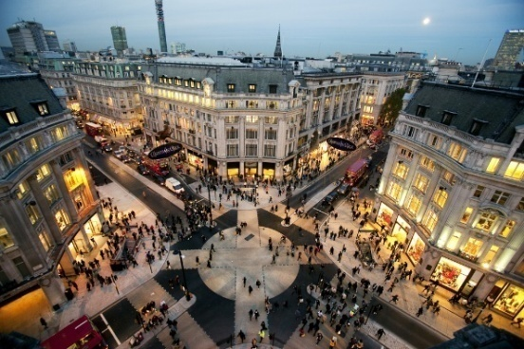Oxford Street (picture C)
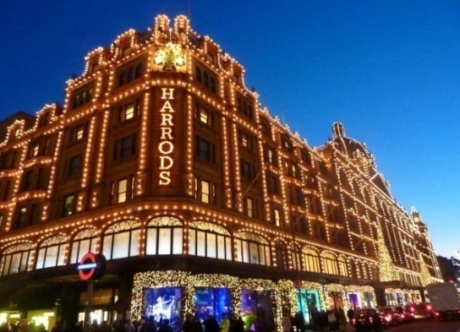Harrods (picture B)
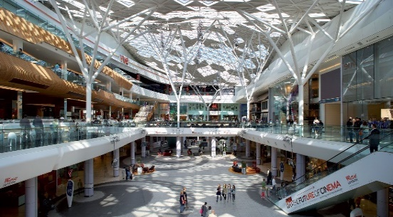Westfield London
(picture F)
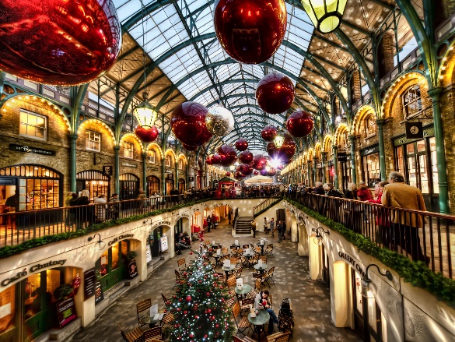Covent Garden (picture E)
- Presenting vocabulary. Find the words in bold in the text that mean:
- Very well-made ( high quality)
- Shopping mall ( shopping centre)
- Things you can buy ( goods)
- On the Internet (online)
- Trademark (brands)
- Smth you buy to remind you of a holiday (souvenirs)
Read the sentences and translate them into Russian.

- Moving activities. “Find someone who…”Физкультминутка.
Students walk around the class and ask questions to find some who…
- has never bought any souvenirs;
- can name 5 Belarusian brands;
- loves window-shopping;
- went to the chemist’s last week;
- loves spending their leisure time in large shopping malls;
- has got a household device made in Belarus;
- has bought something online;
Then students report on their findings.
Find someone who…. | The questions start… | Name
has never bought any souvenirs; | Have you ever bought…
can name 5 Belarusian brands
loves window-shopping;

went to the chemist’s last week;

loves spending their leisure time in large shopping malls;

has got a household device made in Belarus;

has bought something online;

- Reading. Развитие навыков чтения с извлечением информации.
Read an article about shopping in Belarus and find the answers to the questions below. Ex.3a, b p. 99-100
People come to Belarus to see unique architectural sites, learn about the Belarusian culture, enjoy the natureand see top sports competitions. Besides, the Belarusianholidays can include a good shopping programme.
Belarus has shops of all kinds: large malls, department stores, hypermarkets, food markets and fairs(including international ones).In Minsk there are several popular shopping mallsthat offer a wide choice of goods: the famous GUM and TsUM Department Stores, the Nemiga shopping centre, the shopping centres Stolitsa, Arena City, Zamok, etc.They sell everything from socks to dictionaries.For traditional shopping, go to one of the many local
markets. The most popular is the Komarovsky Market in Minsk, one of the city’s oldest food markets.Tourists usually buy Belarusian brands known fortheir high quality and design. They include clothes,shoes, cosmetics, home textiles, sweets and local Belarusiandrinks. Two well-known factories making excellent chocolates are Kommunarka and Spartak. Classic traditional souvenirs include dolls in nationalcostumes, hand-painted wooden toys and spoons, tablecloths and napkins. Online shopping is popular in Belarus as well. It’s often easier and cheaper to buy concert or theatre ticketsand tickets for trains and plains online. Despite this fact more than half of online shoppers in Belarusbuy household items, mobile devices and computers.
1. Can you call Belarusian people the nation of shoppers?
2. Do you know any large shopping malls in Belarus?
3. Can you name any popular department stores?
4. Are there any souvenir shops you’ve heard about?
5. Do you know any old markets?
6. Is online shopping popular in Belarus?
7. Do you know any high-quality products made inBelarus? What Belarusian brands are famous in theworld?

- Revising grammar. Совершенствование грамматических навыков.
Read the sentences and complete them with too or enough.
1. Kommunarka chocolate are good … .
2. The quality of household devices made in Belarus is high … .
3. I’m … old to visit the play areas in large shopping malls.
4. There are … shopping centres in your town.
5. The goods in our market are cheap … .
6.The newsagent’s in our street sells … many souvenirs.
7. Large shopping centres are situated … far from where I live.
8. There aren’t … online shops in Belarus.
9. It’s … expensive to buy clothes in large department stores.
10. Our local supermarket isn’t big … .

- Round up. Рефлексия.
Well done pupils. So at the end of our lessons let`s sum up information about the types of shops.
Match a picture and a word.
https://learningapps.org/5543650

- Conclusion.
Подведение итогов, объяснение домашнего задания, выставление отметок. Explaining home task ( to say about shopping in the UK ( the 1st group) and in Belarus(the 2nd group)). Giving marks.

Thanks a lot for your work. See you tomorrow. Bye.

Раздаточный материал к уроку

British shops | American shops | Goods

Moving activity.
Find someone who…. | The questions start… | Name
has never bought any souvenirs; | Have you ever bought…
can name 5 Belarusian brands
loves window-shopping;

went to the chemist’s last week;

loves spending their leisure time in large shopping malls;

has got a household device made in Belarus;

has bought something online;

