Lesson: Are you doing your fair share?
Lesson map

AIMS
- to practice listening and talking about doing household chores
- to develop Ss' attention and memory, ability to make intelligent guesses and to process and
evaluate information
- to promote positive attitude to chores
MATERIALS AND PREPARATION
• Student's book
• recording for the lesson
Communicative area: speaking about one's family household responsibilities
Vocabulary: to be responsible for, to take care of
- WARM-UP
• Play Hangman for Ss to guess the word chores.
- LISTENING
• Ex. 1. Focus on the instructions.
• Ex. 2. Draw Ss' attention to the phrases in the box. Elicit the meaning of the new phrases take care of and be responsible for. Allow S some time to do the task in pairs.
Explain how to do the table
Men usually take care of | Women usually take care of

• Ex. 3. Play the recording. Discuss the feedback as a class.
• Ex. 4. Ss read the statements before they listen to the recording again.
Encourage Ss to make their predictions. Get feedback.
Keys to ex. 4: see the highlighted parts in the script.

An average person spends nine years, two months and 25 days over a lifetime doing chores.
Women spend two hours and 52 minutes of their day on domestic work and 59 minutes on taking care of children. Their most typical chores are cooking meals, mopping the floor: dusting the furniture, washing up, shopping and doing the laundry.
In contrast, men spend one hour and 37 minutes on domestic work and 22 minutes on taking care of children. They usually do such chores as mowing the lawn and raking leaves or repairing broken things. But the situation is changing. Men do more and more housework and spend more time with their children.
3. Speaking
• Ex. 5. What can children do? Think over these diagram
4-5 years old children

2-3 years old children

Script: Part II
Parents often think that children shouldn't do a lot of household chores, because they should spend their time learning. But psychologists say that when children help around the house they feel like full members of the family, they learn to be independent and responsible. Even two-or three-year-old children can do a lot of things. For example: pick up toys and books, help to feed pets, dust the furniture and put dirty laundry in the washing machine.
As they grow older; the list of chores becomes bigger: Four- to five-year-olds can set and clean the table, load the dish-washer; help to put the shopping away.
At the age of six children can already take care of pets, take out the rubbish, hang up their clothes, water the plants and rake leaves. Some parents think that they can even clean the bathroom sinks and mop the floors.
At the age of 9 children can help their parents to wash the car, do the washing-up, clean the bathroom, help in the garden, mow the lawn. wash and cut vegetables to prepare a meal, and babysit. But many parents believe this list is too long and it's dangerous for children to mow the lawn or clean the toilets, or they are too young to babysit.
Most parents agree that teenagers can be responsible for doing all kinds of household chores. And what about your family.
• Ex. 6. Play the recording for Ss to check their guesses. Discuss the feedback as a class.
. Ex. 7. Play the recording again. Encourage Ss to take notes while Listening. They can compare their notes with a partner before reporting to the class. Keys to ex. 5, 6, 7: see the underlined
parts in the script.
• Moving activity. Ex. 8. Do you have to mop the floor? Use cards

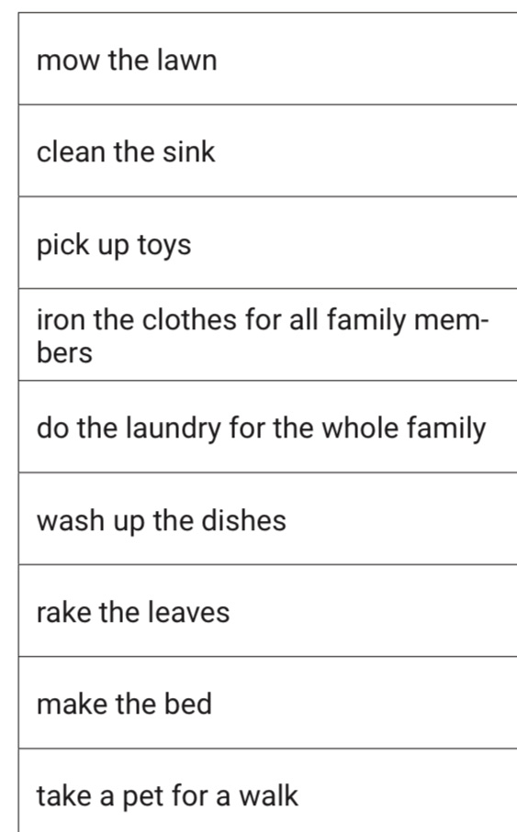
Card
Ex. 9. Monitor the activity for any remedial work. Encourage using the new words.
• Ex. 10a. Monitor the activity. Note down examples of good language use and problem areas to focus on later.
•Ex. 10b. Nominate speakers to report the results of group discussions.
4. ROUND-UP
• Evaluate Ss' performance. Assign homework. Ex.2 p 49WB
Thanks for work
Your marks

