План-конспект урока в 8 классе
Тема: Необычные праздники и традиции
Вид речевой деятельности: Чтение
Тип урока: комбинированный.
Вид урока: традиционный.
Формы работы: индивидуальная, групповая, парная.
Цель: развитие навыков чтения в рамках изучения темы «Обычаи и традиции Республики Беларусь и стран изучаемого языка».
Задачи:
образовательная: создать условия для развития навыков чтения;
развивающая: способствовать развитию памяти, внимания, мышления;
воспитательная: способствовать развитию культуры взаимоотношений при работе в группах.
Оборудование: доска, мел, компьютер.
Дидактическое оснащение: учебник «English 8. Student’s book» (Л. М. Лапицкая и др.); рабочая тетрадь «Workbook, 8» (Л. М. Лапицкая и др.); раздаточный материал.

ХОД УРОКА
I. Организационный момент. Введение в тему урока и определение целей (5)
— Good afternoon, boys and girls! How are you? Today we continue speaking about holidays and traditions.
Look at your desks. Here you have a paper with a secret code. You are to solve it to learn the topic of our lesson. What is the topic of our lesson? You are right. Today we are going to speak about unusual British traditions. You will learn new information about unusual holidays, we will read some texts and we will speak about traditions. (Приложение 1)
II. Речевая зарядка. Развитие навыков говорения (3)
Speaking cards. Let’s talk about holidays. Please, choose one card and ask any of your classmates the question in it.
III. Основной этап урока. Развитие навыков чтения
a) Предтекстовый этап (4)
We are going to read some texts about holidays, customs and traditions in Britain. You have already heard about some of them. But first, let’s watch a short video.
Questions:
What were people speaking about? What holiday did they mention?
Do they like celebrating them?
b) Текстовый этап (8)
— Now you are going to work in groups. Let’s divide into groups. Pick one of these cards. If you have a shamrock on your card you are in group 1, if there is a gift – group 2, pancake – group 3, cheese – group 4. (Приложение 2) Each group will get one text. (Приложение 3) Read the text, discuss it with your group and fill in the information in the cards. Then you will make a story about your tradition. Please, be attentive, because you’ll do a quiz.
IV. Физкультминутка (2)
I think you are a bit tired. Let’s have a rest and dance. https://www.youtube.com/watch?v=vPccTY3sph4&ab_channel=KooKooKangaRoo
c) Послетекстовый этап (15)
Group 1/2/3, please tell about the tradition you have and write the name of it on the blackboard.
And now let’s check what have you learned about traditions and do a quiz. Please, name your teams.
Jeopardy. You are to pick the category and answer it, if you your answer is correct you’ll get points. The group with the highest score is the winner.
VI. Заключительный этап урока (7).
You’ve done a great job today.
What British tradition do you find most interesting? Why?
What is the most unusual tradition?
Would you like to take part in celebrating these holidays?
Open your record-books and write down your hometask. Your hometask is to write about unusual holidays and traditions in Belarus.
— Your marks are…

Приложение 1
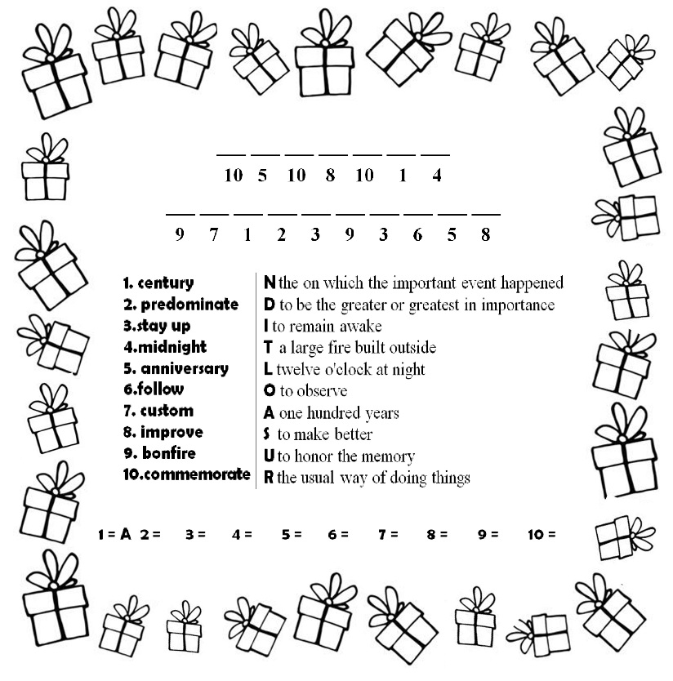

Приложение 2
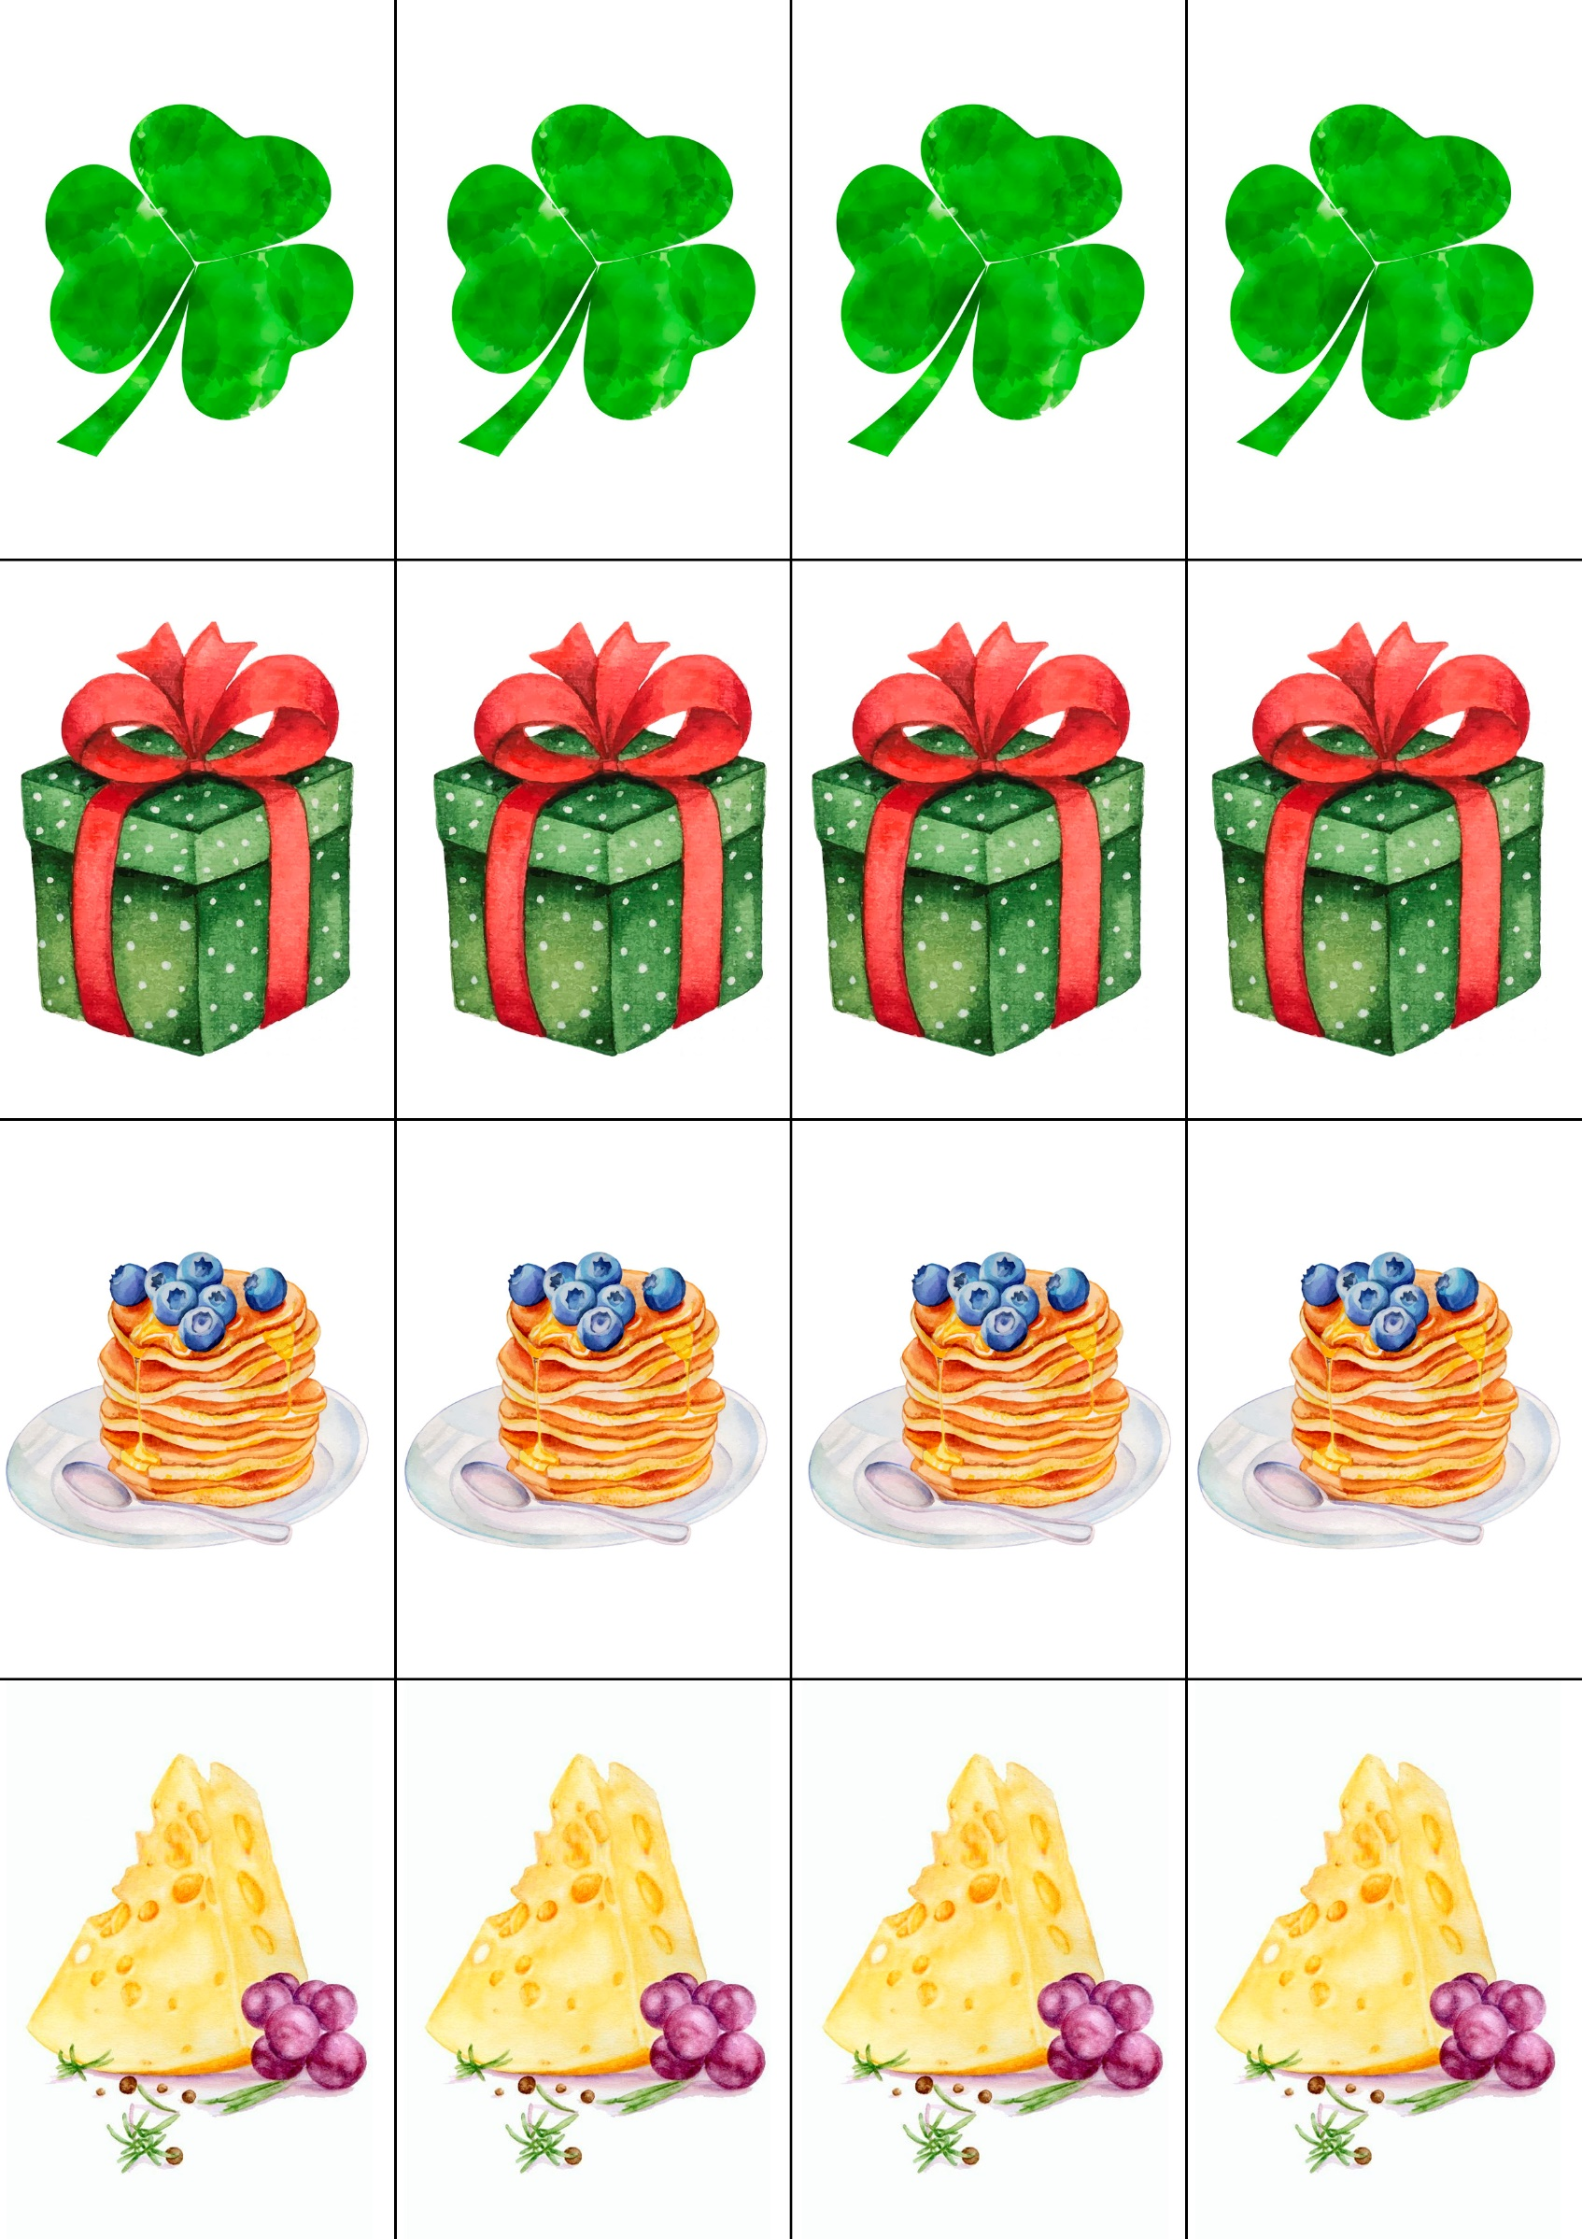
Приложение 3

St. Patrick’s Day
St. Patrick’s Day is celebrated on March 17. The Irish have celebrated this day as a religious holiday for over 1,000 years. On St. Patrick’s Day, which falls during the Christian season of Lent (пост), Irish families would traditionally attend church in the morning and celebrate in the afternoon. Lenten prohibitions (запреты) against the consumption (потребление) of meat were waived (временно отменены) and people would dance, drink and feast (праздновать) –on the traditional meal of Irish bacon and cabbage.
Saint Patrick, is the patron saint (святой-покровитель) of Ireland. Born in Roman Britain, he was kidnapped (похищать) and brought to Ireland as a slave at the age of 16. He later escaped (сбежать), but returned (возвращаться) to Ireland and brought Christianity (христианство) to its people.
Perhaps the most well-known legend of St. Patrick is that he explained the Holy Trinity (Father, Son and Holy Spirit) (Святая Троица (Отец, Сын и Святой Дух) using the three leaves of the shamrock.
Another icon of the Irish holiday is the Leprechaun (лепрекон). Belief in leprechauns probably goes back to Celtic belief (кельтское верование) in fairies (эльфы), tiny men and women who could use their magical powers to serve good or evil. In Celtic folktales, leprechauns were known for their trickery (хитрость), which they often used to protect their fabled (сказочный) treasure. Leprechauns have their own holiday on May 13, but are also celebrated on St. Patrick's, with many dressing up as the fairies.
Today, people from all over the world celebrate St. Patrick’s Day, especially in the United States, Canada and Australia and even in Japan, Singapore and Russia. Popular St. Patrick’s Day recipes include Irish soda bread (хлеб из пресного теста) and cabbage and champ (картофельное пюре). People often wear green on St. Patrick’s Day.

1. It is ____________________________________________________________ (name of the holiday)
2. It is celebrated on __________________________________________________________ ( date)
3. Saint Patrick is ____________________________________________________________________________,
he brought Christianity in ____________________________________________________________ (страна)
4.The symbols of this holiday are ________________________________ (клевер), because St. Patrick explained ___________________________________________________________________________________using it,
____________________________ color and _______________________________________ (леприкон)
5.People in ___________________________________________________________________________________
__________________ (страны) celebrate this day.
6. Popular St. Patrick’s Day food is ______________________________________________________________________________________.

Boxing Day
Boxing Day is a bank holiday or public holiday that became official in 1871. Boxing Day is traditionally celebrated on December 26.
Boxing Day came from a time when the rich used to box up (класть в коробку) gifts to give to the poor. Boxing Day was traditionally a day off for servants (слуги), and the day when they received (получать) a special Christmas box from their masters. The servants would also go home on Boxing Day to give Christmas boxes to their families.
Churches also played a part in the creation of Boxing Day. Through the year they would take money from churchgoers (прихожане) in the form of a collection and hand it out (раздавать) at Christmas. Many of them stored (хранить) the collection money in a box, which they opened on Christmas Day. The money was then handed out to the poor the next day - on Boxing Day.
For some people, Boxing Day is a time to spend with family or friends. Many people will gather (собираться) for meals, spend time outside, or simply relax at home and enjoy the day off. Traditional Boxing Day food includes (включать в себя) baked ham, pease pudding (гороховое пюре), and mince pies (пирог со сладкой начинкой из сухофруктов и специй), along with a slice of Christmas cake or another dessert.
Additionally, Boxing Day has recently become synonymous with watching sports. A number of leagues in England, Scotland, and Northern Ireland hold football and rugby matches, while Australia, New Zealand, and South Africa are known for cricket (крикет) matches on Boxing Day. Other sports that typically occur (проходить) on Boxing Day include horse racing and ice hockey. Fox hunts (охота на лис) are traditionally a part of Boxing Day activities; however, fox hunting with dogs was banned (запрещать) in the UK in 2004. Boxing Day is also when shops traditionally had big sales (скидки) after Christmas in the UK.

1. It is ____________________________________________________________ (name of the holiday)
2. It is celebrated on __________________________________________________________ ( date)
3. This tradition came from the time when _______________________________________________________________________________________.
4. People usually spend time with ________________________________________________________.
5. There is a tradition of watching ____________________________________________________________________(sports)
5. The traditional food is ___________________________________________________________________________________

Pancake Day
Pancake Day, or Shrove Tuesday (прощёный день), is a special day celebrated in many countries around the world. On this day many people eat pancakes.
Pancake Day is always on a Tuesday in February or March. It is the day before Ash Wednesday (пепельная среда (день покаяния), the start of Lent (пост). Lent is a period of 40 days before Easter when people often stop eating things that are bad for them like chocolate or fast food. At the end of Lent is Easter. Traditionally, during Lent, people didn’t eat rich foods like butter and eggs, so to use them up they made pancakes from these ingredients on Shrove Tuesday. As well as using all their eggs and fats before Lent, people would also go to church to confess their sins (признаться в грехах) to a priest (священник). A bell used to ring at about 11 o'clock in the morning to remind (напоминать) people to cook their luxury (роскошный, богатый) ingredients and go to confession. This bell became known as the pancake bell.
Another tradition on Pancake Day in the UK is pancake racing. People run in a race with a pancake in a pan. As they run, they have to toss (подбрасывать) the pancake (throw the pancake in the air and catch it in the pan) several times. In some pancake races people dress up in fancy (пестрый) dress costumes. The most famous pancake race takes place in a town called Olney, in the middle of England. People say that Olney has been celebrating pancake races since 1445!
On average, British people eat two pancakes per person on Pancake Day (though plenty of people will have three or four at least) which means 117 million pancakes will be eaten in one day. While some people might put chocolate spread (паста) or syrup on their pancakes, the most popular topping, by far, is lemon juice and sugar.

1. It is ____________________________________________________________ (name of the holiday)
2. It is celebrated on __________________________________________________________ ( date)
3. The most popular tradition is _____________________________________ racing, it takes place in
________________________.
4. People dress up in _____________________________________ and run, tossing the ____________________
5. People usually eat a lot of _________________________________________, the most popular topping is ____________________________________________.

