План - конспект урока английского языка учителя «Средней школы № 41 г. Гродно» Сидоренко Людмилы Александровны
Класс - 8
Тема - Деньги
Цели урока:
образовательная: формирование и совершенствование лексических навыков по теме;
развивающая: развитие аналитической речемыслительной деятельности, наблюдательности, внимания учащихся.
воспитательная: формирование финансовой грамотности учащихся, повышение мотивацию к изучению иностранного языка, посредством использования онлайн доски linoit.com
Тип урока: комбинированный.
Урок - 1 из 10.
Формы работы: фронтальная, индивидуальная, парная.
Оснащение урока и дидактический материал: ноутбук, проектор, аудиозапись песни “Money makes the world go round”, мобильные телефоны учащихся, картинки с изображением новой лексики, названиями стран и валют; раздаточный материал – карточки самопроверки усвоения новой лексики и понимания прочитанного, карты самооценки учащихся
Aims of the lesson:
- to form and develop lexical skills;
- to improve scanning skills;
- to form students’ financial literacy;
- to learn more about the history of money.
Stage of the lesson: preliminaries.
To warm up.
To create the atmosphere of foreign language, to provide positive motivation for learning English.
Teacher’s activity.
Greetings. My dear pupils I want we start our lesson with the song. “Money makes the world go round” listen to the song
What does it mean? Pupils answers (2min)
To claim aims of the lesson: Can you speak on our topic? Why can’t you? (Pupils answers) (1min)
Before we start to speak on our topic I’ll give you a questionnaire. Answer the questions as you think and put it away. (2min)
Pupils’ activity.
Pupils answer the questions
Interaction model: T – P1-P2-P3…
Stage of the lesson: presentation of new vocabulary.
Teacher’s activity.
Why do you need money? (make a mind-map on the board)
Pupils’ activity. pupils answer the question (2 min)
Interaction model: T – P1-P2-P3…
Teacher’s activity. Please, look at the blackboard. Here you see some pictures. Do you know: What is this?
Pupils’ activity. Pupils explain the new words. They repeat the words after the teacher, one by one, read them individually. P.89 SB (4 min)
Now let’s check up how well you understand the meaning of new words. P.61ex. 1 WB definitions (3 min)
Interaction model: T-Cl
Stage of the lesson: moving activity.
To relax, change activities.
Teacher’s activity. How well do you know the currency of other countries. Exercise: match the names of the countries with their currencies.
Pupils’ activity. Follow the instructions. (2 min)
Stage of the lesson: reading practice, oral practice
To develop reading skills.
Teacher’s activity.
Look at the pictures and after reading the text answer the ?
What do all these things have in common?
Pupils’ activity.
Read the text (3 paragraphs) p. 90-91 (5 min)
Pupils answer the question and give the English equivalents to… (3 min)
обменивать
использовать в качестве денег
Монеты были сделаны из смеси золота и серебра/ Трудно носить Огромные кошельки с золотом/ Бумажные деньги/ Первые монеты были придуманы в Китае/ Люди носят пластиковые карточки в своих кошельках/ Вместо наличных денег/ Из банкомата/ Банкноты разных стран/ Валюта/ кредитка
Now please work individually (4 min)
you should put the missing words and letters
Ex.1
ba…ter co…n car…y cr…dit card c…sh-mac…ine wall…t c…rr…ncyp…rsem…ney ban…not...
Ex.2
1. At first people ….., which means they exchanged things they had for things they needed.
2. Throughout their history people have used different things … money.
3. The first government to make … that looked alike and used them as money was in Ancient Greece.
4. Coins were heavy and difficult to ...
5. With your credit …. you can take money from the ….. at any time you need.
6. Now people carry plastic cards in their …. instead of …
Interaction model: P-T
Teacher’s activity.
Now please work in pairs p.92 ex.5a Put the missing words and ask questions to each other. Pupils’ activity. Pupils work in pairs (3min)
Then ask questions to each other (4 min)
Interaction model: P – P; P1 – P3,P3 – P4, P4-P5…
Teacher’s activity. Now please use your mobile phones to create a sinquain on our online board. use active vocabulary of the lesson (www.linoit.com) (4 min)
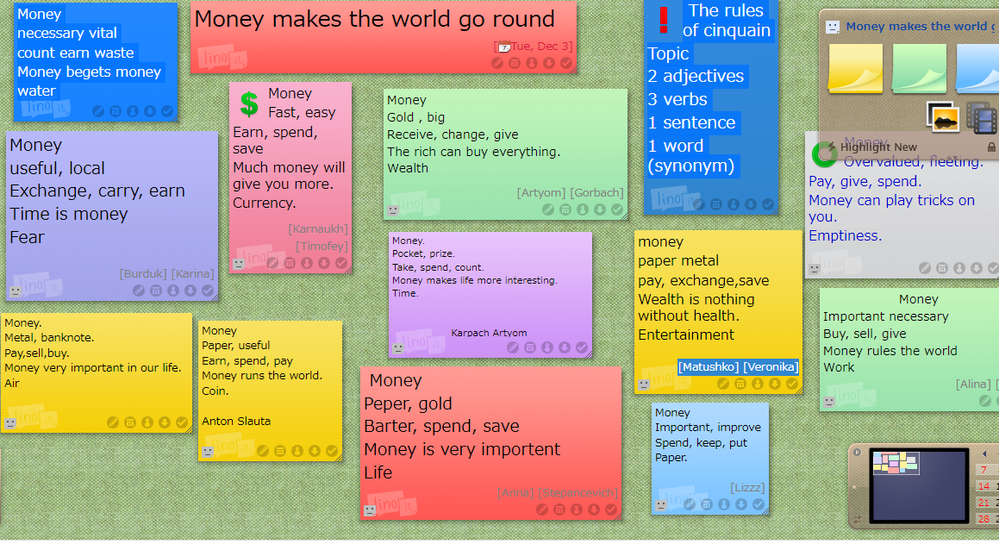
Work individually check as a class
Stage of the lesson: assigning home task. (1min)
To explain and put down the home task.
Teacher’s activity. Pupils’ activity. Pupils put down their task in the record books. p.92 ex.5a Put the missing words and answer the questions. (1 min)
Interaction model: T– Cl
Stage of the lesson: reflection
Let’s come back to your questionnaires. Answer the questions once again
Pupils’ activity. Pupils answer the questions (2 min)What has changed?
What do you now know about money you haven’t known before?
Stage of the lesson: evaluation.
To assess and motivate pupils.
Teacher’s activity. I would like you fill your self-esteem cards and put you a mark (2min)
Estimate your work at the lesson
1. Today I learned ______________________________
2. Today I found out ____________________________
3. Now I can __________________________________
4. The most surprising was ______________________
5. I didn’t understand __________________________________________
6. Today I (was active/was passive/worked hard/ answered all the questions/ didn’t work/ _______________- my mark is…..

