ПЛАН-КОНСПЕКТ УРОКА АНГЛИЙСКОГО ЯЗЫКА В 6 КЛАССЕ

Тема: Национальные символы государства.
Тип урока: урок введения и первичного закрепления лексических единиц
Формы работы: индивидуальная, групповая, коллективная.
Цель: развитие навыков говорения, восприятия и понимания иноязычной речи на слух.
Задачи:
содействовать развитию навыков говорения, аудирования, диалогической речи, грамматических навыков, навыков чтения;
содействовать развитию интереса к изучению английского языка;
способствовать развитию памяти, внимания, мышления, воображения у учащихся в процессе индивидуальной и коллективной работы.
Оборудование: доска, мел, компьютер.
Дидактическое оснащение: учебник («Английский язык: учеб. пособие для 6-го кл. учреждений общ. сред. образования с рус. яз. обучения/ Н.В.Юхнель, Е.Г. Наумова, Е.А. Родовская. – Минск: Адукацыя i выхавынне, 2014. – 288с.: ил.), тетрадь «Workbook 6», раздаточный материал, физическая карта.
CONTENT OF THE LESSON
- Организационный момент

- Hello everyone. Take your seats, please. Let’s start our lesson!
- Tell me, please: Who is on duty today? What date is it today? What’s the day of the week?
What’s the weather like today?
- Ok, very well!
- Listen to the chant. Look at the pictures. Ex.1a,p.13 SB.
- Listen and repeat after the speaker.
- What topic is going to be of our today’s lesson?
- You are right, we are going to speak about national symbols of different countries.

- Речевая зарядка. Совершенствование лексических навыков

- Let’s play «Word Search»! You have got sheets of paper with the grid. Find the words and circle them. (Приложение 1)

- Основная часть
- What symbols do you associate with Belarus/ the United States/ Canada/New Zealand/Australia/ Russia?
- Look at the pictures on the blackboard, please. Match the country and its symbol. (Приложение 2)

- Предтекстовый этап.

- You can see some new words on the blackboard. Please, repeat after me:
flag
emblem
anthem
costume
symbol
national
flax
ornament
stripe

- Текстовый этап. Чтение текста.
- Let’s read the text one by one. Ex.3a,p.14 SB.
- What symbols does it describe? (It describes The Union Flag, the national flag of Belarus, the white stork, the Belarusian national costume, the bison, the cornflower)
- What do Belarusian and British flags have in common? (Belarusian and British flags have red and white colours)

- Контроль понимания прочитанного текста
- You have got sheets of paper on the desks. Mark the statements true (T) or false (F). Complete the sentences according to the text. (ПРИЛОЖЕНИЕ 3)

Mark the statements true (T) or false (F).

1) The Union Flag (or the Union Jack) is the national flag of the United Kingdom of Great Britain. (F- The Union Flag (or the Union Jack) is the national flag of the United Kingdom of Great Britain and Northern Ireland.)
2) The Union Jack combines two older national flags. (F- The Union Jack combines three older national flags)
3) The national flag of Belarus consists of three stripes – green, red and a blue vertical stripe
with red ornament. (F- The flag consists of three stripes – green, red and a white vertical stripe
with red ornament.)
4) The white stork is a symbol of good luck. (T)
5) The blouses and the shirts in the Belarusian national costume are white with beautiful red stripes. (F- The blouses and the shirts in the Belarusian national costume are white with beautiful red ornaments – crosses and stripes.)

Complete the sentences according to the text.

The flag combines three older national flags: the red cross of St George for 1)_______(England), the white St Andrew’s cross for 2)________(Scotland) and the red St Patrick’s cross for 3)_______(Ireland). The national symbols of Belarus are the national flag, emblem, and 4)_______(anthem). The flag consists of three5) ______(stripes) – green, red and a white vertical stripe with red ornament. 6)__________(The white stork) is a symbol of good luck. 7)_________(White) is the symbol of peace. The symbol of Belovezhskaya Pushcha
is 8)_________(the bison), a very strong animal. The symbol of Belarusian fields is 9)_____(the
cornflower) – a small blue flower.

Физкультминутка “Flags and countries”. (ПРИЛОЖЕНИЕ 4)

Ss hang up pictures of flags of some countries on the map. Call the name of a country.

- Let’s continue our lesson. Look at the emblem of Belarus. Read the description of the emblem and fill in the gaps. Ex.5,p.15 (green, star, flag, flax)

-Guess the words by definitions and answer the questions about them. Ex.1,p.5 WB. ( 1 Anthem, We, Belarusians. 2 Flax, fern. 3 ornaments, one. 4 Emblem. 5 Border, Lithuania, Latvia)

- Заключительный этап урока
-What is the name of the United Kingdom of Great Britain and Northern Ireland?
-What colours are on the flag of Belarus?
-What symbols of Belarus do you know?
- What have we done at the lesson?
-Open your record-books and write down your hometask. Your hometask is ex. 7,p.16 SB.
- Your marks are…I am satisfied with your work today. You were active during the lesson. You have 8, 9, 10. Your work was good, but not enough. You should learn the words 6,7. Your work was weak. You should make more efforts and try better. You have 3, 4, 5
-The lesson is over. Have a nice day!

.

ПРИЛОЖЕНИЕ 1

Find the next words: border, lie, area, cornflower, population, symbol, thistle, situated.

a | b | t | h | i | s | t | l | e | m
d | b | r | m | v | x | y | q | y | a
c | o | r | n | f | l | o | w | e | r
h | r | i | o | b | i | o | a | h | e
n | d | p | p | c | e | r | z | g | a
p | e | t | h | i | s | t | l | e | b
a | r | s | i | t | u | a | t | e | d
p | o | p | u | l | a | t | i | o | n

Find the next words: border, lie, area, cornflower, population, symbol, thistle, situated.

a | b | t | h | i | s | t | l | e | m
d | b | r | m | v | x | y | q | y | a
c | o | r | n | f | l | o | w | e | r
h | r | i | o | b | i | o | a | h | e
n | d | p | p | c | e | r | z | g | a
p | e | t | h | i | s | t | l | e | b
a | r | s | i | t | u | a | t | e | d
p | o | p | u | l | a | t | i | o | n

ПРИЛОЖЕНИЕ 2
Belarus
the USA
Canada
New Zealand
Australia Russia

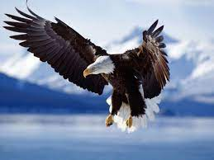
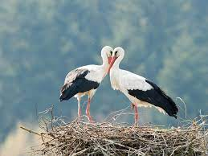
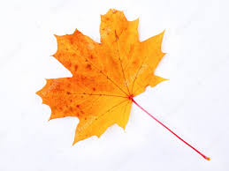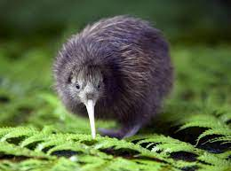

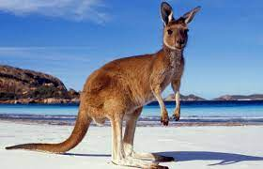

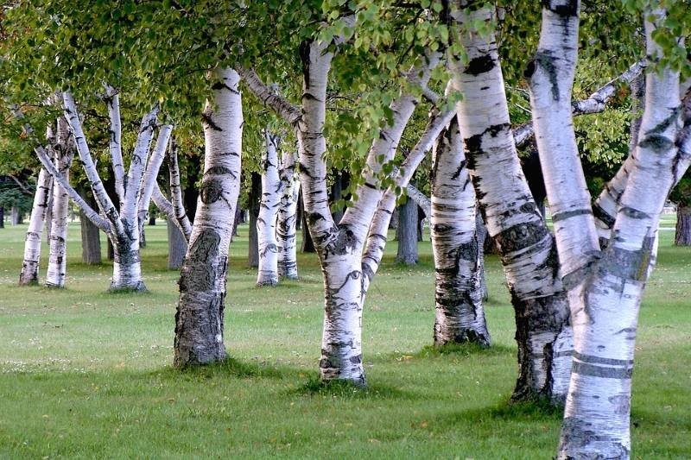

ПРИЛОЖЕНИЕ 3

Mark the statements true (T) or false (F).

- The Union Flag (or the Union Jack) is the national flag of the United Kingdom of Great Britain.
- The Union Jack combines two older national flags.
- The national flag of Belarus consists of three stripes – green, red and a blue vertical stripe
with red ornament.
- The white stork is a symbol of good luck.
- The blouses and the shirts in the Belarusian national costume are white with beautiful red stripes.

Complete the sentences according to the text.

The flag combines three older national flags: the red cross of St George for 1)_______, the white St Andrew’s cross for 2)________ and the red St Patrick’s cross for 3)_______. The national symbols of Belarus are the national flag, emblem, and 4)_______. The flag consists of three5) ______ – green, red and a white vertical stripe with red ornament. 6)__________ is a symbol of good luck. 7)_________ is the symbol of peace. The symbol of Belovezhskaya Pushcha is 8)_________, a very strong animal. The symbol of Belarusian fields is 9)_____ – a small blue flower.

ПРИЛОЖЕНИЕ 4

