Урок в 8 класс
по теме «Shopping»
Тема: «Покупки»
Цель урока: к концу урока учащиеся смогут презентовать диалог по теме урока, используя активные ЛЕ, составить мини-проект по теме “Advertisment of shopping”
Задачи урока:
- Образовательные:
  - формирование умения вести диалог по теме;
  - развитие аудио- фонемических навыков учащихся;
  - развитие умений учащихся оперировать известными понятиями,
составлять высказывания с помощью опор;
  - контроль усвоения изученной темы.
- Развивающие:
  - формирование способности и готовности вступать в иноязычное общение;
  - развитие различных видов памяти (вербальной, образной), внимания, коммуникативности, воображения;
  - развитие мыслительной деятельности, умения переноса знаний в новую ситуацию;
  - развитие языковой догадки.
- Воспитательные:
  - показать значимость умения решать коммуникативные задачи через диалог;
  - расширение кругозора, творческих способностей учащихся;
  - воспитание коммуникативной компетентности учащихся.
Оборудование: ноутбук и экран с проектором/ интерактивная доска, раздаточный материал, иллюстрации на доске

I. Оргмомент
– Good morning , dear friends. I am glad to see you. Let me begin our lesson with some riddles. If you guess them , you will know what we are going to speak about . Listen to me and think.
if you go into a store looking for bread and you don't see any. how can this be?
If oranges are $0.12 a dozen, how many can you get for a dollar?

Yes, the topic is shopping
II. Определение темы урока учащимися по проблемному заданию, ознакомление учащихся с целями и задачами урока
- Usually two or more people take part in this process.
- We do it in a special place.
- We do it very often.
- Usually women like to do it, men don’t like.
- We can’t do it without money.
T: What is it?
P: Shopping
T: Yes, We are going tо speak about shopping. We`ll try to make up and act dialogues, to learn new words, tо see a video film, tо write a test .We have a lot of work. Let’s start.
III. Активизация ранее изученной лексики по теме «Покупки» (речевая зарядка, нахождение соответствий)
T: Do you like to go shopping? What do you prefer to buy clothes or food? I went shopping yesterday. Can you guess what I bought? Ask me questions beginning with the words:
– Did you buy… yesterday?
– Yes, I bought …
– No, I didn’t buy……
T: You know we buy different things in different shops. Will you remind me where you can buy sweets (milk, fish, bread, meat, sugar etc.)
P: We buy … at the …
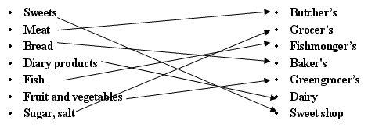

IV Развитие навыков аудирования, погружение в языковую среду
Teacher: Listen to the dialogues and say what the customers buy exactly.
a) (Приложение 5)
– Hello.
– Hello. What can I do for you?
– I'd like a big packet of tea, please.
– Here you are. Anything else?
– A small jar of coffee.
– Here it is.
– Thank you.
Teacher: What did he buy?
Pupil: He bought a big packet of tea and a small jar of coffee.
b) (Приложение 6)
– Hello. Can I help you?
– Yes, please.
– I'd like to buy a can of Coke and a carton of orange juice.
– What else?
– Have you got some nuts? I want: a packet of peanuts, please.
– Here you are.
– Thank you.
Teacher: What did he buy?
Pupil: He bought a can of Coke, a carton of orange juice and a packet of peanuts.
c) (Приложение 7)
– Hello.
– Hello. Can I help you?
– Have you got milk chocolate?
– Yes, of course.
– I want to buy two bars of chocolate and a big box of sweets.
– Here you are.
– Thank you.
Teacher: What did she buy?
Pupil: She bought two bars of chocolate and a big box of sweets.
d) (Приложение 8)
– Hello. Can I have some bread?
– Yes, of course.
– I need a loaf of bread or no, two loaves of bread.
– Here you are.
– Thank you.
Teacher: What did he buy?
Pupil: He bought two loaves of bread.
V Совершенствование навыков монологической речи по средствам составления пословиц и объяснения их значения
Never buy a pig in a poke. | Никогда не покупай свинью в мешке.
Waste not, want not. | Умеришь расходы — не будешь нуждаться.
The more you have, the more you want. | Чем больше имеешь, тем больше хочется.
The worth of a thing is best known by the want of it. | Ценность вещи познается тогда, когда она нужна, а ее нет.
You may know by a handful the whole sack. | По одной пригоршне можно судить обо всем мешке.
A penny saved is a penny gained. | Пенни сбереженное—всё равно что пенни заработанное. Ср. Сбережешь, что найдешь. Неистраченные деньги — приобретенные деньги.
Enough is as good as a feast . | Иметь достаточно — тоже самое, что пировать.
Never spend your money before you have it. | Никогда не трать деньги, пока их не заимел.
«Whoever said money can’t buy happiness simply didn’t know where to go shopping.» Bo Derek | «Тот, кто когда-то сказал, что счастье за деньги не купишь, просто не знал, где делать покупки.» Бо Дерек
«The quickest way to know a woman is to go shopping with her.» Marcelene Cox | «Самый быстрый способ узнать женщину — это пойти с ней по магазинам.» Марселин Кокс
«The odds of going to the store for a loaf of bread and coming out with only a loaf of bread are three billion to one.» Erma Bombeck | «Шансы пойти в магазин за буханкой хлеба и выйти из него только с буханкой хлеба равны три миллиарда к одному.» Эрма Бомбек
«If men liked shopping, they’d call it research.»

VI Развитие лексических навыков используя просмотр видео по теме Shopping
Discuss video in groups, make the list of advantages & disadvantages buying online
VII Совершенствование навыков аудирования
Cross the word you don’t hear in the song
She’s got ten thousand things/rings
And even such/much more
(Ain’t) no wealthy/healthy man
She can adore/ignore
‘Cause every day/weekend she needs
To go shopping/jogging
There is no party chat/that
She’s going to miss/kiss
All high class drunks/hunks
Are worth her kiss/lips
‘Cause every day/weekend she needs
To go shopping/jogging
To go shop-shopping/jo-jogging

VII Развитие навыков диалогической речи
P1-P2
At the Corner’s
– Good morning. How are you?
– Morning. Fine, fine you?
– Fine, thanks. Can I help you?
– Yes. Have you got pineapples?
– Certainly. How much would you like?
– One tin, I think
– What about fresh biscuits?
– No, thank you. I’m on a diet. I prefer fruit and vegetables.
– Anything else?
– May be some fish: sazan or humpback.
– I strongly recommend you to buy humpback.
– OK. Give me one fish. How much does it cost?
– 133 roubles. Oh, just a minute. Do you like lasagne?
– Oh, it’s not bad. But I don’t like Italian food. Here are 150 roubles.
– Thank you. You change is 17 roubles.You are welcome
P3/P4
A: And now we're going to buy some vegetables. Let's cross the road. There's the greengrocer's over there.
Shop assistant: Good morning. What can I do for you?
A: I want a large cabbage, please, and carrots.
Shop assistant: Yes. Anything else?
A: Some fruit, please, oranges and apples.
Shop assistant: Any grapes?
A: No, nothing else, thank you.
B: There is little flour left. Will you go to the grocer's and buy a bag of flour and some sugar, please?
A: Shall we buy a jar of coffee?
B: Could you buy two and a packet of tea?
A: We haven't got any rice. What about salt?
B: There is a lot. But you can buy a bottle of water and two bottles of oil. Is that OK?
P5/P6
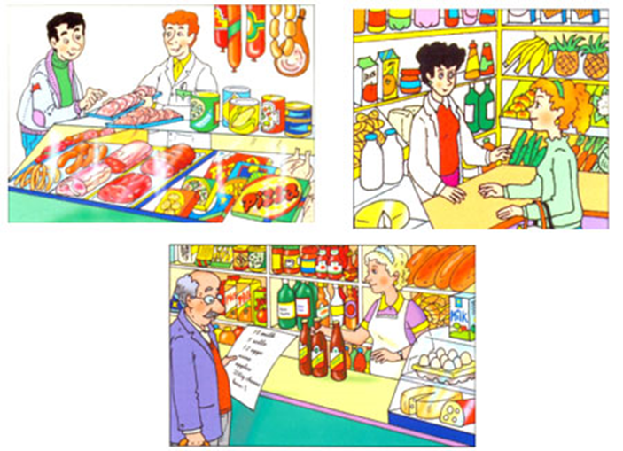
Shop assistant: Good afternoon, sir. Can I help you?
Paul: Yes, please. Well, I'm looking for a pair of jeans to go with my checked shirt.
S.a: And what colour is your shirt?
Paul: It's purple and black.
S.a.: What about these deep blue jeans?
Paul: Oh, yes, they look good. I would like to try them on.
S.a.: All right, let me show you where the changing rooms are.
(after a while)
S.a.: Well, do they fit you?
Paul: No, they are a bit loose. Can you bring me a smaller size, please?
S.a.: Unfortunately, there's only one pair of these jeans left. But I can offer you this model in pale blue. Would you like to have a look? We have these jeans in all sizes from small to extra-large.
Paul: Thank you, but it isn't the right colour. It won't match my shirt. I think the jeans should be darker.
S.a.: I can recommend you this pair of dark blue jeans then.
Paul: But it seems to me that they are too tight, and they are a bit old-fashioned.
S.a.: And what do you think of these black jeans?
Paul: Oh, they look great!
S.a.: Then I'll go and find your size. You can wait in the changing room, I'll bring them in a minute.
(after a minute)
S.a.: They suit you quite well, sir.
Paul: Yes, they look pretty good and are exactly of my size. I think I'll take them. And how much are they?
S.a: These jeans are from our new collection. They cost 79 dollars and 99 cents. And this week we have a special offer: if you buy jeans from the new collection, you'll get a present – a stylish leather belt from spring 2014 collection.
Paul: Oh, and I have a discount card of your shop.
S.a: And which one do you have?
Paul: I have the silver card.
S.a.: The silver card gives 10% discount for a new collection. So for you the jeans will cost 71 dollars and 99 cents. And, of course, you get our present. We have the belts in red, grey, brown and black. Which colour do you prefer?
Paul: I think brown will be alright.
S.a.: I'll take the jeans and the belt to the cash desk.
Cashier: Good afternoon, sir. Here are your jeans. They are 79 dollars and 99 cents. And here is your leather belt, it's free.
Paul: And here is my discount card.
Cashier: OK, that's 71 dollars and 99 cents then.
Paul: Can I pay by credit card?
Cashier: Yes, we accept Visa and MasterCard.
Paul: Here's the card.
Cashier: Enter your PIN-code here, please. OK, your payment is successful. You can take your card and your purchase now.
Paul: Thank you. Goodbye.
Cashier: Goodbye. We'll be happy to see you again.
P7/P8
- May I see that skirt, please? … Do you have it in black? I am looking for a skirt for a business meeting.
- No, sorry. We only have it in white and grey. I suggest a grey one.
- Thank you. OK then. May I try the grey skirt on?
- Sure you can. What size do you usually take?
- Mainly I wear a medium size.
- Here you are. The fitting room is on your left over there. …. So how is it?
- Mmm. I am afraid it’s too short for me. Do you have it a bit longer?
- Let me check. I’ll have a look. … Well, here it is.
- Now it’s really beautiful and comfy. I like it.
- Yes, it suits you. And its colour matches the colour of your hair.
- How much is it?
- It’s on sale now. We sell it at 50 per cent discount and it’s only 15 euros.
- Really? I’ll take it. And I also need some office shoes to match the skirt. But not too expensive, please. I have a size 36 and I prefer heels.
- OK. I’ll get them for you. … So how do they fit?
- Oh, the shoes are too tight. Can I have a bigger size? … Yes, these are cute and stylish.
- I agree with you, they look really nice on you, especially with your new skirt.
- I will buy them. Please, pack the shoes.
- OK. Will you pay by card or by cash?
- I want to pay by card. Here it is.
- OK. Would you put a signature on your receipt, please, and return a copy to me? Thank you for shopping at our store.
P9/P10
At a Shoe Department
Salesman: What can I do for you?
Customer: I’d like a pair of dress shoes size 8.
Salesman: What colour would you like?
Customer: Black or light brown.
Salesman: Do you want shoes in leather or suede?
Customer: In leather.
Salesman: Here is about your size. Would you like to try on these shoes, please?
Customer: They are quite comfortable. What’s the price?
Salesman: 30 pounds.
Customer: I guess I’ll take them. Where do I pay?
Salesman: Is it cash?
Customer: Certainly.
Salesman: You can pay right here. Here’s your change and receipt. Thank you. Come again.

VII Работа в группах ( составление рекламы)

Making projects “Advertisment of the shop”

VIII Рефлексия (составление синквейна) Presenting synquain in English on the topic Shopping

1 noun

2 adjectives
3 verbs
4.phrase to the topic
5.synonim to the topic

IX Подведение итогов. Выставление отметок, домашнее задание: рассказать о последнем посещении магазина (Tell about last visit to the shop)

