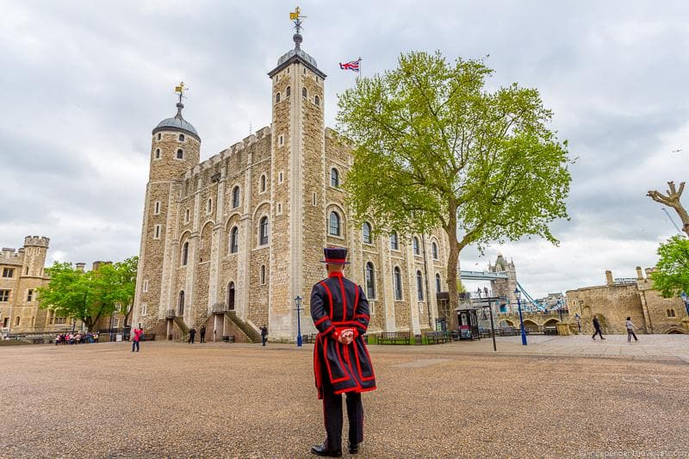

From prison to palace, treasure vault to private zoo, the magnificent Tower of London has fulfilled many different roles down the centuries. One of Britain's most iconic structures, this spectacular World Heritage Site offers hours of fascination for visitors curious about the country's rich history - after all, so much of it happened here. Inside the massive White Tower, built in 1078 by William the Conqueror, is the 17th-century Line of Kings with its remarkable displays of royal armaments and armor.

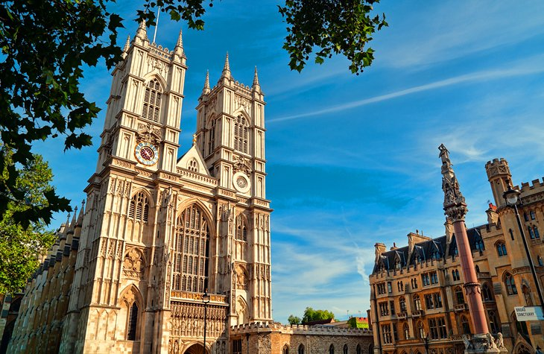

Westminster Abbey stands on a site that's been associated with Christianity since the early 7th century. Officially known as the Collegiate Church of St. Peter in Westminster, Westminster Abbey was founded by Edward the Confessor in 1065 as his place of interment.
From his burial in 1066 until that of George II almost 700 years later, most sovereigns were not only crowned here but were buried here, too. More recently, it's become famous as the preferred location for Royal Weddings.

Completed in 1894, Tower Bridge is the most iconic bridge in London. This impressive feat of engineering is 244 metres (800 ft) long, covered in 22,000 litres (5,812 gallons) of paint and crossed by 40,000 people each day.
Find out more about the bridge’s history and enjoy fantastic views from 42 metres (138 ft) above the Thames on the bridge’s walkways.
Take a look behind the scenes at the famous bridge and discover areas such as the machinery room, which houses the hydraulic system that allows the bridge to rise for river traffic.

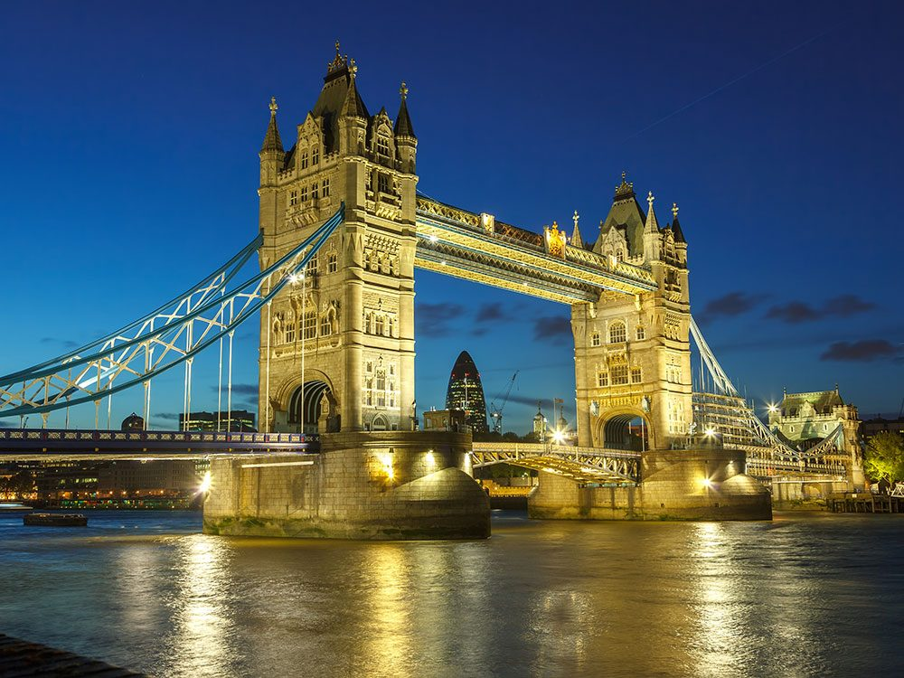

At Madame Tussauds, you'll come face-to-face with some of the world's most famous faces. From Shakespeare to Lady Gaga, you'll meet influential figures from showbiz, sport, politics and even royalty. Strike a pose with Usain Bolt, get close to One Direction or enjoy an audience with the Queen.

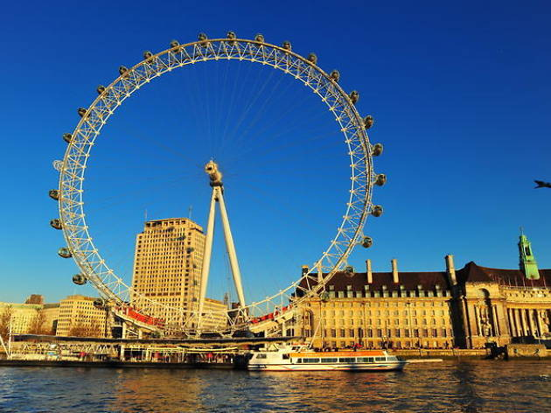

London Eye (officially the Coca-Cola London Eye) is Europe's largest observation wheel. Its individual glass capsules offer the most spectacular views of the city as you embark on a circular tour rising 443 feet above the Thames. The journey lasts close to 30 minutes, often quicker than the time spent lining up for your turn.

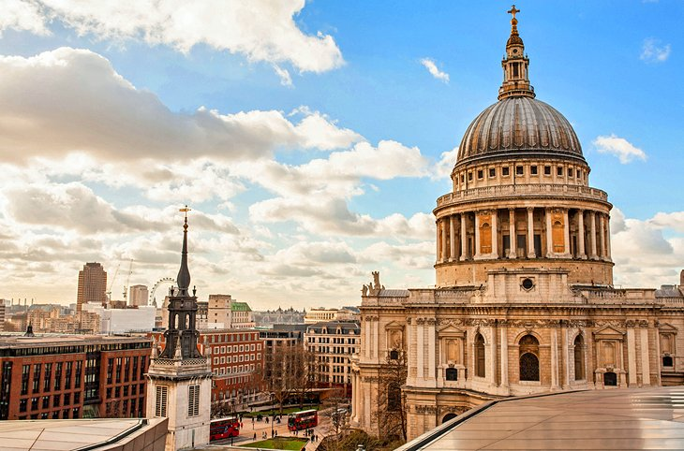
The largest and most famous of London's many churches - and undoubtedly one of the most spectacular cathedral's in the world - St. Paul's Cathedral sits atop the site of a Roman temple. The previous church structure was destroyed in the Great Fire of 1666, and Sir Christopher Wren designed the rebuild. Today, the twin Baroque towers and magnificent 365-foot dome of St. Paul's are a masterpiece of English architecture. If you're up to it, be sure to walk the stairs with their spectacular views of the dome's interior, including the Whispering Gallery - undoubtedly one of the top things to do in London.

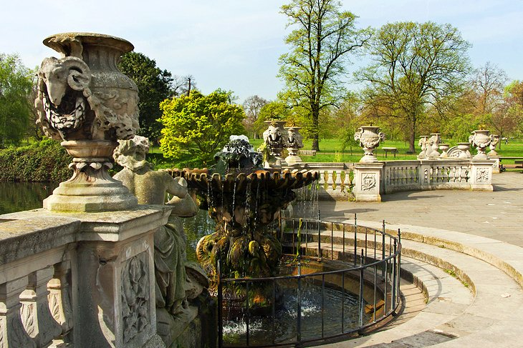
Covering 350 acres, Hyde Park is London's largest open space and has been a destination for sightseers since 1635. One of the park's highlights is the Serpentine, an

18th-century man-made lake popular for boating and swimming. Hyde Park is also where you'll find Speakers' Corner, a traditional forum for free speech - and heckling.

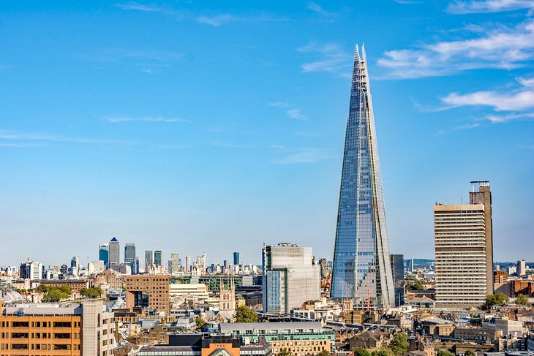
Since it opened in 2012, The Shard has taken its place as one of the most-recognizable and most-visited landmarks in London. Standing 1,016 feet tall and encompassing some 95 stories, this remarkable structure - so-named for its resemblance to a shard of glass - dominates the skyline yet, thanks to its pleasing design, doesn't seem at all out of place when seen next to neighbors such as Tower Bridge.

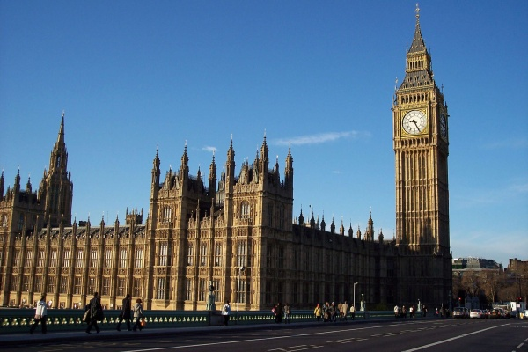

Big Ben is the most popular landmark of Great Britain. The official name of this building is the Elizabeth Tower but we know it as Big Ben. It was built in 1859 and only after 2012 people started calling it ‘Elizabeth Tower’. There are many places in London where you can buy a small souvenir in the shape of this place of interest.

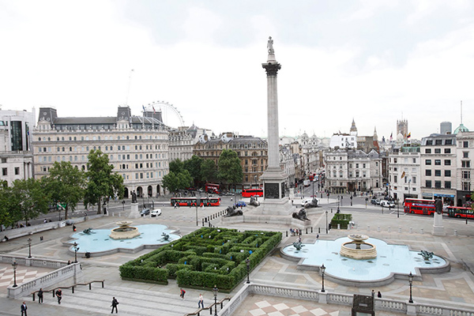

Trafalgar Square is the geographical center of London. There is a monument in the center of this landmark. It is known as Nelson’s Column. This square is used for walking, demonstrations and holidays. It is very popular among tourists and citizens.

