**План-конспект учебного занятия по английскому языку**

**Тема:** Профессии и любимые занятия

**Класс:** 4 «Б»

**Место учебного занятия**: 2/13

**Тип учебного занятия:** учебное занятие формирования навыков говорения

**Вид учебного занятия:** традиционный

**Формы работы:** индивидуальная, коллективная, парная, фронтальная

**Цель:** развитие навыков говорения в рамках заданной темы

**Прогнозируемый результат:** предполагается, что к концу учебного занятия учащиеся смогут назвать профессии на английском языке и рассказать о профессиях в их семьях

**Задачи:**

**Образовательная:** способствовать развитию навыков говорения;

**Развивающая:** создать благоприятные условия для развития памяти, внимания, мышления и воображения у учащихся;

**Воспитательная:** содействовать развитию интереса к стране изучаемого языка

**Дидактическое оснащение**: учебник, рабочая тетрадь, наглядный и раздаточный материал, видеозапись, аудиозапись

**Ход учебного занятия**

1. **Организационно-мотивационный этап**

Good morning, boys and girls! How are you today? I am glad to see you.

Now we’re going to watch a video. Your task is to watch this video and to answer: What is the topic of our lesson?

<https://www.youtube.com/watch?v=wKfrbnRRD-k>

Right you are. The topic of our lesson is “What do you want to be?”

1. **Этап целеполагания**

What are we going to do today? What do you think?

We will speak about jobs.

We will learn new words, talk about parents’ jobs and our favourite jobs.

Well. In addition, we are going to learn how to form jobs from verbs using a suffix –er and to speak about Mike’s family.

1. **Операционно-познавательный этап**

**Формирование лексических навыков**

Look at the pictures on the board. There are different jobs. Listen to me and repeat after me. *A doctor, a driver, a vet, a cook, a farmer, a businessman, a shop assistant, a dentist, a teacher, a worker* (приложение 1).

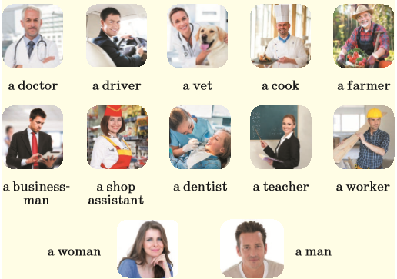

Now, I’ll name one job and show you the cards one by one. Your task is to say ‘No’ until you see the pictures of the job I have named.

We have two more pictures (*a woman, a man*). This is Liz’s mum. She is a beautiful *woman*. And this is Liz’s dad. He is a nice *man*. Repeat after me: a woman, a man (приложение 2).



Take your workbooks and open your workbooks at p.26, ex.1. Match the words to the pictures.

Then do ex.2, p.26. Circle 8 jobs and write them.

**Совершенствование фонетических навыков**

Look at the blackboard. There are three sounds [ʊ], [ʃ], [ᴈ:]. First, repeat the words after me, then read in pairs (приложение 3).

Please, take your books and open your books at p.36, ex 2b. Read the transcription one by one.

Take your workbooks. Do ex.3. p.26. Read the transcriptions and write the correct words.

Good job.

Now, everyone has cards with a description of the jobs and pictures. Someone reads the description of the first job, a person who has a card with this job puts it on the ‘Starting card’, and then reads the description of the next job (приложение 4).

Well done. Answer my question: What do you want to be?

**Релаксационная пауза**

[**https://drive.google.com/drive/folders/1Ku9q8r6xFxw1yNp5HSDPli8j5mGyvTpx**](https://drive.google.com/drive/folders/1Ku9q8r6xFxw1yNp5HSDPli8j5mGyvTpx)

It’s high time to have a rest. That’s why we’re going to do the following. Listen to the chant at p.37 ex.3 and sing the chant all together. Then boys will be ‘Magic Fish’ and will sing her words, girls will be the children and sing their words. After that, we change the roles.

Very nice.

**Формирование грамматических навыков**

Look at the pictures in ex.4a in your books. This is Tina. What can she do?

Right you are. She can sing. What’s her job? She’s a singer.

We add the suffix –er to a verb to get a job word.

For example:

sing + **er** = sing**er**

swim + **er** = swimm**er**

dance + **er** = danc**er**

ski + **er** = ski**er**

Do ex.4b p.37 in pairs. Complete the sentences.

Take your workbooks. Do ex.4a, p.27. Write new words.

**Совершенствование навыков восприятия и понимания иноязычной речи на слух**

**Предтекстовый этап**. **Снятие языковых трудностей**

Ex.5b, p.38 in your books. Look at the pictures. This is Mike’s family. What are their jobs?

**Текстовый этап. Прослушивание текста**

*Аудио:* [**https://drive.google.com/drive/folders/1Ku9q8r6xFxw1yNp5HSDPli8j5mGyvTpx**](https://drive.google.com/drive/folders/1Ku9q8r6xFxw1yNp5HSDPli8j5mGyvTpx)

Ex.5a, p.38. Listen and answer the question: What are their names?

Ex.5b, p.38. Read and match the sentences to the pictures.

**Послетекстовый этап. Контроль понимания прослушанного текста**

Ex.5c, p.38. Speak about Mike’s family.

**Совершенствование навыков говорения**

Now you work in pairs and do ex.6a, p.39. Speak about your family. Then you report to the class about classmates’ families’ jobs (ex.6b, p.39).

Good job.

1. **Контрольно-оценочный этап**
   1. **Контроль**

* What jobs do you know?
* What’s your mum’s job?
* What’s your dad’s job?
* What’s your favourite job?
* What’s the most popular job?

Now, let’s check your knowledge.

**Card 1.** Your task is to complete the sentences.

<https://www.liveworksheets.com/1-bt1202854uo> (приложение 5)

**Card 2.** Write the correct words (приложение 6).

**4.2 Оценивание** (приложение 7)

I’m satisfied with your work, that’s why your marks are the following:

8/9/10 – I’m satisfied with your answers. They were full and nice. You were very active during the lesson.

7/6/5 – Your work was good, but not enough. You have some mistakes. Try to be more attentive.

**4.2.Этап домашнего задания**

Open your record books and write down your hometask:

1. ex.7, p.39 in your Pupil’s books. Write 6-7 sentences about jobs in your family;
2. ex.4b, p.27 and ex.5, p.27 in your Workbooks. Complete the sentences and match the questions to the answers;
3. do the test. <https://docs.google.com/forms/d/1NWyTghJgCqcY5HM2QrNgqmRsh3SqhrbGWm_0QiNGe3Y/edit>

Thank you for your work. Good bye.



Приложение 1



**a doctor**

**a driver**



**a vet**



**a cook**

**a farmer**



**a businessman**

**a shop assistant**

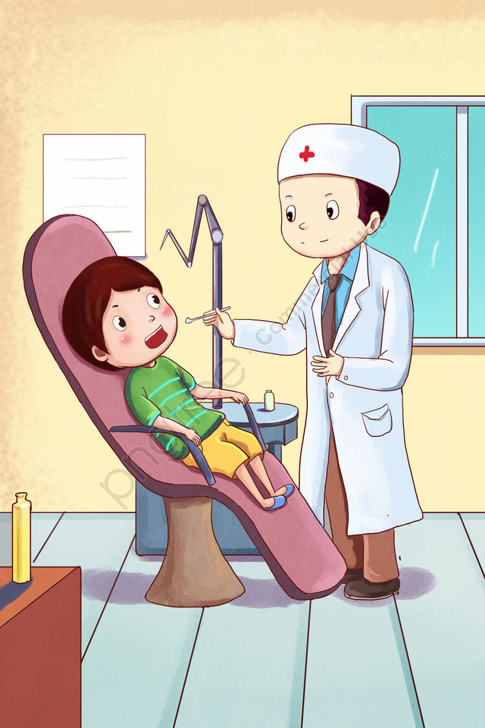

**a dentist**

**a teacher**

**a worker**

Приложение 2



**a man**



**a woman**

Приложение 3

**[ʊ]**



**cook**



**woman**



**good**

**[ʃ]**



**shop**



**fish**

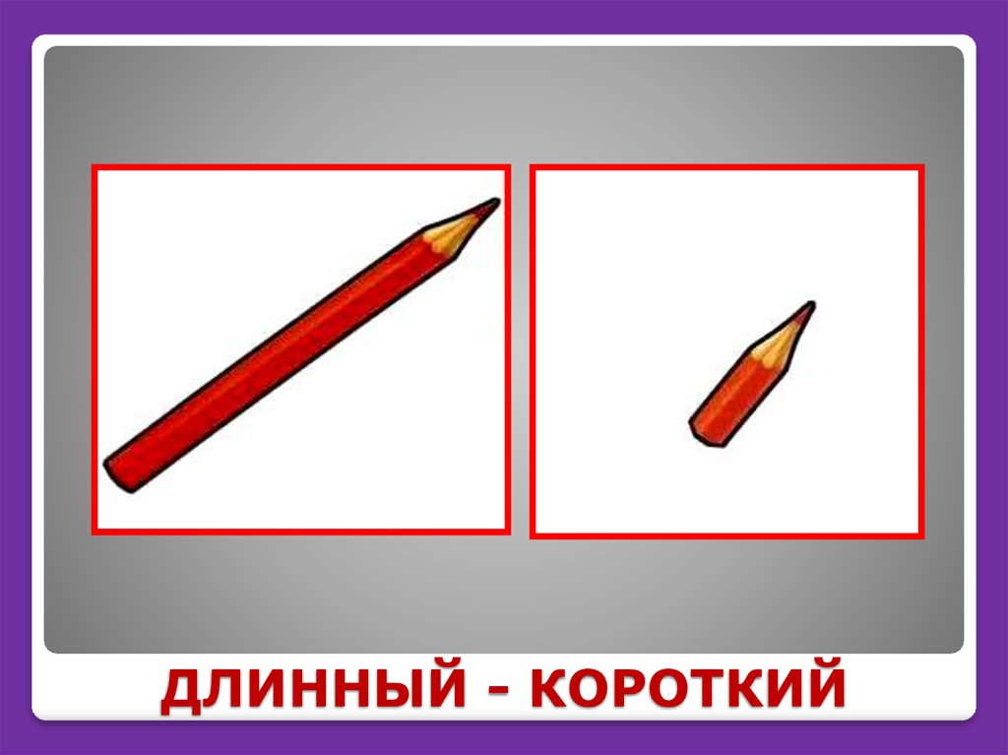

**short**

**[ᴈ:]**



**worker**



**bird**



**circus**

Приложение 4

___________

She can teach very well.

Starting card

_____________

He can cook very well.

___________

She can dance very well.

___________

He has pigs, cows, chickens.

___________

He helps you with your teeth.

 **__________**

**He can drive a car.**

___________

She works in the shop.

 ___________

They can run very well.

 ___________

They can swim very well.

___________

He can sing very well.

___________

He can ski.

___________

He can help your pets.

___________

**Finish!**

Приложение 5

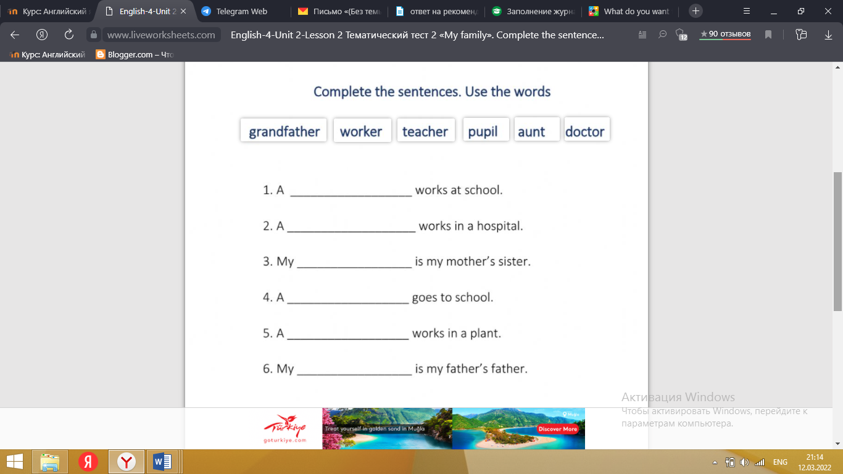

Приложение 6

**Write the correct words.**

1. tev - _________________
2. rotcod - _________________
3. vierdr - _________________
4. rafmer - _________________
5. nedstit - _________________
6. worrke - _________________
7. kcoo - _________________
8. chereat - _________________
9. posh-asstansti - _________________
10. manbsiussne - _________________

Приложение 7

|  |  |  |  |  |
| --- | --- | --- | --- | --- |
|  | | **no mistakes (2 points)** | **have difficulties (1 point)** | **all complicated**  **(0 points)** |
| 1 | Ex.1, p.26 WB |  |  |  |
| 2 | Ex.2, p.26 WB |  |  |  |
| 3 | Ex.2b, p.36 PB |  |  |  |
| 4 | Ex.3, p.26 WB |  |  |  |
| 5 | Ex.4a, p.37 PB |  |  |  |
| 6 | Ex.4a, p.27 WB |  |  |  |
| 7 | Ex.5a, p.38 PB |  |  |  |
| 8 | Ex.5b, p.38 PB |  |  |  |
| 9 | Ex.6a, p.39 PB |  |  |  |
| 10 | Ex.6b, p.39 PB |  |  |  |

Number of points: ____

Your teacher’s mark: ___