План-конспект внеклассного мероприятия по английскому языку «Увлекательный английский»
3 класс
Цели урока:
Образовательная:
- Совершенствовать лексические навыки учащихся.
Развивающая:
- Развивать умения говорения учащихся;
- Развивать мышление, воображение, языковую догадку, познавательный интерес учащихся;
- Создать условия для развития логического мышления.
- Развивать креативные способности учащихся.

Воспитательная:
- Содействовать формированию интереса учащихся к культуре страны изучаемого языка.
Формы, методы, приемы на уроке: коллективная, индивидуальная, групповая, фронтальная.
Оборудование: компьютер, проектор, презентация, раздаточный материал.

Ход урока:
1. Организационно-мотивационный этап. Приветствие, введение в иноязычную атмосферу, представление команд.
Учитель: Good afternoon, children and our guests! How are you? I’m very glad to see you here. Now we will organize a competition called «Wonderful world of English language». Two teams will take part in our game. It’s time to introduce them. The 1st team is «Cats», the 2nd team is «Mice»
Today all of you have a good chance to improve your English during the game.
Now I’m going to teach you how to play this game. The game has 6 contests, they are:
- The ABC Game
- Magic 5
- Parts and Holes
- Interpreter
- Tongue twisters
- Your game
Well, I wish you success. Be active, honest and helpful!
2. Основная часть.
1) And now we have the 1st competition in the game called “The ABC game”. Kids, you’ll get some letters from the English alphabet. You must put the letters in the right order, and get as much words, as possible. Each team can get as many points, as many words they have.
Учитель раздает буквы, учащиеся собирают слова. Буквы: ICTAUBSEGDORANF
2) And now we come to the 2nd contest which is called “A magic 5”. Look at the screen and take a sheet of paper. You’ll get a number. “ …”, it’s your task in this game.
You can get 5 points for the right answer.
1. Say or sing the English alphabet.
2. Name 5 colors.
3. Name 5 family members.
4. Name 5 English names.
5. Name numerals.
6. Name 5 colors in this room.
7. Name 5 English words
8. Name 5 letters after K
3) Физкультминутка
Now my dear friends let’s have a rest. Look at the video and try to repeat all the movements.
4) The 3rd contest is called “Parts and wholes”. I need 1 pupil from each team. You should combine these parts so as to get a popular name. Who will be the first? You can get 1 point for each right answer.
1. Mickey | a) Claus
2 Donald | b) Mouse
3 Winny- | c) Pan
4 Peter | d) Duck
5 Santa | e) the- Pooh

5) The next task is for your captains. The captain should read and repeat it as fast as possible. Who will be the fastest will get more points.
Fat frogs flying past fast.
6) Now you will be little interpreters. Try to translate texts in your team without mistakes. Each right sentence can give you 1 point.
- Mike has got a dog.
- Nick is from America
- I’m from Belarus. And you?
- I have a mum, a dad, a granny and a cat.
- A Rat is on the Hat.
- My family is big.
7) The 5th contest is called “Your game”. The themes are «Colors», «Numerals», and «Grammar». Every theme consists of 4 questions. Every question can bring you points.
(Участники по очереди выбирают вопрос для себя, называя тему и номер вопроса)

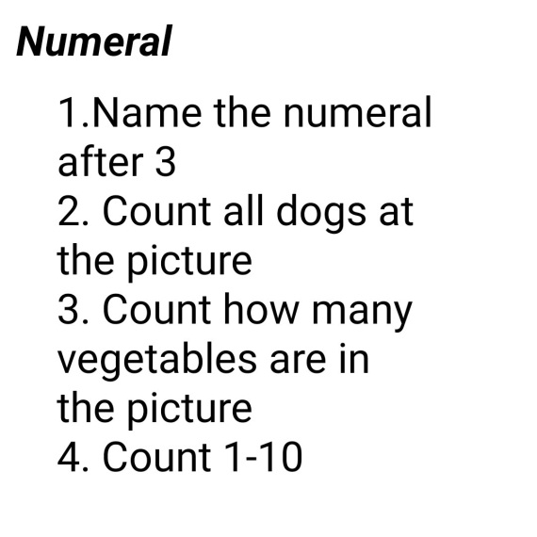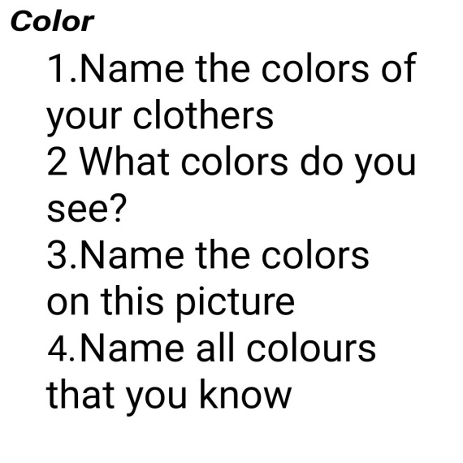
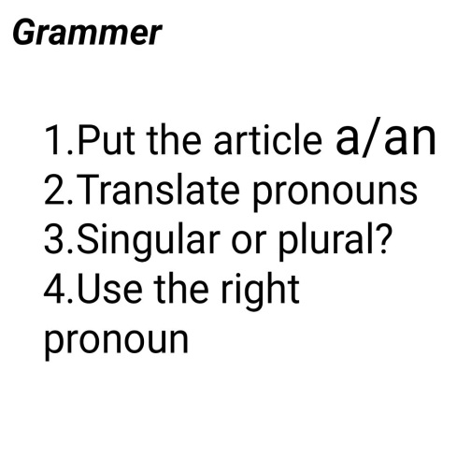
8) Рефлексия, подведение итогов.
The team «Cats» got ___points and , the 2nd team is «Mice» got_______points.
As we can see team___ won.
I think that our contest was interesting for you. If you like it, take a sweet present from the smiled cloud. If no, take a sweet from the other one. Thank you for everything, good-bye.

