План-конспект урока
Английский язык 7 класс

Тема: Town or village?
Тип урока: урок-закрепление знаний
Цель: совершенствование лексических навыков по теме «Town or village»
Задачи:
обучающие:
1. обеспечить условия для развития лексических навыков;
2. создать условия для формирования навыков говорения;
3. способствовать развитию произносительно-интонационных навыков.
развивающие:
Способствовать развитию лингвистических способностей учащихся (внимание, догадка, наблюдательность, память, речь).
воспитательные:
Создать условия для воспитания интереса и уважение к своей малой родине;
Содействовать воспитанию доброжелательного отношения к однокласснику и окружающим людям.

Учебный материал: презентация, интернет-источники, компьютерные тесты, учебно-методический комплекс для 7-го класса (учебник, рабочая тетрадь, Авторы: Юхнель Н. В., Наумова Е. Г., Демченко Н. В. ), компьютеры
Формы работы: групповая, парная, индивидуальная.
Форма проведения: урок-дискуссия

Ход урока

I. Greeting /Орг. Момент, приветствие, постановка целей, тема
T:- Good morning, children. I am glad to see you. Sit down, please.
You’ve got a sheet of paper with a table. Write down your marks for each task.

II. Talking/Говорение
T: -- What town do you live in?
-- Is it a nice town? Is it a clean town?
-- Are there many streets in your town?
-- Is there an underground in your town?
-- Are there many shops in your street?
-- Do you go to school by bus/car/bike/on foot?
-- Is there a fitness centre in your town?
-- Is there a river in your town?
-- Do you like your town?
-- Tell me, where would you like to live: in a city or in a village? Why?..
-- Thank you for your answers. So, What do you think, what the topic of our today` s lesson is?

-- Now look at the screen. There are some letters with numbers. And you see empty boxes. Fill them with letters and guess the proverb. Work in pairs, please.
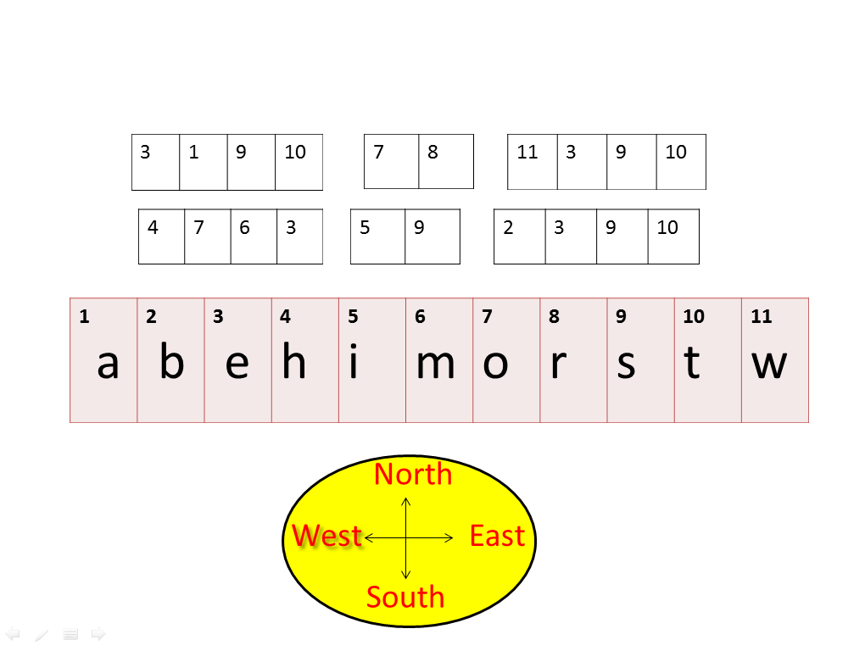

--Are you ready? What proverb is it? Who wants to check? (East or West home is best)
--How do you understand the proverb?
--I understand that home is the best place for each person. Our home is nice and we can feel very convenient there. Now say me one or more adjectives to each letter. Use the words to our topic, please. Let’s work in two groups.
-- Look through the words on the screen. Which of them can you use to speak about the life a) in town b) in a village. Example: Towns are noisy.
Words: crowded, noisy, busy, quiet, polluted, stressful, clean, picturesque, wide, attractive, huge, expensive, modern, boring, exciting, narrow, small, old, interesting, talented, big, dirty,
healthy, unhealthy, safe, dangerous, beautiful, charming, comfortable, uncomfortable

- Write down the mark for your work.

III. Checking homework/Проверка домашнего задания
--I understand that some of you like the life in the country and the others like the life in the city. You homework is to divide into 2 groups and to make the presentation about the life in the village or in the town.
Don’t forget to write down the marks.
IV. Listening/ Аудирование
T: - OK. Thank you for you work. Now we will do the first test. You’ve got some words, put them in two columns: village or city.
-- Now listen to the children discussing life in the country and in the city. Choose the role, what you will write down. Come in and take a sheet of paper. (Unit6_lesson5_ex2,3)
1. The advantages of living in the country
2. The disadvantages of living in the country
3. The advantages of living in the city
4. The disadvantages of living in the city

-- What advantages or disadvantages do you have?
--Listen the conversation again, please. Open your Pupil’s Book at p. 120 ex. 3. Look through the phrases below and say which of them are used in the conversations.

--Let’s do the second test on computers and check how you understand the text.
- There are a lot of nice cottages with lovely bright roofs and chimneys on them.
- There are no skyscrapers or other modern high-rise buildings, the banks.
- A place with many streets and buildings.
- A picturesque place with fields, wood and wild animals.
- There are lots of factories and plants, schools and universities, hospitals and monuments, exhibition and fitness centres, theatres and museums.
- You are free to choose: you choose what school to go to, which film and where to watch, where to spend your free time.
- You can go swimming in the river or in the lake.
- You can dig flower beds and make vegetables beds, grow apple-trees, water vegetables.
- You can go to the disco, to the library or to the supermarkets.
- A large and important town.

V. Practice
--Would you like to move to another place from your town? Why?
--What would you like to change in your town?

--Well, I give you cards. Put the sentences in the correct order. The title of the text is “My dream-town”.
1. The town of my dreams is quite small but it is not far from a big city.
2. There are a lot of nice cottages in my town.
3. There isn’t underground in my town, that’s why you can walk anywhere you need.
4. There are no skyscrapers or other modern high-rise buildings there, the tallest buildings are the town hall and the bank.
5. There is a river running through my town.
6. In my dream-town there are no factories and plants.
7. The air is very fresh.
8. The streets are wide, that is why we have no problems with traffic jams.
9. There are a lot of things to do and sights in our town.
10. There’s a cinema, a fitness centre and an exhibition centre and a nice café by the river.
11. My town is very attractive and worth visiting.
12. Welcome to the town of my dreams!

--Now you should revise your knowledge. I have the third computer-test for you.
--Read the text and insert the missing prepositions of time.

VI. Summarizing. Round up/ Подведение итогов, рефлексия, выставление отметок
T: -- Dear boys and girls, can you tell me where you would like to live in the country or in the city?

T: --Good work. I like your work today. What marks have you got today? How many mistakes have you got?

T: - Now open your records-books and write down your homework WB 1a, p. 68, 1, p.69. Our lesson is over. You may be free. See you soon. Good bye.

Приложение
“My dream-town”.
1. The town of my dreams is quite small but it is not far from a big city.
2. The air is very fresh.
3. There are no skyscrapers or other modern high-rise buildings there, the tallest buildings are the town hall and the bank.
4. There’s a cinema, a fitness centre and an exhibition centre and a nice café by the river.
5. There are a lot of nice cottages in my town.
6. My town is very attractive and worth visiting.
7. There is a river running through my town.
8. There are a lot of things to do and sights in our town.
9. Welcome to the town of my dreams!
10. There isn’t underground in my town, that’s why you can walk anywhere you need.
11. In my dream-town there are no factories and plants.
12. The streets are wide, that is why we have no problems with traffic jams.

- The advantages of living in the country

- The disadvantages of living in the country

- The advantages of living in the city

4. The disadvantages of living in the city

Оценочный лист
Practice | Marks | Mistakes
Talking
Homework
(checking)
Test 1
Listening
Test 2
Exercise
Test 3
Practice | Marks | Mistakes
Talking
Homework
(checking)
Test 1
Listening
Test 2
Exercise
Test 3

