План-конспект урока.
6 «В» класс

Дата: 11.01.2021
Тема: Природа Беларуси и Великобритании
Тип урока: урок комплексного применения знаний, умений, навыков.
Цель (прогнозируемый результат): предполагается, что к окончанию урока учащиеся смогут рассказать и расширить знания о природе Беларуси и Великобритании.
Задачи:
- активизация изученного лексического материала по теме «Природа» в речи;
- учить школьников полноценно пользоваться английским языком во всех видах речевой деятельности (восприятие и понимание речи на слух, чтение, говорение, письмо);
- создать условия для активного взаимодействия, развития аналитического и критического мышления;
- содействовать повышению познавательной активности учащихся; воспитанию ответственности за работу в парах и группах.
Задачи для учащихся: учиться высказывать свою точку зрения на английском языке; учиться применять полученные знания на практике.
Методы: коммуникативный, интерактивный.
Оборудование: компьютер, раздаточный материал, интерактивная программа WordWall

Этапы урока | Деятельность учителя | Время | Примечание
1. Организационно - мотивационный | Good afternoon, boys and girls, take your sits. I’m glad to see you.  I hope you have a good mood to work hard today.  Look at the screen, it’s our beautiful nature. Listen to music. What associations do you have, while looking at these pictures.? Look at the blackboard, there are some adjectives, that will help you to express your feelings. Use them.  As you understand the main aim of our lesson is to talk about nature of Belarus and Britain. We are going to do a lot of exercises, mostly we’re going to work in groups.  Look at the screen. I’ve got an interesting task for you. Open the box. Choose a number. Answer the question. | 5 | Pure  Unexpected  Rich  Exciting  Wonderful  Beautiful  Bright  Charming  Picturesque  Unique  интерактивная программа WordWall

2. Операционно - познавательный этап | Before doing the next task, let’s divide our class into two groups. Choose a piece of paper. If you have a bird, your group is № 1, if you have a castle, your group is the second one.  Look at the blackboard.  Let’s move a little bit. Divide all the words that you have on the table into two groups and match them with the words on the blackboard.  Listening comprehension  And now let’s listen to the texts, which are on your computers.  The first group, you are going to listen to the text about The nature of Belarus. The second – your text is about British nature. I’ll give you time to listen to it and cards (help boxes) which will help you to understand the texts better. Let’s get started.  It’s time to do some tasks.  - Fill in the missing words  - True or False  Are you ready? Let’s check it up. Look at the blackboard, the right answers are there. How many mistakes do you have?  Now, let’s work in pairs. Your task is to exchange the information briefly, using the mind-maps  Speaking  Now, it’s time to do your projects. I’ll give you posters, pictures and your task is to prepare projects about Belarus and Britain. Present your country in the best way. Use the information that you have learnt today. But be attentive, not all of the pictures are suitable for your country. | 5  11  15 | 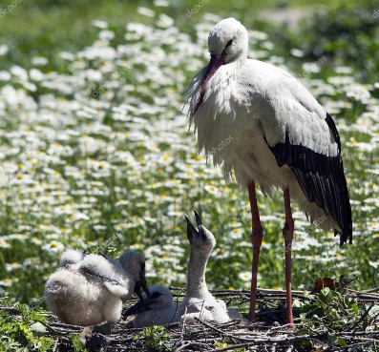  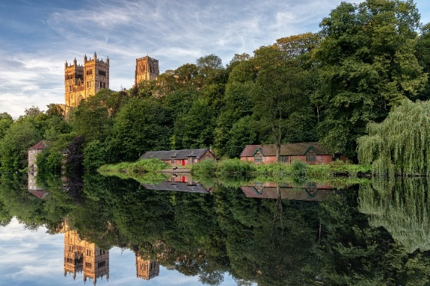  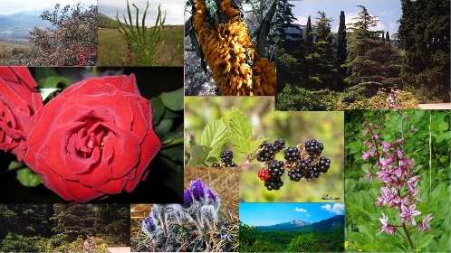  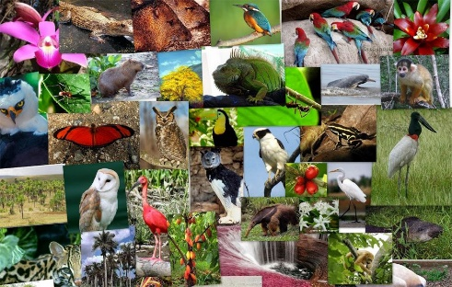  Используется доска  Используется раздаточный материал.

3. Рефлексивно - оценочный | What have we learnt today?  I think we have done a lot of work today. Would you like to travel along the country and see the beauty of nature?  1. I’m satisfied with your work today. Your answers were full and nice. You were active during the lesson. You have 8 (9, 10).  2. Your work was good, but not enough. You should read more (learn the words, translate the text). You have 6 (7).  3. Your work was weak today. You should be more attentive, active. Unfortunately, you have 3 (4, 5).  I’d like to thank you for the good work at the lesson.  The lesson is over. See you soon. | 4 мин | Используется доска

