План- конспект урока по английскому языку
Тема: Friend's favourite holiday
Класс: 5
Тип урока: закрепление и совершенствование знаний, умений и навыков.
Формы работы: индивидуальная, парная, групповая, коллективная.
Цель урока: развитие умений монологической и диалогической речи
(предполагается, что к концу урока учащиеся смогут свободно вести диалог по теме и рассказать про любимый праздник друга)

Задачи:
Образовательная- закрепить лексический минимум по теме «Special days» и грамматический материал по теме Past Simple, совершенствовать навыки чтения и аудирования, а также умения вести диалог по заданной теме;
Развивающая – способствовать развитию мышления, внимания, памяти, творческих способностей и механизма репродукции при обучении говорению пот теме «Friend's favourite holiday»;
Воспитательная- способствовать расширению кругозора и познавательного интереса учащихся к иноязычной культуре и традициям Республики Беларусь.

Дидактическое оснащение: учебник 5 класса ( Л.М. Лапицкая), раздаточный материал ( карточки со словами, упражнения по грамматике, поздравительные открытки)
Оборудование: ТСО (компьютер, наушники, мультимедийная аппаратура)

Ход урока

Этап урока | Задачи этапа | Содержание |  | Время | Форма работы
I. Ввведение.  1. Организа-ционный момент. | Введение в атмосферу иноязычного общения | Good morning, children! I`m very glad to see you. My name is Anastasia Valeryevna, I’m a teacher of English. What is your name? (acquaintance with children). Nice to meet you! Children, look at the board and read the topic of our lesson. Boys and girls, what will we do in our lesson today? (children answer)  Children today we:  1.Remember words “Special days”  2. Revise grammar tense “Past Simple”  3. Make dialogs «Friend's favourite holiday»  4. Read a story “Mike’s favourite holiday»  5. Listen to the story Liz’s favourite holiday»  Boys and girls, do you like holidays? My friend, Mr Rat, likes holidays also. Mr Rat is a friend of Santa. Today Mr Rat come to us with letters from Santa Claus. We have 10 letters. Each of us has one letter on the table. We will open the letters one by one, read them and follow Santa’s tasks.  (ПРИЛОЖЕНИЕ 1)  Ok, let’s start! | 3 min |  | Front work
2.Фонктическая  зарядка | Развитие фонетических  навыков | It’s time to open the first letter.  Who has the letter №1? Open and read, please. ( read a poem)  Children, Look at the board, please. Here is the poem ‘It’s Cristmas’. Listen to me and repeat line by line. Are you ready?  It's Christmas!  It's Christmas! Merry Christmas!  Yes, it's merry, merry Christmas,  it's time for hanging stockings,  It's time for riding sleighs,  It's time for jolly greeting,  Snow and holly, overeating,  Oh, I love you merry Christmas,  You're the best of holidays  Now, Who wants to read the poem?  (Children read the poem) (ПРИЛОЖЕНИЕ 2)  Thank you, children! Very well! | 3 min |  | Front work
3. Повторение пройденного материала | Активизация лексических единиц | It’s time to open the second letter.  Who has the letter №2? Open and read, please. (Christmas words) Children, our task is remember the Christmas words! We have a New Year Tree. We should decorate our New Year tree with lights, angels, sweets and stars. I will show you the pictures and ask a question: What’s this? Your task is up your hand and answer with the help of construction “ It’s a….” then you take the picture and hang it on our New Year tree. Do you understand the task? Let’s start! Children, name all the pictures, please!  (ПРИЛОЖЕНИЕ 3)  Very well, boys and girl! | 3 min |  | Front work
II.Основной этап.  4. Составление диалогов | Развитие умение д.р. | It’s time to open the third letter.  Who has the letter №3? Open and read, please. (Dialogs)  Children, Now you will work in pairs. I will give you the dialogs but the sentences are mixed in dialogs. Your task is to put sentences in correct order and read the dialogs on roles.  (ПРИЛОЖЕНИЕ 4)  But before we start let’s make exercises for your eyes. (go from mouse to Santa Claus).Do you understand the task? You have 3 minutes!  Let’s start! Now let’s read dialogs! Wonderful! | 5 min. |  | Work in pairs
5. Грамматика | Совершентсво-  вание грамм. навыка  (структура предложения) | It’s time to open the fourth letter.  Who has the letter №4? Open and read, please. (Christmas Calendar)  Children, Now you will work in groups. You have snowflakes on your tables. Take them, please. 1 group is green snowflakes, 2 group is pink snowflakes. Let’s divided into groups. I will give you the words Your task is to make right sentences then stand correctly and read a correct sentence. Are you ready? Let’s go! | 3 min |  | Group work
 | Совершентсво-  вание грамм. навыка  (Past simple) | It’s time to open the fifth letter.  Who has the letter №5? Open and read, please. (Verbs) Now we will revise irregular verbs. Look at the board, please. Read the verbs. Now let’play! Children, stand up, please and make a circle. I will throw the ball and call the first form of the verb and you will tell me the second form of the verb. Ok! Let’s start! | 3 min. |  | Front work
6. Монолог-ая речь | Развитие умений монологической речи | It’s time to open the sixth letter.  Who has the letter №6? Open and read, please. (Make a story about Rotty and Moldy). Children, find a card on your table with Rotty and Moldy. Our next task is to make story about Rotty and Moldy using the help box in the past tense. I will start and you continue. | 5 min |  | Front work
7. Здоровье сберегающая пауза | Снятие мышечного и эмоц-го напряжения | It’s time to open the seventh letter.  Who has the letter №7? Open and read, please. (Have fun).  Children, stand up, please and repeat after the penguin. | 2 min |  | Ind-al work
III. Заключит. этап.  8. Восприятие и понимание речи на слух | Формирование восприятия и понимания речи на слух | It’s time to open the eighth letter.  Who has the letter №8? Open and read, please. (Listening) Children, Now we will work with computers. Your task is to put on headphones listen to the audio about Liz’s favourite holiday. Now, children read the sentence on the board and define if sentence true or false. Take card and up correct card .  1.Liz’s favourite holiday is Valentine’s Day. (T)  2.Liz doesn’t like Easter. (F)  3. Liz likes sends cards. (T) | 4 min |  | Front work
9.Чтение | Формирование навыков изучающего чтения | It’s time to open the ninth letter.  Who has the letter №9? Open and read, please. (Reading) Now, children, we will read the text about Mike’s favourite holiday . Open your books at page 114 ex. 1a. So, let’s start!  Children, look at the board and choose the right variant according to the text : ( children make a test) | 5 min |  | Ind-al work
10.Письменная речь | Совершенств.  навыков письма | It’s time to open the tenth letter.  Who has the letter №10? Open and read, please. (Writing) Children, find a yellow card on your desk. Your task is to write a card to your classmates with the best wishes. Look at the board! You have an example. Then you read them to us. You have 2 minutes, start, please.  (ПРНИЛОЖЕНИЕ 5) | 3 min. |  | Ind-al work
IV. Оценка деятельности учащихся. Рефлексия |  | Children it’s time to check the aims, the results and your mood on our lesson! Children do you like our lesson? The aims were achieved!  Look at the board and say a few words about our lessom:  It was… easy/ interesting/ exciting/ amusing  I like ….. reading/ grammar/ listening/ dialogs  I work good/ not so good  Now , children ,choose any smile which will show your mood today a hang on our New year tree.  Children, your marks for today… I have a surprise for you! I have The eleventh letter from Santa. It is so big! What is it? It’s presents for you! I’m and Mr Rat thank you for your brilliant work you are good pupils!!! Take your presents! | 5 min |  | Front work
V. Домашнее задание |  | Children, write down your hometask: ex. 2c p. 116 (PB)  Thank you for the lesson! | 1 min |  | Front work

ПРИЛОЖЕНИЕ 1
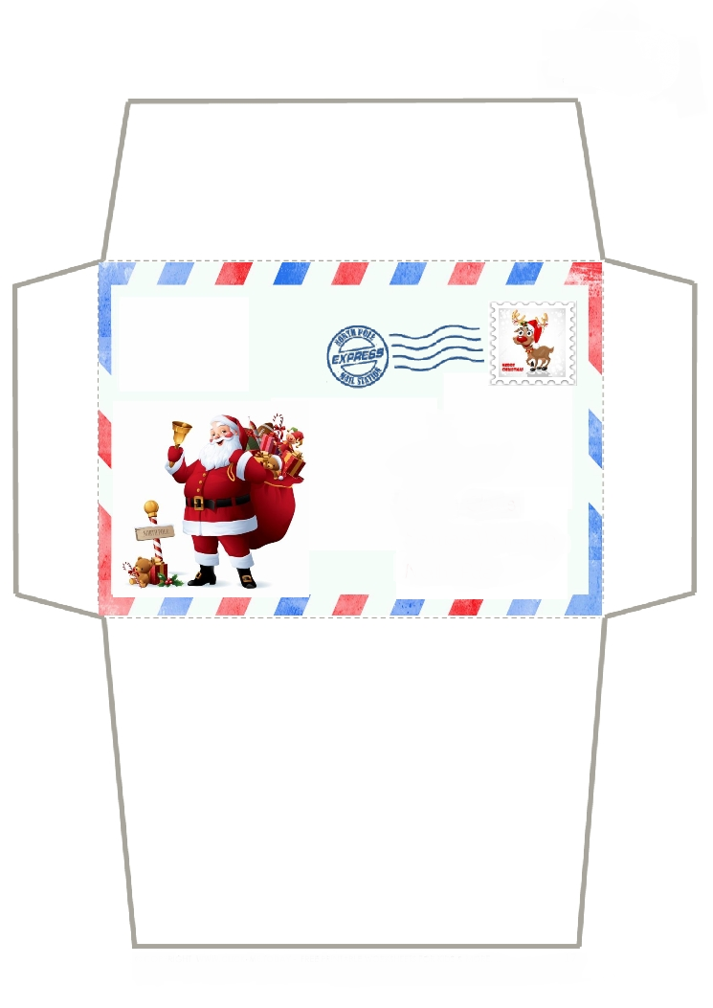

ПРИЛОЖЕНИЕ 2
It's Christmas!
It's Christmas! Merry Christmas!
Yes, it's merry, merry Christmas,
it's time for hanging stockings,
It's time for riding sleighs,
It's time for jolly greeting,
Snow and holly, overeating,
Oh, I love you merry Christmas,
You're the best of holidays

ПРИЛОЖЕНИЕ 3
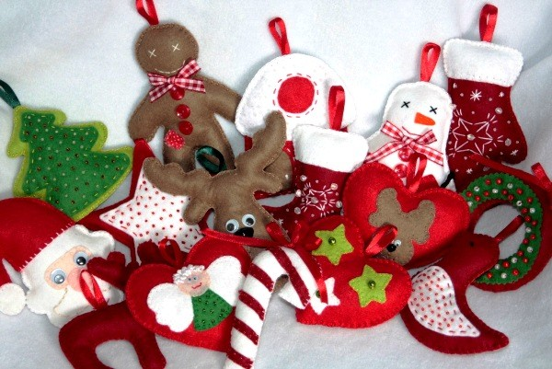

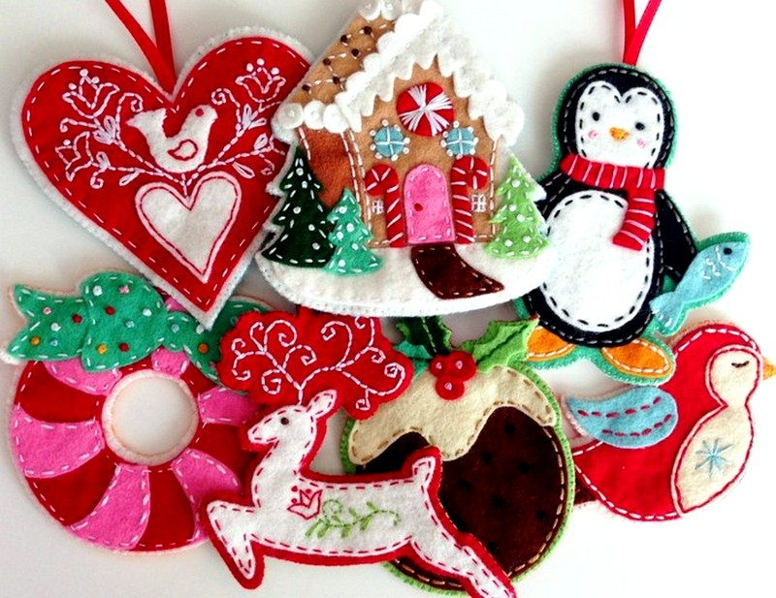
ПРИЛОЖЕНИЕ 4
DIALOGS
- Tell me, please, what is your family’s favourite holiday?
— Oh, it is the New Year’s Day.
— Great! How do you celebrate it?
— We decorate Christmas tree, give presents to each other, invite friends, prepare holiday table, sing songs and congratulate each other.
— Oh, it is very interesting and joyful!
— Oh, yes!

ПРИЛОЖЕНИЕ 5

