План учебного занятия английского языка в 7 “A” классе
Пояснительная записка
Предлагается план учебного занятия в 7 А классе по теме «From Belarus To Australia». Предложенный урок является уроком развития умений говорения согласно данной цели отбиралось его содержание.
Работа в парах и группах предполагается, как средство развития умений учащихся работать в команде. Использование видео о туристических объектах Беларуси и Австралии, раздаточный и иллюстративный материал, интерактивного страноведческого теста, возможности лингафонного кабинета способствует формированию коммуникативной компетенции, включению учащихся в диалог культур, а также нацелено на повышение мотивации учащихся к изучению иностранного языка и патриотическое воспитание. Овладевая социокультурными знаниями и умениями, учащиеся расширяют свои лингвострановедческие знания о стране изучаемого языка, природных особенностях, культуре и реалиях.

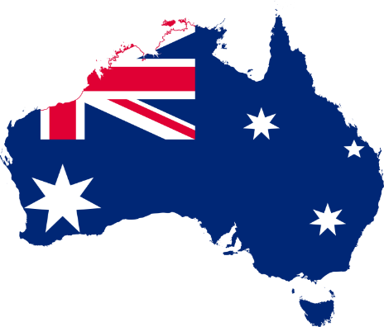
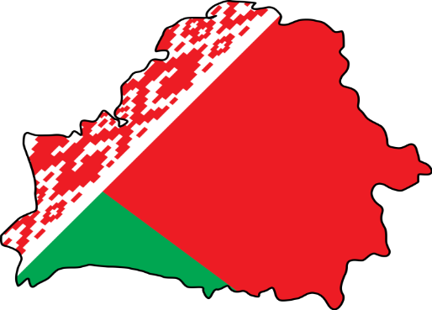
Тема учебного занятия: «From Belarus To Australia»

Тип урока: развития устной речи

Образовательный аспект:
- формирование коммуникативной компетенции учащихся, совершенствование навыков восприятия на слух и ознакомительного чтения с целью извлечения конкретной информации и развитие речевых умений в рамках коммуникативной ситуации урока;

Развивающий аспект:
- сформировать представление о географическом положении, достопримечательностях Австралии, расширить представления об основных фактах истории Австралии, создать условия для активного взаимодействия, развития умения анализировать и сравнивать сведения и факты родной и иноязычной культуры;

Воспитательный аспект:
- содействовать формированию умения сотрудничества в ходе коллективной работы, формированию уважения и интереса к культуре других стран.
Прогнозируемый результат: предполагается, что к окончанию учебного занятия учащиеся смогут составить и описать тематический экскурсионный маршрут, рассказать о туристических объектах Австралии и Беларуси, предложить тур в страну, аргументировать предложение туристического маршрута.

Технология: коммуникативная, ИКТ, здоровье сберегающая (предупреждение переутомления учащихся путем смены деятельности);

Методы: коммуникативный, проектный, объяснительно-иллюстративный, исследовательский, частично-поисковый, интерактивный.

Этап урока | Задачи этапа | Ход этапа учебного занятия
1.Начало урока:  1.Организационно-мотивационный  2.Речевая зарядка  (3 мин)  3.Целеполагание | Наладить взаимодействие с учащимися;  Создание психологической готовности класса к уроку, введение в атмосферу иноязычного общения  Настроить учащихся на активную работу на уроке, сознательное усвоению учебного материала, определение целей, конечного результата, мотивация на познавательную деятельность | - Dear pupils, I'm glad to see you again. Today we are having an unusual lesson: English and Geography together. YI hope, you like Geography and know many interesting facts about different continents, countries, rivers, mountains, cities. So, I have a riddle for you.  It’s the smallest continent. One country occupies the whole continent. When we have summer they have winter. Children have the longest holidays there. What continent is this?  People call this country ‘a blue-eyed country’ or a ‘land beneath white wings” What country is it?  You’re right. We are going to speak about the most mysterious country of the world - Australia and our native Belarus. By the end of the lesson I hope you’ll be able to  organize a tour around these countries.  To work in our Travel Agency you are to decode the secret messages for you on our board What do they mean? How are they associated with Australia?  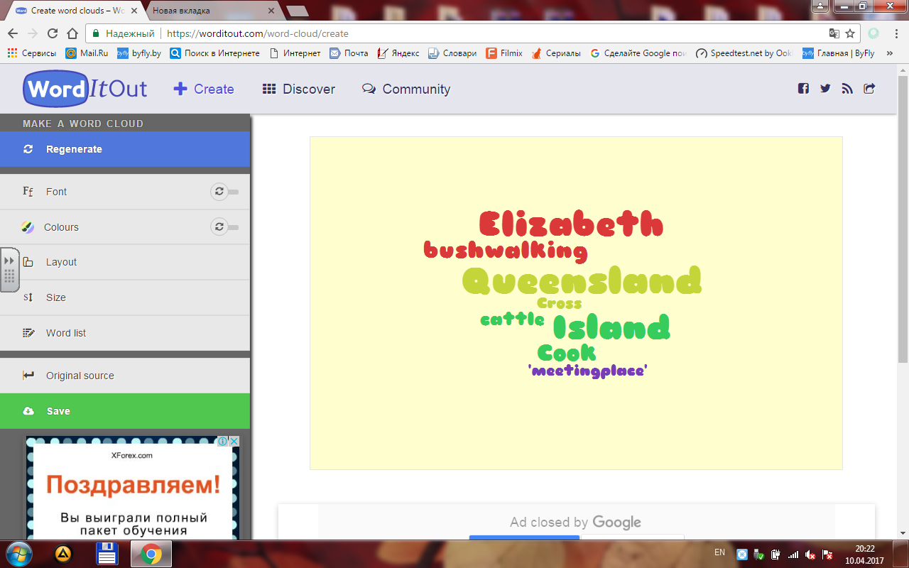
2.Актуализация знаний  (2 мин) | Актуализировать имеющиеся у учащихся языковые знания по теме  (тематическая лексика, страноведческие знания, Conditional I) | - Do you know why Australia is called an upside-down world?  Australia is on the other side of the world. For us it is an upside-down world. Australia is sometimes called "down-under" because of its geographical position. The seasons here are the other way round. Summer is from December to February, New Year is in the middle of summer, autumn is from March to May, winter is from June to August ,etc.  - Have you ever been to Australia? Would you like to go to Australia some day? How can you get to Australia? How long will it take if you go there by ship? by plane?  What will you see\do if you go there?
3. Операционно- познавательный этап:  (10 мин)  1. Восприятие на слух при просмотре видеосюжета и аудиотекста о туристических объектах Австралии | Совершенствование навыков восприятия и понимания иноязычной речи на слух с целью извлечения необходимой информации для дополнения смысловой карты  Совершенствование навыков УР на основе на основе прослушанного текста | - Today you’ll go to Australia on business. You are working as travel agents, so you should know many facts about different countries. 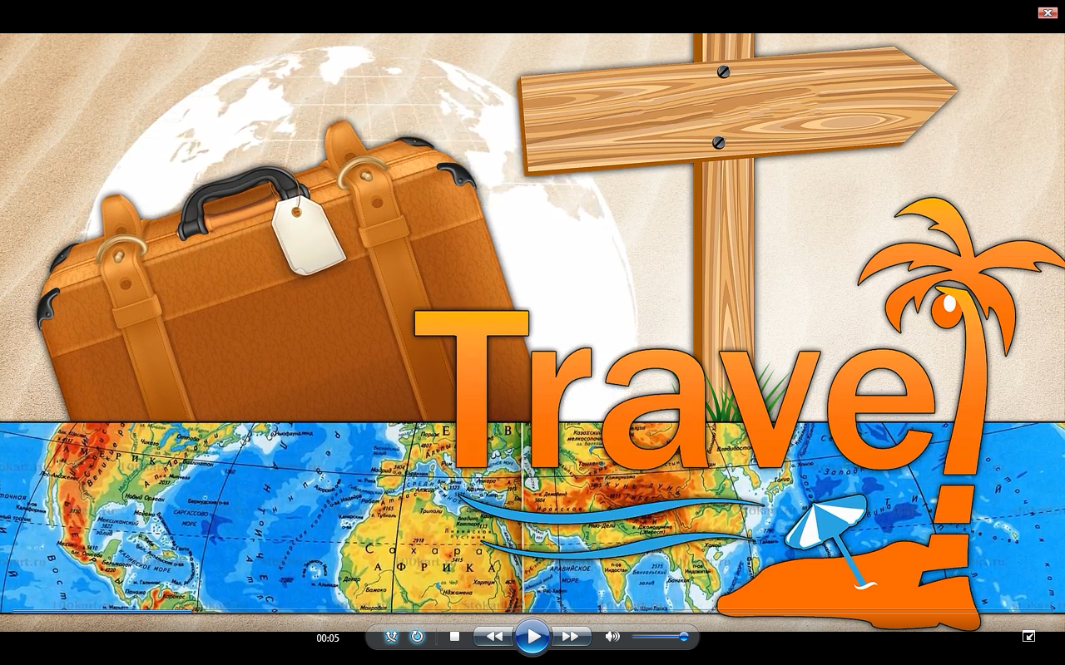 -What information should you find out about Australia to make a travel brochure? (about area, climate, capitals, population, history, landmarks, etc.)  - Now you are going to watch a video about “Terra Incognita”. Be very attentive, as you will have to answer a question “Why should tourists visit Australia?”  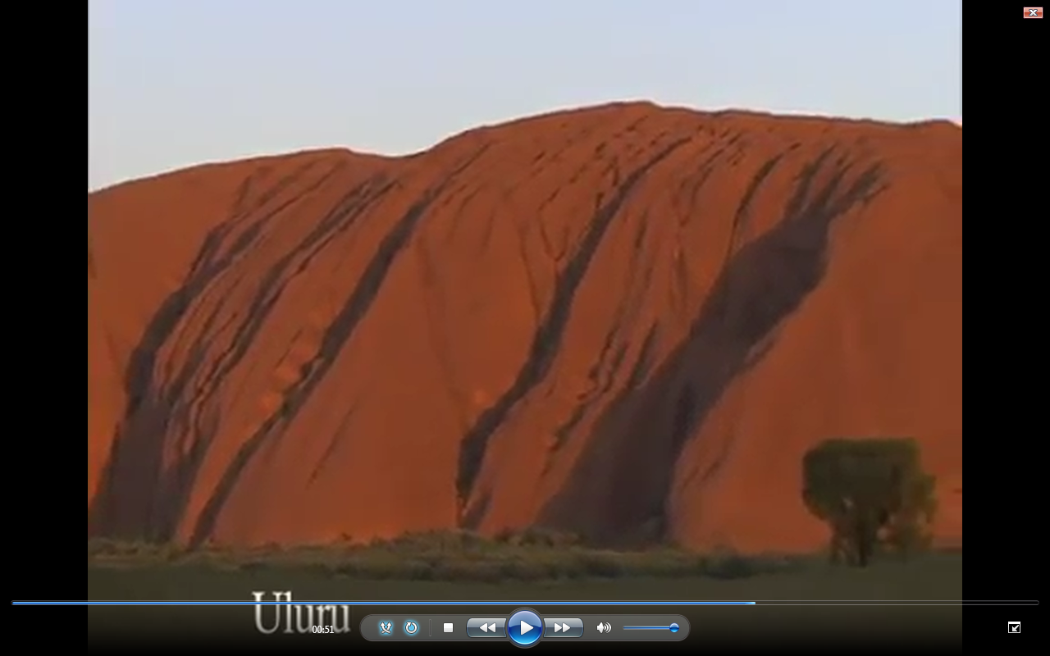  1.What natural landforms can we see in Australia? (mountains, cliffs, islands and lakes)  2. Why should tourists visit Australia?  Uluru. It used to be called ..... (Ayers Rocks). It is located in the...( Northern Territory).Tourists can ... (climb the Rock) ... or explore its .... (caves).  The Great Barrier Reef. It’s the largest .....(Coral Reef). It includes hundreds of ... (islands) where people like to ...(swim and sunbathe)  -Now your task is to get more information for your travеl brochure about other facts like capital, territories, climate, landscape, etc. Listen and complete your mind map. Speak about Australia with the help of our map.  -Now let’s see, if are you experts on Australia or not?  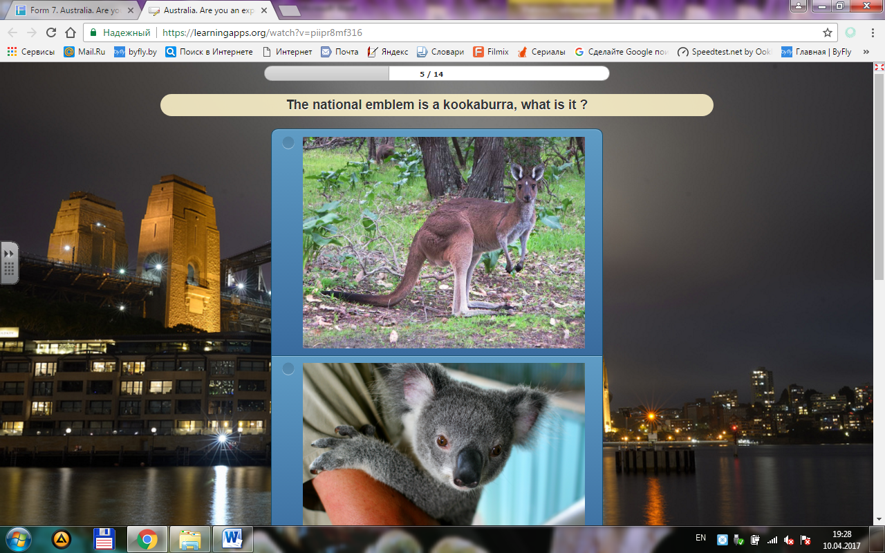
2. Работа в группах с текстом для чтения  (10 мин) | Совершенствование навыков ознакоми-тельного чтения с целью поиска и систематизации необходимой информации о Беларуси, совершен-ствования навыков УР | -Now you are to work in groups. Look through the parts of the text and find out the same facts about Belarus to make the passport of Belarus
3.Пауза для релаксации  (3 мин) | Снятие у учащихся эмоционального и статического напряжения | -Collect the pictures from the wall. What countries are they connected with- Australia or Belarus?  - Watch a video presentation and clap if you see Belarusian landmarks.
4.Ролевая игра «В турагентстве»  (15 мин) | Развитие умений монологической речи, которая характеризуется коммуникативной направленностью, и смысловой завершенностью | “THE UNKNOWN SOUTHERN LAND”  “ THE LAND BENEATH WHITE WINGS”  - Dear guests! Welcome to our Tour Agency. I am a manager of our tour agency and you are my agents. In groups you are going to prepare some information about Australia and Belarus and create travel leaflets about these countries. Finally you’ll present your tours for our guests and tourists.
4.Контрольно-оценочный этап (3 мин)  1.Разъяснение домашнего задания,  рефлексия,  подведение итогов | Осознание учащимися результативности своей деятельности на уроке, уровня усвоения учебного материала,  подведение итогов урока; | - Are you satisfied with your work?  - There are 5 islands on the blackboard: an island of poor knowledge, an island of interest, an island of satisfaction, an island of disappointment, an island of success. Pin your name to the island you are on now.  -Prove “The world is the book, and those who do not travel, read only a page”. Do you agree?  -Thank you for your active work at the lesson. I was greatly impressed with your answer. You showed your excellent knowledge. Are you satisfied with the results of your work at the lesson?  Н\Т: 1/create a travel brochure to organize a tour around Belarus / Australia  2/ write a letter to your pen friend and recommend to visit landmarks of Belarus / Australia

SUPPLEMENT 1
- Watch a video about “Terra Incognita” and answer the questions:

1.What natural landforms can we see in Australia?
2. Why should tourists visit Australia?

Uluru. It used to be called .......................... It is located in the..............................Tourists can ... .......................... ... or explore its .... .......................................

The Great Barrier Riff. It’s the largest ...........................It includes hundreds of ... ................ where people like to ....................................................

SUPPLEMENT 2
Belarus
The Republic of Belarus, it’s an independent state with its own government, constitution, state emblem, flag and anthem. Belarus is situated in the centre of Europe. It borders on Poland in the west, the Baltic States — Lithuania and Latvia — in the north-west, on Russia in the north and east, on the Ukraine in the south.
Belarus stretches for 560 kilometres from south to north and for 650 kilometres from east to west. It occupies the territory of 207.6 thousand square kilometres. The largest of which are Minsk, Gomel, Vitebsk, Mogilev, Grodno and Brest. The capital of Belarus is Minsk with the population about 2 mln people. (About Minsk p 154)
Belarus is situated on a plain rising to hills, the highest of which is Mt.Dzerzhinskaya , it’s 350 metres above sea level.
There are more than 3,000 rivers in Belarus. Seven of them are more than 500 kilometres long each. They are the Dnieper, the Neman, the Western Dvina,the Prypiat,the Berezina,the Sozh and the Vilia. Belarus is a lake-country. There are about 10,800 lakes here. The largest is Lake Naroch — 80 square kilometres. The lakes are known for their depth, clean water and beautiful scenery.
A third of Belarus is under forests. The largest forests are called pushchas. The Belovezhskaya Pushcha is famous for its bisons. Fauna is rich and diverse there: one can see elks and deer, wild boars and wolves, bears and foxes, beavers and lynxes, lots of birds.
Forests, pinewoods, oak groves, birch groves and all sorts of other mixed forests are the charm, wealth and pride of our homeland. The climate is continental.So, winters are cool and summers are warm and sometimes hot.
By the way, Belarus is the country with unique history and rich cultural heritage. It is an interesting region from the tourist point of view.

SUPPLEMENT 3
Official name | The Commonwealth of Australia
Head of the country | Queen Elizabeth II
Population | ___ million
Capital | Canberra
Official language | English
States and territories | 6 states, 2 territories Each state has its own government and capital city
The largest cities | Sydney,Perth, Brisbane, Melbourne, Hobart, Adelaide
Area | About 8,000,000 square kilometres, but deserts take 2,000,000 square kilometres in central Australia. Mountains run from the north to the south of the east coast.
Landscape | The center of the country is flat. There are some mountains along the east and west cost.There are some strange rocks.The most famous is Ayers Rock.
Climte | In the North the weather is tropical-hot and wet, in the center the climate is very dry and desert, in the South it is mild with cool winters and warm summers
Places of interest | Canberra, Uluru, the Great Barrier Reef, the Sidney Opera House
Famous for | Gold mining, wheat and fruit growing, sheep and cattle farming and the production of minerals, oil wool, meat and sugar, marine fishing, Australian wildlife and the beautiful landscape. People of Australia are open and friendly.

SUPPLEMENT 4

Official name | The Republic of Belarus
Capital | The capital of Belarus is Minsk with the population about 2 mln people
Head of the country | The President
Population | About 10 million people
Official language | Russian, Belarusian
States and territories | 6 regions
The largest cities | Grodno, Vitebsk, Mogilev,Gomel, Brest
Area | It occupies the territory of 207.6 thousand square kilometres
Climte | The climate is continental.
Landscape | Belarus is situated on a rolling plain rising to hills, the highest of which is Mt.Dzerzhinskaya , it’s 350 metres above sea level.
Famous for | Blue-eyed country. There are more than 3,000 rivers in Belarus. There are about 10,800 lakes here.  A third of Belarus is under forests. The largest forests are called pushchas. The Belovezhskaya Pushcha is famous for its bisons.  Brest Fortress, Mir & Nesvizh Castle, the National Library, the Naroch, the capital Minsk

SUPPLEMENT 5

Help Box
Agent 1. I invite you to visit Australia. Australia. It is a very interesting country. You can see the exotic birds, kangaroos, koalas, Ayres Rocks, The national Gallery. It has more than 70000 art objects in its collection. Welcome to Australia!

Agent 2. There are many countries in the world. But my country is the best. Belarus is my Motherland. I admire its nature, mountains, and rare animals.

Welcome to the travel Agency “From .... to....!
Our tour will show you all the places of interest in... (some information about the country)
We are going to begin from…
Then we will go to…
After that we’ll visit…
You also will see…
And at the end of our trip you’ll visit/see/go…
Choose our Travel Agency! We wish you a good rest with us!

A TOUR
“THE UNKNOWN SOUTHERN LAND”

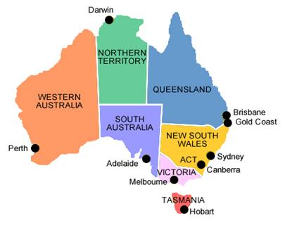

A TOUR
“THE LAND BENEATH WHIGHT WINGS”

