Государственное учреждение образования «Гимназия имени И.М.Ерашова г. Лепеля»

ПЛАН-КОНСПЕКТ УРОКА АНГЛИЙСКОГО ЯЗЫКА
В 11 КЛАССЕ (ПРОФИЛЬ)
«ПУТЕШЕСТВИЕ ПО БЕЛАРУСИ»

Составила учитель английского языка:
Заяц Екатерина Александровна

Лепель, 2020

План-конспект урока в 11 классе (профиль)
по теме “Путешествие по Беларуси”

учителя английского языка высшей квалификационной категории ГУО «Гимназия имени И. М. Ерашова г. Лепеля»
Заяц Екатерины Александровны
Пояснительная записка
Предлагается урок в 11 классе по теме «Путешествие по Беларуси» (учебник Юхнель Н.В., Демченко Н.И., Севрюкова Т.Ю. и др. Английский язык 11 класс» 2012г.) . Это 11 урок в тематическом блоке «Туризм» . При проектировании данного урока учитывалось, что учащиеся имеют довольно высокую познавательную активность, кроме того, были учтены уровень сформированности языковых навыков и развития речевых умений учащихся, их психологические особенности.
В процессе подготовки к уроку были изучены программные требования, проанализирован предусмотренный программой учебный материал, содержательная база учебника, требования к санитарно-гигиеническому режиму и условия проведения урока. Предложенный урок является уроком развития монологической речи. Согласно данной цели отбиралось его содержание. В соответствии с концепцией учебного предмета «Иностранный язык» на уроке планируется использовать коммуникативно-когнитивный личностно-ориентированный подход, а также элементы метода проектов и групповая работа. Все задания имеют коммуникативную направленность. Речевому поведению урока способствует и использование приемов интерактивного обучения. При подготовке к уроку также учитывалось, что у учащихся есть собственный опыт по предлагаемой ситуации общения, на который можно опираться в процессе урока. Для организации обратной связи осуществляется контроль на всех этапах урока. В конце урока учащиеся защищали созданный в рамках урока буклет.
Предмет: английский язык
Класс: 11
Тема урока: «Путешествие по Беларуси».
Тип урока: урок развития умений говорения (монологической речи).
Цель (прогнозируемый результат): предполагается, что к окончанию урока учащиеся смогут построить монологическое высказывание (с опорой на буклет).
Задачи:
- активизировать лексический материал в устной речи;
- создать условия для активного речевого взаимодействия;
- содействовать совершенствованию навыков просмотрового и поискового чтения;
- способствовать развитию умений монологической речи;
- способствовать формированию умений планировать свое коммуникативное поведение.
Задачи для учащихся:
- учиться высказывать свою точку зрения на английском языке;
- учиться применять полученные знания на практике.
Методы: коммуникативный, интерактивный, проектный.
Оборудование урока: компьютер или телевизор, раздаточный материал.

Ходурока
1. Организационно-мотивационныйэтап.
Teacher: Good morning, my dear friends. How are you today? Look at the board and read the poem.
My country is for love, so say its customs.
My country is for peace, so say its castles.
My country is for health, so say its forests.
My country is for rest, so say its lakes.
My country is for people to love their Motherland.
My country is for animals to rare their cubs.
My country is for travelers to see its sights.
My country is for pleasure and happy delights. (удовольствие)

What is this poem about? What feelings does it arose?
What is our lesson dedicated to?

Before we start our lesson I’d like to revise some material on the topic of the lesson.

Name 5(Students get cards, answer the questions and get a sweet for their answer. Later they will be divided into teams according to the colour of the sweet.).
- Kinds of transport;
- Types of tourism;
- People involved in tourist industry;
- Aims of travelling;
- Ways of travelling;
- Places to visit abroad;
- Emotions while travelling.

Think what we are going to speak about today? You are right, at the lesson we will speak about our country, its sights, culture and history.

2. Операционно-деятельностный этап.
I’ve got two foreign friends who want to visit our beautiful country. But they are always quarrelling because one of them is interested in history and culture and the other is crazy about entertainment and sports. Help me to make a travel booklet for them.
Today at the lesson we will work to create a travel brochure about Belarus. Our task is to make a 3-day tour.
What does each excursion start from?
- You are right. It starts with its capital. My favourite place in Minsk is Nemiga. There are a lot of shops there and the nature is very beautiful there as well. You can seat on the bench and adore nature. What is your favourite place in our capital?
(Student’s own answers)
As you know people have different aims of travelling. You are divided into 2 teams (with the help of the sweets) .And we are ready to start creating of our travel guide. The 1st day is Capital tour. Look through the texts (Appendix 1) about places of interest in Minsk, choose 3 places you advise to visit and explain your choice. The 1st group makes Historic and Educational booklet , the 2nd team makes Sports and Entertainment booklet. You have 10 minutes to do this task.
Do you think our guests will be satisfied with the 1st day of their tour? Why?

Let’s go on.
Yesterday I have received some letters from my friends abroad. They sent me some pictures of the places they would like to learn about. Open the envelopes and look at the pictures. Do you know these places? Have you ever been to Mir and Nesvizh castle? How do we call the second day? (Castle Tour)
Using QR codes watch the video about the castle in your picture and complete the table.(7 minutes)
Please, choose one member of the group and exchange the information you have read.Complete the 2nd part of the table. (3 minutes)
Mir Castle
 | Mir Castle | Nesvizh Castle
Famous Owners
Date of Foundation
UNESCO World Heritage Site
Open hours
Exhibitions

Price

Cafes + Belarusian dishes

Nesvizh Castle
 | Mir Castle | Nesvizh Castle
Famous Owners
Date of Foundation
UNESCO World Heritage Site
Open hours
Exhibitions

Price

Cafes + Belarusian dishes

Souvenirs

As you remember, we started our lesson with the poem about Belarusian beautiful nature. Some poets call our country “blue eyed”. Why? Belarus is also considered to be the lungs of Europe? Why?
Let’s do the 3rd day of our tour “Ecological tour”. What are the most popular lakes and forests in our country?
Listen to the guide and give a recommendation why should we visit this place. (Each team gives one recommendation of a place). Video is created by the help of service Voki.(Appendix 2).
(Students may use the card if they need help.
I am convinced that _______________ is worth visiting because___________________________. I also think that ____________________. What is more, you can find(visit) _____________________________ there. Besides, I would like to add _____________________________________________________.
That`s why I ___________________________________________________________(strongly recommend you to visit this place and receive unforgettable impressions.)

3. Рефлексивно-оценочный этап.

Now it’s high time for you to present your travel booklet. Listen to each other attentively because your home task will be to write a review of another group’s travel booklets.(20 sent)

I really like your travel booklets, and today I’ll send your guides to my foreign friends. I am sure these tours will help them what places to visit in our country.
Are you satisfied with your work?

Thank you for your work at our lesson. You’ve worked hard and I am pleased with your work. Your marks are… have a nice day. Good bye!
At the work on each stage each student completes the table on his work.
 | Name 5 | Questions  About Minsk | Reading task | Castle tour | Listening | Presentation
10-9
I worked hard and helped my team a lot
8-7
Satisfactory work. Sometimes expressed the opinion
6-5
Not bad. The task was difficult for understanding. The work wasn’t constant.
4-3
I didn’t work at all. I need help.

Additional task.
Fill in the gaps with the right derivatives
I am sure, everyone needs at least one holiday a year. So, when you begin spending ________________ nights thinking about the sun and the sea – you are ready for a holiday. There is no doubt that ________________ is necessary to us. It keeps us from growing stale and old, it stimulates __________________, it gives us that ___________________ and change which are necessary to our well-being. Some people travel in search of ________________, others – to satisfy their _______________. And many people consider travelling to be a very good form of rest. I should say, I am ________________ fond of travelling and feel _________________ envious of any friend who is going anywhere. I hate seeing ________________ off. I prefer being seen off myself. | SLEEP  TRAVEL  IMAGE  MOVE  BEAUTIFUL, CURIOUS  EXTREME  TERRIBLE  PERSON

Appendix 1

Sts. Simon and Helena Church, or Red Church
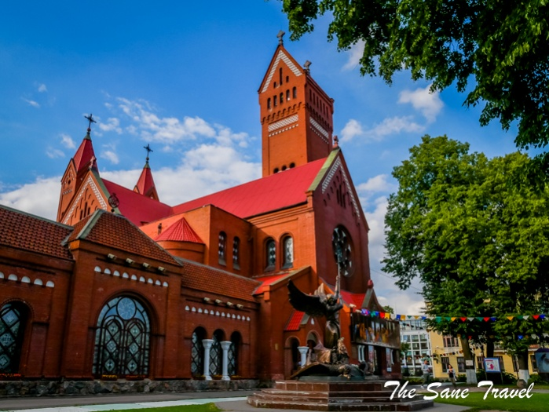
The Red Church is a symbol of Minsk. The official name of the church is quite rare and, probably, can’t be found elsewhere in the world: Sts. Simon and Helena Church. It’s because the church was built to commemorate the premature death of two young children, Simon and Helena Wojnilowicz, of a Belarusian aristocratic family. It is known as the ‘Red’ Church because of its red brick walls. This neo-Gothic church was designed by Polish architect Tomasz Pajzderski and consecrated in 1910.
In 1923, almost all of its treasures were expropriated, and the church was finally closed in 1932. Later it housed the BSSR State Polish Theatre, and then it was converted into a cinema studio. In 1990, the Church of Saints Simon and Helena was returned to the Roman Catholic Church. The interior has been fully restored, and it’s now an important centre of religious, cultural and social life in Minsk.
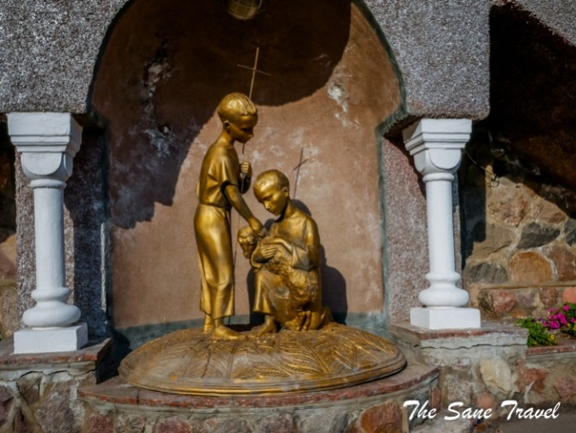
In September 1996 a statue of Archangel Michael killing a dragon was erected in front of the Red Church. The bronze statue is 4.5 meters high; it represents Archangel Michael as a symbol of victory and the glory of Heaven.

The central part of Nezavisimosti Avenue
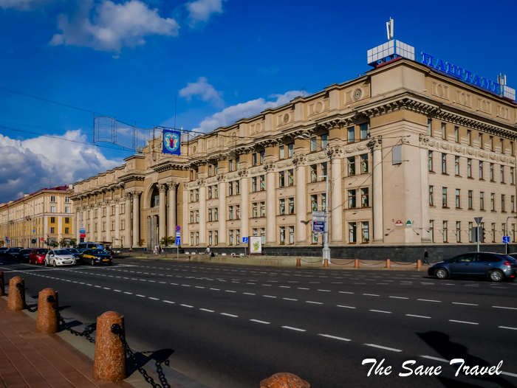
Minsk suffered a lot in the Second World War, with 80% of the buildings destroyed. A new city had to be built afterwards. It was rebuilt in grand Stalin’s empire style: wide boulevards are lined with ornate imperial grandeur buildings. Some researchers consider it a variation of art deco. This architectural style was apparently derived from the French empire style of Napoleon Bonaparte.
Begin walking Nezavisimosti Avenue from the Red Church to Pobedy (Victory) Square and see the Government House, City Council, KGB Headquarters, Post Office, ‘GUM’ the department store, Palace of the Republic, House of Officers, and the Residence of the President, among the others.
The main Post Office can be found at the beginning of Nezavisimosti Avenue. Notice the unusual sculptures and the clock on the building.
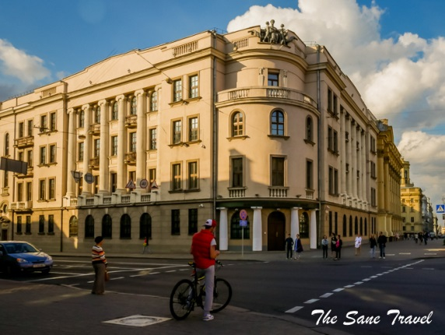
The secret police in Belarus is still named KGB. The headquarters occupy a very prominent location in the centre of Minsk.

The Trade Unions Palace of Culture is a nicely decorated classical style building from 1954. It now houses two nightclubs.

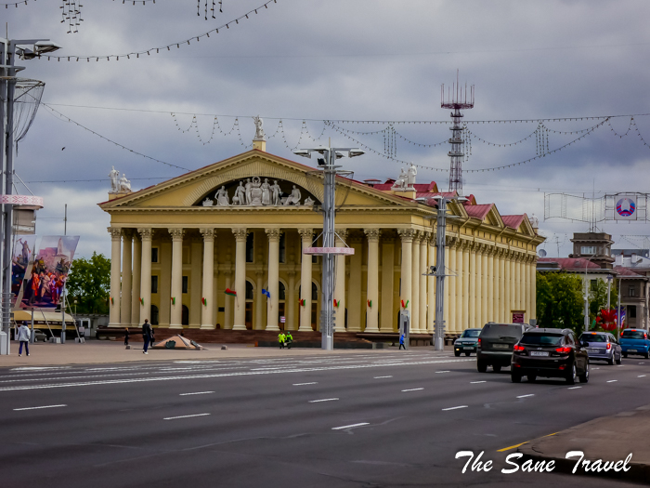

The Upper Town
The rich and famous inhabitants of the city had their houses in the Upper town since the middle of the 16th century. It’s the central part of Minsk with so much to see. I’ll just bring a few highlights to your attention.
Minsk City Hall
Minsk City Hall was initially wooden. After the fire in the middle of the 17th century, it was rebuilt in stone and was the symbol of independence. In the middle of the 19th century, the tsar of Russia Nikolay I ordered destroying the building. After the independent Belarusian state was established, the City hall was rebuilt from scratch and opened its doors to visitors in 2004.

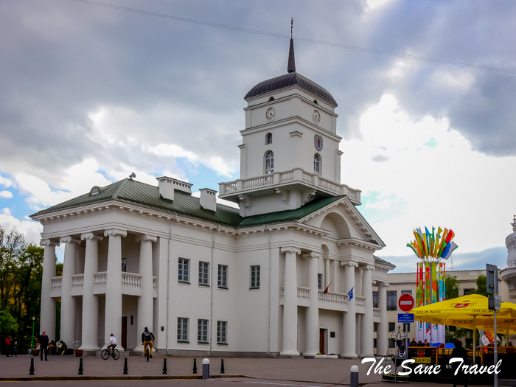
Cathedral of the Holy Spirit
It’s one of the most visible churches in Minsk, located in the centre and overlooking the Svisloch River in the historic Upper Town. The Cathedral is the most important Russian Orthodox church in the city. Back in the 17th century, the building served as a Catholic Bernardine monastery. It was closed in 1922, then converted to Orthodoxy, expanded and renovated. Its holiest icon is the image of the Mother of God, said to have been found by Minsk residents in 1500.
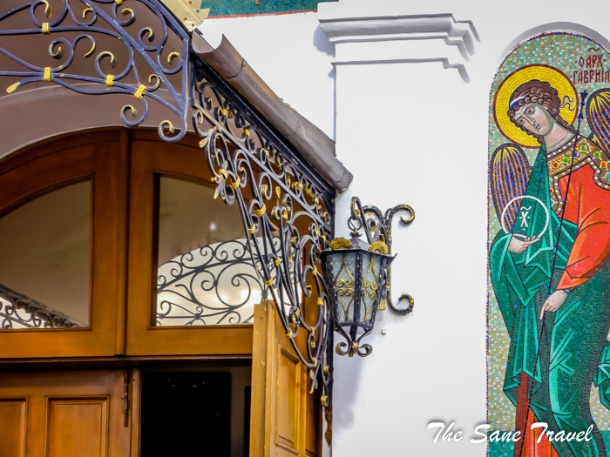
Cathedral of the Holy Name of Mary
This Jesuit church was built in early18th century. In those times, it was visited by Russian tsars Peter the Great and Nikolay the 2nd, Swedish King Karl XII, and others. In the Soviet times it was closed and after Second World War served as the office of a sport union. In the 1993 it was returned to the Church, and restoration artists of Belarus and Poland brought the former splendour back to the brilliant Baroque style building.
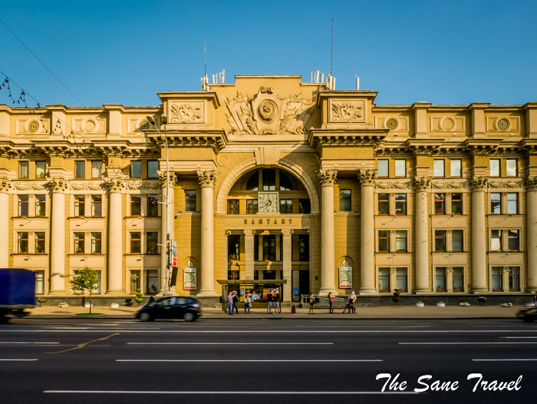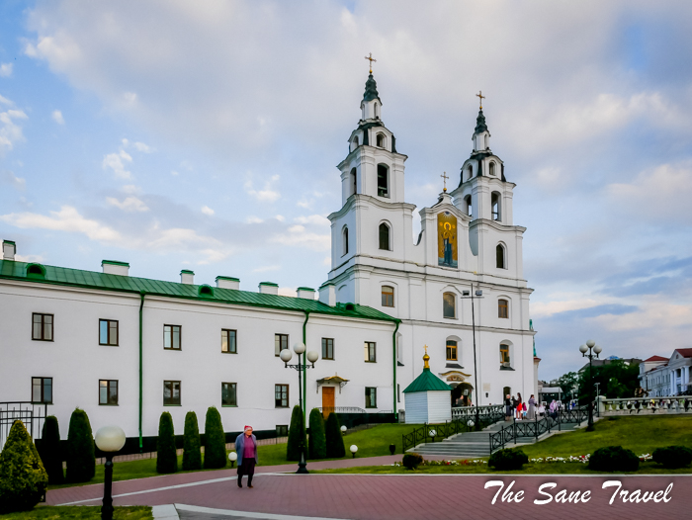

Bolshoi Opera and Ballet Theatre of Belarus
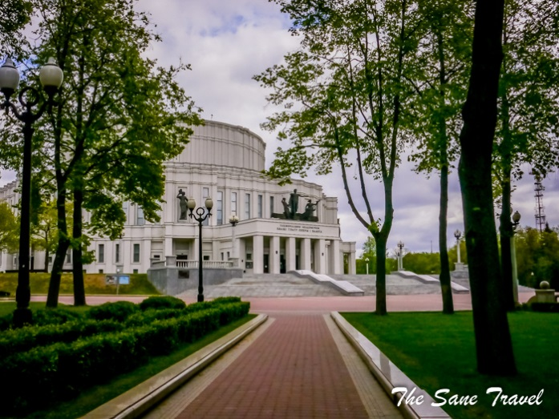
The theatre was designed by architect IosifLangbard and opened in 1939, its grandiose style inspired by Roman amphitheatres. The building suffered from bombing in the Second World War and was opened again after reconstruction in 1947. In 2009 the restoration works were completely finished under the guidance of architect Anatoly Shabalin. The new elements include crystal chandeliers of the 1950s style, gypsum details, ceiling paintings, golden stucco work along with red velvet curtains and drapery. The interior features natural stones, marble and granite. Floors are made from nine kinds of granite and adorned by ornaments.
The facade of the theatre is adorned by the sculpture of Apollo and two flying nymphs. In the park in front of the theatre, you can admire a light cascade fountain that resembles the silhouette of the theatre.
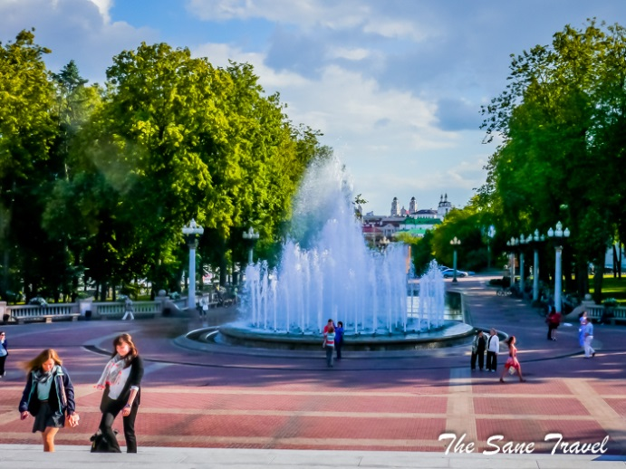
If you have more time, you can visit an opera or a ballet performance. Swan Lake ballet is one of the most popular ones. You have to book tickets a few months in advance. The next part of your visit might require using the convenient and cheap Minsk public transportation.

Kupala park and Loshitsa Park
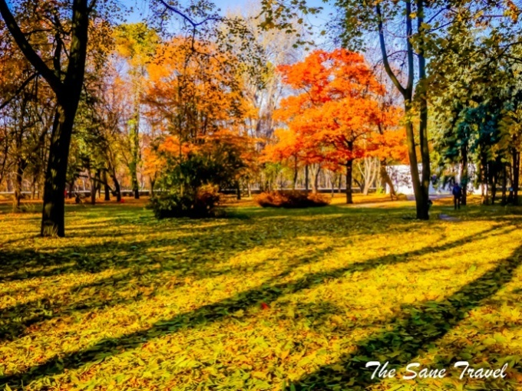
Minsk is a very green city with a lot of parks. Many of them are located on the banks of the river Svislotch. Which park to visit? The choice is yours and depends on your spare time. If you have little, just take a walk in JankaKupala Park next to the Bolshoi theatre in the city centre.
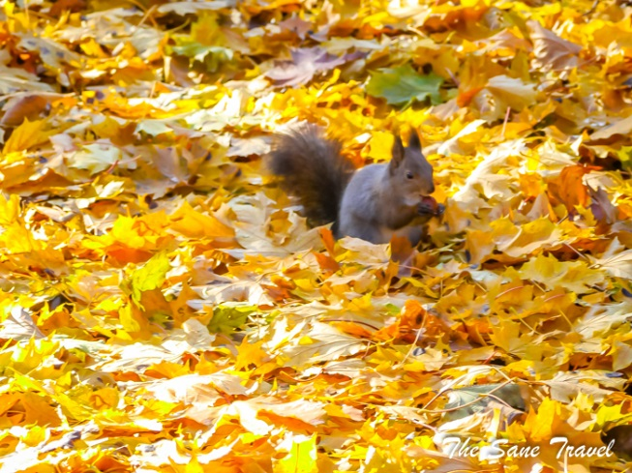

The main attraction there is the numerous squirrels you can admire.
If you have more time on your hands, I very much recommend visiting Loshitsa Park. Both parks look very picturesque in autumn.

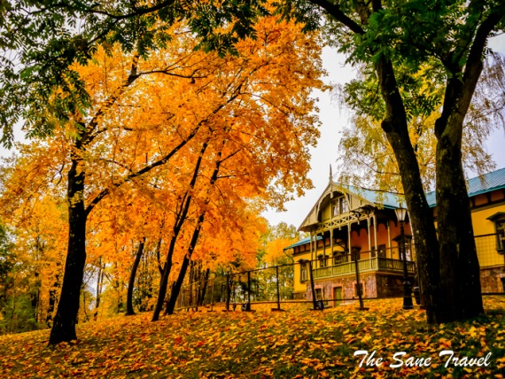
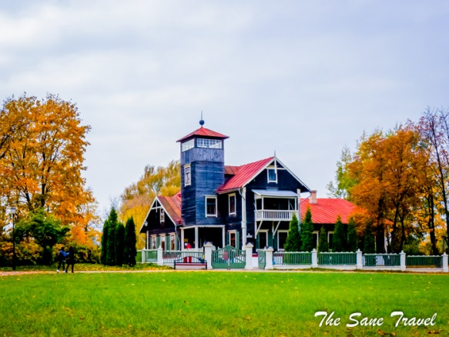
The Loshitsa Estate in Minsk was built in the 16th century. In the late 18th century, Adjutant-General Count Stanislaw Pruszynskiremodelled the estate into a large residence that welcomed many outstanding historical figures like the last King of the Polish-Lithuanian Commonwealth Stanislaw August Poniatowski and Russian Emperor Paul I, among the others. The last owners of the Loshitsa Estate, EustacjuszLubanski and his wife Jadwiga, made it even more beautiful. The picturesque park featured exotic plants and the house was transformed into an elegant mansion where the family held theatre and poetry evenings and celebrated folk holidays. EustacjuszLubanski left it in 1913, after Jadwiga’s tragic death. Today the Loshitsa estate and park is one of the most beautiful places in Minsk.

One can walk along the old alleys and visit the residence-museum.

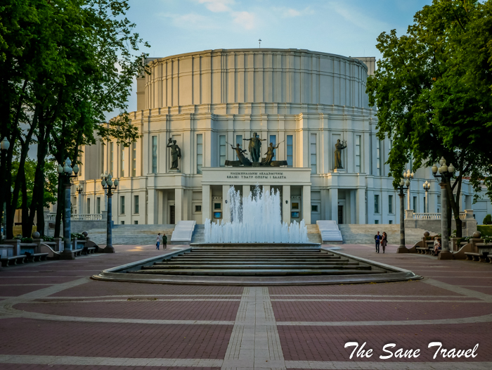

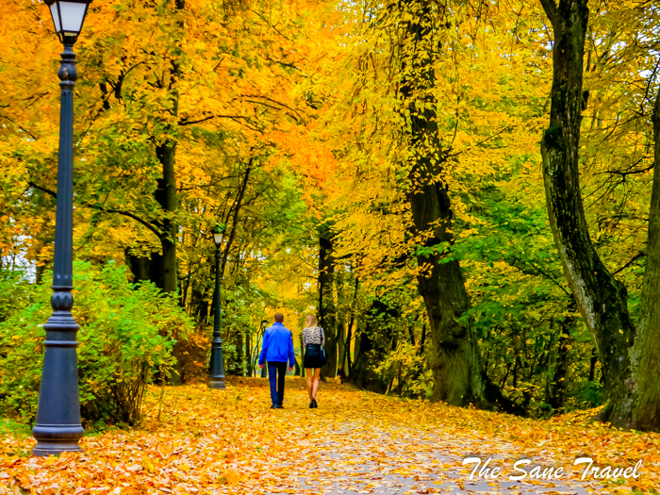
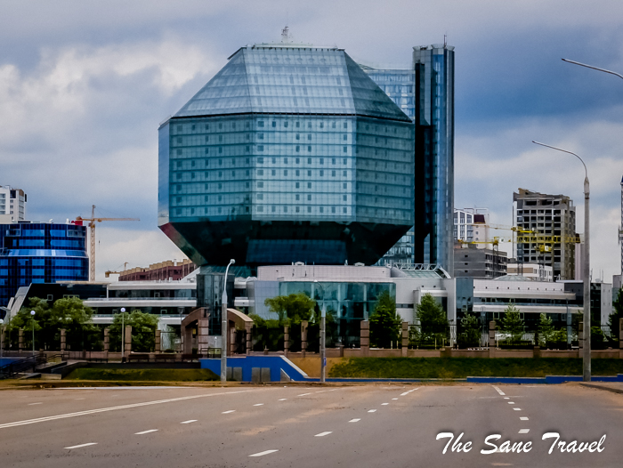

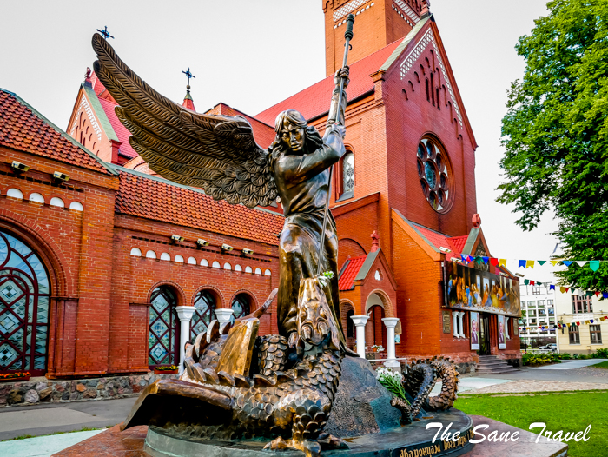

The National Library of Belarus
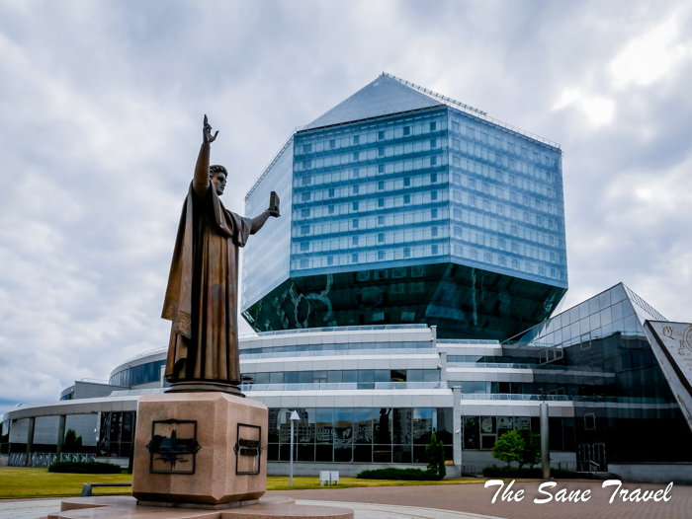
Viktor Kramarenko and Michael Vinogradov designed the 23-storey National Library of Belarus as a gigantic diamond. It’s a symbol of the precious knowledge stored in the books within. It was completed in 2006.
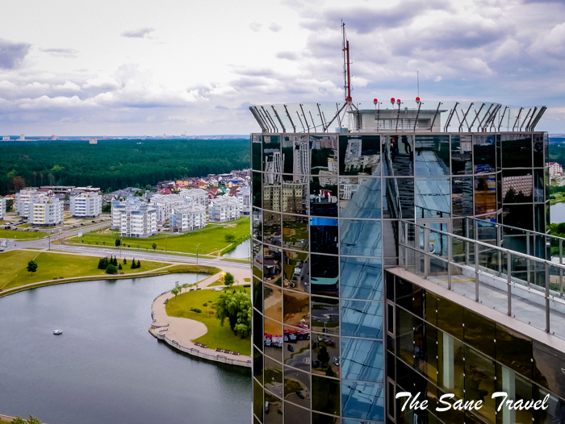
There are different opinions about the architectural value of the building, but it’s worth visiting at least for two reasons. Firstly, it hosts a museum of rare books, e.g. original books of FrancyskSkaryna, an outstanding personality in the Belarusian history. His sculpture is placed next to the library building. The exposition hosts 10 originals of the Bibles published in the early 16th century. The second reason for visiting the library is the viewing platform on top of the building offering great views of Minsk.

Minsk arena, the venue of 2014 World Ice Hockey Championship
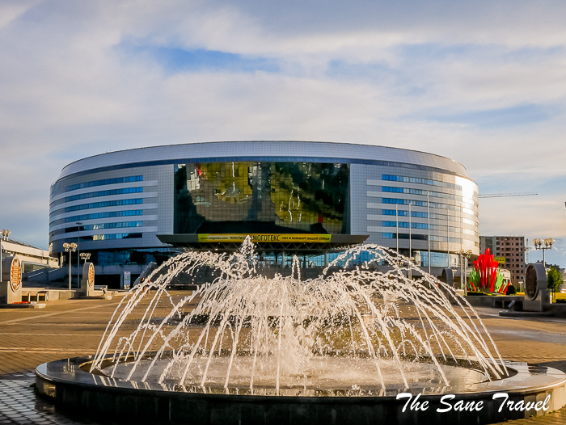
It is one of Europe’s biggest cultural and sports facilities, a great example of Belarusian contemporary architecture. The multipurpose centre is comprised of the arena, a velodrome, a skating stadium, and a multilevel car park. The official opening ceremony of the venue took place in January 2010 as part of the Second KHL All-Star Game, featuring the teams of JaromirJagr and Alexei Yashin. In May 2014 Minsk Arena hosted the 2014 IIHF World Championship.
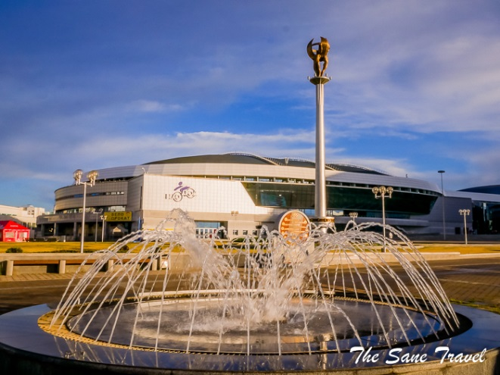
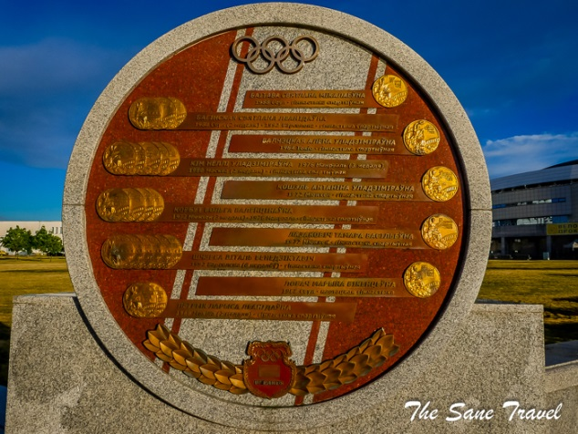

Various concerts, shows, big exhibitions, and forums also take place there. These walls have heard live music of Rammstein, Sting, Joe Cocker, Jennifer Lopez, Depeche Mode, Scorpions, Linkin Park, Elton John, Jose Carreras, and Shakira.
If you have more time, you can continue your journey from Minsk Arena to the recreation area Drozdy to walk in the woods or take a swim in the summertime. There are several bicycle and Segway rent facilities in the area and nice bicycle paths.
For swimming in any weather, go to the nearby waterpark “Lebyazhy” on the bank of the reservoir “Drozdy”. The entertainment complex can welcome up to 2 thousand people at a time. It is the first real waterpark in Belarus, the fifth largest by size in Europe. Different forms of entertainment are combined with the latest technology and high-quality service.
.

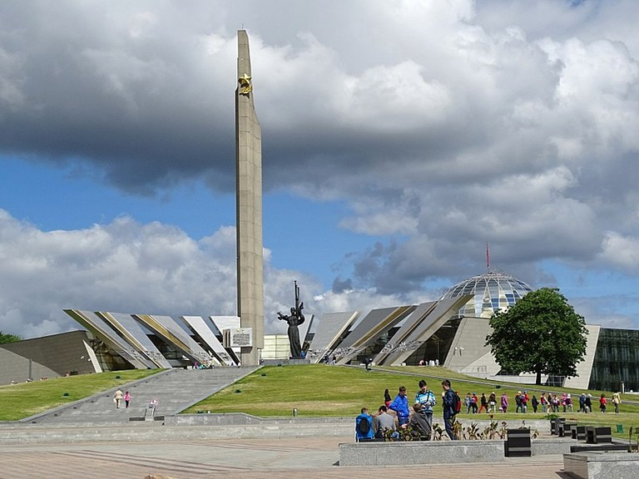

The Belarusian Great Patriotic War Museum
The Belarusian Great Patriotic War Museum was opened in 1944. This in itself is unique, as at the time, the Second World War was still happening. Belarus was hugely affected by the war, losing millions of its population, a fate the country suffered again during Stalin’s reign in the Soviet Union. However, the museum was moved and enlarged during its history. It is now housed in a splendid building in Heroes Square. The museum was re-opened in 2014, on the eve of Independence Day as a tribute to the 70th anniversary of Belarusians’ liberation from the Nazi invaders.

The National Football Stadium
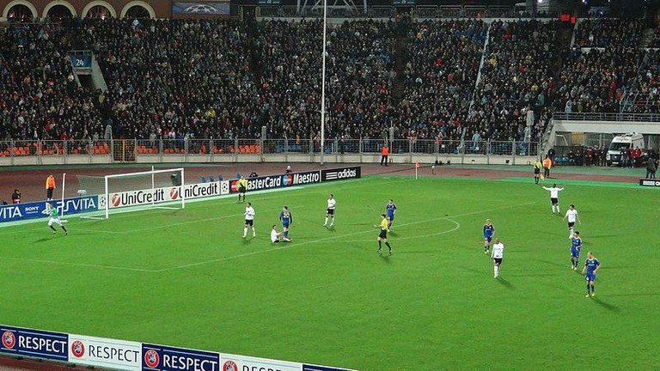
Belarus may not have set the world alight in the football stakes just yet, but the city has a highly impressive national football stadium. Dinamo Stadium has a long history and was reopened as recently as 2017. It was first opened in 1934 but was sadly destroyed during the Second World War. It was used for the 1980 Summer Olympics and the 1985 under-20s World Cup; both times Belarus was part of the former Soviet Union. Local teams Dinamo Minsk and FC Minsk have played here down the years. Today it is the main home for the Belarus National Team.

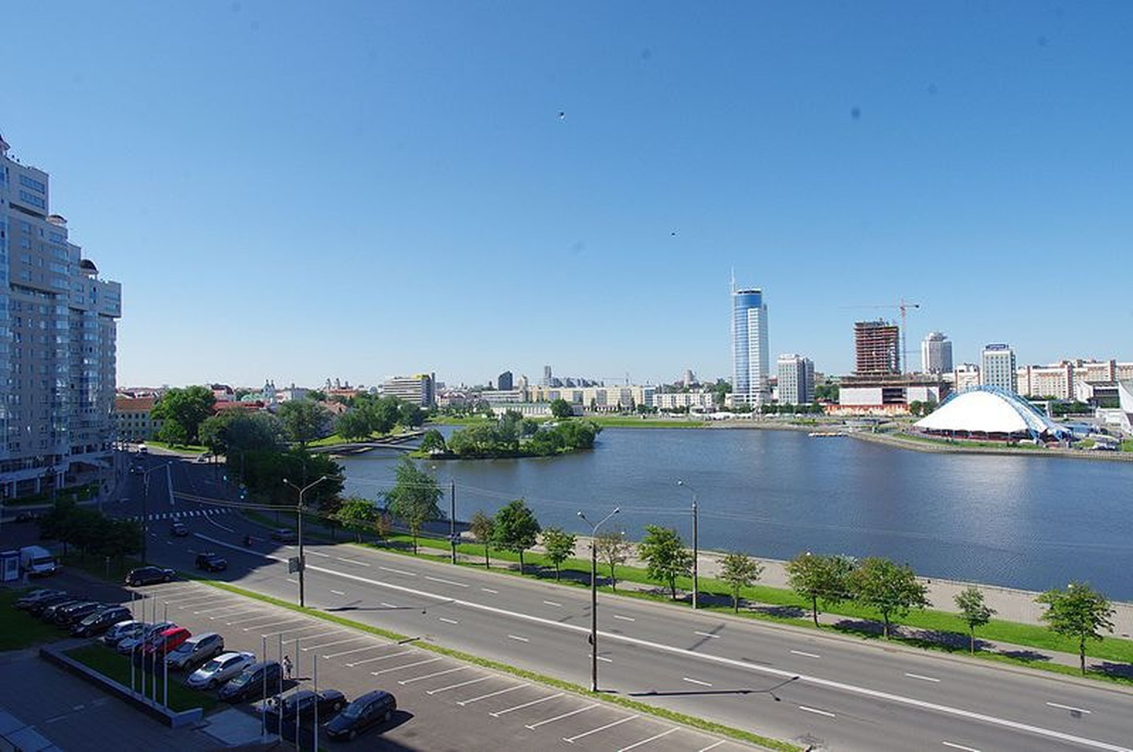

The Island of Tears
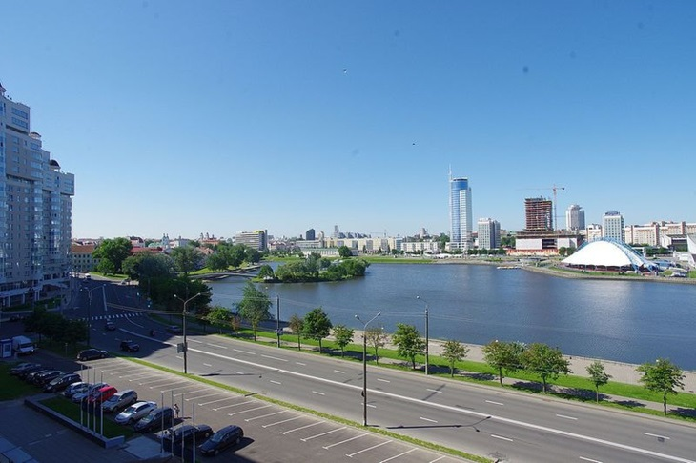
As symbolic a memorial as you can find in the former Soviet Union, the “Island of Tears” is worth a trip. You enter onto the island via a small footbridge. Here there is a memorial to commemorate the Soviet Union’s nine-year war with Afghanistan, which occurred between 1979 and 1988. On the island there is also a sacred statue of a young boy with angel wings. His private parts are more golden than the rest of the sculpture, as many Belarusian girls touch them on their wedding day in a superstition that means they will be certain to have children.

Traeckaje Suburb
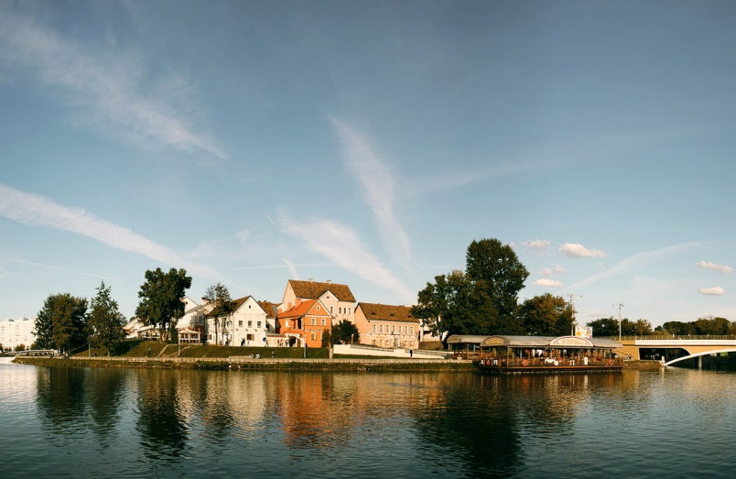
The small island of the “old” Minsk. It is known that already in the 16th century, townspeople and artisans settled on the site of the modern Traeckaje suburb. But in 1809 there was a devastating fire that burned the area to the ground. The new Traeckaje was planned and built under the control of Alexander I himself: landlords, merchants, and other townspeople settled on this 10 streets.
The 20th century gave Traeckaje the hard time (as, in general, to every area of the city), and by 1980 a lot of authentic houses here were destroyed. Around the same time, the suburb began to be slowly restored and rebuilt. Many historians are skeptical about the suburb, they say it has little to do with the ancient architecture. Still, there are many important and valuable buildings in Traeckaje today, for example, the Zitver factory of 1871 or the house of Vidhorčyk, where JankaKupala lived.
The restored Traeckaje suburb is in the top list of the tourist attractions of Minsk. Here you can wander among the nice houses, look at the museum pharmacy, sit in a cafe or just walk along the Svislač, enjoying one of the best views of the city.

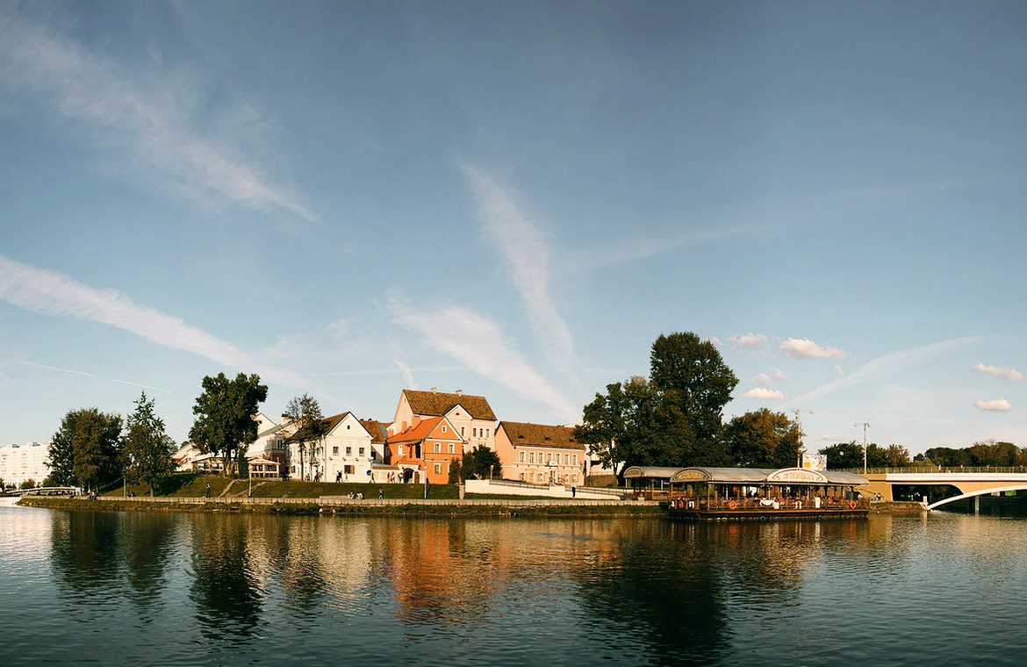

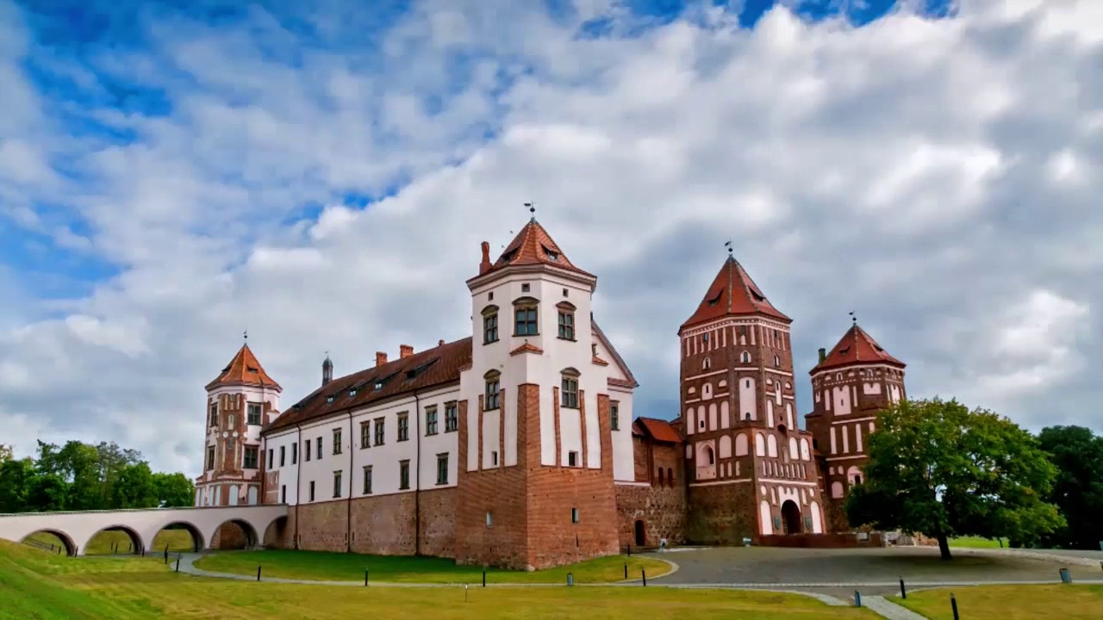

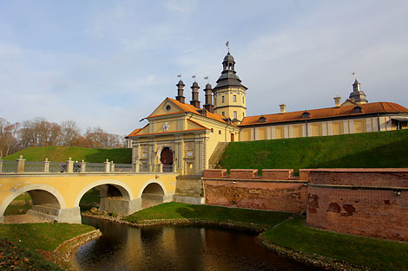

Appendix 2

Tapescript «Belarusian National Parks»

Good afternoon, and welcome to «Belarusian National Parks», the programme for tourists and nature lovers. Today we will be talking about BelovezhskayaPushcha and Braslav Lakes.
If you want to take back with you the impressions of the oldest European wood in Western part of Belarus then BelovezhskayaPushcha is the right place.
Nowadays the national park occupies the area of 85 thousand hectares.
There are 400 years old oak-trees, so you can plunge into the scenery of old forest and listen to the wind and birds here, breath fresh air of pine trees and enjoy walking.
Variety of flora and mild climate form favourable conditions for life of forest animals. 55 species of mammals and more than 200 species of birds lives here. However, the treasure of the park is European bison called "zubr" in Belarusian. At the edge of the forest you can find places where black storks build their nests.
There are all facilities for a wonderful holiday: a large library with a great range of books, a museum of rare plants, animals and a zoo where you can feed animals. You can even try variety of handicrafts, cycling, walking.
Now, let’s move to Vitebsk region, where the name of our country “Blue eyed” comes from. The area is unique for its clean lakes framed with picturesque hills. Around 260 lakes can be found on the territory of Braslav District.
The Braslav National Park is an excellent place for tourism, fishing and hunting.
There are many archaeological, historical and cultural monuments too. National Park is located in the center of one of the oldest Belarusian towns, Braslav, (first mentioned in the chronicles of the 11th century). The town is situated on the green hill of the northern bank of Drivyaty Lake.
During the trip you have a chance to see a number of remarkable sights. Climb the Castle Hill in Braslav and the Mayak Hill, walk along ecological routes of picturesque reserve, enjoy historic monuments of Druya as well as other monuments of nature and history.
Early in the morning or late at night you can take nice colourful photos. Join our new winter tour. Welcome to Belarus!

Used sources: https://infourok.ru/plan-konspekt-uroka-putevoditel-po-respublike-belarus-klass-3670117.html
https://thesanetravel.com/travels/belarus/things-to-do-in-minsk
https://mirzamak.by/en
https://www.youtube.com/watch?v=2oHLSyPQptQ
https://niasvizh.by/en/
https://www.youtube.com/watch?v=HeL9jJkgmhE

I am convinced that _______________ is worth visiting because___________________________. I also think that ____________________. What is more, you can find(visit) _____________________________ there.Besides, I would like to add _____________________________________________________.
That`s why I ___________________________________________________________(strongly recommend you to visit this place and receive unforgettable impressions..

I am convinced that _______________ is worth visiting because___________________________. I also think that ____________________. What is more, you can find(visit) _____________________________ there. Besides, I would like to add _____________________________________________________.
That`s why I ___________________________________________________________(strongly recommend you to visit this place and receive unforgettable impressions..

