План-конспект урока для 6 класса
Тема: Школа
Речевая ситуация: Школы РБ и Великобритании
Образовательная цель: развитие умений говорения; развитие умений восприятия и понимания речи на слух; развитие умений чтения.
Развивающая цель: развитие памяти, внимания; расширение социокультурных знаний учащихся о школе и школьной жизни в Великобритании.
Воспитательная цель: воспитание уважения к своей школе и школе Великобритании, осознание важности соблюдать школьные правила.
Коммуникативные задачи: уметь запрашивать информацию о школе / школьной жизни, отвечать на вопросы собеседника.
Сопутствующие задачи: совершенствовать речевые лексические и грамматические навыки.
Языковой и речевой материал: грамматические структуры с модальными глаголами have to / must; лексические единицы a timetable, a subject, to wear, a uniform, to follow rules, to behave; названия школьных предметов.
Оснащение урока: учебное пособие “English 6”, рабочая тетрадь “English 6”, видеоролик, раздаточный материал.
Ход урока
Этапы урока | Содержание
 | Деятельность учителя | Деятельность учащихся
Введение в атмосферу иноязычного общения, целеполагание | Good morning, pupils! Today we’ll continue speaking about school, subjects and rules. Can you guess what subjects I liked at school most of all? | Угадывают любимые предметы учителя
Фонетическая зарядка | Let’s remember other school subjects. Repeat them after me.  Student’s Book, p.48 | Повторяют названия предметов после учителя
Речевая зарядка | What are your favourite subjects at school? Why? | Отвечают на вопрос
 | Read and guess riddles. What school subjects are they?  1) A subject where you learn to do things with your hands.  2) The study of the use of the computer.  3) It’s about the world – the planets, the stars, about water and air, about animals and trees.  4) You read a lot and learn poems by heart.  5) The study of past events.  6) People speak this language in France.  7) The scientific study of human body. | Читают загадки и угадывают школьные предметы
 | At school we study a lot of subjects. For some pupils school is associated with subjects. And what do you associate school with.  Let’s complete the mind map.  SCHOOL  OK. At the end of the lesson we’ll see what can be added to our mind-map. | Предлагают свои идеи заполняют ассоциаграм-му на доске
Совершенствование грамматических навыков (грамматические структуры с модальными глаголами have to / must) | When at school you must follow school rules. From the sentences below choose the things that you and your classmates have to / must do.  have to or must?  1) I … get up early in the morning.  2) We … do homework every day.  3) Pupils … work hard to get excellent marks.  4) I … go to bed early so that to come to school on time.  5) We … wear school uniform.  6) You … always come to school on time. It’s a rule.  7) I’m late. I … go.  8) Your eyes are bad. You … wear glasses. | Вспоминают правило о модальных глаголах  have to и must, выполняют упражнение
 | Exercises 1, 2 p.28-29 in workbooks | Выполняют упражнения в рабочей тетеради
Развитие умений восприятия и понимания речи на слух | There are a lot of rules to follow at school. And one of the rules is to wear a school uniform. Are school uniforms good or bad?  Listen and complete the sentences.  1) School uniforms are good because …  2) School uniforms are bad because … | Слушают и дополняют предложения
What do you think about school uniforms? Are they good or bad? Let’s divide into two groups. One group thinks of as many reasons for school uniforms and the other group thinks of as many reasons against school uniforms. The more reasons the better.
Possible answers:
School uniforms are good because
1) they save time in the morning,
2) they make everyone equal,
3) they are smart,
4) they make pupils feel proud of their school.
School uniforms are bad because
1) they don’t let students show their personality,
2) they let know students name,
3) they are boring,
4) they are expensive,
5) everybody looks the same.
Пауза для релаксации | To have a rest I suggest doing a crossword on the topic “School”.  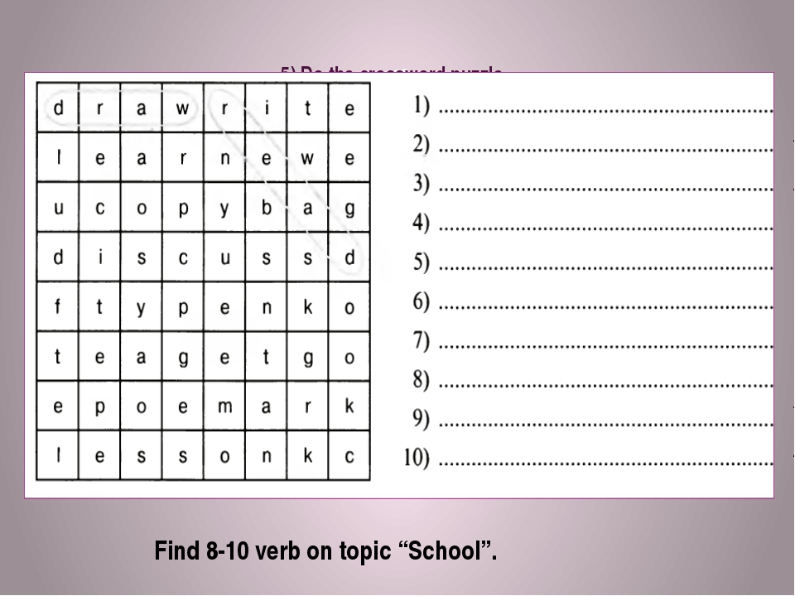 | Находят 8-10 слов по теме
Развитие умений чтения | What do you know about schools in England? Let’s read the text and find some facts about schools in England.  Are not the same – не такие как  Infant schools – начальная школа (для детей от 5 до 7 лет)  Like a kindergarten – похожа на детский сад  Junior schools – начальная школа ( для детей от 7 до 11 лет)  Secondary schools – средняя школа  SCHOOLS IN ENGLAND  Schools in England are not the same as in Russia. Children begin to go to school when they are five. From five to seven they are in infant schools. An infant school is like a kindergarten. Children draw, sing and listen to the stories which the teacher reads to them. In these schools children begin to learn to read and write.  From seven to eleven children in England go to a junior school. In these schools children learn to read, write and count.  From eleven to sixteen boys and girls in England go to a secondary school. They begin to study in form one. The sixth form is the last form in this school. They have many subjects on their timetable: English, English literature, a foreign language, Mathematics, History, Geography, Physics, Biology, Music.  In England schoolchildren do not go to schools on Saturdays and Sundays.  - Are schools in England the same as in Russia?  - What kinds of schools are there in England?  - When do children begin to go to an infant school?  - Do children begin to go to an infant school from six to eight?  - What do children do at an infant school?  - Do children begin to learn to read and write in infant schools?  - When do children begin to go to a junior school?  - Do children begin to go to a junior school from eight to twelve?  - What do children do at a junior school?  - When do children begin to go to a secondary school?  - Do children begin to go to a secondary school from twelve to eighteen?  - In what form children begin to study at a secondary school?  - What is the last form in the secondary school?  - What subjects do children learn at a secondary school?  - Do schoolchildren go to school on Saturdays and on Sundays? | Читают текст, отвечают на вопросы о школах в Англии.
Развитие умений диалогической речи | Now let’s work in pairs. Make up dialogues. One of you is a pupil from an English school, the other pupil is from Belarus. Use the questions to interview your partner.  1) When does your school day start?  2) Do you wear a school uniform?  3) When does your school day finish?  4) Do you have lessons on Saturdays and Sundays?  5) How many lessons do you usually have?  6) Do you have lunch at school?  7) What subjects do you study at school?  8) What foreign language do you study at school?  9) Do you have to clean the blackboard? | Составляют диалог в парах
Рефлексия | To finish the lesson let’s make a cinquain which will reflect your attitude to the topic discussed at the lesson.  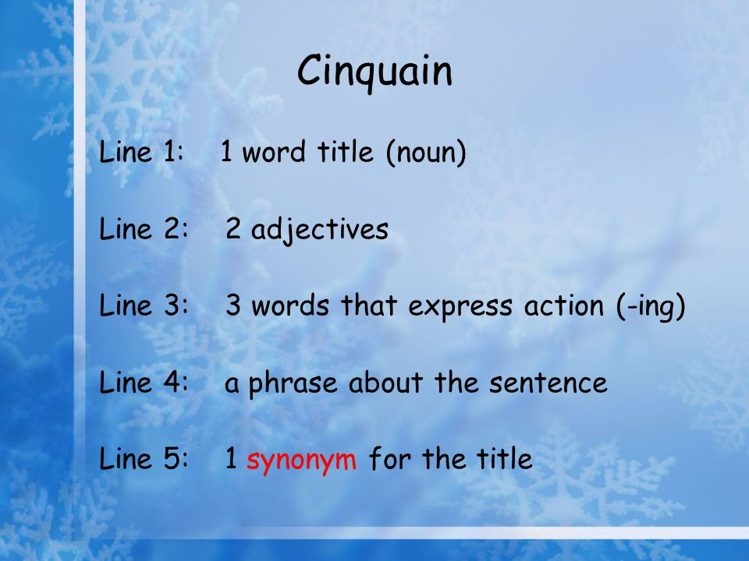 | Составляют синквейн
Домашнее задание | At home you’ll write a story about your school (10-12 sentences). | Записывают домашнее задание
Оценивание | You worked well all the lesson. Now I’d like to give you marks for the lesson.

