Государственное учреждение образования «СШ №12 г. Лиды»

Урок по английскому языку в 8 классе по теме:
Кухня народов мира.

Учитель: Щетко Марина Алексеевна

Лида 2021
ПЛАН-КОНСПЕКТ УРОКА АНГЛИЙСКОГО ЯЗЫКА В VIII КЛАССЕ ПО ТЕМЕ «FOOD FROM ALL OVER THE WORLD»

Тема: Food from all over the world (Еда со всего мира), урок №4 в теме «Еда».
Тип урока: комбинированный урок
Цель урока: развитие коммуникативной и когнитивной компетенции учащихся.
Задачи урока:
- создать условия для развития коммуникативной и когнитивной компетенции;
- содействовать развитию навыков говорения и восприятия речи на слух;
- расширить знания учащихся о блюдах разных стран.
Формы работы учащихся: фронтальная, групповая, индивидуальная.
Оборудование урока: интерактивная доска.
Дидактические материалы: презентация «Food from all over the world».

Ход урока
- Организационно-мотивационный этап урока 5мин
Приветствие
Good morning, my dear students. I`m glad to see you today. We have many nice guests in our classroom. They`d like to watch and enjoy work. Don`t be shy. Be active smart and brave as usual, please. Let`s start our work. What day is it today?
Введение в тему
First of all, please, look at the riddle. What are your thoughts about it? (Слайд 1)
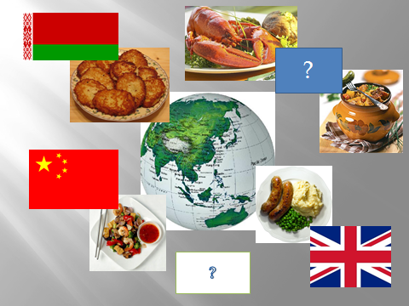
Let`s watch the video. And check yourself.
Who can tell me what we are going to speak about today?
Right you are. Today at the lesson we are going to continue our work on the theme “Food». As you know it is one of the most popular topics in English.
Целеполагание
By the way, what skills we are going to develop? (We are going to develop speaking, listening and reading skills). Right, and grammar skills: we`ll discuss quantifiers. And now I suggest you such a plan of the lesson: Слайд 2.
- Warm-up(vocabulary game).
- Checking homework.
- Listening about breakfast.
- Grammar presentation and practice: quantifiers.
- Listening, reading and discussing the famous dishes.
- Homework.
- Round-up.
Do you like such a plan?
Речевая разминка
- There is no love sincere than the love of food. (George Bernard Show) (на доске)
How do you understand it?
We eat every day and everywhere. We can`t live without food. We eat not only our national food but have a lot of dishes from other countries. Today we’ll speak about food from all over the world. We’ll discuss dishes of different countries. Then you’ll compare them with our traditional ones.
*We all like to eat and have to work very well and attentively today to have good results and get smth delicious at the lesson. And remember that a good beginning makes a good ending.
- Now look at the blackboard, please. (на доске флаги разных стран)
What do you see? Flags. Your task is to guess the country. What country is it? Go to the blackboard and check yourself. (Учащиеся называют страну, выходят к доске и снимают флаг, под флагом название страны. Флаг крепят ниже).
Every country has its history and traditions, and of course its cuisine. One of the most pleasant ways to understand the soul of a nation is to start exploring its national cuisine.
Проверка домашнего задания 3 мин
Before speaking about the dishes of other countries let’s check up your hometask. Who wants to be the first to tell us about our traditional Belarusian meals? (Слайд 3-6)
(Одна из учениц подготовила необычное письмо (видео-письмо) в котором она рассказывает и показывает бел. блюда в ее семье).
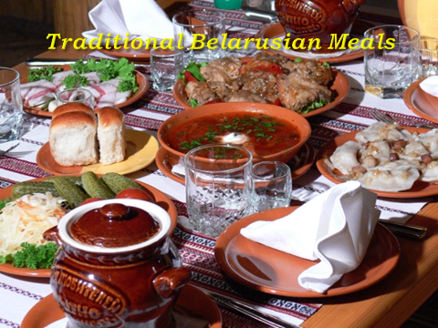

Актуализация знаний учащихся по теме 5 мин
Предтекстовый этап
Now look at the pictures of three different breakfasts. Guess which breakfast Lee from China, Alesya from Belarus and Yan from Scotland eat. (Слайд 7).
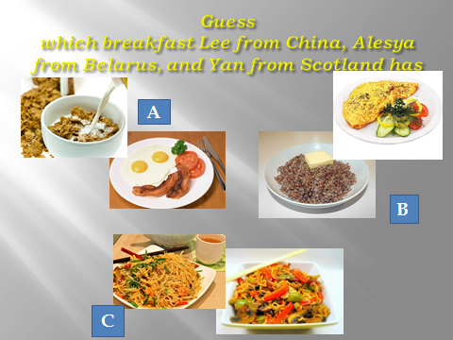

Текстовый этап
While listening make a list of things the children eat for breakfast. (Слайд 8)
Answer my questions, please.
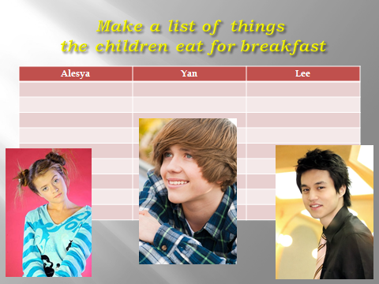
- What does Alesya from Belarus usually have for breakfast?
- What does Yan from Scotland usually have for breakfast?
- What does Lee from China usually have for breakfast?

Послетекстовый этап
Imagine that you are Alesya (Yan, Lee) and tell us about your breakfast.

Now let’s have some fun. Let`s sing the song. Fish and chips.

Операционно-познавательный этап 30
Разминка
You can see that all the countries have their own national dishes. Let’s take some countries, for example, Italy. Who knows what dish this country is famous for? What about Japan? I have some more countries for you. (Слайд 9)
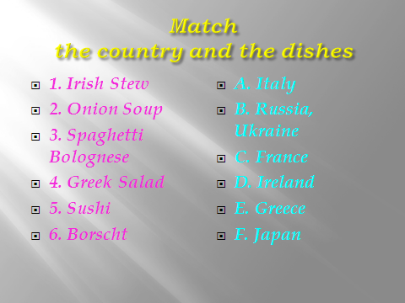

Match the countries and the dishes.
1. Irish[ ] stew [ ] | A.Italy
2. Onion [ ] soup | B. Russia, Ukraine
3. Spaghetti [ ] Bolognese[ ] | C. France
4. Greek salad | D. Ireland
5. Sushi [ ] | E. Greece
6. Borscht [ ] | F. Japan

1. | 2. | 3. | 4. | 5. | 6.

Чтение
Слайд 10 (unknown words)
Do you know anything about these dishes? Try to search some brief information in the letters.
Let’s exchange the information you have found. (Слайды 11-16)

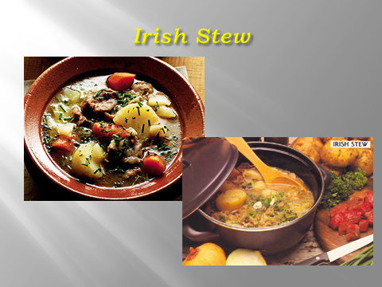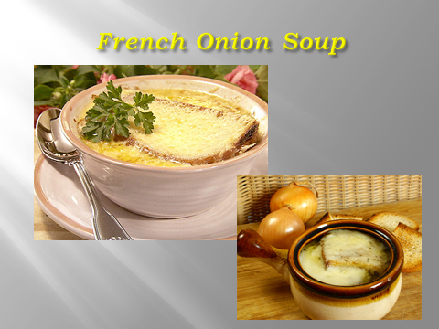
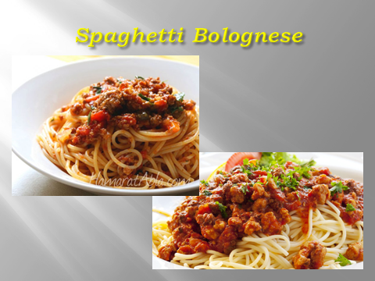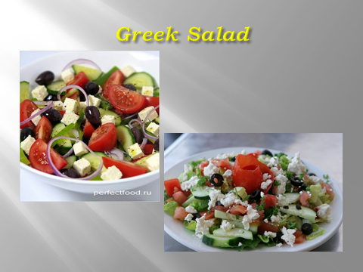

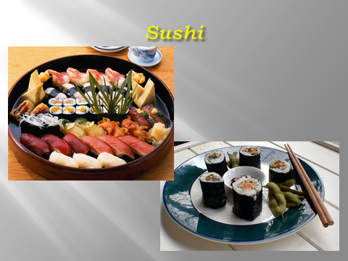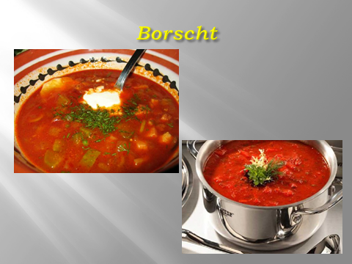

But you should listen very attentively and remember what your classmates will tell you because you’ll do some tests.

Fill in the missing words. (приложение 3)

It is Ireland’s best-known dish from … or … .
French onion soup is made of onions and … or chicken … .
Spaghetti Bolognese mixes spaghetti with … and tomato … .
Greek Salad is made with tomatoes, … , black … and cubes of … .
Slices of very fresh …, … and vegetables wrapped in … are laid on … .
Borscht is eaten … in summer and … in winter. Sometimes meat or …, cabbage, … and … are added.

(Слайд 17)
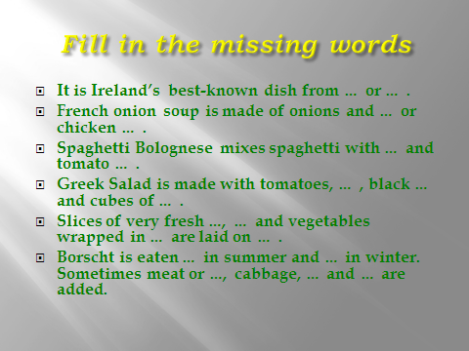
Развитие навыков диалогической речи
Discuss in pairs which of them
- Have you tried
- Has a simple recipe
- Is hard to cook
- You would like to try
- Has simple ingredients
- You can cook.
Let`s imagine that you are in a restaurant of multinational cuisine. What people do work in such places? Chief, cook, waiter/waitress, administrator, barman, guests. Which one would you like to choose for your occupation?
(Тот ученик, который пожелает быть поваром, выходит к доске, надевает халат и шапку повара, берет коробку с угощеньями( пряники с флагами разных стран) и задает вопросы по теме. Ответив, вручает пряник!

Рефлексивно-оценочный этап 5 мин
Рефлексия
Think of the words that are connected with our lesson. (Слайд18 or19) ,(слайд 20)

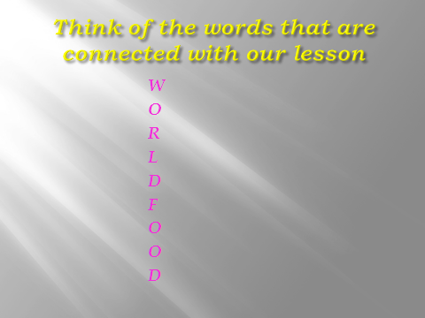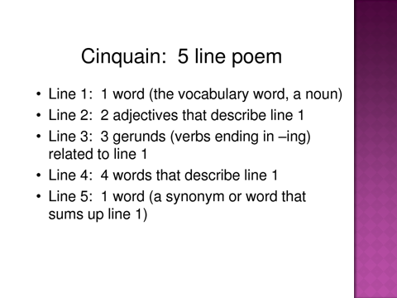
Домашнее задание
p.73 ex. 5b (Write about your favourite Belarusian dish). (Слайд 21)
www.belarus.by Cuisine Dishes of Belarusian cusine
Выставление и комментирование отметок учащимся
(На протяжение урока учащиеся заполняют оценочные листы, в конце урока оценивают себя сами и считают средний бал)
Thank you for your work. The lesson is over. Good bye.

Приложение 1

презентация Power Point «World Food»

Приложение 2

аудиозапись «Conversation of children »

Приложение 3

Карточки с заданием

Match the countries and the dishes.
1. Irish[ ] stew [ ] | A.Italy
2. Onion [ ] soup | B. Russia, Ukraine
3. Spaghetti [ ] Bolognese[ ] | C. France
4. Greek salad | D. Ireland
5. Sushi [ ] | E. Greece
6. Borscht [ ] | F. Japan

1. | 2. | 3. | 4. | 5. | 6.

Приложение 4

Карточки с заданием

Fill in the gaps.
1. It is Ireland’s best-known dish from lamb ( ягненок) or ….… .
2. French onion soup is made of onions and ………. or chicken stork (бульон).
3. Spaghetti Bolognese mixes spaghetti with ……… and tomato sauce.
4. Greek Salad is made with tomatoes, … … , black …… and cubes of ……. .
5. Slices of very fresh …., seafood and vegetables wrapped in seaweed are laid on … .
6. Borscht is eaten ….. in summer and … in winter. Sometimes meat or …….., cabbage, carrots and potatoes are added.

Для слабых учащихся предлагаются слова для справки:
(mutton (баранина), meat, cucumbers, olives, beef (говядина), fish / rice, cold / hot, mushrooms, feta).

