Тема: What brings friends together.
Класс: 9
Тип урока: комбинированный.
Вид урока: традиционный.
Формы работы: индивидуальная, парная, коллективная.
Цель урока: к концу урока учащиеся должны усовершенствовать речевые умения, включая элементы аргументации и рассуждения.

Задачи:
Образовательная: создать условия для совершенствования умений и навыков говорения, чтения, восприятия и понимания иноязычной речи на слух.
Воспитательная: создать условия для воспитания культуры общения
учащихся средствами иностранного языка.
Развивающая: создать условия для развития и совершенствования речевых умений, развития внимания, памяти, воображения и логического мышления

Оборудование: карточки для повторения лексики, раздаточный материал, аудиозапись, рабочая тетрадь “English 9. Workbook-1”, учебник “English 9. Pupil’s Book-1”, мультиборд, планшеты.

Ход урока

Этап | Содержание | Время
Начало урока  Приветствие | Good morning. I’m glad to see you. I hope you are ready for the lesson.
Организационно-мотивационный этап | - What day is it today? – Какой сегодня день?  - What is the date today? – Какое сегодня число?  Let's welcome the guests.  (picture slide) Look at the screen. So what is the topic of our lesson? Correct, but to be more exact….
Целеполагание | What are we going to do in class?  Aims  To present and practise vocabulary  To develop listening and reading skills  To develop speaking skills  Answer the questions.  Do exercise.  Make dialogues.  Make your own dialogue.  Discount in pairs.  Work in groups. | 1 мин
 | Proverbs on the topic  A friend in need is a friend indeed.  A friend to all is a friend to none.  Better be alone than in bad company.  The friends you choose help you win or loose.  Books and friends should be few but good. | 2 мин
Речевая зарядка | “Word cloud”  How do you usually spend time with your friends?  Which activities seem interesting to you? Why?  (pictures on the slide)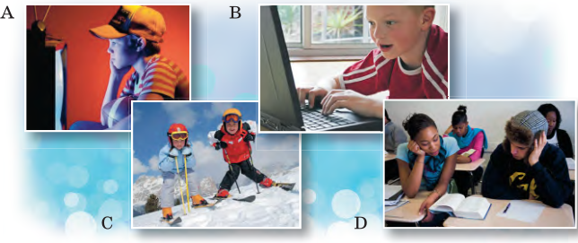 | 3 мин
Основная часть.  Проверка домаш-него задания  Работа с учебником. | Now let’s check up your homework  Ex.4a,p.32  You have mind map. Speak about your friend.  Open your Pupil’s books please at p. 38 and look at the screen. Choose the right synonym to the following words and phrases. Ex. 2b.  Ex. 2a What activities do British teenagers suggest taking up? Listen and read along the newspaper article. Which activities would you choose? (listen to the text, do an exercise to the text to answer the main question)  We have lisent the text. First, we will do an exercise related to this text that will help us answer the main question. Which activities would you choose?  Let's continue working in the program https://learningapps.org  Which activities would you choose?  Ex. 2d. p. 39 / Answer the questions below. Work in pairs.  Now let's work in pairs and find out how your classmates like to spend their free time.  Then tell how your classmate likes to spend time.  Приём живой диалог  You see colored leaves. You need to choose any color.  Now divide into groups. Pink leaves will sit here, and blue leaves will sit here.  You need to make a dialogue. The all group will go to the board and line up in the correct order. The second group checks.  Let’s check on the screen. Well done. | 10 мин + 5
Debate | Now using this dialogue as an example, make your own dialogue. Work in pair.  You made up the dialogues, now let's talk  Now you need to split up on the following statements . Choose what you like. –  Spending time with one’s family is more useful than with friends.  Friends are more important than a family for a teenager.  One can live without friends.  You need to express your opinion why you chose this particular option. Other groups listen and express their opinions. | 10 мин
Заключительная часть урока  Подведение итогов урока | Look at the blackboard. Have you completed all the tasks?  What did we do in class today?  Thank you for your work at our lesson. | 1 мин
Рефлексия учащимися своей учебной деятельности | Our lesson is almost over. Look at the blackboad, please. Here you see the table:  Use this table and share your opinions about the lesson.  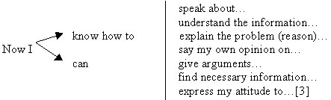 | 2 мин
Предъявление и объяснение домашнего задания | At home you must do ex. 4 at page 40 (PB).  Write an article “Top Fun Ways of Spending Time with Your  Friends” for your school newspaper. Use the highlighted phrases  from ex. 2a, Lesson 2. | 1 мин
Выставление отметок | -Your marks are…..  Положительная отметка. I’m satisfied with your work today. Your answers were full and nice. You were active during the lesson. You have 8 (9, 10).  Нейтральная. Your work was good, but not enough. You should read more (learn the words. translate the text). You have 6 (7).  Негативная. Your work was weak. You should be more attentive.active. Unfortunately. you have 3 (4. 5).  Thank you very much. The lesson is over. Goodbye. | 2 мин

