Тема урока: « LET`S HAVE FUN. Belarus and Great Britain»
Тип урока: комбинированный.
Вид урока: урок-путешествие.
Формы работы: индивидуальная, парная, фронтальная, в команде.
Методы работы: создание проблемных ситуаций, коммуникативный метод.
Цель: предполагается, что к окончанию урока учащиеся смогут рассказать и расширить знания о Беларуси и о Великобритании.
Задачи: развивать навыки говорения, чтения, восприятия речи на слух;
закрепить умения в применении изученного материала в новых ситуациях общения; формировать умение у учащихся строить монологическое высказывание по теме урока на иностранном языке.
Дидактическое оснащение: компьютер, интерактивная доска, раздаточный и иллюстративный материал, карта мира.

ХОД УРОКА
I. Warm-up
- Good morning, children! I’m glad to see you. Sit down, please. How are you?
- I’m fine/ ok/ good…
- Can you guess the topic of our lesson today? (слайд 1 + наглядности на доске)
- I think it`s …
- Yes, you are right. Look at the screen. Our topic today is “LET`S HAVE FUN. Travelling around Belarus and Great Britain”.
So, today we are going to travel around our Belarus and Great Britain.
II. Vocabulary presentation
- We live in Belarus. It`s famous for its nature, lakes, rivers and picturesque places. Can you show me our Belarus on the map? P…
- What`s official language in Belarus?
P1…
-Great. What foreign language do you learn at school? Do you like it?
P…
- You learn British English. This is a language of Great Britain. Show us Great Britain on the map.
P…
- Well. Which ocean and seas is washed by Great Britain?
P…
- Excellent! I see that you are ready for our trip! ` LET`S HAVE FUN`.
- You are divided into 2 teams. Your team is `British` and your team is `Belarusians`. Choose a captain.
(слайд 2)
Let`s play a game `Outburst`. You have 2 categories:
English speaking countries and Russian speaking countries. You choose a word, shout out it, run to the board, stick the word and go to your place.(названия стран разрезаны и перемешаны). Do it one by one. I`ll give you a minute.
P…
- Let`s check. (слайд 3)Look at the screen.

Russian speaking countries English speaking countries

Russia Australia
Belarus Ireland
Ukraine (not official) New Zealand
Lithuania The Unite Kingdom
Kazakhstan The United States of America

- Well done! Take your points.
(слайд 4)
Let`s play `Speak the button game`. At first I`ll give you the numbers. Each student receives a number from 1 to 6. All teams have the same numbers. Your team has 1 and yours, and etc. Look at these gorgeous buttons! Take them and lay it on the desks! Now, be attentive! I will read a question (say True or False, answer the question). (слайды 5- 10)You can look at the screen or listen to me. Then I`ll take and tell you a number. That pupil who will listen his number should touch the button and scream `Speak the button`. Who will do it the 1st, will answer the question.

- Which ocean has Belarus?
- The Pacific Ocean
- The Atlantic Ocean
- Where Is the River Thames?
- Brest
- London
- The River Sozh in Minsk.
- The Pacific Ocean is the deepest.
- What`s called `Union Jack`?
- A document
- Flag
- London is the capital of Wales.

P…
- Take your points. (за каждый правильный ответ, команда получает балл)
- Gorgeous!
- (слайд 11) Next game is `Guess the puzzle`. Now, It`s the captains` battle. Your team can help you (the captain). You answer by tern. Look at the screen (слайд 12-21 с ответами).

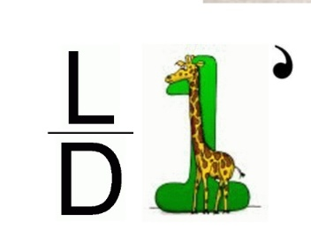
- It`s the capital

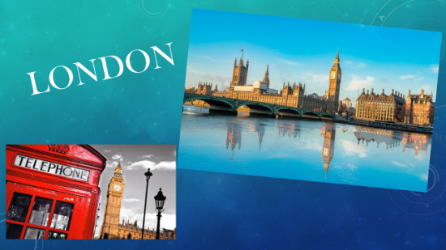
Answer:

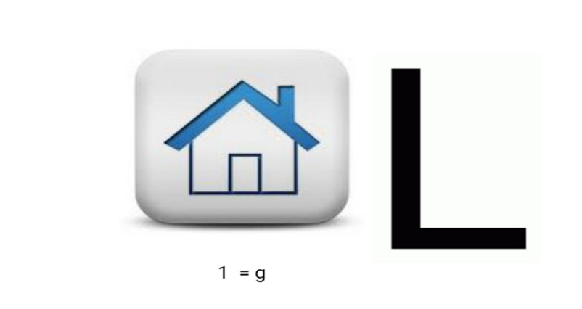
- It`s a region in Belarus

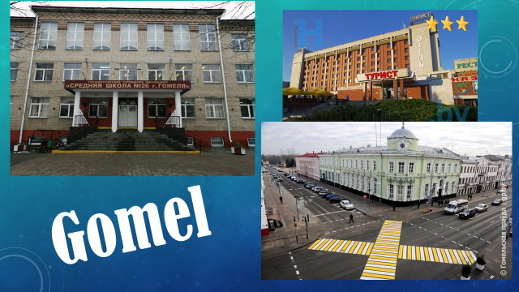
Answer:

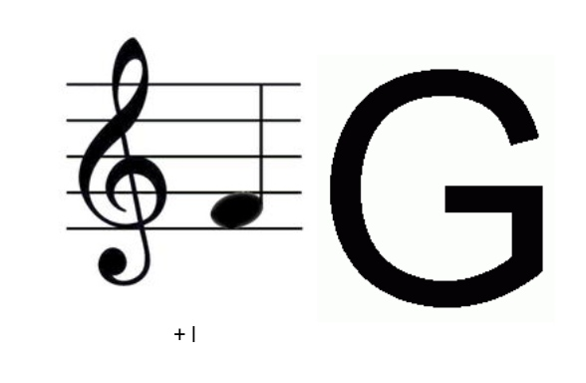
- This symbol has each country, but it has different colors

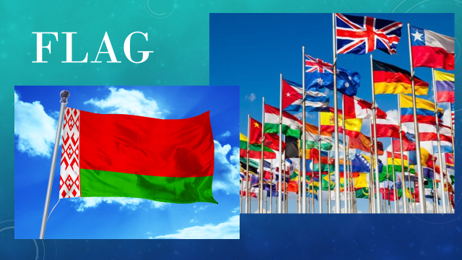
Answer:

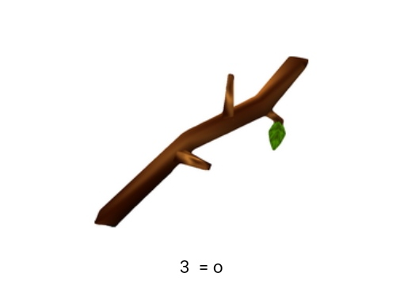
- This bird is a symbol

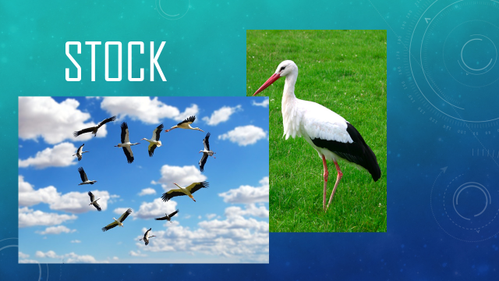
Answer:

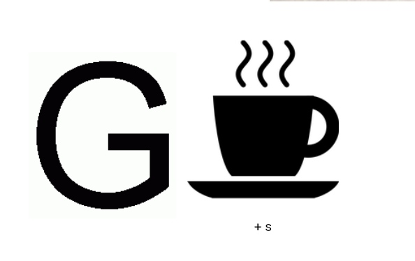
- You can`t touch it. You can only see it or listen strange sounds

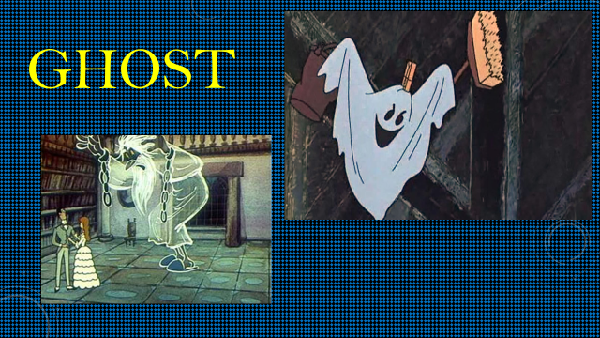
Answer:

P1…P2…
- That`s cool! You are so clever!
Ⅲ Moving activity
(слайд 22)
- Let`s warm-up and play `Noughts and Crosses`.The captains choose a card. You are noughts and you are crosses. Look at the screen (слайд 23). This is your questions. You should take a question, answer it. If you are right, you`ll go to the board and write a nought or a cross. One of the team should cross out its symbols faster than the other team. Let`s start:
1. What`s official name of Belarus?
2. What`s official name of Great Britain?
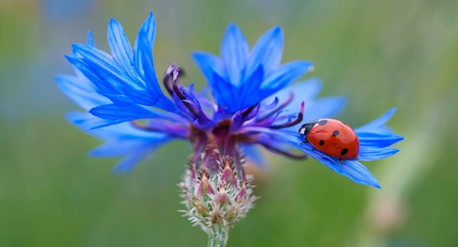
3. What`s this? (picture)

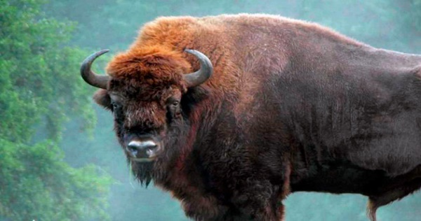
4. What`s this? (picture)

5. How many regions has Belarus? Count them.
6. How many countries consists of Great Britain? Count them.
7. What`s the capital of Belarus?
8. What`s the capital of Great Britain?
9. What color is Belorussian flag?
10. What color is British flag?
P1..P2…P3…P4…
T- Take your points.
- Well done! Now, last competition is `Grammar races`. Take your lists with tenses. Let`s revise the grammar! If you haven`t them I`ll give you the copy.
(Учащиеся вместе с учителем повторяют временные формы глагола и степени сравнения).
All of you take a card (or a number), for each correct answer you`ll receive a point. I`ll give you 2 minutes to prepare for your answer.
(слайд 24)
1 | 2 | 3
4 | 5 | 6
7 | 8 | 9

- Correct the mistakes:
- We didn`t went to Mir castle last week.____________________________
- They have already went there.____________________________________
- I already finished packing my suitcase._____________________________
2. Wright and translate the irregular verbs:
V1 | V2 | V3 | Translation
Give
Make
Do
Eat
Write

3 What tense is it? Why? The Past Simple, The Present Perfect, the Present Simple, the Present Continuous:
1. Last summer I went to my granny in Rissia.____________
2. I`m busy.I`m cleaning my room at the moment._____________
3. I play football on Sunday._______________
4. Choose the Past Simple or The Present Perfect:
1. Mary (to buy) a new hat.________________________________________
2. I (to buy) a pair of gloves yesterday. ______________________________
3. She (to see) this film last Sunday._________________________________
5. It`s the symbol of Belarus
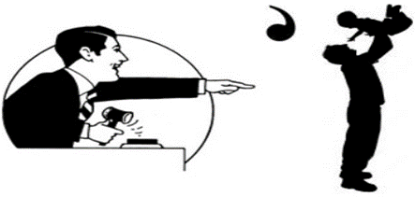

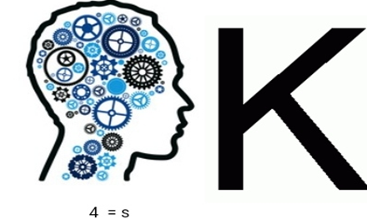

It`s the largest city in Belarus

6 Correct the mistakes:
1. Lake Baikal is the deeper.________________________________________
2. You should touch wild animal.____________________________________
3. Winter is more colder than spring._________________________________
7. Wright and translate the irregular verbs:
V1 | V2 | V3 | Translation
Learn
Buy
Do
Take
Read

8 Choose the Past Simple or The Present Perfect:
1. Alex (to meet) his friend two hours ago. ____________________________
2. I just (to meet) our teacher._______________________________________
3. He (visit) that place last year._____________________________________
9. Write the correct form of the verb: the Past Simple, The Present Perfect, the Present Simple, the Present Continuous:
1. I __________just ____________(meet) our teacher.
2. My mum __________(get) up at 6 o`clock in the morning.
3. Granny __________(plant) tomatoes last week.
P1…P2…P3…etc
Ⅳ Round-up
- Ok, count your points. The winner is… . You all worked hard. I`m very proud of you!
Thank you for your work, I hope our lesson would be rather useful.
(слайд 25) Do you remember what we have learnt at the lesson today? What do you know about Belarus? Great Britain?
- We’ve answered the questions.
- We’ve played the games.
- We`ve revise the grammar
-We`ve spoken about Belarus and Great Britain.
And it is time to get marks for the lesson. Your marks are...
That’s all for today. Good-bye.

